

Sustainability Report
  - Quarter One, 2025/2026

Citation: Health New Zealand | Te Whatu Ora. 2025. Sustainability Report – Quarter One, 2025/26
Wellington: Health New Zealand | Te Whatu Ora.
Published in February 2026 by Health New Zealand | Te Whatu Ora
PO Box 793, Wellington 6140, New Zealand
ISSN 3021-4106 (online)

This document is available at tewhatuora.govt.nz
 | This work is licensed under the Creative Commons Attribution 4.0 International licence. In essence, you are free to: share i.e., copy and redistribute the material in any medium or format; adapt i.e., remix, transform and build upon the material. You must give appropriate credit, provide a link to the licence and indicate if changes were made.

Contents
Contents 3
Related reports 5
National Overview 6
Key objectives and progress 7
Health System decarbonisation 7
Emission sources report – Quarterly totals and top emissions sources 8
Regional Summaries 13
Northern Region 14
Te Manawa Taki 15
Central Region 17
Te Waipounamu 19

Sustainability Performance Quarterly Summary​

Total quarterly greenhouse gas emissions for Health New Zealand | Te Whatu Ora (Health NZ) remained comparable to the same quarter last year.

Reduced emissions from natural gas and coal sources continue to demonstrate a successful transition away from fossil fuel use and the impact of associated energy efficiency projects. Emissions from natural gas consumption were down 6% from Q1 in the previous year and coal emissions reduced by 56%, with conversion of the last remaining coal boiler also underway.

These reductions were offset by increases in emissions from staff air travel (17%, particularly in September), medical gases (19%) and electricity (4%). Fleet fuels and waste related emissions are largely steady.

Analysis of three districts with higher staff air travel in September shows the increase was mainly due to conferences, training, and seminars (including that for contractually agreed Continuing Medical Education). There was also a higher share of international travel than in previous quarters, which increases emissions. Overall, staff air travel emissions remain well below FY2022/23 levels. Changes to travel booking suppliers this quarter have limited the level of detail available, but new, consistent coding will support clearer analysis in future quarters.

Medical gas emissions are based on purchasing not consumption data so may exhibit quarterly variability. Electricity consumption is expected to increase as we transition away from fossil fuel energy sources. Electricity emissions are also currently impacted by a higher emissions factor resulting from a lower percentage of renewables generation in grid supplied electricity.

Related reports
Sustainability Report – Quarter 1 2023/24; Sustainability Report – Quarter 2 2023/24;
Sustainability Report – Quarter 3 2023/24; Sustainability Report – Quarter 4 2023/24; Sustainability Report – Quarter 1 2024/25; Sustainability Report - Quarter 2 2024/25; Sustainability Report - Quarter 3 2024/25; Sustainability Report - Quarter 4 2024/25.


National Overview

Key objectives and progress

Health System decarbonisation
Goal: To reduce health system carbon emissions in line with a 1.5-degree scenario.
Emissions Inventory for FY2024/25 completed, independently audited and published.
Approval provided for Stage 2 of the Energy Transition Programme, a co-funded $38.4m budget to be allocated for projects commencing in FY2025/26.
Inaugural meeting of the National Medical Gases Committee, a cross-disciplinary body enabling improved medical gas management.
Health System Resilience and Adaptation - Goal: To safeguard our health system by planning for and adapting to the impacts of climate change.
Ongoing development and internal engagement for a Climate Adaptation Framework for Health NZ.
Health NZ participation at the Climate Health and Sustainable Healthcare Conference.
Environment in all Practices - Goal: Realise co-benefits that include the environment alongside health, equity, social and economic values.
Approval to commence revision of NZ Standard 4304:2002 Management of Healthcare Waste.
Promotion of Plastic Free July campaign within Health NZ, including internal Pānui articles and resources for staff.

Emission sources report – Quarterly totals and top emissions sources

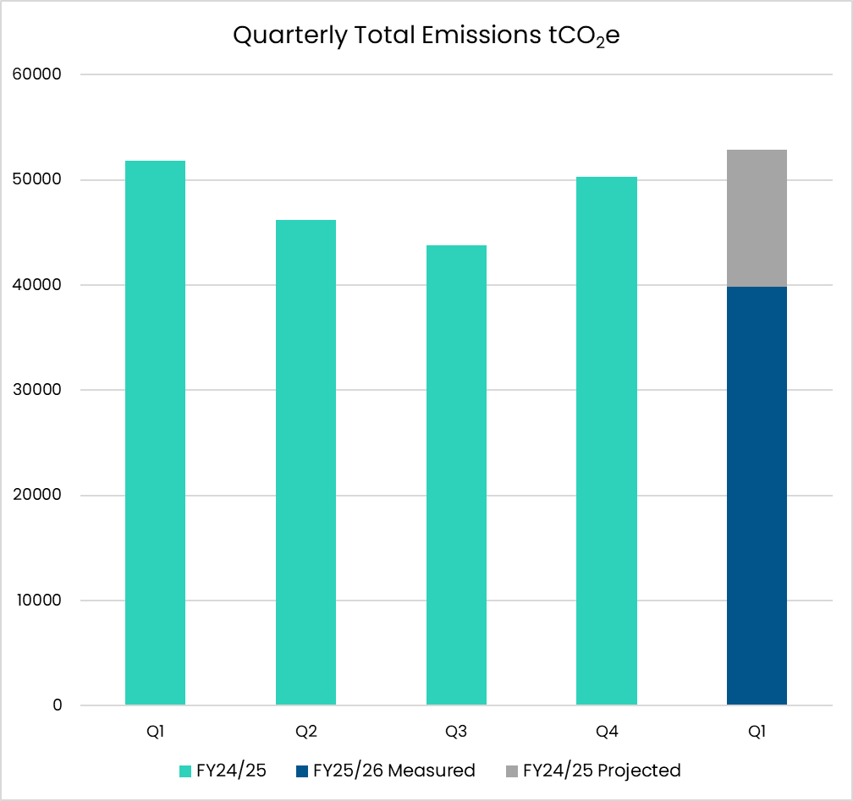
Figure 1 - Graph showing the total emissions for Health New Zealand for this quarter. Previous four quarters included for reference.

Note on Quarterly Total Emissions
These graphs illustrate quarterly emissions for key measured sources. For total emissions this quarter, sources which are only measured and reported annually are estimated and shown in greyscale above the current year quarterly actuals total.

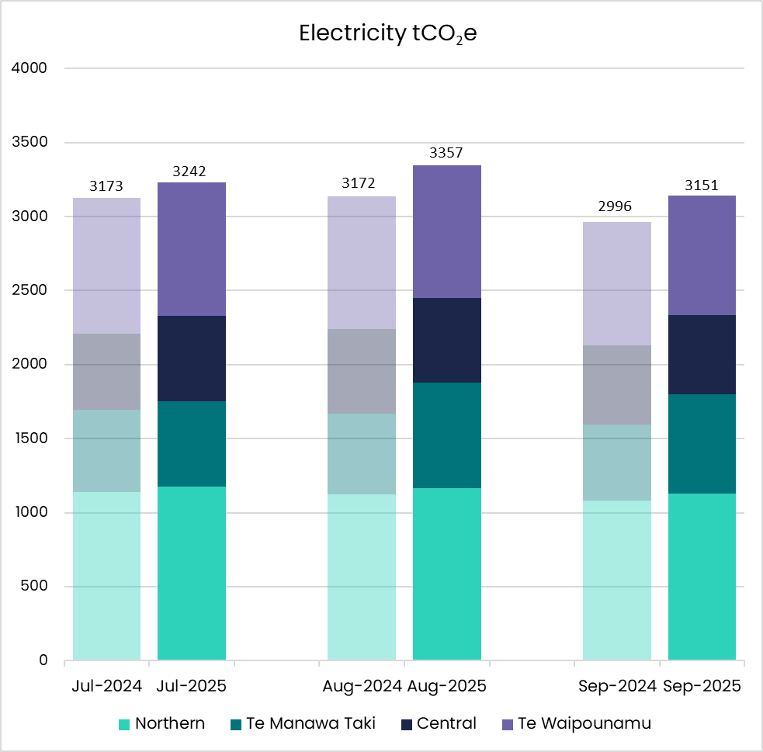
Figure 2 - Graph showing Electricity emissions for the quarter broken down by month and region.

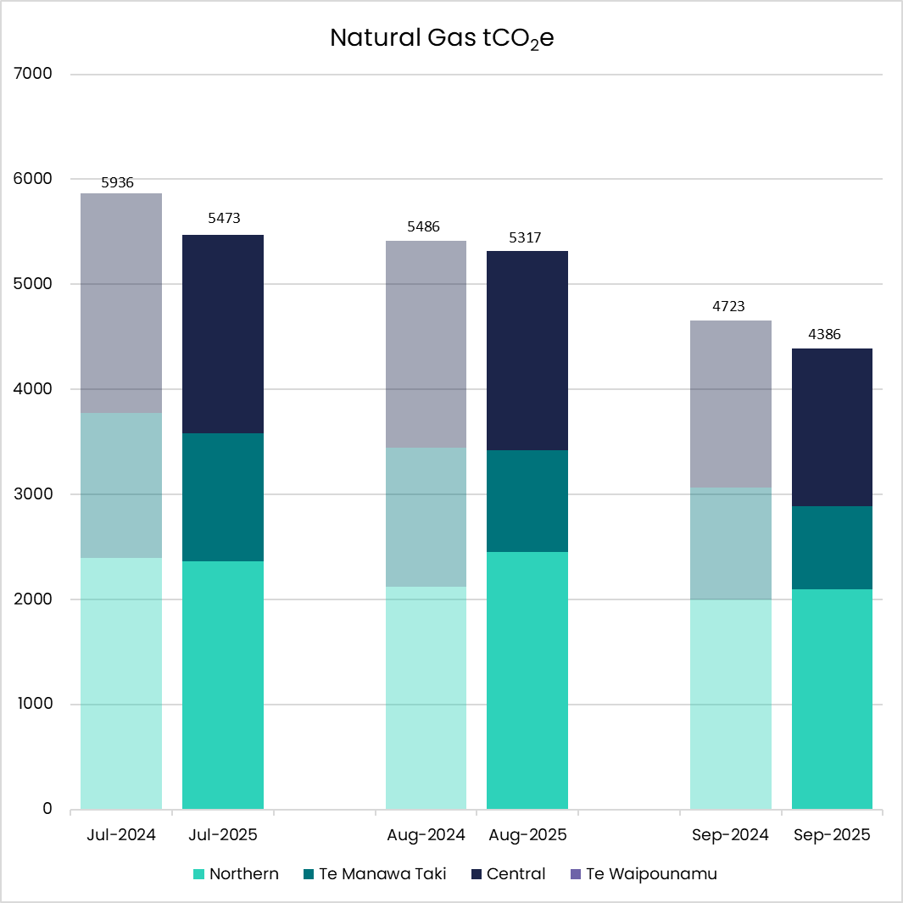
Figure 3 - Graph showing Natural Gas emissions for the quarter broken down by month and region.

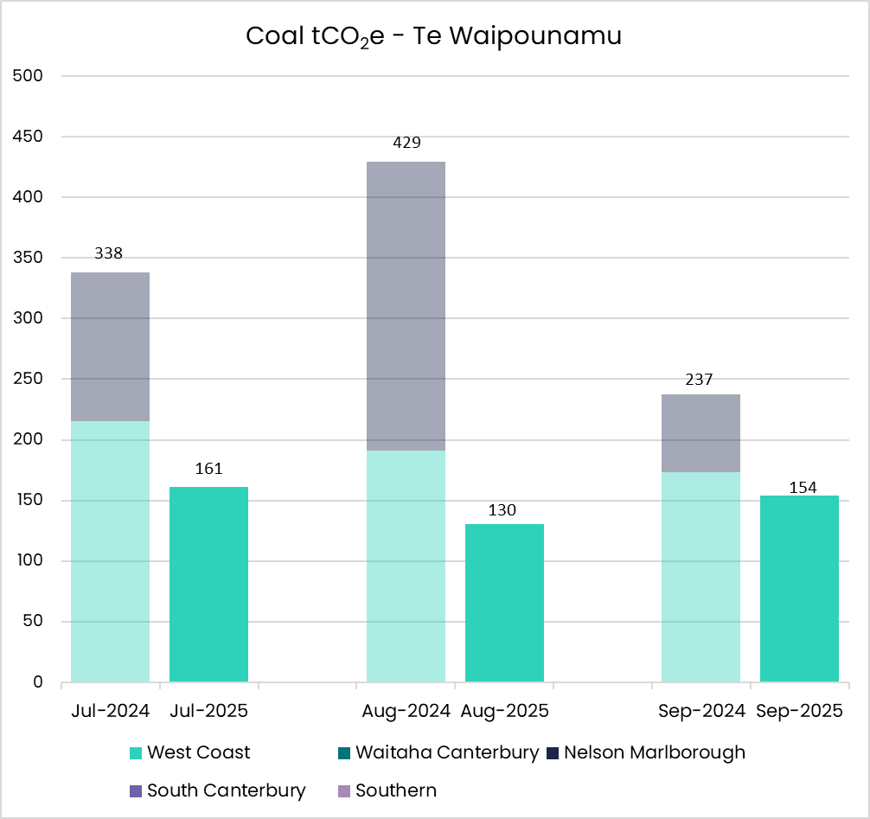
Figure 4 - Graph showing Coal and Steam from Coal emissions for the quarter broken down by month.

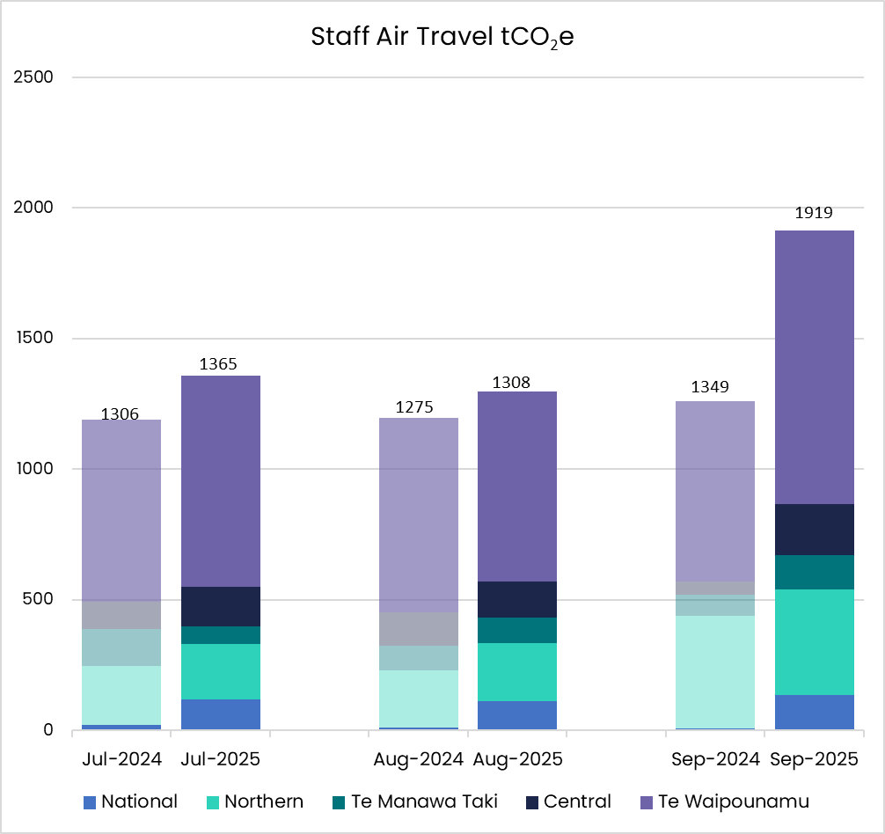
Figure 5 - Graph showing Staff Air Travel emissions for the quarter broken down by month and region.

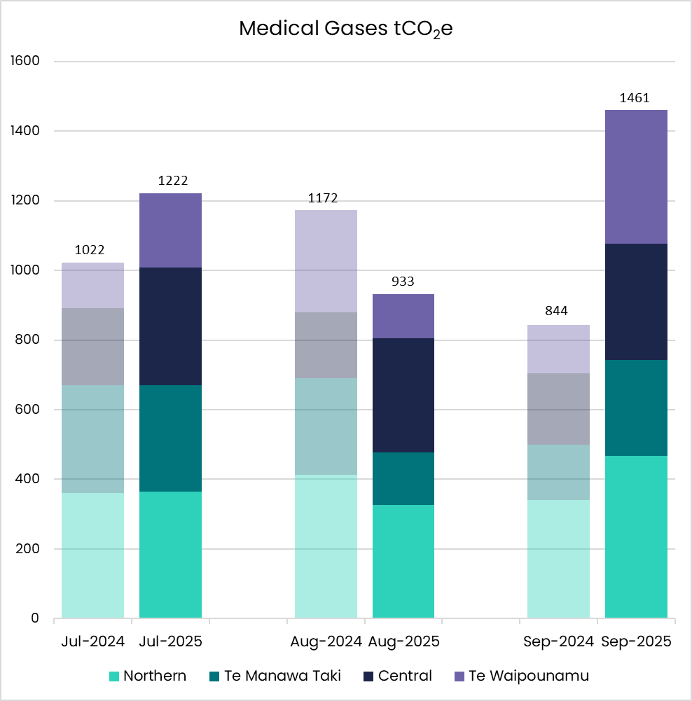
Figure 6 - Graph showing Medical Gases emissions for the quarter broken down by month and region.

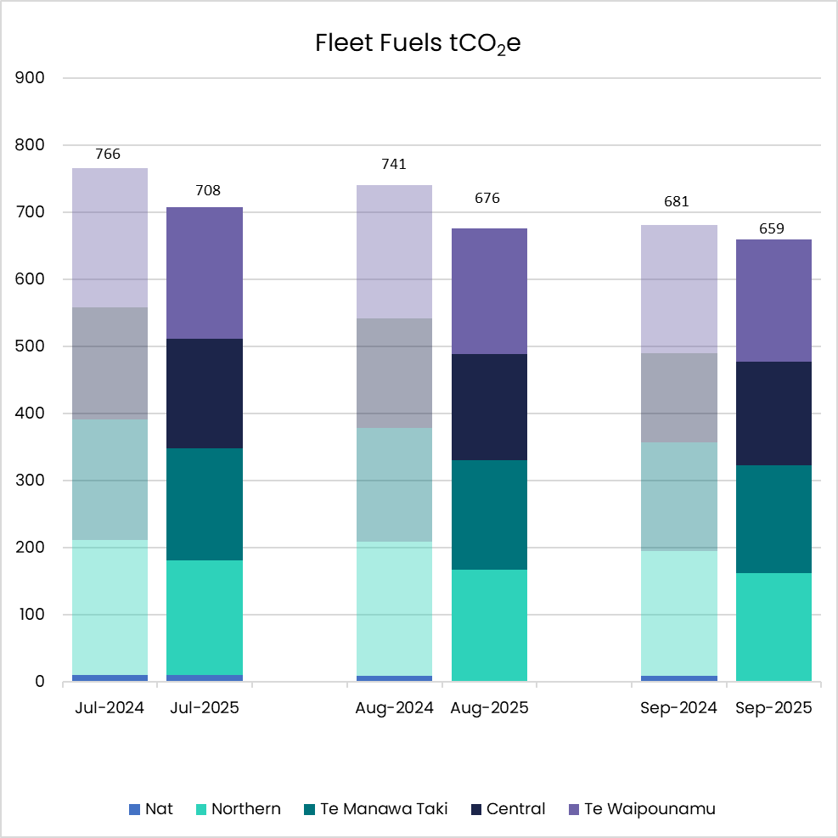
Figure 7 - Graph showing Fleet Fuel emissions for the quarter broken down by month and region.

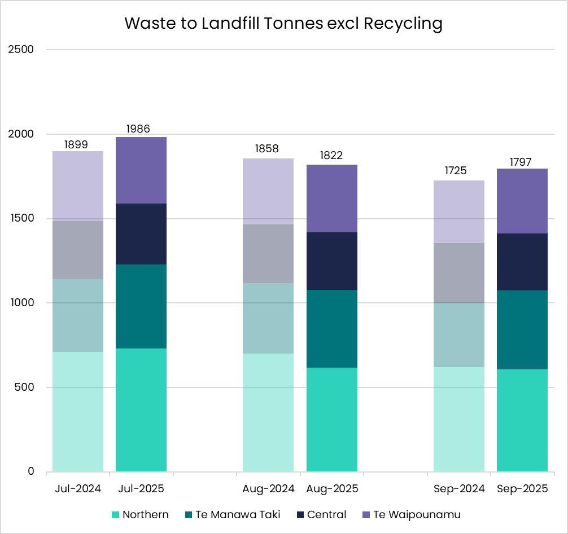
Figure 8 - Graph showing Waste tonnes sent to landfill for the quarter broken down by month and region.

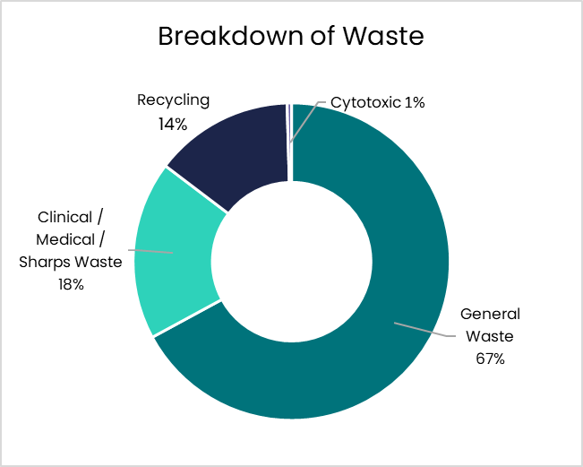
Figure 9 - Graph showing Breakdown of waste for the quarter by type of waste.


Regional Summaries

Northern Region
Key Objectives and Progress update
The quarter saw fleet fuel emissions reduce (14%) and natural gas emissions (10%) drop from last year.
Health System Decarbonisation - Goal: To reduce health system carbon emissions in line with a 1.5-degree scenario.
Energy Transition Programme:
4 new projects approved:
- Steam boiler transition project at Manukau Health Park
- Steam boiler transition at Middlemore Hospital
- Chiller replacement project at Middlemore Hospital
- Steam boiler removals at North Shore Hospital
11 energy transition projects in flight for the region.
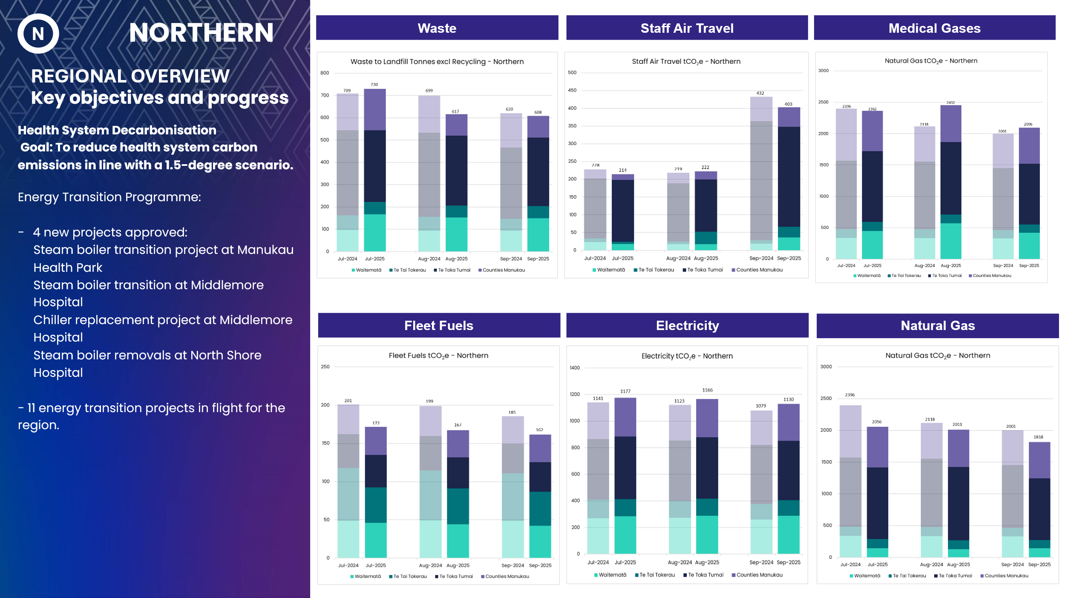
Figure 10 - Graphs showing Waste, Staff Air Travel, Medical Gases, Fleet Fuels, Electricity and Natural Gas emissions for the Northern region.

Te Manawa Taki
Key Objectives and Progress update
Increases in waste (16%) but also a significant reduction in natural gas emissions (21%).
Health System Decarbonisation - Goal: To reduce health system carbon emissions in line with a 1.5-degree scenario
Energy Transition Programme:
The Waikato Hospital e-boiler became operational replacing gas consumption with associated carbon and cost savings.
4 energy transition projects in flight for the region.
Environment in all Practices - Goal: Realise co-benefits that include the environment alongside health, equity, social and economic values.
A metered-dose inhaler recycling trial with pharmacies throughout the Bay of Plenty runs until November, helping capture and destroy residual greenhouse gases.​
Tauranga Hospital trial diverting kitchen food waste to anaerobic digestion, partnering with Compass Group and EcoGas. The hospital kitchen is diverting an average of 100kg a day.
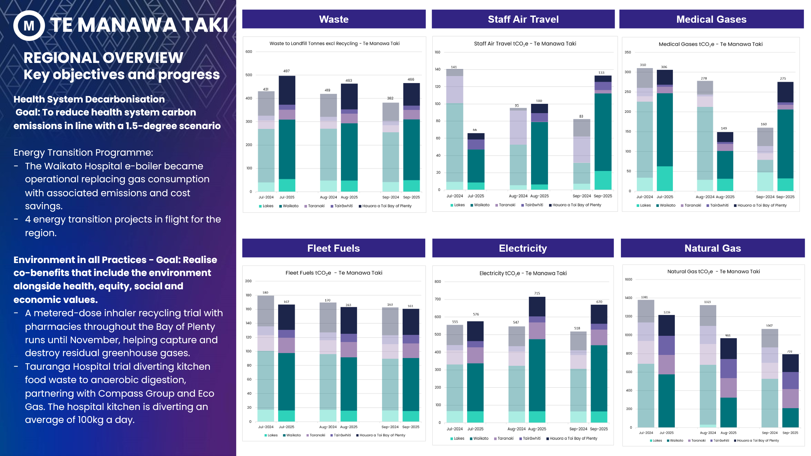
Figure 11 - Graphs showing Waste, Staff Air Travel, Medical Gases, Fleet Fuels, Electricity and Natural Gas emissions for Te Manawa Taki region

Central Region
Key Objectives and Progress update
A September month spike in staff air travel emissions (390%) alongside reduced natural gas emissions (6%).
Health System Decarbonisation - Goal: To reduce health system carbon emissions in line with a 1.5-degree scenario
Energy Transition Programme:
3 lighting projects completed:
- Lighting upgrade project at Palmerston North Hospital.
- Lighting retrofit project at Horowhenua Health Centre.
- LED lighting upgrade at Napier Health Centre.
1 new project approved:
- Chiller replacement and heat recovery project at Horowhenua Health Centre.
12 energy transition projects in flight for the region.

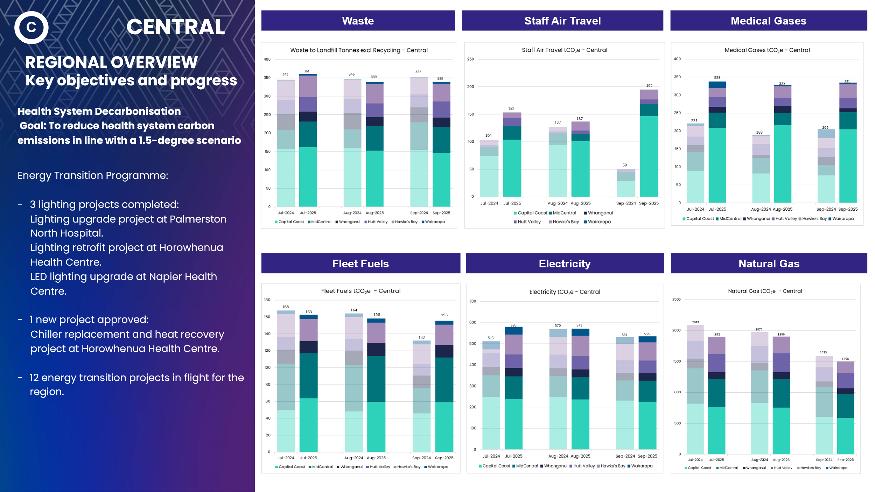
Figure 12 - Graphs showing Waste, Staff Air Travel, Medical Gases, Fleet Fuels, Electricity and Natural Gas emissions for Central region.

Te Waipounamu
Key Objectives and Progress update
A September month spike in staff air travel emissions (52%), but also a continued decrease in coal emissions (56%).
Health System Decarbonisation - Goal: To reduce health system carbon emissions in line with a 1.5-degree scenario.
Energy Transition Programme:
2 new projects approved:
- Chiller unit replacement at Christchurch Hospital (Oncology)
- Calorifier conversion to heat pump at Hillmorton Hospital.

21 energy transition projects in flight for the region.

Coal Boiler Replacement Programme:
Greymouth Hospital coal boiler to heat pump project inflight, scheduled for final commissioning in March 2026.
Ongoing steam reduction projects inflight for Southland Hospital.

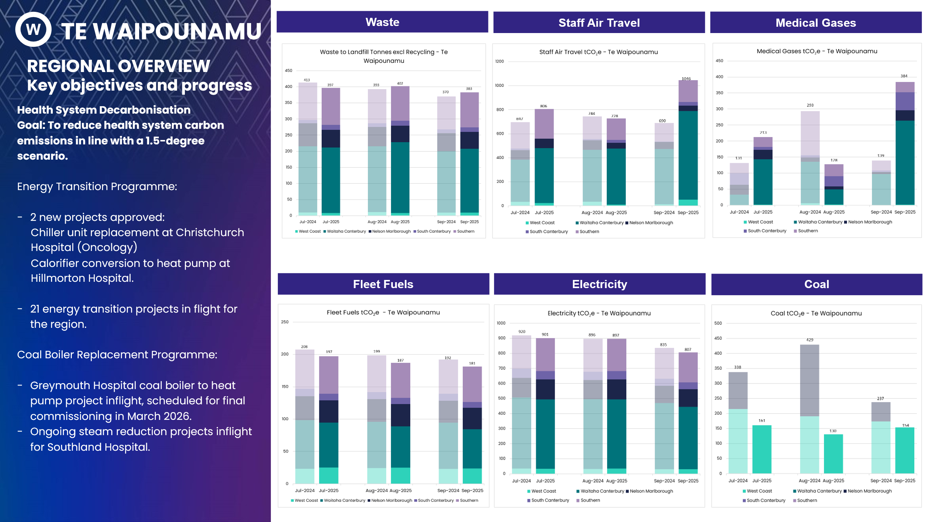
Figure 13 - Graphs showing Waste, Staff Air Travel, Medical Gases, Fleet Fuels, Electricity and Natural Gas emissions for Te Waipounamu region.


