

Q1 2025/26 health target results
  - with ethnicity and rurality disaggregation

Improved childhood immunisations
The percentage of children who have all their scheduled vaccinations by the time they are two years old. Baseline is 77.3% |; 2025/26 milestone is 87% |; 2030 target is 95% |.

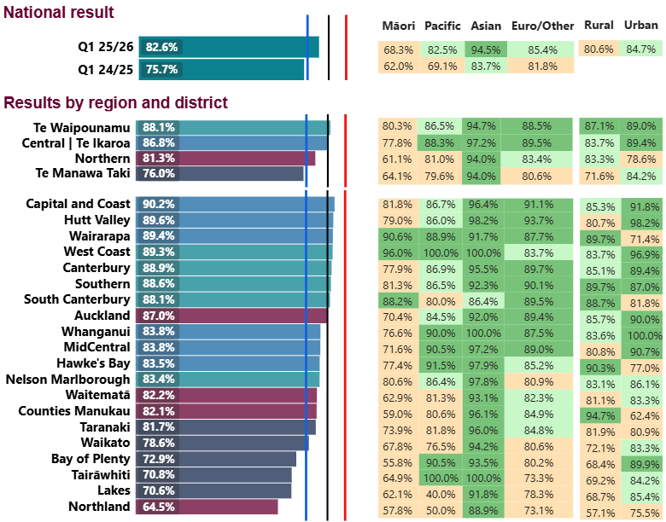

Faster cancer treatment
The proportion of eligible cancer patients who received their first treatment within 31 days of a health professional’s decision to treat. Baseline is 84.2% |; 2025/26 milestone is 87% |; 2030 target is 90% |.

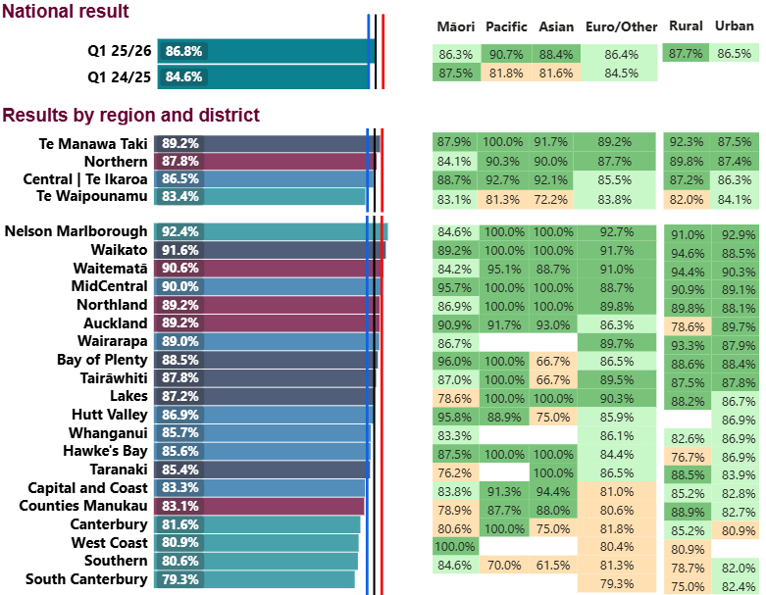
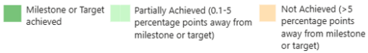

Shorter stays in emergency departments
Patients admitted, discharged or transferred from an ED within six hours as a percentage of all patients who attended ED. Baseline is 69.7% |; 2025/26 milestone is 77% |; 2030 target is 95% |.

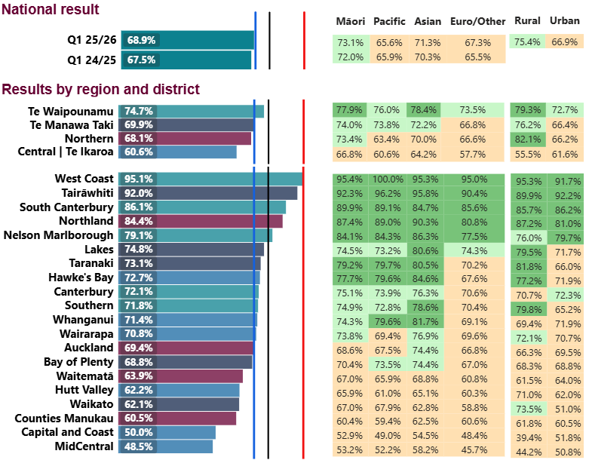

Shorter wait times for first specialist assessment
The proportion of people waiting less than four months for their first specialist assessment from the date of referral. Baseline is 61.5% |; 2025/26 milestone is 65% |; 2030 target is 95% |.

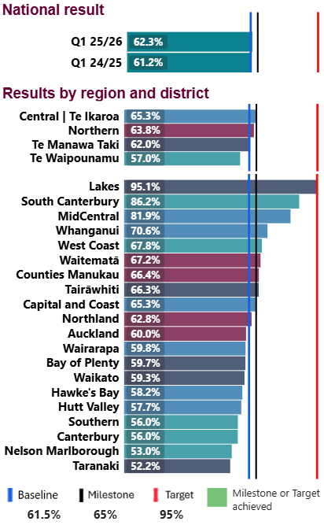

Shorter wait times for elective treatment
The proportion of people given a commitment to treatment waiting less than four months, as a proportion of all people waiting for a procedure. Baseline is 62.2% |; 2025/26 milestone is 70% |; 2030 target is 95% |.







