Mental Health and Addiction target results

The mental health and addiction target results for Quarter One 2024-25.

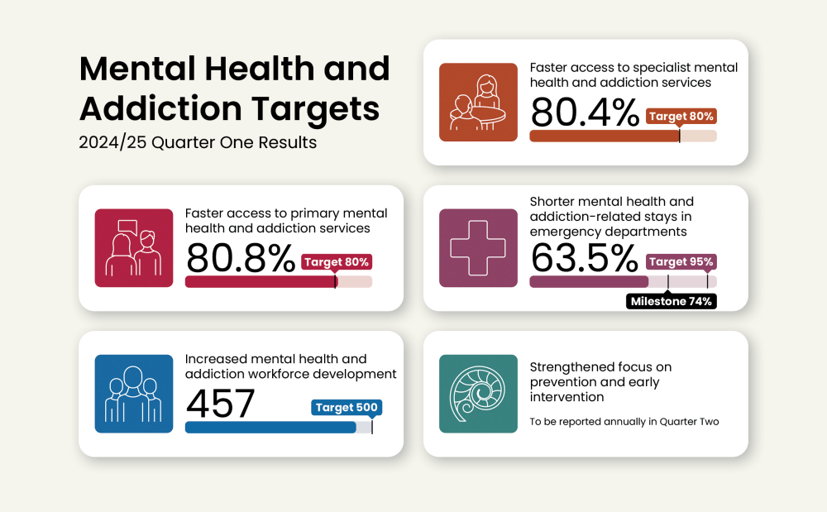

Target results by ethnicity
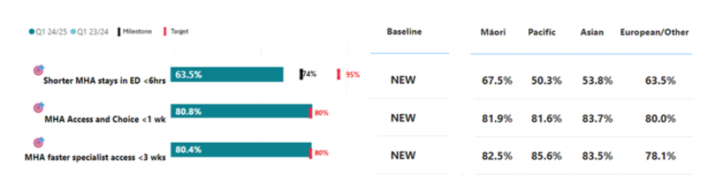

Faster access to specialist mental health and addiction services

Results by region and district
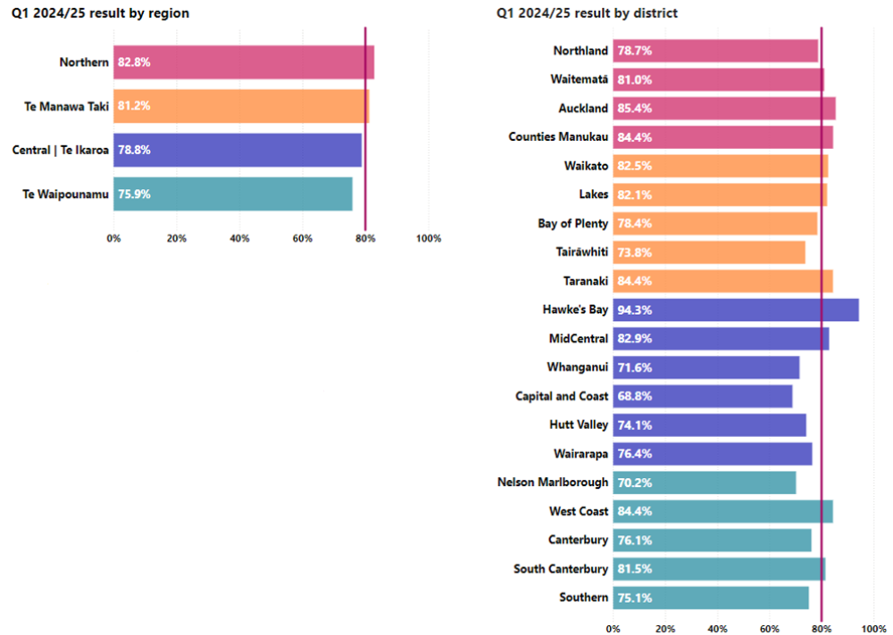

Faster access to primary mental health and addiction services
This measure presents the percentage of people accessing primary mental health and addiction services through the Access and Choice programme within one week.

National result
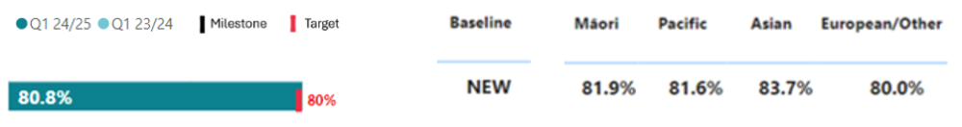

Results by region and district
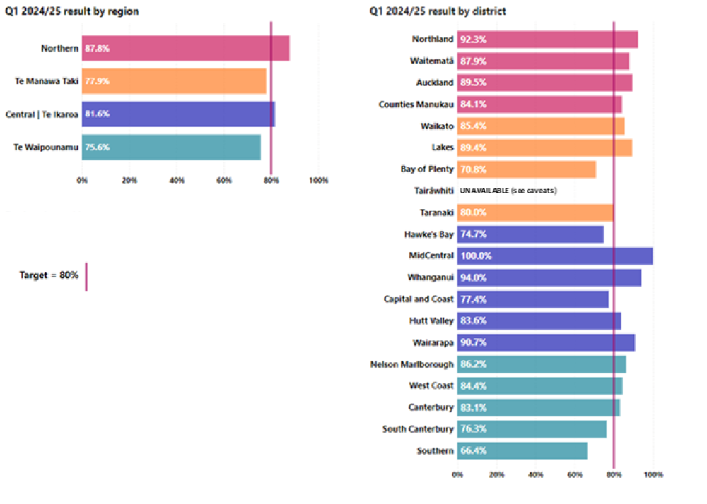

Shorter mental health and addiction related stays in emergency departments
This measure presents the percentage of mental health and addiction related emergency department presentations admitted, discharged or transferred from an emergency department within six hours as a proportion of all mental health and addiction related attendances.

National result
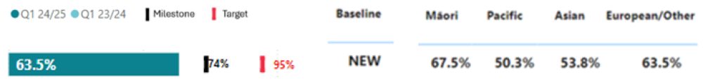

Results by region and district
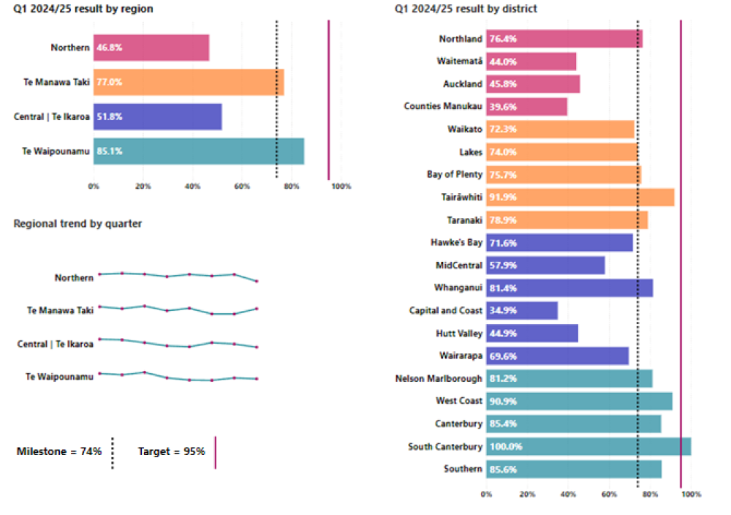

Data caveats

Faster access to primary mental health and addiction services
Inclusion of referral date was mandated in October 2024. As such, data is incomplete for quarter 1 and will be rectified in quarter 2. Data for Tairāwhiti is unavailable for quarter 1.
This quarter, youth, Māori and Pacific providers are not included in the results as they are not yet submitting data at a patient level. These providers represent approximately 30 per cent of activity in the Access and Choice programme. Work is underway to ensure we can include these providers in future quarters, starting with youth providers in quarter 1 2025/26.

Faster access to specialist mental health and addiction services
Measurement change occurred for 2024/25 to support more current and inclusive monitoring. We have moved from a rolling 12 month average to measuring each quarter separately, by activity seen dates and inclusion of addiction services. This is reflected in results presented for any prior quarters in this report. Results for quarter one are estimated to be under-reported by 2 per cent due to delays in the data pipeline.

Shorter mental health and addiction-related stays in emergency departments
Quarter 1 reporting is under-estimated due to a high proportion (9 per cent) of ED presentations having no specific presenting complaint recorded. Presenting complaint is required to identify MH&A related presentations. The result excludes three level 2 ED facilities (not publicly funded).

Increased mental health and addiction workforce development
Workforce training figures exclude psychiatry training figures in quarter 1. The definition only includes psychology interns, new entry to specialist practice nurses, occupational therapists, social workers and stage one psychiatry registrars. Other key workforces including support workers and alcohol and drug practitioners cannot be measured at this stage but work will be undertaken to add them in the future.

