


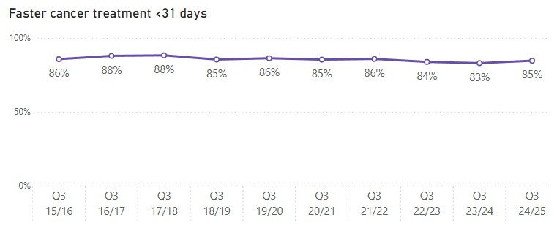
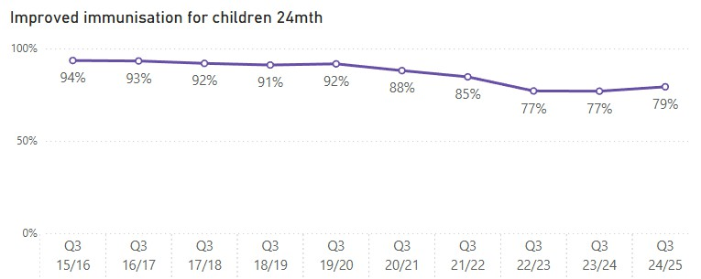
Health Targets 2024/25 Quarter 3 Last 10 Years
Treated in < 31 days Q3 24/25
3,694
Treated in < 31 days Q3 23/24
3,785
Reductions in wait time will mean you and your whānau will be guided through complex cancer care pathways to receive treatment sooner.
Children
Immunised
Q3 24/25
11,359
Children
Immunised Q3 23/24
12,078
Better immunisation coverage will reduce the risk of measles, mumps, rubella and other infectious diseases which can cause harm to children.

Reductions in wait time will mean you receive diagnosis, treatment, and progress through to a hospital bed (if needed) sooner.

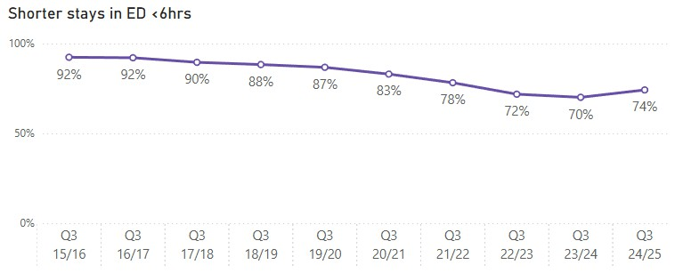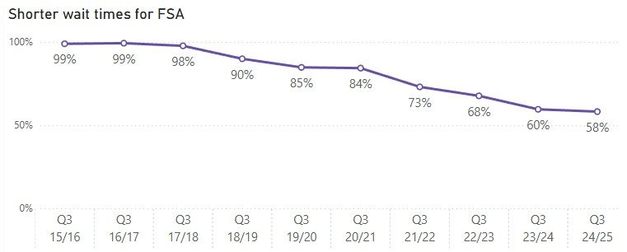

Seen within
6 hrs Q3 24/25
247,643

Seen within 6 hrs
Q3 23/24
225,542



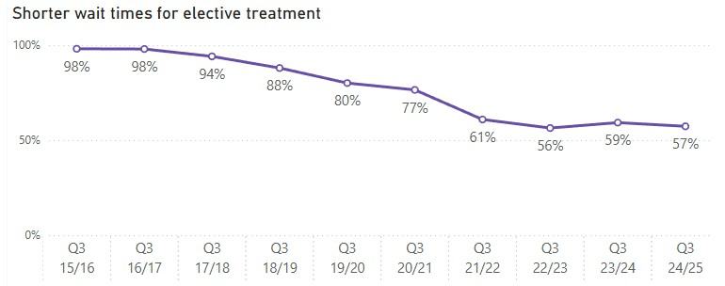
People waiting <4 months

People waiting < 4 months Q3 24/25
116,594
People waiting < 4 months Q3 23/24
114,855

Reductions in waiting will mean you are seen by a hospital specialist sooner who will start plans for your condition.

Reductions in waiting times will mean you receive your treatment sooner.
Q3 24/25

47,114
People waiting < 4 months Q3 23/24

44,303
Note: All results are rounded to the nearest whole number. When comparing data to previously published results, theremay be slight variations as data is now morecomplete. See caveats.

