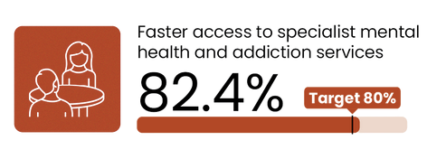
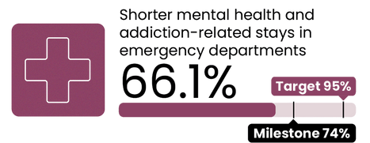
Faster access to specialist mental health and addiction services
2030 target = 80%
This measure shows the percentage of people accessing specialist MH&A services seen within three weeks of referral.
National result
Results by region
Northern Te Manawa Taki Central | Ikaroa Te Waipounamu
Target
85.6
78.5
Results by district
Taranaki West Coast South Canterbury
MidCentral Auckland Hawkes Bay
Counties Manukau
Waitematā Waikato Northland Bay of Plenty Southern Whanganui
Lakes Canterbury Hutt Valley
Nelson Marlborough Capital and Coast
Wairarapa Tairāwhiti
Target
84.7
83.4
82.0
79.6
78.8
78.3
77.6
77.1
77.1
73.4
71.8
69.4
69.0
80.6
82.0
Shorter mental health and addiction-related stays in EDs
2030 target = 95%
This measure shows the percentage of mental health related ED attendances that were admitted, discharged or transferred from an ED within six hours as a proportion of all mental health related attendances.
National result
Results by region
Te Waipounamu Te Manawa Taki Central | Ikaroa
Northern
Milestone
Target
85.2
76.9
Results by district
West Coast South Canterbury
Southern Tairāwhiti Canterbury
Nelson Marlborough
Northland
Lakes Waikato
Bay of Plenty Hawke's Bay Taranaki Whanganui MidCentral Auckland Wairarapa Hutt Valley Waitematā
Counties Manukau Capital and Coast
55.2
52.5
Milestone
Target
94.4
91.7
86.4
85.7
85.0
81.9
81.4
79.8
76.2
75.7
74.3
74.1
70.2
62.7
60.5
60.5
52.1
44.6
40.4
36.2
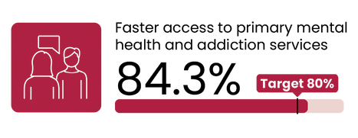
91.3
90.4
89.9
88.2
87.8
86.5
85.7

Faster access to primary mental health and addiction services
2030 target = 80%
This measure shows the percentage of people accessing primary MH&A services through the Access and Choice programme within one week.
National result
Results by region
Northern Te Waipounamu Te Manawa Taki Central | Ikaroa
Target
85.1
84.9
84.4
81.4
Results by district
Waikato Southern West Coast Auckland Whanganui MidCentral Northland Bay of Plenty
Counties Manukau
Lakes Hawke's Bay Canterbury Waitematā Capital and Coast South Canterbury
Wairarapa Nelson Marlborough
Hutt Valley Taranaki
Target
98.2
91.6
91.2
88.4
88.1
86.8
86.7
84.6
84.4
84.4
83.7
82.5
82.0
80.5
80.0
77.6
77.6
71.8
70.0
Tairāwhiti UNAVAILABLE (see caveats)
All figures displayed are percentages.

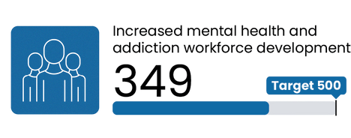
Increased mental health and addiction workforce development
Target = 500 more trained yearly
National result
Semester 1
2025 result
This measure shows the number of mental health and addiction professionals trained each year in New Zealand.
Q3 overview
349 people in the identified professions started their training in semester one of the 2025 calendar year. This is a partial result as some professions also have a second semester intake. The full result for this measure will be reported in Q2 2025/26.
Some of the national initiatives to support improvements include:
Training of peer support workers, with contracts in place for the delivery of Level 4 Health and Wellbeing (Peer Support) Training to further support this workforce.
The number of people entering New Entry into Specialised Practice training remains strong with 200 enrolled and starting nursing, and 51 in allied training so far in 2025.
Shorter mental health and addiction- related stays in EDs
Q3 overview
Performance has improved and 12 out of 20 districts have met the milestone.
The strong performance in Te Waipounamu can be attributed to the physical proximity of crisis teams to emergency departments and strong points of contact between teams that enables consistent early planning.
Steps to improve performance in districts in the Northern and Central regions include:
Counties Manukau and Waitematā have established a consistent approach to support engagement across their teams, utilising escalation plans and/or alternative admission pathways.
Auckland is working with partner agencies to address occupancy pressures in Te Whetu Tawera (inpatient unit), where barriers to discharge have housing, social, and dual diagnosis drivers.
Northland is trialling a simultaneous physical and mental health and addiction assessment approach and will share their learnings with other districts.
In March, the Wellington City Mission Crisis Café and the peers in the emergency department initiatives began at Capital and Coast.
Collaboratively, Capital and Coast, Hutt Valley, and Wairarapa are working with NGO sector to explore opportunities to partner and expand the number of acute step-down / alternative placement options.
Faster access to primary mental health and addiction services Q3 overview
All regions have achieved the 80 per cent target, with Northern being the best performing region.
Activity continued in Central region this quarter to improve performance:
Review meetings with Integrated Primary Mental Health and Addictions Services (IPMHA) providers commenced with a focus on improving accurate data collection and reporting against the targets. MidCentral, Whanganui and Hawke’s Bay review meetings were completed in quarter three, and Wellington, Wairarapa and Capital and Coast are scheduled for early in quarter four.
MidCentral introduced a new data collection tool to improve reporting accuracy.
Faster access to specialist mental health and addiction services
Q3 overview
All regions are focused on sustaining or improving performance.
One of the best performing districts, West Coast has a new model of care that supports more timely triaging of adult referrals.
Te Waipounamu, the only region not to achieve the target, is building a picture of the barriers to success to inform planning.
Canterbury is undertaking a model of care review to improve access to treatment and streamline the flow through services.
Nelson Marlborough has recruited a nurse practitioner to initiate a Clozapine clinic, to transfer care management of patients to a single point in the service and improve capacity for intake of patients.
Waikato is implementing lessons from its quality improvement reviews on waitlists, referrals and capacity. Actions include care co- ordination management; implementing a prioritisation matrix; conducting caseload flow meetings and adopting data-driven operational management approaches. The region will share these findings with other districts.
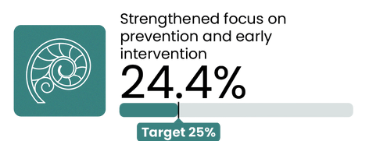
Strengthened focus on prevention and early intervention
2030 target = 25%
National result
This measure presents the proportion of mental health and addiction ringfenced investment allocated to prevention and early intervention.
Q3 overview
This result is the annual budgeted investment; it does not represent the proportion of the mental health and addiction ringfence that has been spent during the quarter.
Activity this quarter includes the completion of a request for proposal for a mental wellbeing promotion campaign, with contract negotiations underway. Additionally, increased investment in maternal mental health services and infant, child and youth services in districts with the lowest levels of investment continues.

