

Aotearoa New Zealand
Guidelines for the Prevention, Diagnosis, and Management of Acute Rheumatic Fever and Rheumatic Heart Disease
2024 Update

Summary guide for clinicians

Summary guide for clinicians 2
Contents
Scope and purpose
This summary guide is intended to be a resource for busy clinicians. It contains key messages and changes in clinical guidance, along with tables and algorithms summarising recommendations for diagnosis and management of acute rheumatic fever and rheumatic heart disease.
For more detailed information (including references) please refer to the main guideline document.

 Cultural Responsiveness 3
Primary Prevention of Acute Rheumatic Fever:
Sore Throat Diagnosis and Management 5

 Diagnosis of Acute Rheumatic Fever 9
Initial Management of Acute Rheumatic Fever
and Secondary Antibiotic Prophylaxis 15
 Diagnosis and Management of Rheumatic Heart Disease 22


 Screening for Rheumatic Heart Disease 27
Appendix 1: Secondary Antibiotic Prophylaxis for
People with Acute Rheumatic Fever 29
Appendix 2: Secondary Antibiotic Prophylaxis for
People with Non-Acute Rheumatic Heart Disease 32

Cultural Responsiveness

Key points

- This new chapter outlines key concepts of cultural responsiveness and cultural safety that are critical to services providing care for Māori and Pacific communities at risk of acute rheumatic fever (ARF) and rheumatic heart disease (RHD).
- Cultural responsiveness is crucial for achieving safe, equitable healthcare outcomes. It involves understanding equity in patient and whānau engagement and ensuring inclusive practices at all levels of healthcare.
- Applying cultural models of health in sore throat management, ARF and RHD service delivery and design promotes culturally safe and responsive care.
- Cultural safety requires critical self-reflection by healthcare professionals to address power dynamics, biases, and stereotypes that impact patient care.
- Upholding the articles of Te Tiriti o Waitangi is crucial in emphasising equitable engagement, leadership, and resource allocation for Māori (and Pacific) communities.
- Indigenous data sovereignty is integral to Indigenous rights and self-determination, empowering communities to control the collection, use, and protection of their data for their benefit.
- Collaborating with Māori and Pacific communities in designing sore throat, ARF and RHD interventions is essential for tailoring culturally responsive care, ensuring services meet community contexts effectively.

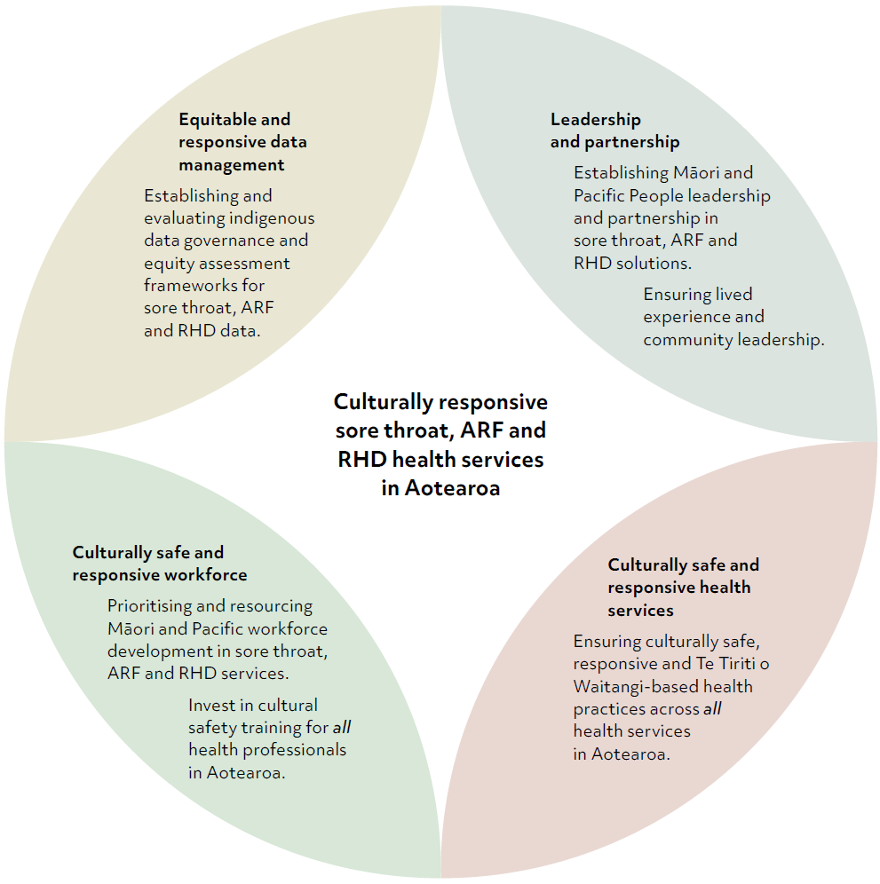
Figure 1.1. Key areas to focus on improving culturally responsive sore throat, acute rheumatic fever and rheumatic heart disease health services in Aotearoa

Primary Prevention of Acute Rheumatic Fever: Sore Throat Diagnosis and Management


Key changes

- Modifications have been made to the assessment of ARF risk in a person with a sore throat. These changes focus on high-risk age groups and align more accurately with current ARF epidemiology in Aotearoa.
- Culture remains the gold standard for diagnosis of Strep A sore throat.
- Rapid antigen diagnostic tests (RADT) are not recommended in Aotearoa.
- Rapid molecular tests are recommended to support timely diagnosis of Strep A sore throat in high-incidence ARF populations, as part of community-based ‘test and treat’ sore throat services, however there is an urgent need for nationally coordinated clinical governance and oversight of rapid molecular testing for Strep A.
- Phenoxymethylpenicillin dosing has been simplified to twice daily dosing.
- Recommendations have been added for the administration of intramuscular (IM) benzathine penicillin. Roxithromycin has been removed for people with documented penicillin allergy, while erythromycin remains available for this indication.

Key points

- In Aotearoa, the primary reason for treating Strep A sore throat is to prevent ARF. Historical studies (pre-1960s) show that treating Strep A sore throat with antibiotics reduces the risk of ARF by up to two-thirds.
- Assessing the risk of ARF in patients is key to appropriate clinical management.
- People at low risk of ARF usually only require their symptoms to be managed and neither swabbing nor antibiotics are usually indicated.
- Strep A sore throat in people at risk of ARF should be treated with a 10-day course of antibiotics.

Algorithm 1: Assessment and management of sore throats in Aotearoa
See Table 5.1 for recommended antibiotic treatment for Strep A sore throat
(Grade A).

Antibiotic treatment approach for people at higher risk of ARF
OR

Give empiric treatment – if timely follow-up not possible or uncertain
- Give 10 days of antibiotics without swabbing
OR

Do the following in school-based primary prevention programmes
- Take throat swab and wait for result.
- If test results are likely to be delayed or follow up is not possible, treat empirically or follow local protocols.
- If the person is Strep A positive, treat with 10 days of antibiotics.
EITHER

‘Test and treat’ – if follow-up possible
- Start ten days of antibiotics
- Swab throat as long as results can be followed up (recommended).
- Stop antibiotics if culture is negative.
Yes
No
Yes
No
Persons with sore throat at higher risk of ARF:

EITHER
Māori or Pacific peoples who are 3-35 years (with emphasis on those 4-19 years)

OR

Personal or family history of ARF / RHD
Sore throat
Are they acutely unwell?
Are they at
higher risk of ARF?
Treat with antibiotics for 10 days
If a decision has been made to treat a Strep A sore throat with antibiotics, give a 10 day course as for the higher risk treatment approach.
Aim to avoid swabbing and reduce antibiotic over-use.

Majority of sore throats are from viral infections. Only swab if at high risk of spreading infection, or if additional personal risk factors – e.g. food handler, immune compromised.
Refer to hospital if systematically unwell and/or:
- Signs of sepsis
- Evidence of suppurative disease
- Peri-tonsillar abscess

Table 5.1. Recommended antibiotic treatment for Strep A sore throat

Antibiotic and type of patient | Dose
Phenoxymethylpenicillin (Pen V) | 15mg/kg (maximum 500mg/dose) two times daily PO
Amoxicillin | 50mg/kg (max 1000mg/dose) once daily PO
Benzathine penicillin  Single dose — tamariki <20kg | 600,000 international units (450mg) IM  Use with lignocaine and distraction techniques. See Chapter 9: Administration of Intramuscular Benzathine Penicillin (Bicillin®L-A)
Benzathine penicillin  Single dose — tamariki ≥20kg and adults | 1,200,000 international units (900mg) IM  Use with lignocaine and distraction techniques. See Chapter 9: Administration of Intramuscular Benzathine Penicillin (Bicillin®L-A)
Erythromycin ethyl succinate — tamariki and adults, for documented penicillin anaphylaxis or suspected true penicillin allergy (see Table 5.3) | 20mg/kg/dose two times daily for 10 days (Max 1.6 g daily)

Algorithm 3: Managing recurrent Strep A sore throat in tamariki and rangatahi at high risk of ARF (Grade D)
Tamariki or rangatahi in high-risk population (see Algorithm 1) presenting with three or more consecutive symptomatic Strep A positive sore throats in a three-month period?

Strep A negative
Strep A infection resolved

For any further sore throats, manage as per Algorithm 1.
Use a health literacy approach:
- Ask what the whānau understands about the treatment of sore throats to prevent rheumatic fever.
- Fill in any gaps in understanding, explain Strep A carriage, potential risk in high-risk whānau, and treatment options available.
- Check what they’ve understood. Help them solve problems so they can complete their treatment.
- Discuss the importance of antibiotic adherence and basic hygiene practices (hand washing, sneeze/couch into elbow or a tissue).
- Assess and treat any skin infections as per local Health Pathways.
- Discuss referral to Healthy Homes Initiative if relevant (see Healthy Homes Initiative – Health New Zealand | Te Whatu Ora for local contact information) and/or offer advice on keeping home warm and dry (see Healthy Homes – Health New Zealand | Te Whatu Ora).
Seek advice from specialist paediatrician, ID physician or clinical microbioligist on appropriate management which may include further antibiotic regimens – see Table 5.5.
Persisting Strep A positive
Take a follow up post treatment swab 3-6 days after finishing oral amoxicillin treatment or one month after IM benzathine penicillin.
In addition, swab the whānau/ household as per Algorithm 2 and treat if Strep A positive.
Give a single dose of IM benzathine penicillin OR 10 days of amoxicillin with directly observed therapy.


Diagnosis of Acute Rheumatic Fever Key changes

- Transient advanced atrioventricular (AV) block is now included as a major manifestation.
- Streptococcal antibody titres to support the diagnosis of ARF have been revised and the updated reference intervals produced (see Table 6.4).
- For persons with carditis, either a Strep A throat culture, polymerase chain reaction (PCR), or serology is acceptable to confirm the diagnosis of Definite ARF.
- For persons without carditis, positive serology is required to confirm the diagnosis of Definite ARF.

Key points

- Accurate diagnosis of ARF is important:
  - Missing the diagnosis may lead to an individual experiencing further attacks of ARF, cardiac damage and premature death.
  - Over-diagnosis will result in the individual receiving benzathine penicillin injections unnecessarily every four weeks for a minimum of ten years.
  - Misdiagnosis may result in another condition remaining undiagnosed and untreated.
- In Aotearoa, high-risk population groups for ARF and rheumatic heart disease (RHD) are Māori and Pacific tamariki and rangatahi, especially those living in low socioeconomic environments.
- In tamariki and rangatahi from high-risk population groups, ARF should always be considered when they present with arthritis or arthralgia.
- Persons with suspected ARF should be discussed with the appropriate hospital team (paediatrics or adult medical) and an acute admission should be arranged for a diagnostic workup.
- Māori tamariki and Pacific tamaiti, with suspected septic arthritis but no identified pathogen on joint or bone aspirate, should be investigated for ARF.
- All persons with suspected ARF should undergo echocardiography (echo), to identify carditis and to assess the severity of valvular regurgitation.
- Categories of Definite, Probable and Possible ARF can be determined by applying the Aotearoa diagnostic criteria (adapted Jones criteria) to each case.

Table 6.1. 2024 Aotearoa criteria for the diagnosis of acute rheumatic fever

Manifestations of ARF | Criteria
Major manifestations** | - Carditis§ (including evidence of subclinical rheumatic valve disease on echo or advanced AV block §§)  - Polyarthritis or aseptic monoarthritisª  - Sydenham’s chorea‡‡  - Erythema marginatum  - Subcutaneous nodules
Minor manifestations^ | - Fever ≥38°C  - Raised ESR ≥50mm/hr or CRP ≥30mg/L  - Polyarthralgia  - Prolonged P-R interval on ECG (corrected for age)
Definite initial episode of ARF | 2 major manifestations and evidence of preceding Strep A infection  1 major and 2 minor manifestations, and evidence of a preceding Strep A infection*
Probable initial episode of ARF | 1 major and 2 minor, with the inclusion of evidence of a preceding Strep A infection* as a minor manifestation (as per Jones, 1956)
Possible initial episode of ARF | Strong clinical suspicion of ARF, but insufficient signs and symptoms to fulfil diagnosis of definite or probable ARF
Recurrent ARF in a person with a known history of ARF or RHD | - Definite: 2 major manifestations  - Probable: 1 major and 2 minor manifestations  - Possible: 3 or more minor manifestations or strong clinical suspicion but insufficient to fulfil diagnosis of Definite or Probable Recurrence  Evidence of preceding Strep A infection must be present

Notes
CRP = C-reactive protein
ECG = electrocardiogram
ESR = erythrocyte sedimentation rate
All categories assume that other more likely diagnoses have been excluded.
* Elevated or rising antistreptolysin O or other streptococcal antibody (Table 6.4) is sufficient support for diagnosing definite ARF. A positive throat culture, PCR, or rapid test alone is less secure, as 50% of people with a positive throat culture will be carriers only.
** Modified from Jones (1992) and Jones (2015): See text for details about major manifestations.
^ See text for key points about minor manifestations.
‡‡ Chorea can be a stand-alone manifestation for ARF diagnosis, provided other
causes are excluded.
§ When carditis is present as a major manifestation (clinical and/or echocardiographic), a prolonged P-R interval cannot be considered an additional minor manifestation.
§§ Advanced AV block (transient second or third-degree heart block or junctional rhythm) is now included in the definition of carditis and as a major manifestation of ARF. Among people with other manifestations of ARF, advanced AV block is highly specific for ARF.
ª History of any joint too sore to walk is considered to be arthritis. Other causes of arthritis/arthralgia should be carefully excluded (refer to the differential diagnosis section). If polyarthritis or monoarthritis is present as a major manifestation, then polyarthralgia cannot be considered an additional minor manifestation.

Table 6.3. Summary of Strep A testing for acute rheumatic fever diagnosis in Aotearoa

Test | Timing | Evidence to support diagnosis
Strep A serology | At presentation  Repeat at 2–4 weeks if not initially raised | Can support a diagnosis of Definite or Probable ARF
Positive Strep A throat culture or PCR | At presentation or in the 2–4 weeks prior to symptom onset (occasional cases occur outside this timeframe) | Can support a diagnosis of Definite ARF if carditis is present  Can support a diagnosis of Probable or Possible ARF in the absence of carditis
Positive Strep A rapid Antigen test of throat |  | Insufficient evidence and is not accepted as evidence for diagnosis in Aotearoa
Positive Strep A skin swab |  | Insufficient evidence and is not accepted as evidence for diagnosis in Aotearoa

Table 6.4. 2024 updated upper limits of normal for serum streptococcal antibody titres used in Aotearoa for acute rheumatic fever

Antibody titres | International units/ mL for Aotearoa in 2024 | International units/ mL for Aotearoa in 2006 and 2014
Anti-Streptolysin-O (ASO) | ≥450 | ≥480
Anti-DNase B (ADB) | ≥400 | ≥680

Table 6.6. Echocardiographic criteria for pathological regurgitation

Type | Criteria
Pathological mitral regurgitation (MR)  (all criteria must be met) | - Observed in two views  - In at least one view, MR length >2cm. In those weighing <30kg MR, jet length >1.5cm  - Peak velocity >3.0m/s for one complete envelope  - Pan-systolic jet in at least one envelope
Pathological aortic regurgitation (AR)  (all criteria must be met) | - Observed in two views  - Jet length >1cm  - Peak velocity >3.0m/s in early diastole  - Pan-diastolic jet in at least one envelope
Mitral stenosis  (all criteria must be met) | - Restricted leaflet motion with reduced valve opening  - Mean peak gradient >4mmHg
These criteria can usually readily distinguish a small colour jet of physiological regurgitation in normal tamariki from pathological regurgitation in a tamariki with ARF or RHD. The proportion of tamariki with physiological valve regurgitation in Aotearoa was 15% and large international cohort studies show that this proportion rises with age.
If the aetiology of AR or MR on the Doppler echo is not clear, the following features support (but are not individually specific for) a diagnosis of rheumatic valve damage:
- Both mitral and aortic valves have pathological regurgitation.
- The mitral regurgitant jet is directed posteriorly, as excessive leaflet motion of the tip of the anterior mitral valve leaflet (AMVL), often referred to as prolapse, is the most common mechanism of MR. Anterior leaflet prolapse is more common than posterior valve prolapse.
- Multiple jets of MR are evident.
- The presence of excessive leaflet motion of the tips /edges of the AMVL or posterior mitral valve leaflet (PMVL) is due to chordal lengthening, rupture, or both.
Morphological features of RHD take time to develop but may be present in ARF. Echo cannot date the duration of any of these changes. More advanced features that support an acute ARF on chronic RHD presentation are:
- Restrictive leaflet motion with gross subchordal thickening †,‡
- Gross thickening of AMVL at >5mm
- Unequivocal immobile PMVL †,‡
- Mitral stenosis with a mean valve gradient of >5mmHg (up to 5mmHg can be enhanced mitral filling in acute severe MR)
(Also see Chapter 10: Diagnosis of Rheumatic Heart Disease)

Symbols used
† Immobility of the subchordal apparatus and posterior leaflet is observed only after several months. Other findings have also been reported, including acute nodules, which show a beaded appearance of the mitral valve leaflets.
‡ It is recommended to avoid using descriptive terms such as ‘elbow,’ ‘dog leg’ or ‘hockey stick’ when describing a deformity of the AMVL — such appearances are due to the combination of valve thickening and restrictive leaflet motion.
Source: The content in this table is based on an original study by Wilson NJ and Neutze JM as well as criteria that further evolved as part of both the Aotearoa and the Australian guidelines on rheumatic fever diagnosis, the WHO working groups on echocardiography and the 2023 WHF guidelines for echocardiographic diagnosis of rheumatic heart disease.

Table 6.7. Severity of acute rheumatic fever carditis

Severity | Presentation
Mild carditis | - Mild MR or AR clinically or on echo (fulfilling the minimal echocardiographic standards in Table 6.6 without heart failure, cardiac chamber enlargement on X-ray, ECG, or echo).
Moderate carditis | Any one of these:  - Mitral or aortic valve lesion of moderate severity, as found on clinical examination  - Cardiac chamber enlargement, as seen on an echo  - Any valve lesion graded as moderate, as seen on echo.  Regurgitation is considered moderate if:  - A broad high-intensity proximal jet is filling half the left atrium — this means a mitral or a lesser volume high-intensity jet is producing a prominent blunting of the pulmonary venous inflow  - Diameter of the regurgitant jet is 15% to 30% of the diameter of the left ventricular outflow tract, flow reversal in the upper descending aorta.  When both MR and AR exist, one must be moderated by echo criteria for the carditis to be classified as being moderately severe.
Severe carditis | Any one of these:  - Impending or previous cardiac surgery for RHD  - Valve lesion associated with significant cardiomegaly or heart failure or graded as severe on clinical examination  - Any valve lesion graded as severe on an echo.  In tamariki:  - An abnormal regurgitant colour and Doppler flow patterns in pulmonary veins is a prerequisite for severe MR  - Doppler reversal in the lower descending aorta is required to diagnose severe AR.  In adults:  - Doppler flow reversal in the pulmonary veins (for severe MR) or abdominal aorta (for severe AR) is specific if present, but can be more difficult to detect — indeed, severe regurgitation may still be present if not detected.

Initial Management of Acute Rheumatic Fever and Secondary Antibiotic Prophylaxis


Key changes

- Early discharge is now an endorsed option for medically stable patients where close follow-up from community services and whānau support can be assured.
- Level of physical activity during initial ARF episode: strict bedrest is no longer recommended for those with no or mild carditis. Mobilise as joint symptoms permit.
- Benzathine penicillin weight threshold is now 20kgs for 1,200,000 unit dose.
- Routine swabbing of all household members of new ARF cases is not recommended. Assess the household for those with symptomatic sore throat. Household members with a sore throat should be swabbed or treated empirically.
- Revised recommendations regarding the duration of secondary antibiotic prophylaxis (SAP), including recommendations for people with RHD, are included.
- The National Rheumatic Fever Care Coordination System (RFCCS), which functions to coordinate secondary prevention and as a national register, is launched.

Key points

- The initial phase of managing ARF aims to alleviate symptoms — particularly joint pain, but also chorea or heart failure symptoms.
- Refer any person with suspected ARF to the hospital for initial assessment and investigation, including inpatient echo, regardless of clinical signs of carditis.
- Avoid giving nonsteroidal anti-inflammatory drugs (NSAIDs) until a diagnosis of ARF is confirmed. Give paracetamol instead.
- SAP should be started as part of initial management.
- Notify the regional public health service of all suspected new cases — rheumatic fever is a notifiable condition in Aotearoa.
- Where the diagnosis of ARF is not clearcut initially, a person may require observation and investigation over several weeks, including a repeat echo.
- Health services for secondary prevention of acute rheumatic fever (ARF) and RHD need to be culturally safe, provide a holistic approach and recognise the long-term nature of the condition.
- SAP in Aotearoa is best delivered in the community by trained nurses who are resourced to engage with whānau and coordinate care and support.
- IM benzathine penicillin is recommended every 28 days (4 weeks) unless the person has experienced a recurrent episode of ARF.
- Following ARF, SAP is usually recommended for 10 years after ARF diagnosis or until age 21, whichever is longer. The duration of SAP should be reassessed when the person is around 21 years old according to RHD severity and is extended for people with persisting moderate or severe RHD.

Table 7.1. Key priorities in the initial management of acute rheumatic fever

Step | Action
Admission to hospital | - Admit all patients with suspected ARF to facilitate investigations, particularly inpatient echo, clinical observation, and symptomatic management.  - Ensure a multi-disciplinary team provides whānau-centred, culturally safe care in the hospital. The care should include cultural support, healthcare interpreters, play specialists, social workers, housing needs assessment, dietician and dental review, and other referrals as indicated.  - Encourage early discharge for stable patients. ‘Stable’ means without progressive or severe carditis or severe chorea. Only consider discharge if whānau agrees and community services and supports are available.
Determine the diagnosis | - Take a careful history and physical examination.  - Explain the investigations required to confirm a diagnosis of ARF to whānau.  - Avoid NSAIDs until the diagnosis is confirmed — use paracetamol initially.  - Exclude other diagnoses. If confirming an ARF diagnosis is not possible, discuss the need to re-evaluate over time.  - Carry out the necessary investigations (see Table 7.3).  - Consider whether the patient has Definite, Probable, or Possible ARF (note the initial classification may change with subsequent investigations).  - Classify carditis as none, mild, moderate, or severe (according to echo).  - Organise a whānau hui to discuss the diagnosis and management plan.
Notify the Public Health Service | - When the diagnosis is suspected, notify the appropriate regional or local Public Health Service using the local disease notification pathway.
Antibiotic treatment | - Give oral penicillin V or amoxicillin for 10 days or until the first dose of benzathine penicillin is given (see Chapter 9: Administration of Intramuscular Benzathine Penicillin (Bicillin®L-A)).  - For those with penicillin anaphylaxis, give erythromycin instead.  - Obtain consent for registration on the RFCCS from patient/caregiver.  - Refer for SAP.
Arthritis | - Give paracetamol for analgesia until the diagnosis is confirmed.  - When the diagnosis is confirmed, naproxen or ibuprofen should be given.  - Mobilise the patient gently, as tolerated, unless they have severe carditis.
Sydenham’s Chorea | - Explain the condition to the patient and whānau in detail.  - Give medication (carbamazepine or valproate) if symptoms affect daily functioning (for example, eating, writing, walking).  - Involve the play therapist, psychologist/psychiatrist, and occupational therapist in managing motor and/or neuropsychiatric manifestations.  - Discuss severe and refractory cases with a paediatric neurologist.
Carditis | Level of activity — use severity of carditis as a guide.  - No carditis, mild-moderate carditis — mobilise as joint symptoms permit.  - Severe carditis — refer to a paediatrician with cardiology expertise. After initial bed rest, mobilise according to cardiac evolution.  Medication — is usually only indicated for severe carditis. Be guided by a cardiologist or paediatrician/physician experienced in managing ARF/RHD.  Surgery for severe carditis — the cardiosurgical team will consider whether surgery is needed and guide timing. The usual practice is to wait for inflammatory markers to normalise, but urgent surgery may be required for unstable patients.

Table 7.4. Medication for acute rheumatic fever

Type of medication | Aotearoa Guidelines 2024 | Tamariki (children) | Rangatahi (adolescents) and adults
Initial Strep A eradication | Phenoxymethylpenicillin (Penicillin V)  OR | Weight <20kg 250mg two times daily for 10 days  Weight ≥20kg 500mg two times daily for 10 days | 500mg two times daily for 10 days
Initial Strep A eradication | Amoxicillin | 50mg/kg once daily for  10 days (max 1000mg/day) OR  25mg/kg two times daily for 10 days (maximum 500mg per dose) | 1000mg once daily for 10 days  OR  500mg two times daily for 10 days
Secondary antibiotic prophylaxis (SAP) | Benzathine penicillin (see Chapter 9: Administration of  Intramuscular Benzathine Penicillin (Bicillin®L-A)) | Weight <20kg 600,000 units (450mg) IM  Weight ≥20kg 1,200,000 units (900mg) IM | 1,200,000 units (900mg) IM
Initial Strep A eradication or SAP, if allergy to beta-lactams | Erythromycin | 20mg/kg two times daily for 10 days (maximum dose 1.6g/day)
Initial analgesia | Paracetamol | Refer to New Zealand Formulary and New Zealand Formulary for Children for dosing
Analgesia once a diagnosis is confirmed | Naproxen (immediate release)  OR | 10–20mg/kg/day PO two times daily (max of 1250mg/day)  Taper dose as joint symptoms ease
Analgesia once a diagnosis is confirmed | Ibuprofen | Refer to New Zealand Formulary and New Zealand Formulary for Children for dosing
Steroids | Prednisone or prednisolone | 1–2mg/kg once daily (maximum 60mg/day)  If used for more than 1 week, taper by 20–25% per week
Cardiac drugs | Seek specialist cardiologist advice regarding diuretics and cardiac medications  Refer to New Zealand Formulary and New Zealand Formulary for Children for dosing guidance
Cardiac drugs | Digoxin, frusemide, spironolactone  ACEi for impaired left ventricular function (enalapril, lisinopril, captopril)  (choice depends on the clinical situation; monitor BP)
Chorea medication | Seek specialist neurologist advice, especially for severe or refractory cases  Refer to New Zealand Formulary and New Zealand Formulary for children for dosing
Chorea medication | Carbamazepine or valproic acid

Note: Weight-based dosing bands may be used in local guidelines.
The New Zealand Formulary (nzformulary.org) and New Zealand Formulary for Children — New Zealand Formulary for Children (nzfchildren.org.nz).

Table 7.5. Recommended clinical management and anticipated duration of secondary antibiotic prophylaxis following an initial episode of acute rheumatic fever: guidance at the time of discharge
Initial guidance regarding SAP duration and clinical management should always be reviewed depending on the person’s situation and the progression of echo findings (see Chapter 8: Secondary Prevention). When inflammatory markers have resolved (typically within six months), any residual carditis is termed chronic RHD.

Severity | Clinical follow-up | Echo | Antibiotic prophylaxis for endocarditis | Penicillin prophylaxis (4-weekly)
Definite or Probable ARF with normal heart or mild carditis | Annual GP and dental review.  Paediatric or physician follow- up 1–3 yearly (less often if stable). | 2-yearly (less often if stable) | Recommended if any carditis | Minimum of 10 years or to age 21 years, whichever is longer.  (Consider 5 years if  >16 years at first episode and minimal carditis).
ARF with moderate carditis/RHD | Annual specialist, medical, and dental review.  See Chapter 11: Management of Rheumatic Heart Disease | Annual | Recommended  — lifelong | Minimum of 10 years or until around age 21 years, whichever is longer, then reassess.  If still moderate RHD or progresses to severe RHD, continue to age 30 years, then reassess.
ARF with severe carditis/RHD | 6–12 monthly specialist, medical and dental review.  See Chapter 11: Management of Rheumatic Heart Disease. | 6–12  monthly | Recommended  — lifelong | Reassess at 30 years.  Beyond 30 years, individualised care is provided by the patient and physician.  See Chapter 11: Management of Rheumatic Heart Disease.
Possible ARF | Specialist follow-up 6–12 months,  then as needed if ARF/RHD is confirmed. | At 6  and 12 months | Not required | 1 year and review.  SAP may stop earlier if another diagnosis (e.g. juvenile arthritis) is confirmed.  If a person from a high- risk population group has no other diagnosis confirmed, 5 years of SAP is recommended.

Diagnosis and Management of Rheumatic Heart Disease


Key changes

The guidelines now include:
- A discussion on equity of care for RHD patients.
- A review and care plan based on the risk and severity of the individual cardiac diagnosis.
- High-risk — Follow-up for bioprosthetic mitral valves changed to 6 monthly (previously 6–12 monthly).
- Moderate — Follow-up for isolated stable moderate mitral or aortic regurgitation changed to 2 yearly (previously 2–3 yearly).
- Moderate mitral stenosis — Follow-up has changed to annually if mitral valve area (MVA) is <1.5cm² (previously 2–3 yearly) as this is classified as severe in valve management guidelines.
- Mixed valve moderate disease — Treat as severe RHD. Annual follow-up is recommended.
- A section on:
  - transitioning from paediatric to adult cardiac services
  - best practice discharge
  - complications of RHD
  - managing RHD in primary care.

Key points

Table 11.1. Best practice rheumatic heart disease management principles

Best practice rheumatic heart disease management principles
- The fundamental goals in the long-term management of RHD are:
  - To support patients and their whānau on their RHD journey and provide culturally safe care.
  - To recognise and understand the lived experience of individuals with RHD.
2. Provide access to a physician experienced in RHD for mild disease and a cardiologist for moderate to severe disease.
3. Ensure access to timely echocardiography (echo).
4. Manage secondary prevention with penicillin prophylaxis (see Chapter 8: Secondary Prevention) and ensure patient referral and registration to the national Rheumatic Fever Care Coordination System.
5. Refer patients for consideration of heart valve intervention in a timely manner, following best international practice guidelines.
6. Provide effective systems of care to support anticoagulation therapy in patients with atrial fibrillation (AF) and/or mechanical prosthetic valves.
7. Optimise oral health with regular dental reviews.
8. Offer annual influenza vaccination.
9. Implement strategies to prevent infective endocarditis by reducing the risk from oral microbes. Refer to a dentist with some urgency.
10. Provide individualised discussions with appropriate specialists to support informed decision-making regarding pregnancy.
11. Increase awareness and encourage early recognition of RHD complications.
12. First-degree relatives of newly diagnosed RHD cases should undergo echocardiographic screening for RHD. See Chapter 14: Screening for Rheumatic Heart Disease.

Table adapted from Okello et al and page 108 of the New Zealand Guidelines for the Diagnosis, Management and Secondary Prevention of Acute Rheumatic Fever and Rheumatic Heart Disease: 2014 Update second edition.

Table 11.4. Best practice discharge after cardiac surgery

Area of care | Recommendation
Routine review and structured care planning | Develop and document a structured care plan in agreement with the patient.
Baseline echo | Perform a baseline echo before discharge or within 3 months of valve surgery.
Cardiac rehabilitation | Refer the patient to local cardiac rehabilitation services.  Also, see the Heart Foundation’s page on cardiac rehabilitation.
Secondary antibiotic prophylaxis | The surgical team should discuss the need for continued prophylaxis. If uncertain, seek clarification from the patient’s cardiologist or physician.  For more details, see Chapter 8: Secondary Prevention.
Preventing infective endocarditis | See Prevention of Infective Endocarditis — Guideline by the Heart Foundation.
Anticoagulation | Refer individuals with mechanical prosthetic valves to their local General Practitioner (GP) or pharmacy as appropriate for ongoing INR monitoring. A Referral to the community Pharmacy Anticoagulation Management Service should be made via the GP.
Oral health care | Refer the patient to dental services for check-ups at least annually.  For dental procedures requiring antibiotic prophylaxis, see Table 10.5.
Specialist advice about pregnancy | Provide pre-conception counselling before valve replacement surgery. Where this is not possible, offer contraception and consultation with an appropriate obstetric medicine specialist.
Immunisations | Encourage annual influenza vaccinations.  Ensure polysaccharide pneumococcal vaccination (Pneumovax® 23) is repeated once after 5 years.  Find out about Pneumovax23.

Table 11.6. Recommended antibiotics for infective endocarditis prophylaxis for dental procedures

Adult or tamariki | Antibiotic and dosage | Administration
Adult | Amoxicillin 2g | PO
Tamariki | Amoxicillin 50mg/kg up to 2g | One of these:  - PO 1 hour before the procedure  - IV given just before the procedure  - IM given 30 minutes before the procedure.
Administer the amoxicillin parenterally if the person cannot take medication orally. Administer through IV if IV access is readily available.
For penicillin allergy, or if a penicillin or cephalosporin-group antibiotic is taken more than once in the previous month (including for those on long-term penicillin prophylaxis for acute rheumatic fever):
Adult | Option 1: Clindamycin* 600mg | One of these:  - PO 1 hour before the procedure  - IV given over at least 20 minutes, just before the procedure  - IM given 30 minutes before the procedure.
Adult | Option 2: Clarithromycin† 500mg | PO 1 hour before the procedure.
Tamariki | Option 1: Clindamycin* 15mg/kg up to 600mg) | One of these:  - PO 1 hour before the procedure  - IV, given over at least 20 minutes, just before the procedure  - IM, given 30 minutes before the procedure.
Tamariki | Option 2: Clarithromycin† 15mg/kg up to 500mg | PO 1 hour before the procedure.
Adapted from the Heart Foundation of New Zealand. New Zealand Guideline for the Prevention of Infective Endocarditis Associated with Dental and Other Medical Procedures 2008.
* Clindamycin is not available in syrup form in Aotearoa.
† Beware of potential interactions between clarithromycin and other medications.


Screening for Rheumatic Heart Disease

Key changes

- A randomised control trial conducted in Uganda (the ‘GOAL’ study) has shown that secondary antibiotic prophylaxis (SAP) reduces disease progression of mild rheumatic heart disease (RHD) detected by echocardiography (echo).
- Following publication of the GOAL study in 2022, echo screening for RHD broadly meets the criteria for a suitable screening test.
- The 2023 World Heart Federation guidelines describe four stages for the echo diagnosis of RHD. Stage A is equivalent to the 2012 WHF ‘borderline’ category, and Stage B is similar (but not identical) to the previous ‘definite’ RHD category. Stage C describes moderate or severe RHD. Stage D describes moderate or severe RHD with cardiac complications. See Table 14.1.

Key points

- Siblings of a person recently diagnosed with acute rheumatic fever (ARF) or new RHD should be offered echo screening (Grade C).
- Parents or guardians of a person under 30 years of age recently diagnosed with ARF or RHD should be offered echo screening (Grade D).
- Any pregnant person with RHD should be referred to their local high-risk maternity service for cardiac reassessment (Grade C).
- Current evidence does not support routine antenatal RHD screening for all Māori and Pacific peoples during pregnancy. However, lead maternity carers need to be aware that undetected RHD may be present in pregnant people/women from high-risk populations. Referral for suspected RHD is recommended on clinical grounds (Grade C).

Figure 14.1 shows stages A to D of RHD, as described in the 2023 World Heart Federation guidelines for the echocardiographic diagnosis of rheumatic heart disease.
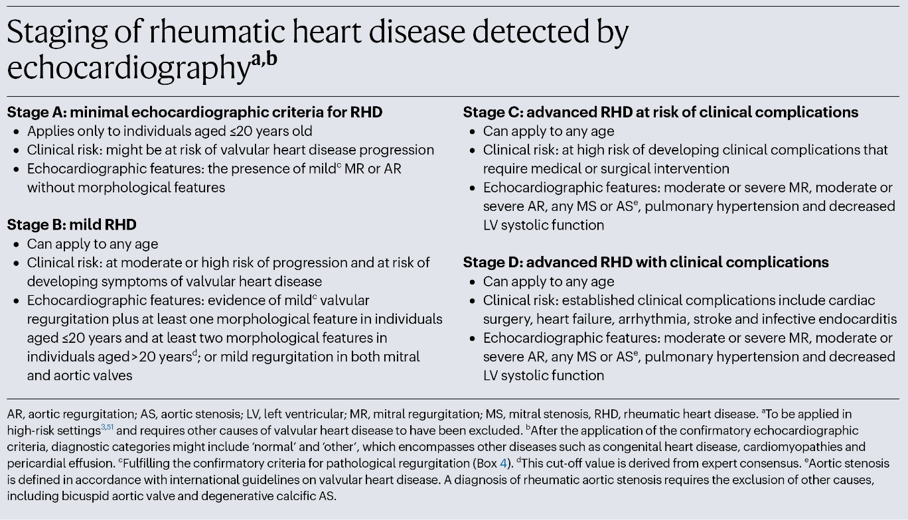
Figure 14.1. Staging of rheumatic heart disease detected by echocardiography

Rwebembera J, Marangou J, Mwita JC, Mocumbi AO, Mota C, Okello E, et al. 2023 World Heart Federation guidelines for the echocardiographic diagnosis of rheumatic heart disease. Nature Reviews: Cardiology. 21, 4, 250–263. 2020, reproduced with permission from SNCSC.

Appendix 1: Secondary Antibiotic Prophylaxis for People with Acute Rheumatic Fever
Table 8.3. Anticipated duration of secondary antibiotic prophylaxis — guidance according to diagnostic classification and conditions for ceasing prophylaxis

Diagnosis | Definition | Duration of secondary antibiotic prophylaxis (SAP) (first episode or recurrence) | Conditions for ceasing prophylaxis⁴
Definite ARF, with or without cardiac involvement¹ | 2 major, or 1 major and 2 minor manifestations  PLUS  Evidence of a preceding Strep A infection | Minimum of 10 years after the most recent episode of ARF, or until age 21 years (whichever is longer).^{2, 3, 4}  Reassess around age 21 years (clinical assessment and echo). If still moderate RHD or progressed to severe RHD, continue SAP to age 30 years and reassess. | No ARF recurrence within the previous  10 years.⁴
Probable ARF¹ | Highly suspected ARF (1 major and 2 minor manifestations) — evidence of a preceding Strep A infection counts as a minor manifestation) | Minimum of 10 years after the most recent episode of probable ARF, or until age 21 years (whichever is longer)³ | No ARF recurrence within the previous 10 years.⁴
Possible ARF¹ | Incomplete features of ARF but no other diagnosis confirmed | 12 months, then reassess with clinical review, echo and ECG.  - SAP may stop earlier if another diagnosis (for example, juvenile idiopathic arthritis) is confirmed during this period.  - In a high-risk whānau with no other diagnosis confirmed by 12 months, a minimum of five years of SAP is recommended. | No signs or symptoms of ARF within the previous 12 months. Normal echo and ECG.⁴

Notes:
¹ Evolution and resolution of initial carditis in ARF may take some months. Initial guidance about SAP should always be reviewed depending on the progression of echocardiographic findings, and the situation of the individual and their whānau.
² See definitions of mild, moderate and severe carditis in Table 6.7 in Chapter 6: Diagnosis of Acute Rheumatic Fever.
³ Stopping SAP early may be possible in these lower-risk situations:
- In people aged ≥16 years when their ARF was diagnosed (initial episode), cessation after 5 years may be considered if the person had no or mild carditis initially AND a normal follow-up echo at the time of cessation.
- In people aged ≤16 years when ARF was diagnosed (initial episode), cessation may be considered from 18 years of age if the person had no or mild carditis initially AND a normal follow-up echo at the time of cessation AND has completed 10 years SAP at the time of cessation.
Overall, these guidelines are relatively conservative compared to Australian and WHO guidelines. Late recurrences of ARF continue to occur among rangatahi and young adults in Aotearoa.⁸ No new local evidence supports further shortening of SAP duration.
⁴ Moderate carditis frequently improves to mild carditis or better, and occasionally severe carditis improves. However, people with initial severe carditis, including those who have early RHD surgery, are likely to need longer duration SAP. They are likely to have persisting severe RHD, although evidence for SAP in older adults with RHD is limited. Recurrent
ARF is rare after 35 years. As well as assessing RHD severity, consider the risk of Strep A exposure or recurrence and the benefits of continuing SAP. Any regression or progression of RHD should be determined by echo. Future recommendations for SAP should be determined by shared decision-making with the person and their whānau, based on echo findings and personal/whānau circumstances.
⁵ Clinical review and echo of all patients with moderate–severe carditis at 12–24 months after cessation of SAP is recommended as part of ongoing RHD management. This ensures no deterioration of RHD and promotes ongoing awareness of appropriate management of Strep A infections, oral health and other health issues.
The diagnosing clinician should obtain consent for registration on the RFCCS and refer the patient to the local district or regional secondary prevention service. Patients will be registered on the RFCCS by each SAP service.

Appendix 2: Secondary Antibiotic Prophylaxis for People with Non-Acute Rheumatic Heart Disease
Table 8.4: Recommendations for secondary antibiotic prophylaxis for persons with newly diagnosed and non-acute RHD (includes RHD detected by echocardiographic screening, as an incidental finding and those with prior ARF)

WHF 2023 Stage | Echocardiographic features | Clinical management | Duration of secondary antibiotic prophylaxis | Conditions for ceasing prophylaxis
Stage A RHD  This diagnosis applies only to people ≤20 years of age with no prior history of ARF. | Pathological MR or AR without morphological features in high prevalence population. | Screen-detected RHD  Counsel whānau that the echo findings may or may not prove to be RHD. Usual advice is not to start SAP unless there is family history of ARF or RHD. Shared-decision-making and consideration of whānau preferences is required. Experience from screening in Aotearoa is that whānau of persons with Stage A RHD (previously called borderline RHD) tend to choose SAP if another family member has had ARF/RHD.  If starting SAP, consent to register on the RFCCS.  If not starting SAP, place the person on the screening programme database as relevant.  Clinical review with echo in 1–2 years. | Screen-detected RHD  If SAP is started, give for 1–2 years and consider stopping SAP if echo findings have normalised.  If Stage A RHD persists after 1–2 years, SAP is recommended for 5 years.  If SAP was not started but the follow-up echo shows persisting Stage A RHD, recommend 5 years of SAP.  If the follow-up echo shows progress to Stage B or C, recommend prophylaxis for 10 years as per Stage B and C recommendations below. | If Stage A echo findings are normal after 12–24 months.  OR if Stage A findings have normalised or not progressed after five years’ SAP.
Stage B RHD or any prior ARF episode | In individuals aged  ≤20 years — mild pathological valvular regurgitation plus at least one morphological feature.  In individuals aged  >20 years — at least two morphological features, or mild pathological regurgitation in both mitral and aortic valves. | Person with prior ARF diagnosis (with or without residual RHD) or screen-detected RHD  SAP is recommended for all persons with Stage B RHD or prior ARF, with clinical review and repeat echo 1–2 years after diagnosis.  Ensure the person is consented and registered on the RFCCS. | Clinically diagnosed ARF or RHD  Minimum of 10 years or age 21, whichever is longer.  Reassess SAP around 21 years of age.  Screen-detected Stage B RHD  10 years duration currently in Aotearoa. This is an evolving area. International research to determine whether people with screen-detected Stage B RHD can safely have a shortened duration of SAP (e.g. 5 years) is in progress. | No probable or definite ARF within the previous 10 years; no progression of RHD.
Stage C | Moderate or severe MR, moderate or severe AR, mitral stenosis of any severity. Persons with Stage C RHD are at risk of clinical complications. | Any person with Stage C RHD  SAP is recommended for all persons with Stage C or D RHD.  Specialised RHD care as per Chapter 11: Management of Rheumatic Heart Disease.  Ensure the person is consented and registered on the RFCCS. | 10 years or until age 21 years, whichever is longer.  Reassess SAP around 21 years of age.  Those with continued moderate or severe RHD should continue to age 30–35 years and reassess.  Consider individual risk of Strep A exposure or recurrence when deciding about cessation vs continuation of SAP. | No probable or definite ARF (within the previous 10 years).  No progression of RHD.
Stage D | Established moderate or severe RHD detected by echocardiography with overt clinical complications including need for cardiac surgery, heart failure, arrhythmia, stroke and infective endocarditis. | Any person with Stage D RHD  SAP is recommended for all persons with Stage C or D RHD.  Specialised RHD care as per Chapter 11: Management of Rheumatic Heart Disease.  Ensure the person is consented and registered on the RFCCS. | 10 years or until age 30–35 years, whichever is longer.  Reassess SAP around 30–35 years.  SAP beyond age 30 years is individualised. Assess RHD severity, risk of Strep A exposure, and benefits /risks.  In people with decompensated severe RHD who are not candidates for cardiac surgery, or are under palliative care, consider daily oral penicillin (as per AHA 2022 Advisory). | Individualised as detailed in Chapter 11: Management of Rheumatic Heart Disease.
Adapted from the 2023 World Heart Federation guidelines.

