Advisory
Advisory_2026_NCAMP_ Change to Purchase Units for Community Radiology – CS01001
Date of Issue:
12 December 2025
Proposed Implementation Date:  1 July 2026 |  | Subject: Change to Purchase Units for Community Radiology – CS01001
ADVISORY NOTIFICATION
Summary:
Currently Districts submit activity to NNPAC for CS01001 – Community Radiology (GP referred radiology into a hospital) with an RVU unit of measure. From 1 July 2026 the unit of measure will change from an RVU to “test”.
As multiple radiology scans can be provided during the same event, the PMSUID will need to link to the radiology system event number rather than the local system event level ID as illustrated below:
A GP refers a patient to radiology for an orthopaedic condition. The patient has an X-ray and a CT scan during the same visit generating a single event number in the District’s system for the visit, but two event numbers in the radiology system.
National Collections Impacted by Change: |  | NNPAC
Context of the change
Current State - Unit of Measure = RVU (relative value unit):
One event is reported to NNPAC (episode no 600700) with an RVU of 4.6 consisting two scans, an X-ray and a CT.
- Radiology event 123456, episode 600700 (NNPAC) XR (RVU = 1)
- Radiology event 123457, episode 600700 (NNPAC) CT (RVU = 3.6)
1 July 2026 change – Unit of Measure = Test
Two events are reported to NNPAC with a different episode number – each with a volume of 1
- Radiology event 123456, episode 123456 (NNPAC)
Radiology event 123457, episode 123457 (NNPAC) Context of the change
- The unit of measure for community radiology (CS01001) is currently an RVU. This RVU is defined in the Community Radiology Service Specification (updated Sep 2024) as:
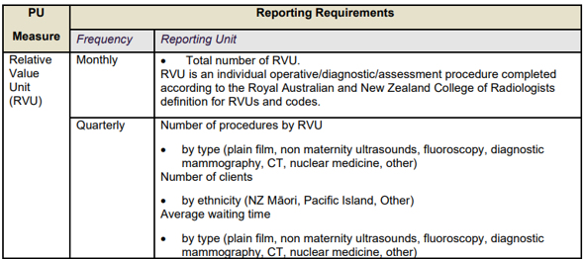
However, this RVU structure has not been updated from some years and Districts all use their own versions.
- From an operational perspective, there is a growing push to monitor CS01001 activity by test type, e.g. X-ray, CT etc.
- Over the past two years, cost data has been collected by modality to enable a new suite of purchase units to be developed with associated pricing work occurring alongside.
- The proposed suite of purchase units will be modality based, but some issues need to be resolved. For example:
  - Some Districts capture bone densitometry against CS01001 and others capture it against CS04005 – community referred endocrinology. There are other areas of inconsistency that need to be resolved, e.g. non maternity ultrasound.
  - Further work is required to clarify the boundary between some areas. Some Districts map image guided injections to fluoroscopy, while others map it to the modality used, e.g. Ultrasound
What is expected of the sector
- Due to timing, we are proposing a two year implementation process. Year 1 is a shift to report tests at an event level rather than RVU. Year 2 will be to report against new purchase units based on modality using a national agreed criteria.
- Districts will be required to change the unit of measure from 1 July 2026. Records for tests after 30 June 2026 that are reported with RVU as the unit of measure will be rejected from NNPAC. It is planned that reporting against new purchase units based on modality will be mandatory from 1 July 2027.
Impact of Change on National Collection(s):
This change will impact NNPAC.
Contact: If you have any questions regarding this change notice, email ncamp@tewhatuora.govt.nz

