


Ministry of Health
Primary Maternity Data Collection
System (PMDCS) Service Guide
Version 2.2
30 January 2014

Document Change Control
Version | Date | Author | Notes
1.0 | 03 April 2013 | James Bebbington | With updates from MOH.
1.1 | 03 April 2013 | Lew Skinner | Added paragraphs on Retrospective data. Updated data element table to include retrospective data.
1.2 | 17 April 2013 | Lew Skinner | Changes after feedback changes marked
1.3 | 22 April 2013 | Oermila Jewell | Update to FAQ Section
1.4 | 22 April 2013 | James Bebbington | Update to email & FAQ sections
1.5 | 04 December 2013 | George Manjooran | Updated to manage  - Retrospective (= Historical Files),  - Automatically sending files to ODS if required and  - Ability to delete records and files in the ODS.
2.0 | 22 January 2014 | Lew Skinnner | Document Review and feedback
2.1 | 28 January 2014 | Daniel Irving | Update following feedback
2.2 | 30 January 2014 | Lew Skinnner | Final Review

Table of Contents
Document Change Control 2
Table of Contents 3
1 Introduction 4
1.1 Changes in Version 2 5
1.2 Overview of system 7
1.3 Getting Started 8
1.4 System generated emails 11
1.5 Ongoing and Retrospective data 11
1.6 Getting Help 12
2 What data do you need to provide? 14
3 Related documents 15
4 Submitting Maternity Files 17
4.1 Introduction 17
4.2 Submitting an ‘xml’ or ‘csv’ file 17
4.3 Acknowledgement files 18
4.4 Interpreting Acknowledgement files 19
5 Using the Web Portal to Manage Files and records 21
5.1 Using the Web Portal to search for records 21
5.2 Finding and repairing existing records (in PMDCS)via the Web Portal 23
5.3 Adding new records via the Web Portal 23
5.4 Data Entry Form 24
5.5 Submitting files to the MOH ODS via the Web Portal 26
5.6 File Status Screen 27
6 Delete record from PMDCS 29
7 Create Delete Request to be sent to ODS 30
8 Emails notification and acknowledgements 31
8.1 PMDCS web portal & MOH ODS email notifications 31
8.2 PMDCS web portal & MOH ODS Acknowledgement 31
9 Overview of Data 32
9.1 List of Data Elements 35
10 Frequently asked questions 37
11 Service Request Template 39
12 Simpl Support Process 40
13 Definitions and Glossary 41

Introduction
DHBs provide primary maternity care to approximately 30 per cent of pregnant and postpartum women nationwide. Up until 30 June 2007, DHBs claimed for the provision of primary maternity services under the Primary Maternity Services Notice, issued pursuant to section 88 of the Public Health and Disability Act 2000 (the Notice).
Since 1 July 2007 each DHB has been bulk funded to provide primary maternity care based on their historic claim volume. This funding was ‘top sliced’ from the national maternity services budget held by the Ministry of Health. DHB reporting requirements for this top slice funding were specified in draft, at the time of the notice change, but never implemented. As a result the Ministry of Health has not received any data on primary maternity services provided by DHBs since 2007 and collection and storage of this data within each DHB is understood to be variable .
This missing DHB data is required to support the Ministry of Health’s core monitoring and analysis functions, add to the Maternity Quality and Safety Programme and improve the quality and scope of the National Maternity Collection. It will also contribute to quality of responses to requests for information from ministers, DHBs, the Perinatal and Maternal Mortality Review Committee (PMMRC), other sector stakeholders, and other government departments.
The collection of this data will give the Ministry of Health the ability to report on the complete picture of publicly funded maternity care provided nationally and ties in with the Ministry of Health focus on improving the quality and safety of care for pregnant women and their babies under the Maternity Action Plan.

In 2010, the Minister requested the Ministry of Health focus on delivering four priority maternity actions, one of which is to improve maternity information systems and analysis, as recommended by the PMMRC.

The deliverable for this priority area is enabling the Ministry of Health to report on all publicly funded maternity services and the women and babies who access them. This is needed to support the Ministry of Health’s core monitoring and analysis functions, add to the Maternity Quality and Safety Programme and improve the quality and scope of the National Maternity Collection:

This has been undertaken as a two-step process.

The first step rebuilt the National Maternity Collection using existing data (includes hospital events data submitted via the National Minimum Dataset and primary maternity services funded through the Notice submitted via Lead Maternity Carer claims, excludes primary maternity services funded through DHBs). This was completed successfully in August 2011.

The second step will collect and incorporate the missing DHB data into the rebuilt National Maternity Collection

This step has been further divided into two discrete but complementary projects.

1. The ‘Ministry-facing’ project is to deliver, within the Ministry of Health, the capabilities and processes necessary to receive primary maternity data from DHBs and incorporate this into the Ministry of Health’s recently rebuilt National Maternity Collection.

Work is almost complete on the project. This deliverable is often called the “ODS” which is the Operational Data Store.

2. The ‘DHB-facing’ project is to collect retrospective primary maternity data from each DHB for services provided between 01/07/2007 and 30/06/2012, and report this to the Ministry of Health, and to deliver the ability to report a specified ongoing minimum dataset to the Ministry of Health, once this is implemented. The minimum dataset is specified in Appendix 1 of the Maternity Services – DHB-funded Primary Maternity Services Tier Two Service Specification. From 01/07/2012 all DHBs are required to collect and store this dataset for all primary maternity services they provide. This will be delivered in two tranches. Firstly data from 1 July 2012 and then a smaller compulsory set back to 1 July 2007

The storage mechanisms and coverage relative to a defined minimum dataset and over time were scoped for each DHB in 2010, based on estimates provided by each DHB if they were required to collect the data directly. This information gives an understanding of the scope and the complexity of the problem in each DHB with respect to the retrospective data. The costs involved in collecting data through an external vendor may differ.

In the 2011 revision of the Maternity Services – DHB-funded Primary Maternity Services Tier Two Service Specification, a minimum dataset of information on all mothers and babies utilising DHB-funded primary maternity services was agreed and included in Appendix 1. This requirement states DHBs must ‘collect and retain’ a core dataset and make it available to the Ministry of Health upon request. The Service Specification does not include the requirement for DHBs to report this data to the Ministry of Health, but states the ‘Ministry of Health will work with DHBs on a means of submitting this information to national collections on a regular basis’. The Service Specification was agreed in July 2011 and published in October 2011. It should be noted that some DHBs may have to make system changes to enable the collection of this dataset. The date from when a DHB may be expected to hold the full specified dataset in a means suitable for reporting is July 2012.

Additional work in Maternity Health Informatics includes the National Health Board’s ongoing work on developing, piloting and implementing a comprehensive electronic clinical maternity information system for every DHB, known as the Maternity Clinical Information System project. From the time that each DHB has this facility, (planned as a staged uptake), an electronic transfer of a minimum dataset of maternity information will take over as the method of collection of DHB-funded Primary Maternity Services data for incorporation into the Ministry of Health’s national collections.

Changes in Version 2
This upgrade manages:

Management of Retrospective data
Retrospective data is data from 1 July 2007 until 30 June 2012.
The system now accepts and processes data for this period, although with less stringent specifications. Details can be found summerised in section 7.1 and in detail at ……
The ministry wishes to collect this data to get a full picture of Maternity data and will work with each DHB to assist them
Detailed specification can be found at
http://www.health.govt.nz/nz-health-statistics/national-collections-and-surveys/collections/national-maternity-collection/dhb-primary-maternity-data-collection

Note changes to screens
- It is important from a data entry perspective that users do not confuse retrospective and on-going data entry forms. To help you distinguish the difference, the retrospective Maternity data entry form has been coloured blue while the on-going Maternity data entry form remains grey. Please note the difference between 5.3.1 on-going & 5.3.2 retrospective in colour and form header.

Automatic ODS Submission of batched files
PMDCS will now automatically submit batched Maternity records to the Ministry’s Maternity Data Store (ODS) if that batch is valid. This process has changed from a manual process to a ‘by default process’ meaning your batched files will be processed without manual intervention if it is valid . This scheduled task will occur at 3am everyday and will process any valid batched files waiting in the processed queue. As part of the validation process, any batched files containing errors will not be processed but will trigger an error notification email as outlined in 1.4
If a DHB wishes to maintain the manual configuration and not rely on the automated ODS Submission process then a request must be sent to Simpl. The request must specify the disabling of the automatic batch file submission flag.

Allow deleting of files and records from the ODS
If incorrect data has been sent to the Ministry’s Maternity Data Store (ODS) then this record (or records or batch file) can now be deleted.

Overview of system

The Big Picture
Place file in the ‘IN’ folder on the SFTP Server
File is accepted with no errors
File is accepted with errors
File is rejected
All records ‘Complete’
(all segments present),
or the file was made from new/returned records
Some records ‘Incomplete’
Fix all validation errors using the Web Portal
Fix issues noted in the Acknowledgement & resubmit
Click ‘Submit File’
File is sent to the ODS
File is accepted by the ODS
File is accepted by the ODS, with some errors reported
Update ‘Returned’ records using the Web Portal

Complete

Create new records either retrospective or ongoing using the Web Portal
Add missing sections to all records using the Web Portal
OR
PMDCS
Acknowledgement Email Sent
Acknowledgement Email Sent
Acknowledgement Email Sent
ODS
Acknowledgement Email Sent
Click ‘Submit New Records’
Click ‘Submit Returned Records’
ODS
Acknowledgement Email Sent
Restart

The PMDCS
The Primary Maternity Data Collection Service (PMDCS) provides District Health Boards (DHB) and the Ministry of Health (MOH) with the ability to:
- Enter data manually
- Accept files of data
- Repair data, both from the DHB file and from files returned from the MoH’s ODS system
- Send correct data to the Ministry’s ODS.
The PMDCS is designed to allow the DHBs to upload both current primary data in XML and CSV formats as well as correct any errors, and add any additional data or records before sending to the Ministry of Health.
The DHBs will be able to log onto a secure web portal where they will be able to view their uploaded records, correct any data quality issues, create new records, add data into fields and check the status of the records.
The PMDCS will provide continuous feedback on any data quality issues through its validation service, ensuring that the MAT files sent to MOH are as accurate as possible.
Both the PMDCS and the MOH ODS Batch Process will produce feedback to the DHB in the form of Acknowledgement files containing the number of records processed, and any errors reported during processing. If the ODS Batch Process reports any errors back to the PMDCS, the web portal will indicate which records have a problem, allowing the DHBs to correct (using PMDCS)and resend the records back to the MOH ODS Batch Process.

Production and Compliance environments
Note that this document makes reference to two separate environments. The Production environment is used to submit and validate production data that will ultimately be loaded into the Maternity Database. The Compliance (COMP) environment is for testing purposes and ensuring that the DHB files comply to the rules; data submitted to this environment via either the web portal or the SFTP site will not be added to the Maternity datamart.

Getting Started
As a DHB starts to deliver Maternity data to the system they will firstly send (or enter) data into the ‘Compliance’ (COMP) system.
The purpose of the compliance system is to allow a DHB to confirm that its file is compliant, to practice fixing and/or adding fields and making sure that their data can be submitted without being rejected. Note that data submitted to the Compliance system will not be used except for testing – it will be sent to the ODS compliance system which will test the data that cannot be tested by the PMDCS – for example the NHI, DoB and name are correct.
Once a DHB is satisfied that their data has been entered into the compliance system successfully, and all the relevant rules are understood, they can start using the Production (PROD) system.
The following steps need to be performed to get started using the system:
- Set up a new DHB with the Simpl Helpdesk this will include
  - Giving a name, phone and email of person at DHB who is responsible for the delivery of the data – this is a more senior person
  - Giving email addresses that the PMDCS and ODS systems will send messages (eg for successful validation ) This should be a generic name such as Matprimdata @nnDHB, which the DHB can auto forward to a person or persons.
  - Simpl will send these email addresses to the Ministry to be set up in their parts of the system.
  - MoH will give names of EFT folders and passwords to Simpl who will give them to DHBs
- Check that you can access the Compliance Web Portal
- Request one or more Username and Password for the Compliance Web Portal
- Submit data using the Compliance Web Portal, and the Secure File Transfer if desired
- Create a file or submit a file on PMDCS
- Check that you can access the Production Web Portal
- Request a Username and Password for the Production Web Portal
- Begin submitting data to the Production environment
  - This can happen when you have successfully submitted files to the COMP ODS system
These steps are described in more detail below.

Set up a new DHB with the Simpl Helpdesk
Before a DHB can begin using the PMDCS system for the first time, they need to be activated by Simpl Support. Contact Simpl Support using the details provided in section 1.6 and provide the following details:
- The name and email address of the person who can approve access to the system and who has responsibility of data being sent to the ministry
  - An email address (or set of addresses) where notifications will be sent when files are processed This should be a generic name such as Matprimdata @nnDHB, which the DHB can auto forward to a person or persons.
- A name, contact number, and email address that can be used for communications between Simpl, the Ministry and the DHB

Check that you can access the Web Portal
The PMDCS web portal can be accessed by navigating to the following URL from within the Connected Health Network:
- Production Website: http://166.83.32.2/
- Compliance Website: http://166.83.32.2:81/

Note that the Compliance website will have the words “UAT” in the website title, and will display a green background on the Search screen (once logged in) to distinguish it from the blue background of the Production website.
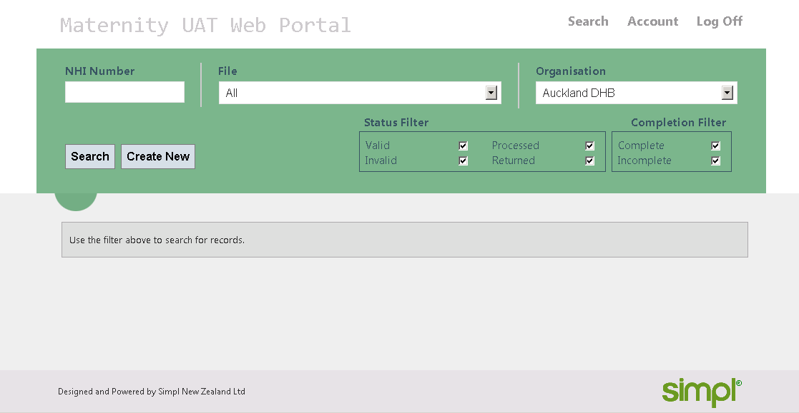

Request a Username and Password for the Web Portal
You will require a username and password to log in to the Web Portal; these will be provided by Simpl.
To request a new user be set up in to the Compliance and/or Production environment, please provide the following details to Simpl Support:
- The first and last name of the user
- The associated DHB
- The email address of user
- A contact number
You will receive an email with the username and password that you can use to log in to the website.

Notes on Password Management
After first logging in, you will be required to change your password. In addition, the system will ask you to reset your password every 90 days.
If you enter your password incorrectly after five attempts, you will be locked out, and will need to call Simpl Support to have your account reset.
Your password must be at least 8 characters, it must not contain your account or full name, and it must contain at least three of the following four character groups:
- English uppercase characters (A through Z);
- English lowercase characters (a through z);
- Numerals (0 through 9);
- Non-alphabetic characters (such as !, $, #, %).

Using the Web Portal
The Web Portal will be used by Data Enterers to create new records and modify/repair existing records.
All data can be entered manually through the web portal if desired. After having entered a number of records and having ensured that you have fixed all errors you see, you can submit the data to the MOH ODS system by clicking the “submit” button. If the submit button does not work, this means that there are still errors in the records.
Section 5 provides detailed information on how to use the Web Portal, and section 6 gives an overview of the data itself.

Using the Secure File Transfer
DHB technical users will have access to the SFTP site where batch files can be submitted to, and acknowledgement files can be retrieved from.
Before submitting a file, refer to the rules that files must adhere to (see section 0).
The SFTP Site can be accessed by your IT staff
- To submit or retrieve files from Production, use the ‘PROD’ folder.
- To submit or retrieve files from Compliance, use the ‘COMP’ folder.
If you have any issues when lodging your first file, contact Simpl Support for help.
After having submitted a file, you can then enter the Web Portal to fix and add fields if necessary. Once the file is complete and correct you can submit it to the Ministry’s ODS system, and await results.

System generated emails
Note that whenever data is submitted to the PMDCS or MOH ODS an acknowledgement file will be produced that informs the user of the file’s status. The acknowledgement file will confirm whether the submitted data has been accepted or rejected and if any errors exist with the data. The acknowledgement files that are created, are placed on the Ministry’s SFTP site, please refer to Section 8 for more information.

Ongoing and Retrospective data
Initially the system will only collect “ongoing data” – that is data from 1st July 2012 and ongoing until the DHB has implemented the MCIS system all data will be entered in the format specified in the MAT Specification Document.
Over time the data format may change, and new versions will be released. DHBs will be able to continue submitting data in the most recent historical format if necessary by specifying the file version in the XML or CSV file as described in the MAT & CSV Specification documents.
Note that when creating new records via the web portal, they will always use the latest version.
Once the data is being entered for “on-going data” the Ministry will negotiate with DHBs to collect “historic data” – that is data back to 2007. This data will have less mandatory requirements.

Ongoing data.
Ongoing data is data collected from 1 July 2012 and ongoing from that date. This is the data that you are required to collect delivered by you and either sent by file or entered via PMDCS on a monthly basis ongoing until your DHB begins delivering this data from the proposed MCIS system
The definition of “data from July 1st 2012 is:
- Determine what is the earliest date from these sources - for a given record.
- Womans - Antenatal - Antenatal date of first antenatal service
- Womans - Labour and Birth - Delivery Date
- Womans - Postnatal - Postnatal Date of last postnatal Service
- Baby details - Baby Identity - Baby date of Birth

- If that date is less than 1 August 2012 (Allow one month grace from date your Service Specification became operative –
Then accept record for processing.

- If that date is equal to or greater than 1 August 2012
Then reject the record
Only have “ongoing data” in an ongoing file

When sending files with Ongoing Data the file version for ongoing data must be 00001.00

Do not mix ongoing and retrospective records in the same file!

Historic (aka Retrospective Data)
This is data from 1 July 2007 until 30th June 2012 .
We wish to collect this historic data and we realise that you may not have been collecting all the fields from 2007. For this reason we have a set of “relaxed” rules for historic data. This are summarised in the table in section 7.1 of this document and are detailed in the document “DHB Primary Maternity Service Data Collection System MAT ODS - Retrospective File Specification”

If you have data that is additional to the core historical data, we do want it! Remember if you do enter additional fields they will be validated so must be correct.
When sending files with Retrospective Data the file version for retrospective data must be 00000.01

Getting Help
Please contact the Simpl Support desk using the following number or email address:

PMDCS Support Details
Phone: | 0800 002 480
Email: | pmdcs.support@simpl.co.nz
Website: | www.simplgroup.com

Simpl will require the following details when a support call is logged with the Service Desk:
(refer to section 11 for other information that may assist in resolving your Issue)
  - DHB
  - Name
  - Contact Number
  - The name of the relevant File
  - Description of the issue

What data do you need to provide?
- This data needs to be provided when DHBs provide the following services:
Service Definition (from Tier level two service specification)
The Service includes primary maternity care provided by DHBs for women who are not accessing Lead Maternity Carer (LMC) services funded under the Primary Maternity Services Notice. DHB primary maternity services will be provided when LMC services are not feasible.
DHB-funded primary maternity services are provided for one of the following purposes:
  - LMC services from a DHB-employed LMC where the DHB is able to provide this service;
  - Co-ordinated Primary Midwifery Care for women as the alternative where the DHB has used its best endeavours to provide an LMC service in the absence of an LMC funded under the Primary Maternity Services Notice and has been unable to do so; and
  - Midwifery services for labour and birth, and/or postnatal care for women who have a General Practitioner (GP) or Obstetrician LMC under the Primary Maternity Services Notice, and the LMC has arranged to utilise DHB-funded primary maternity services.
For more information please see the document MATERNITY SERVICES – DHB-Funded PRIMARY MATERNITY SERVICES Tier Level Two SERVICE SPECIFICATION

- You need to provide the data elements as described in the MAT ODS file specification for each module where a service is provided as described in A above.

Related documents
If you do not have the latest version of any of the following documents, please contact Simpl Support to obtain a copy.
MATERNITY SERVICES – DHB-Funded PRIMARY MATERNITY SERVICES Tier Level Two SERVICE SPECIFICATION
Latest version August 2012 – available on MoH website:
http://www.nsfl.health.govt.nz/apps/nsfl.nsf/pagesmh/444
This tier two service specification applies to all District Health Board (DHB)-funded Primary Maternity Services. It must be used in conjunction with:
- the tier one Maternity Services – DHB-funded Service Specification.
This service specification also links with:
- other tier two service specifications for maternity services, including: DHB-funded primary maternity facilities, DHB-funded secondary and tertiary maternity services and facilities, and pregnancy and parenting education
- the Primary Maternity Services Notice 2007, pursuant to section 88 of the New Zealand Public Health and Disability Act 2000 (the Primary Maternity Services Notice).
In general DHBs are required to provide Maternity data to the Ministry for services provided as described in the service specification
DHB Primary Maternity Data Collection Service MAT ODS File Specification
Latest Version: v4- dated 21 March 2013
This manual gives the complete details of the data to be collected for ongong data, including the formats and the exhaustive set of rules used to validate the data. It is primarily aimed at technical staff, although sections 6.1-7.12 of the File Specification explain the rules that the data must adhere to in order to be accepted as valid.
DHB Primary Maternity Data Collection Service MAT ODS File Specification (Retrospective Data)
Latest Version: v1- dated 28 March 2013

http://www.health.govt.nz/nz-health-statistics/national-collections-and-surveys/collections/national-maternity-collection/dhb-primary-maternity-data-collection

This manual gives the complete details of the data to be collected for retrospective (aka historical) data, including the formats and the exhaustive set of rules used to validate the data. It is primarily aimed at technical staff, although sections 6.1-7.12 of the File Specification explain the rules that the data must adhere to in order to be accepted as valid.

CSV File Format Document
Latest Version: v0.2 - dated 23 Jan 2013
This manual provides an overview of the format that data is required to be in when submitted to the PMDCS system as a CSV file.
XML Schema
Latest Version: v0.3
The DHB_Primary_Maternity_Data_Collection_v1.0.xsd schema, and the included DHB_Primary_Maternity_Common_Types_v1.0.xsd schema, outline the data format that ongoing xml files must adhere to when submitted to the PMDCS system.
The DHB_Primary_Maternity_Data_Collection_v0.01.xsd schema, and the included DHB_Primary_Maternity_Common_Types_v0.01.xsd schema, outline the data format that retrospective xml files must adhere to when submitted to the PMDCS system.

Submitting Maternity Files

Introduction
Batch files are submitted to the PMDCS via the SFTP site into the Dropoff directory. . You can also access Acknowledgement files from the PMDCS and MOH ODS systems from the Pickup directory

Submitting an ‘xml’ or ‘csv’ file

XML File formats.
If submitting data in an XML file, the rules in the document “DHB Primary Maternity Data Collection Service MAT ODS File Specification” must be followed exactly as well as conforming to the XML schema provided by the Ministry of Health.
Please note that there have been some recent changes to the schema. See section 5.3 for the details of these changes, and some additional notes, that will help you ensure your documents conform to the schema.

Submitting a file
To submit a file to the PMDCS system, it simply needs to be placed into the ‘IN’ folder on the MOH SFTP Site. Note this folder will be located in following directory:
‘…\<DHB>\DHB Maternity\<Target System>\IN’
Where:
- <DHB> = The submitting DHB’s name and code
- <Target System> = COMP if submitting to Compliance, or PROD otherwise
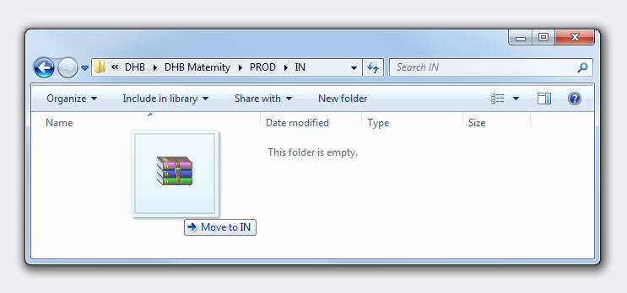
Any files copied into this folder will be picked up by the PMDCS system within a few minutes.
Note that currently only zipped ‘xml’ or ‘csv’ files, or unzipped ‘xml’ files are accepted, and the file itself must comply with the naming and format standards specified in the ‘MAT File Specification’ document, or the ‘PMDCS CSV File Format’ document.
All onoing data CSV files will be suffixed with ‘_C’ and all historical / retro data CSV files will be suffixed with ‘_H’.
Example
Ongoing CSV File Name Format : PROD_MAT20130101_1000_001_WOMAN_C.csv
PROD_MAT20130101_1000_001_BIRTH_C.csv

Retro CSV File Name Format : PROD_MAT20130101_1000_001_WOMAN_H.csv
PROD_MAT20130101_1000_001_BIRTH_H.csv

PROD_MAT20130101_1000_001_EXTRACT.xml
PROD_MAT20130101_1000_001_EXTRACT.xml
PROD_MAT20130101_1000_001_EXTRACT.zip
PROD_MAT20130101_1000_001_EXTRACT.zip
PROD_MAT20130101_1000_001_WOMAN_C.csv
PROD_MAT20130101_1000_001_BIRTH_C.csv
containing
containing
Examples of Accepted File Types:

Acknowledgement files
After a file has been validated by the PMDCS system—which may take up to 15 minutes—an acknowledgement file will be placed in the Pickup direcftory on the MOH SFTP Server.
Note that acknowledgement files are XML documents that relate to a given input file, and specify if that input file was able to be successfully processed, the number of requests (records) received in that file, and any validation errors with individual records. The detailed format of the acknowledgement files is described in the ‘MAT File Specification’ document.

Viewing Acknowledgement files
After a file has been processed by the PMDCS system—which may take up to 15 minutes—an acknowledgement file will be placed in the ‘OUT’ folder on the MOH SFTP Server.
You can read these files using the PMDCS portal
Note that acknowledgement files are XML documents that relate to a given input file, and specify if that input file was able to be successfully processed, the number of requests (records) received in that file, and any validation errors with individual records. The detailed format of the acknowledgement files is described in the ‘MAT File Specification’ document.
Note this folder will be located in following directory:
‘…\<DHB>\DHB Maternity\<Target System>\OUT’
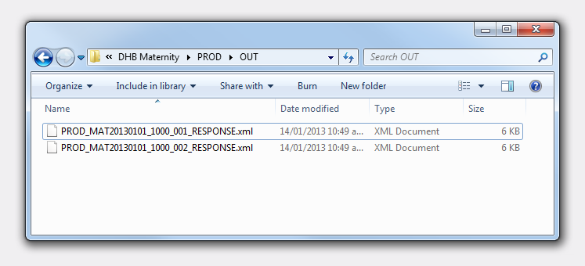
Once an acknowledgement file has been produced, an e-mail will be sent out to the e-mail addresses that have been recorded for the relevant DHB. This email will confirm that an acknowledgement file has been created.

Interpreting Acknowledgement files
Accepted means that the file name is correct and the file format is correct. (That is PMDCS can read the file).
Rejected means that PMDCS cannot read the file.
Note that a file may be:
- Accepted with no errors <mat:Status>Accepted</mat:Status>
- Accepted with errors, or
- Rejected <mat:Status>Rejected</mat:Status>
As shown above, the ‘Status’ tag in the acknowledgement file informs whether a file has been accepted or rejected.
Rejected Files
If a file is rejected, then it will not appear in the PMDCS Web Portal. Instead, the file will be copied to the ‘ERROR’ folder on the MOH SFTP Server:
‘…\<DHB Code>\DHB Maternity\PROD\ERROR’
The file will need to be modified to resolve the error(s) mentioned in the acknowledgement file, and resubmitted.
Note that a file may be rejected due to any of the rules relating to the input file name, the extract file root segment, the DHB details segment, or a request type segment, as described in sections 6.1.2, 7.1.2, 7.2.3, and 7.3.2 of the ‘MAT File Specification’, not being met.
Accepted Files
If a file is accepted, then the file, and the maternity details of all records included in the file, will appear in the PMDCS web portal, regardless of whether or not there were any errors. Note that any errors referred to in an accepted acknowledgement file will be to do with individual Maternity Detail records.
The relevant validation rules that result in errors being associated with a record are specified in sections 7.4 to 7.12 of the ‘MAT File Specification’ document. Note that the status of any records that have failed one or more of these rules will be set to ‘Invalid’ in the Web Portal. These records will need to be repaired before the file can be submitted to the MOH ODS. See section 5.2 for more details on how to resolve these types of errors using the Web Portal.
Note that once a file has been sent to, and processed by, the MOH ODS the acknowledgement file (relating to a given input file) in the ‘OUT’ folder on the MOH SFTP Server will be replaced by an acknowledgement file from the ODS. Since the file has already been validated by the PMDCS, errors should be rare. If any records are rejected by the ODS, however, then those records will be marked as ‘Returned’. See section 5.5.1 for more details on how to deal with these records using the Web Portal.

Using the Web Portal to Manage Files and records

Using the Web Portal to search for records
- To access the web portal, navigate to one of the following addresses from within the Connected Health Network:
- http://166.83.32.2/ for the Production Website
- http://166.83.32.2:81/ for the Compliance Website
- Log in to the website using the User name and Password provided to you by Simpl Support.
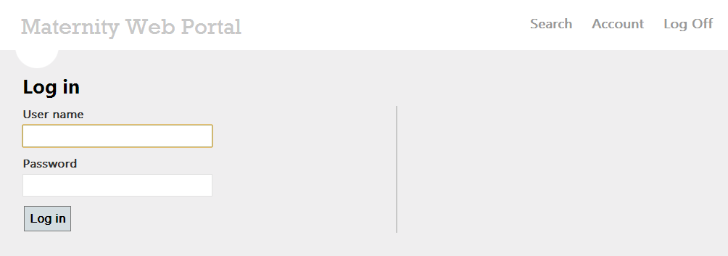
- When you first log in to the PMDCS Web Portal, you will be required to change your password.
- Once your password is updated, you will be presented with the following search screen:
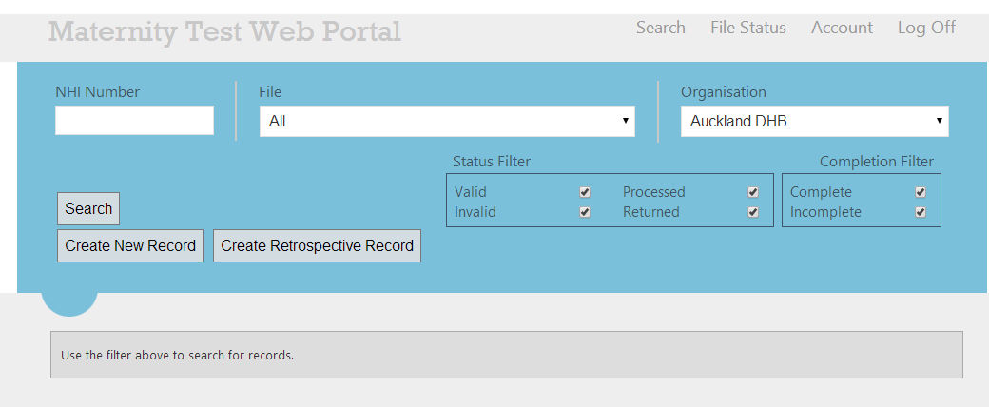
You can search for Maternity Detail records using any combination of the following filters:
- NHI Number
Search for record(s) that have the specified NHI Number only.
- File
Search for records that were submitted as part of the selected file. Select ‘None’ to view records that have been created manually using the Web Portal.
The list of available files will be populated with all of the files that have been accepted by the PMDCS system, for the selected DHB. See section 5.1.1 for more details.
- Organisation
Search for records belonging to the selected DHB.
- Status Filter
Search for records whose status matches any of the selected values. The statuses have the following meaning:
- Valid: The record has passed all validation rules, and is ready to be submitted to the MOH ODS.
- Invalid: The record has failed at least one validation rule, and will need to be repaired before it can be sent to the MOH ODS (as described in section 4.3).
- Processed: The record has been processed and sent to the MOH ODS.
- Returned: The file was processed by the MOH ODS system and this record was rejected. It can be updated and resubmitted.
- Completion Filter
Search for records that are complete, incomplete, or both:
- Complete: All segments of data are present (see section Error! Reference source not found. for more details).
- Incomplete: At least one section is missing (see section Error! Reference source not found. for more details).
Note that if you click ‘Search’ without changing the default filter, all available records for the given DHB will be returned.

Finding information on previously submitted files via the Web Portal
All files that have been submitted to and accepted by the PMDCS will be displayed in the list of available files in the Web Portal. When you select a file from the drop down list, a link to the related acknowledgement file will appear. Click on the link to view a web form showing the details of the acknowledgement file (as described in sections 4.3 and 4.4) relating to this input file.
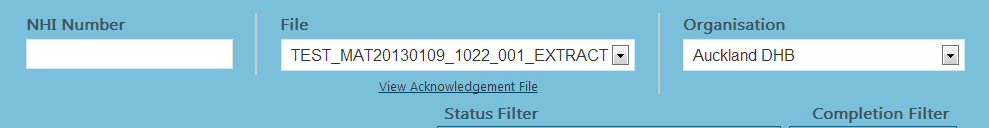
Click to View an Acknowledgement File

Note that the acknowledgement file link will initially provide details on the acknowledgement file produced by the PMDCS. Later when the file is sent on the MOH ODS, and a response is received, the link will be updated to point to the details of the acknowledgement returned from the ODS.
The acknowledgement file states the number of records that were ‘Rejected’; these correspond to records that have failed one of the validation rules as described in section 4.4, and so will be displayed as ‘Invalid’ on the search screen. Invalid records need to be updated before a file can be submitted to the ODS.

Finding and repairing existing records (in PMDCS)via the Web Portal
After having searched for a set of records, you can modify any existing record that has not yet been sent to the ODS (i.e. does not have a status of ‘Processed’), by clicking on the NHI Number for the given record to take you to the Data Entry screen.
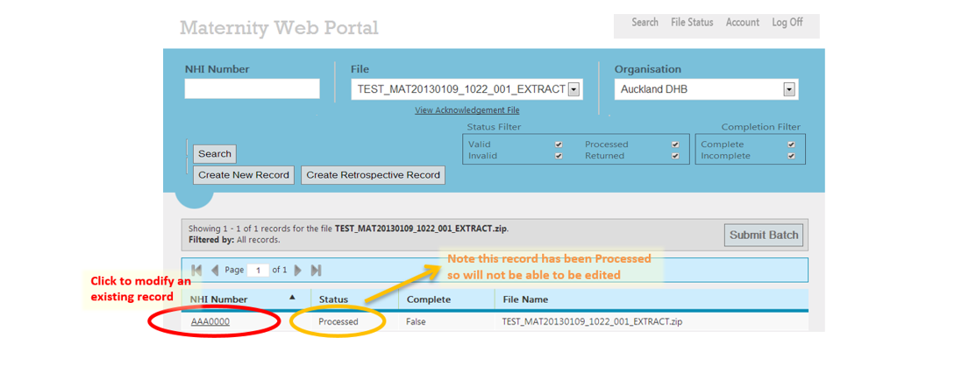

Adding new records via the Web Portal
You can also create a new record for the selected DHB by clicking the ‘Create New Record’ or ‘Create Retrospective Record’ button. This will take you to the Data Entry screen.

Create a new Maternity On-going Record
On clicking ‘Create New Record’, the user will be taken to the data entry screen for the ongoing data.
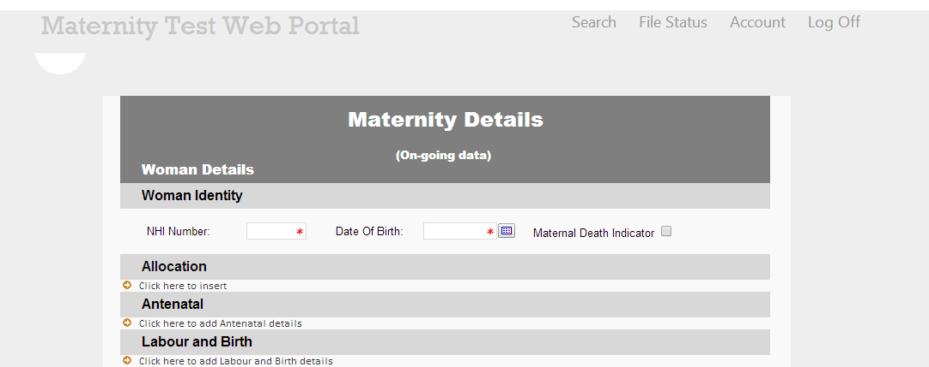

Create a new Maternity Retrospective Record
On clicking the ‘Create Retrospective Record’ the user will be taken to the data entry screen for the retrospective / historical record.
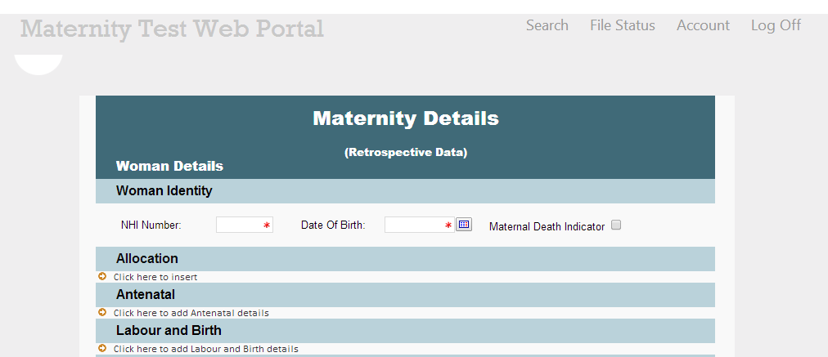

Note that newly created records will always conform to the latest version of data in use by the relevant DHB (as shown in the ‘Organisation’ drop down). Newly created records will be sent to the MOH ODS when you batch them up into a File to send to the ODS—see section 5.5.1.

Data Entry Form
Selecting to modifying an existing record or create a new record will take you to the Data Entry screen where you can update the details of the record as desired.
To assist with data entry, mandatory fields will show an asterix next to them. If data that is in an invalid format is entered into a field, the border will change to a dashed red line.

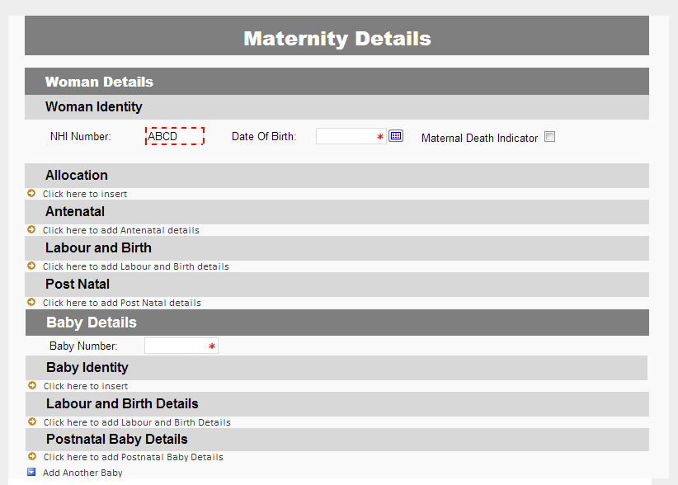
Invalid Data Format
Mandatory Data
Optional Segments

The Data Entry screen also lists any validation rules that failed for the current record.
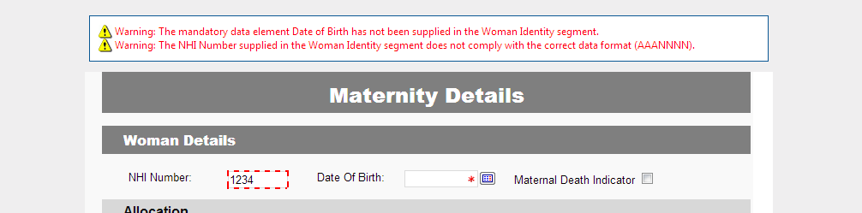
Note that entire segments of data can be added or removed if necessary. Section Error! Reference source not found. has more details on the role of segments.

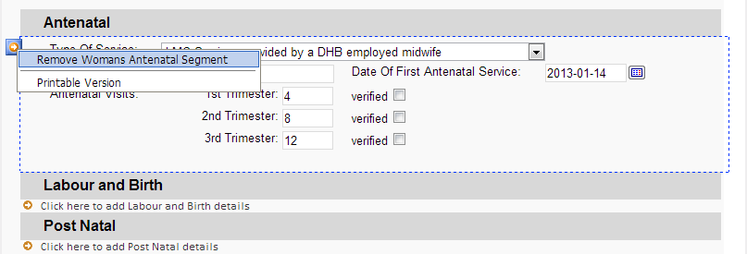
Click to add a new segment
Click to remove a segment. Note you first need to click within the segment for the ‘Remove’ icon to appear

Once you have updated a record, click ‘Save’ to create or update the record. Validation will be performed on the record again, and you will be notified of any failed rules. Note that if there were no validation errors, you will immediately be redirected back to the Search screen.

Submitting files to the MOH ODS via the Web Portal
Once all the records in a file are ‘Valid’ (have passed all the validation rules) and ‘Complete’ (contain all segments of data as described in section Error! Reference source not found.), either because the file originally submitted to the PMDCS contained only records that were valid and complete, or because some records were corrected via the web portal, the file will automatically be marked as ready to submit to the MOH ODS. At this point, the status of all records included in the file will be set to ‘Processed’.
Files will be sent to the ODS in sequential order, as determined by the Extract Date and Sequence Number rules. This means that any files with an earlier extract date, or the same extract date but an earlier sequence number, have to be corrected before a given file can be sent.
Files with any records whose status is ‘Invalid’ cannot be sent to the ODS; all the records will need to be updated so that they pass all the validation rules (and their status is updated to ‘Valid’). Files that contain ‘Incomplete’ records can be sent to the ODS if desired, but they won’t be sent automatically. To manually trigger the sending of a file:
- Select the relevant ‘File’ from the Search screen, and click ‘Search’.
- Click the ‘Submit Batch’ button that appears above the Search Results.
Note this button will only be able to be clicked if the file contains no ‘Invalid’ records.
You will receive a confirmation message telling you that the file will be submitted to the ODS shortly.
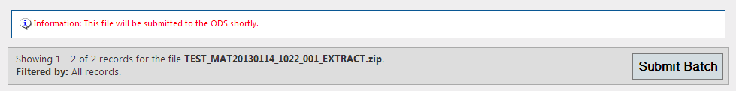

Submitting newly created, or returned records to the ODS
To batch new records into a file to send to the ODS, perform the following steps:
- Select ‘None’ from the ‘File’ drop down on the Search screen, and click ‘Search’.
- Click the ‘Submit Batch’ button that appears above the Search Results.
Note this button will only be able to be clicked if at least one record has been created, and none of the records shown are ‘Invalid’.
A new file will be created that contains the newly created records only. A confirmation message will let you know the name the file has been given (which will automatically conform to the extract date & sequence number ordering required by the ODS). This new file will become visible in the web portal after 10-15 minutes, once it has been processed by the PMDCS.
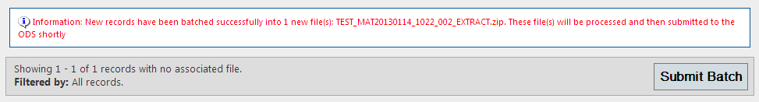
You may also want to resubmit records that were rejected by the ODS, and thus have had their status marked as ‘Returned’:
- Select a file that has been processed by the ODS, and includes at least one returned record, from ‘File’ drop down on the Search screen, and click ‘Search’.
- Click the ‘Submit Batch’ button that appears above the Search Results.
Note this button will only be able to be clicked if the file includes at least one ‘Returned’ record.
A new file will be created that contains each of the returned records. Again a confirmation message will let you know the name the file has been given.
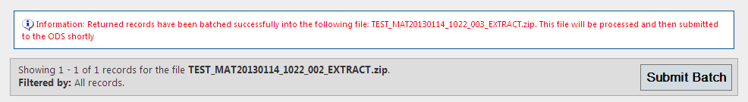
Note you should make sure you attempt to fix all of the errors relating to returned records, as specified in the Acknowledgement File provided by the ODS, before resubmitting those records.
Also note that once you create a new file with the returned records, the records will no longer show up under the original file.

File Status Screen
A new page to display the list of files submitted by a DHB is added to the system. The user can navigate to this page and select any organistaion from the list and click ‘View Files’ to get a list of files submitted by the selected organisation / DHB.

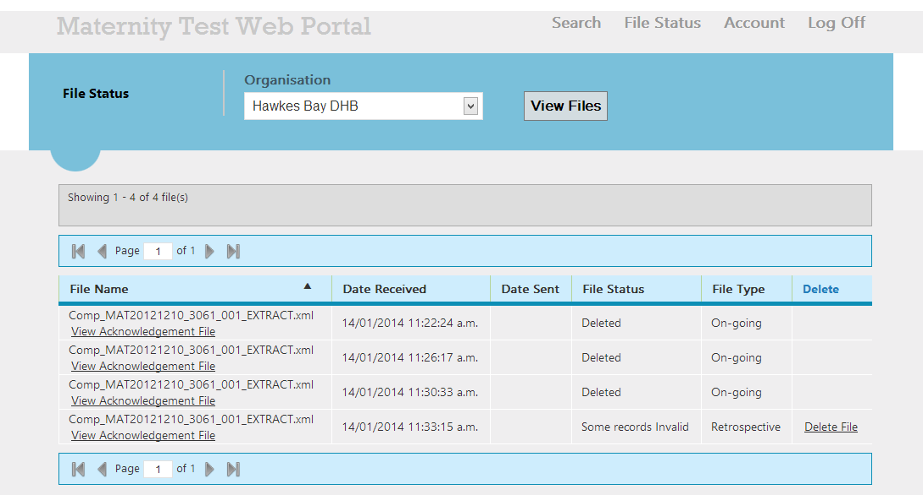

Following details are displayed in the grid
- File Name
  - If an acknowledgement file exists for the file, a link will appear just below the File name
- Date Received – Date on which the file was received by PMDCS
- Date Sent – If the file is sent to ODS, the sent date will be displayed in this column
- File Status – Status of the file.
- File Type – Version of the file (On-going or Retrospective)
- If the file is not sent to ODS, user will be provided with a ‘Delete File’ link.

View Acknowledgement file from File Status
If an acknowledgement file has been generated for the MAT file, a link will appear below the file name. On clicking the link, user will be navigated to the

Delete file from PMDCS
If the file is not already sent to ODS, a ‘Delete File’ link is provided to the user. User can delete the file by clicking the link.

Delete record from PMDCS
If a record created through the web-portal or submitted in a file has to be deleted (due to some mistake or wrong data etc.), user can do so so if the record/file is not sent to ODS. A ‘Delete’ link will appear against the record as part of the search results. On clicking the ‘Delete’ link, the record will be deleted and will not be sent to ODS.
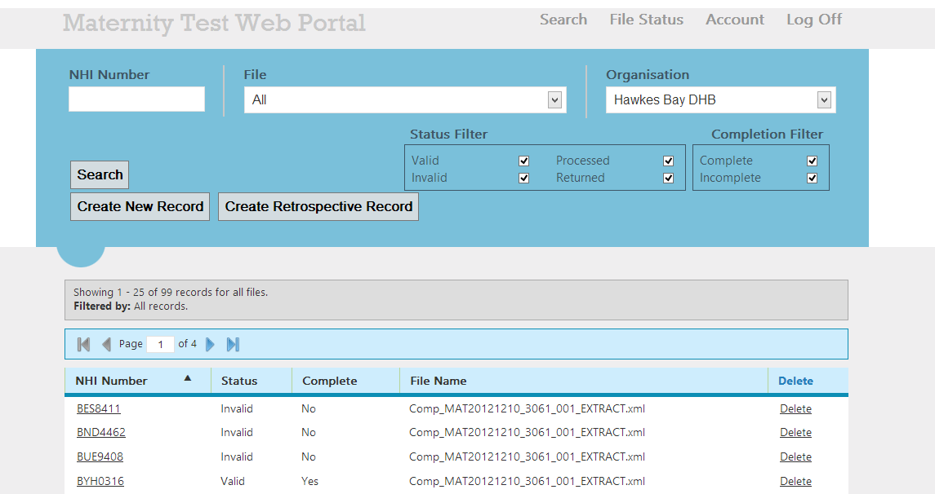

User can edit/update the record by clicking on the NHI number. User must delete the record only if it has to be removed completely. The deleted record(s) will not be displayed in the search results.

Create Delete Request to be sent to ODS
If a record is processed and has already been sent to ODS, user can delete the record from ODS by submitting a ‘Delete Request’ through the PMDCS web portal. Once the user submits a ‘Delete request’ for a record, the request will be displayed in the search results with a red background. The NHI number of the ‘Delete request’ record will not be a hyperlink.
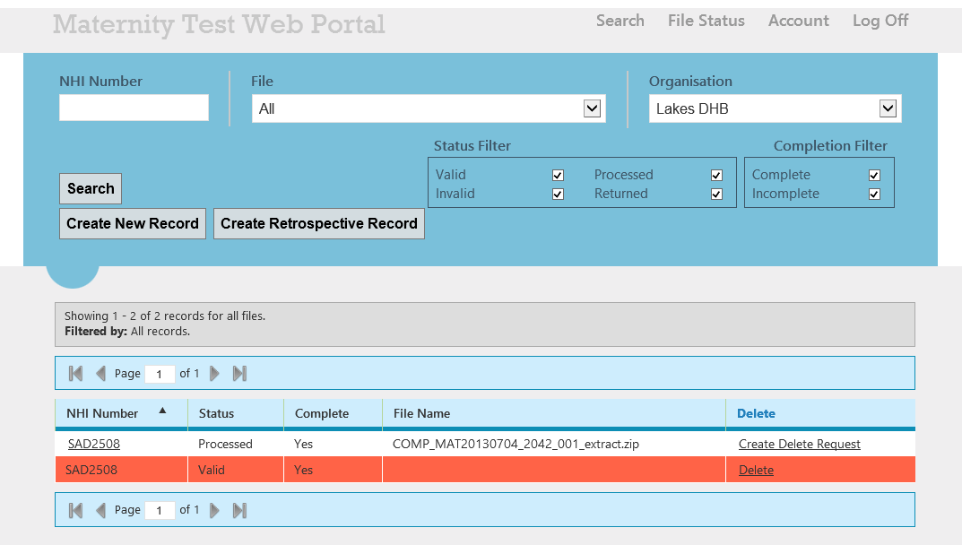

The ‘Delete request’ record has to be submitted to ODS similar to how a normal MAT record is submitted to ODS.
(Once the delete request is placed, set the File dropdownlist as ‘None’ and on doing a search, the records that are not yet submitted to ODS will be displayed. The new ‘Delete request’ record will be displayed with a red background in the search result)
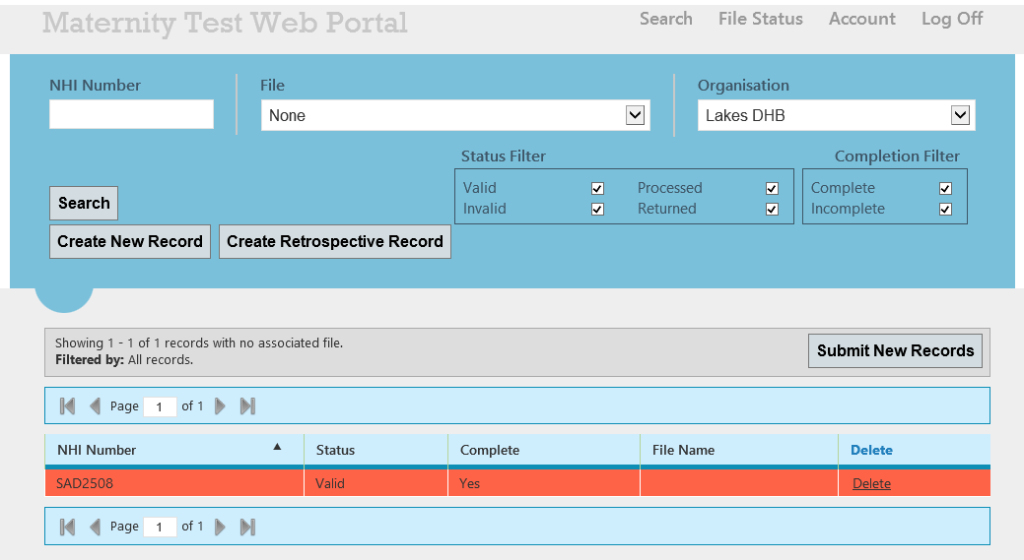
If the user wants to delete a ‘Delete request’, the delete link will appear against the record if the record is not sent to ODS. User can delete the record by clicking on the ‘Delete’ link.

Emails notification and acknowledgements
The PMDCS and ODS system is supported by a full complement of email notifications to keep you informed and help you manage the end to end Maternity file submission workflow. When data is submitted to MOH ODS through PMDCS, acknowledgement files and emails are generated to provide you with the status of any given record or file. This status will be delivered in the form of an XML acknowledgement file/s placed in the MOH Secure FTP site and an email directed to the submitting DHB (user).
Please note: Access to the MOH SFTP site and the receipt of system generated emails is only accessible by following the steps outlined in Section 1.3 Getting Started

PMDCS web portal & MOH ODS email notifications
You will receive email notifications when:
- The PMDCS system has processed an input file and an acknowledgment file is ready, an email is only sent if this file is invalid (contains errors).
- The PMDCS system has processed a file that was created from entering new records using the web portal that has been submitted and an acknowledgment file is ready.
- The ODS system has processed a file submitted to it by PMDCS and an acknowledgement file is ready.
These messages will be sent to a mail address given to Simpl (1,2) & the MOH (1,3).

PMDCS web portal & MOH ODS Acknowledgement
File acknowledgements will be loaded in MOH SFTP inbox and outbox for DHB access when:
- PMDCS acknowledges that an input file has been received in the MOH SFTP drop off folder.
- PMDCS processes the files received in the MOH SFTP input folder, an xml acknowledgement will be generated containing each of the line by line records processed and a record status of approved or rejected
- ODS will generate an acknowledgement file when ever a file is received from PMDCS, this is to advise the DHB that a file has been processed by the ODS system and whether there are invalid records that were rejected.
- ODS will generate an acknowledge meant file in the event a Delete Request is unsuccessful.

Overview of Data
This section gives you an overview of the data. If you are presenting you data in a XML file then this document gives an overview of the conditions. It is also useful for those collecting and entering data into the PMDCS portal;
Key points to note:
- The extracted data must be validated against the XML Schema provided by the Ministry.
- Data for multiple pregnancies can be submitted on one file (in separate records)
- A file should contain no more than a maximum of one thousand pregnancy records.
- Files not compliant with the XML schema will be rejected and the DHB notified accordingly. Repairs can me made using the PMDC web portal
- A DHB shall submit one record and only one record for each pregnancy. (That is all modules for a person’s maternity service provided by a DHB must be submitted in one record. Note If the postnatal service/module has a different Woman identity (eg adoption) then this will be submitted in a new record (with a unique GUID)
- Each pregnancy (ie service for a woman) must be given a unique identifier by the DHB. This unique identifier must be a globally unique identifier (GUID)
- Only valid pregnancy data is accepted into the Maternity operational data store database. Invalid data will result in the whole record being rejected with acknowledgement back to DHB of all errors associated with the record.
- If a segment is started, then all mandatory data in that section must be fully completed, and all business rules relating to that segment must be satisfied.
- There are three “Modules of care” Antenatal, Labour and Birth and Postnatal
- DHBs should submit data relating only to the modules for which they provided care. Modules of care generally relate the segments as follows:

Modules of care | Segments
Antenatal | Woman’s Identity
 | Allocation
 | Antenatal
Labour and Birth | Woman’s Identity
 | Labour and Birth
 | Baby Details
 | Baby Identity
 | Labour and Baby Birth Details
Postnatal | Woman’s Identity
 | Postnatal
 | Baby Details
 | Baby Identity
 | Postnatal Baby Details

However there are circumstances where all segments within a module of care are not required. The following are examples of how some situation might apply. Please refer to the File Specification document for full details.

Example of where a DHB provided all care with one woman . The record must have the following segments:
- DHB Details
- Request
- Woman’s Identity
- Allocation
- Antenatal
- Labour and Birth
- Postnatal
- Baby Details
- Baby Identity
- Labour and Baby Birth Details
- Postnatal Baby Details

Example of where a DHB provided antenatal care only. The record must have the following segments:
- DHB Details
- Request
- Woman’s Identity
- Allocation
- Antenatal

Example of where a DHB provided antenatal and labour and birth care for a live birth. The record must have the following segments:
- DHB Details
- Request
- Woman’s Identity
- Allocation
- Antenatal
- Labour and Birth
- Baby Details
- Baby Identity
- Labour and baby Birth Details

Example of where a DHB provided antenatal and labour and birth care for a still born. (Baby Identity is optional)The record must have the following segments:
- DHB Details
- Request
- Woman’s Identity
- Allocation
- Antenatal
- Labour and Birth
- Baby Details
- Labour and baby Birth Details

Example of where a DHB provided postnatal care only. The record must have the following segments:
DHB Details
Request
Woman’s Identity
Postnatal
Baby Details
Baby Identity
Postnatal baby Details
Example of adoption after Labour and Birth ie for postnatal module with a new woman identity This will be a new record with a new Woman’s identity
DHB Details
Request
Woman’s Identity (new NHI)
Postnatal
Baby Details
Baby Identity
Postnatal baby Details

Remember – if any segment has one field filled in then ALL mandatory fields must be completed.

So, as an example – if a DHB does not provide postnatal service then don’t fill in any postnatal details.

List of Data Elements

Segment | Data Element | Type | Format | Ongoing | Retro*
 |  |  |  | M/O/C | M/O/C
Woman Identity (7.4) | NHI Number | ID | AAANNNN | M | M
Woman Identity (7.4) | Date of Birth | Date | YYYY-MM-DD | M | M
Woman Identity (7.4) | Maternal Death Indicator | Boolean | ‘true’ or ‘false’ | M | M
Allocation (7.5) | Ethnicity 1 | Code | NNNNN | M | O
Allocation (7.5) | Ethnicity 2 | Code | NNNNN | O | O
Allocation (7.5) | Ethnicity 3 | Code | NNNNN | O | O
Allocation (7.5) | Height in | Positive Integer | NNN | O | O
Allocation (7.5) | Weight in Kgs | Decimal | NNN.N | O | O
Allocation (7.5) | Smoking Status at Allocation | Boolean | ‘true’ or ‘false’ | O | O
Allocation (7.5) | Smoking Quantity at Allocation | Code | A | O | O
Allocation (7.5) | Gravida | Integer | NN | O | O
Allocation (7.5) | Parity | Integer | NN | O | O
Allocation (7.5) | LMP | Date | YYYY-MM-DD | O | O
Allocation (7.5) | EDD | Date | YYYY-MM-DD | M | O
Antenatal (7.6) | Type of Service | Code | N | M | M
Antenatal (7.6) | Date of First Antenatal Service | Date | YYYY-MM-DD | M | M
Antenatal (7.6) | DHB Practitioner | ID | X(10) | C | O
Antenatal (7.6) | Antenatal Visits 1st Trimester | Integer | NN | M | O
Antenatal (7.6) | Antenatal Visits 2nd Trimester | Integer | NN | M | O
Antenatal (7.6) | Antenatal Visits 3rd Trimester | Integer | NN | M | O
Labour and Birth (7.7) | Type of Service | Code | N | M | M
Labour and Birth (7.7) | Delivery Date | Date | YYYY-MM-DD | M | M
Labour and Birth (7.7) | Home Birth Indicator | Boolean | ‘true’ or ‘false’ | M | M
Labour and Birth (7.7) | VBAC Indicator | Boolean | ‘true’ or ‘false’ | O | O
Postnatal (7.8) | Type of Service | Code | N | M | M
Postnatal (7.8) | Date of Last Postnatal Service | Date | YYYY-MM-DD | M | M
Postnatal (7.8) | Smoking Status at 2 Weeks | Boolean | ‘true’ or ‘false’ | O | O
Postnatal (7.8) | Smoking Quantity at 2 Weeks | Code | A | O | O
Postnatal (7.8) | Postnatal Inpatient Visits | Integer | NN | M | O
Postnatal (7.8) | Postnatal Home Visits | Integer | NN | M | O
Postnatal (7.8) | DHB Practitioner | ID | X(10) | C | O
Postnatal (7.8) | GP Referral | Code | A | O | O
Postnatal (7.8) | Wellchild Referral | Code | A | O | O
Baby Details Attributes (7.9) | Baby Number | Positive Integer | 99 | M | M
Baby Identity (7.10) | NHI Number | ID | AAANNNN | C | C
Baby Identity (7.10) | Date of Birth | Date | YYYY-MM-DD | C | C
Baby Identity (7.10) | Sex | Code | A | C | C
Labour & Birth Baby Details (7.11) | Ethnicity | Code | NNNNN | O | O
Labour & Birth Baby Details (7.11) | Birth Condition | Code | XX | M | M
Labour & Birth Baby Details (7.11) | Apgar Score at 5 Mins | Non-negative Integer | NN | C | O
Labour & Birth Baby Details (7.11) | Birth Weight | Positive Integer | NNNN | C | O
Labour & Birth Baby Details (7.11) | Gestational Age | Positive Integer | NN | C | O
Postnatal Baby Details (7.12) | Breast Feeding Status at 2 weeks | Code | X(10) | C | O
Postnatal Baby Details (7.12) | Breast Feeding Status at Discharge | Code | X(10) | C | O
Postnatal Baby Details (7.12) | Date of Neonatal Death | Date | YYYY-MMDD | O | O
* Red cells note change from ongoing data
Note that several fields also include a “verified” flag that indicates that the value has been verified as correct. This should be ticked when a recorded value is outside of the expected range (for example, if a woman’s height is over 215cm), if the value is known to be correct.
For more information on the data elements, and the surrounding rules, see the ‘MAT File Specification document’.
Also note that all Create_Requests must come before any Replace_Requests, and all Replace_Requests must come before any Delete_Requests.

Frequently asked questions
Data Entry FAQ
I am attempting to Create/Modify a record, but am receiving a validation error due to one of the segments being required.
Some segments are required under certain conditions. For example, if either the Allocation or Antenatal sections are supplied, then both sections must be supplied.

I have created some records via the web portal, but the ‘Submit New Records’ button isn’t showing or is disabled. How do I submit the records?
Make sure you have ‘None’ selected in the File drop down list, then click search and the ‘Submit Batch’ button will appear. To ensure the button is enabled, make sure that all of the records associated with ‘No Files’ are Valid (that is, none are ‘Invalid’).

I am getting errors regarding the format of the DHB Practitioner/Midwifery council numbers in PMDCS. What exactly is the required format?
The DHB Practitioner number must be the following:
- An optional 2 digit prefix with a dash followed by up to 5 digits.

Here are some examples of valid/invalid DHB Practitioner numbers:
- Valid: 12-12345
- Valid: 12-1234
- Valid: 12345
- Valid: 1234
- Invalid: 123456
- Invalid: 12-123456
- Invalid: 1-12345

After submitting a file to ODS, I receive several errors stating that the DHB Practitioner number does not exist in the HPI database, even though I have used the Midwifery Council Registartion Number.
Ensure that all Midwifery registration numbers are prefixed with ‘15-‘.

Other FAQ
I submitted a file to the SFTP Site for Compliance testing, and it was rejected because the file name does not conform to the required format.
Make sure that you have used the correct prefix, which is now ‘COMP’ (for Compliance), and not ‘TEST’.

I submitted a file via the SFTP Site. Why is it not showing in the Web Portal?
It may take 10-15 minutes for a file to be processed by the PMDCS system before being displayed in the web portal. Additionally, if a file is rejected it will not show in the Web Portal. Check the relevant ACK IN folder on the SFTP site to see if an acknowledgement file has been produced. If so, this will give details as to why the file has been rejected.

How do I refresh the list of files in the Web Portal after submitting a new file?
Simply refresh the page (F5).

All the records in a file are shown as ‘Processed’ and have been for some time. Why has the file not yet been sent to the MOH ODS?
Files can only be sent to the MOH ODS in sequential order. If there is another file with an older extract date or the same extract date but a lower sequence number, then that file must be repaired & submitted to the MOH ODS before the latter file can be sent.

When inputting the number of Postnatal Inpatient Visits: Do you count for each day or each time you visit the patient’s room eg. 3 dates but 9 individual contacts with the patient?
Section DA29, and on page 1070 of the Section 88 document “the Notice” in patient postnatal care is defined as “daily”
When are we able to submit live data?
Each DHB is required to submit a file in the Compliance (COMP) environment that will need to be processed without any errors in PMDCS. This file can either be submitted via the SFTP site, or can consist of new records created within the PMDCS web portal. This file then needs to be submitted to the MOH ODS Batch Process compliance system. If the ODS accepts the file with no errors this means the DHB’s file is compliant and the DHB can be signed off by the Ministry as being compliant.

You are then able to submit files to, and enter data in PMDCS Production.

Service Request Template
Below is the list of information that the Simpl Administrator will ask when you call the help desk number for assistance:

PMDCS Service Request Template
PMDCS Support
Commencing 25th February 2013
Phone: | 0800 002 480
Email: | pmdcs.support@simpl.co.nz
Website: | www.simplgroup.com
Simpl will require the following details when a support call is logged with the Service Desk:

DHB  (circle one)  List Description overleaf _  Page 2) | CAK | BOP | CTY | CAP | SAK | HWB | HUT | LKS | MWU | NLM | NLD | OTA | SCY | STH | SLD | TRW | TKI | WKO | WRP | WTM | WCO | WNI

Date | ___/___/___ | Time Call Taken : |  | Time Issue Given to 1st Level Support | ____h____ | Date Resolved | ___/___/___
User Name & Surname
User Contact Number
Name of the relevant File (if applicable)
Description of the Issue
Time Passed onto Development
Resolved? Yes/No (please circle)
If Yes, provide info on Issue*/and Resolution**
If No, state why below***
Issue*

Resolution**
Reason Not Resolved***

Simpl Support Process
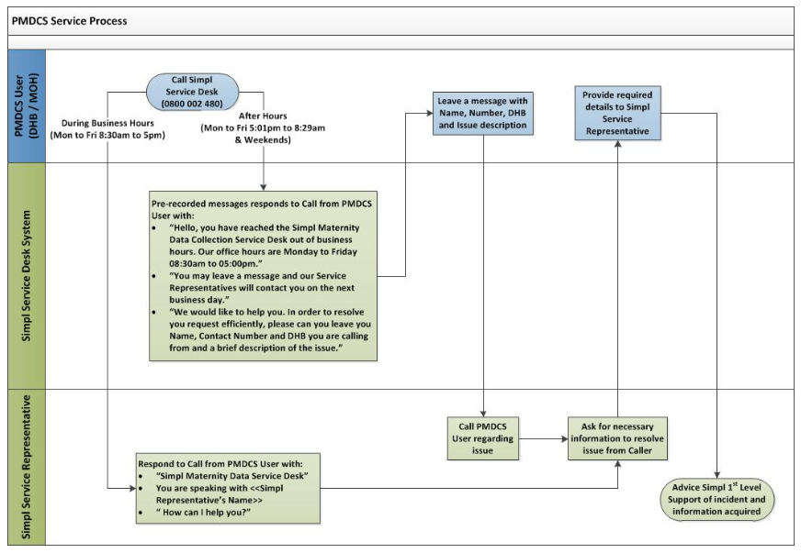

Definitions and Glossary

Abbreviation/Term
DHB | District Health Board
EDD | Estimated Date of Delivery  The latest Estimated Date of Delivery for the woman that has been recorded during the antenatal period.
Gravida | The number of pregnancies for the woman, including the current one.
GUID | Globally Unique Identifier (or 'Universally Unique Identifier'). A GUID is a 128-bit integer number commonly used as an identifier in software for things such as database keys. The value of a GUID is represented as a 32-character hexadecimal string, such as {21EC2020-3AEA-1069-A2DD-08002B30309D} and is unique for each maternity event (?)
Historic data | See Retrospective data
aHPI | Health Practitioner Index  The Health Practitioner Index is a database of health practitioners, facilities and organisations that either fund or deliver health and/or disability services.
Incomplete record | A maternity record contains multiple segments, mandatory and optional fields. Incomplete is defined as segments or optional fields remaining empty after file submission. An incomplete record can still be processed as long as it adheres to the PMDCS business rules and files specifications.
LMC | Lead Maternity Carer
LMP | Last Menstrual Period
Module or  Module of care | A maternity event is divided into modules of care. i.e.  - Antenatal  - Labour and Birth  - Postnatal
NHI | National Health Index
NHI Number | The primary unique lifetime identifier for all New Zealand that takes precedence over all other identifiers for consumers of health care services
MOH | Ministry of Health
ODS | Operational Data Control System – this is the system where all Maternity Data is eventually submitted to. The data will be processed and, if of high enough quality, stored in the Maternity database by the MOH.
Parity | The number of times a woman has borne children counting multiple births as one and including stillbirths.
Record | A record constitutes a DHB’s data for a maternity event.. A record may contain all the data for the maternity if the DHB provided all the care and services related to the maternity. If more than one DHB provided care and/or services there would be more than one record for the maternity each containing the modules for which the relevant DHB provided care and/or services.
Retrospective data | Also known as historic data. Is the capture of primary maternity data (records) from each DHB for services provided between 01/07/2007 and 30/06/2012,
SFTP | SSH File Transfer Protocol.  A network protocol that provides file access, file transfer, and file management functionality over any reliable data stream.  For this maternity project this is the process for managing files: accepting files from DHBs, moving these files to the PMDCS then to the ODS and managing error files etc
Valid record | Maternity Records processed and stored at the Ministry of Health’s ODS DataMart must adhere to the business rules and file specifications outlined in this document 8.1. Any records that do not meet this criteria will be rejected by PMDCS as an invalid record.
Invalid record | Maternity Records that do not comply with the set file specification and Business rules for the Maternity ODS will be rejected.
VBAC | Vaginal birth after previous birth by caesarean section and no previous vaginal birth
Verified | The Verified attribute of data elements in the Extract File is a boolean indicator that the DHB may use to confirm that the value for the element being submitted is legitimately outside the permissible range.

There are rare circumstances where the baby segments are not provided eg still birth
As for footnote 1
Refer footnote 1

