DHB Primary Maternity Service Data Collection System MAT ODS

File Specification

Document Version | 4.3
Date | 07 July 2025
Owner | National Collections
Status | Final

Citation: Ministry of Health. 2016. DHB Primary Maternity Service Data Collection System MAT ODS File Specification
Published in 2016 by the
Ministry of Health
PO Box 5013, Wellington, New Zealand

This document is available on the Health New Zeland website:
mat-file-specification-v4.3-July2025.docx


Table of Contents
1. Front Matter 6
1.1. Reproduction of material 6
1.2. Disclaimer 6
1.3. Publications 6
2. Introduction 7
2.1. Purpose of this document 7
2.2. Intended audience 7
2.3. Related documents 7
2.4. National Health Information Principles 7
2.5. Compliance with standards 8
2.6. Date standards 8
2.7. Connection to national systems 8
2.8. Authority for collection of health information 8
2.9. Contact 8
3. Overview of National Maternity Collection 9
4. File Processing 11
4.1. Input File Types 11
4.1.1 Extract File 11
4.1.2 Reversal Request File 11
4.2. Output File Types 12
4.2.1 Extract Acknowledgement File 12
4.2.2 Extract Report File 12
4.2.3 Reversal Request Acknowledgement File 12
4.3. Extract File Processing Overview 13
4.4. Extract File Processing Steps 13
4.5. Reversal Request File processing steps 14
5. MAT File Structure & Data Relationships 16
5.1. MAT Extract File XML Message Structure/ Format 16
5.1.1 DHB_Primary_Maternity_Data_Collection (Root Entity) 17
5.1.2 DHB_Details 17
5.1.3 Create_Request 18
5.1.4 Replace_Request 18
5.1.5 Pregnancy_Details 19
5.1.6 Woman-Details 19
5.1.7 Baby_Details 20
5.1.8 Woman-Identity 20
5.1.9 Allocation 21
5.1.10 Antenatal 22
5.1.11 Labour_And_Birth 23
5.1.12 Postnatal 24
5.1.13 Baby_Identity 25
5.1.14 Labour_And_Birth_Baby_Details 25
5.1.15 Postnatal_Baby_Details 26
5.2. MAT Acknowledgment File XML Message Structure/ Format 27
5.2.1 DHB_Primary_Maternity_Data_Collection_Acknowledgement (Root Entity) 27
5.2.2 Error 28
5.2.3 Rejected_Create_Request 29
5.2.4 Rejected_Replace_Request 30
5.2.5 Rejected_Delete_Request 30
5.2.6 Rejected Segments 31
5.2.7 Explanation of the Error Segment 31
5.3. MAT Reversal Request XML Message Structure/ Format 33
5.3.1 DHB_Primary_Maternity_Data_Collection_Reversal (Root Entity) 33
5.4. MAT Reversal Acknowledgement File XML Message Structure/ Format 33
5.4.1 DHB_Primary_Maternity_Data_Collection_Reversal_Acknowledgement (Root Entity) 34
6. Initial Input File Validation 35
6.1. Input file name format and file attributes 35
6.1.1 Input file name code set attributes 36
6.1.2 Antenatal 36
6.1.3 Input file initial validation rules 36
6.1.4 Input file initial validation error messages 37
7. MAT Segment Formats, Code Sets and Validation Rules 39
7.1. Extract file root segment 39
7.1.1 Extract file root segment data attributes 39
7.1.2 Extract file root segment rules 39
7.1.3 Extract file root segment error messages 39
7.2. DHB Details Segment 40
7.2.1 DHB Details segment data elements 40
7.2.2 DHB Details segment code set elements 40
7.2.3 DHB Details segment rules 40
7.2.4 DHB Details segment error messages 41
7.3. Request segment 42
7.3.1 Request segment data attributes 42
7.3.2 Request segment rules 42
7.3.3 Request Type segment error messages 42
7.4. Woman Identity segment 43
7.4.1 Woman Identity segment data elements 43
7.4.2 Woman Identity segment rules 43
7.4.3 Woman Identity segment error messages 44
7.5. Allocation segment 45
7.5.1 Allocation data elements 45
7.5.2 Allocation segment code sets 45
7.5.3 Allocation segment rules 46
7.5.4 Allocation segment error messages 47
7.6. Antenatal segment 48
7.6.1 Antenatal data elements 48
7.6.2 Antenatal segment code sets 48
7.6.3 Antenatal segment rules 49
7.6.4 Antenatal segment error messages 50
7.7. Labour and Birth segment 51
7.7.1 Labour and Birth data elements 51
7.7.2 Labour and Birth segment code sets 51
7.7.3 Labour and Birth segment rules 51
7.7.4 Labour and Birth segment error messages 52
7.8. Postnatal segment 53
7.8.1 Postnatal data elements 53
7.8.2 Postnatal segment code sets 53
7.8.3 Postnatal segment rules 53
7.8.4 Postnatal segment error messages 56
7.9. Baby Details segment 57
7.9.1 Baby Details segment data elements 57
7.9.2 Baby Details segment rules 57
7.9.3 Baby Details segment error messages 57
7.10. Baby Identity segment 58
7.10.1 Baby Identity segment data elements 58
7.10.2 Baby Identity segment code set elements 58
7.10.3 Baby Identity segment rules 58
7.10.4 Baby Identity segment error messages 59
7.11. Labour and Birth Baby Details segment 60
7.11.1 Labour and Birth Baby Details data elements 60
7.11.2 Labour and Birth Baby Details segment code sets 60
7.11.3 Labour and Birth Baby Details segment rules 61
7.11.4 Labour and Birth Baby Details segment error messages 62
7.12. Postnatal Baby Details segment 62
7.12.1 Postnatal Baby Details data elements 62
7.12.2 Postnatal Baby Details segment code sets 63
7.12.3 Postnatal Baby Details segment rules 63
7.12.4 Postnatal Baby Details segment error messages 64
7.13. Reverse file root segment 65
7.13.1 Reverse file root segment rules 65
7.13.2 Reverse file root segment error messages 65
7.14. Reversal segment 65
7.14.1 Reversal data elements 65
7.14.2 Reversal segment rules 65
7.14.3 Reversal segment error messages 66
8. MAT Extract File Record Types 67
8.1. Extract file record request processing rules 68
8.2. Extract file record request processing error messages 69
9. MAT Extract File Reversal 71
9.1. Reverse file initial processing rules 71
9.2. DHB Details 71
9.3. Extract file reversal request processing rules 71
9.4. Extract file reversal request processing error messages 71
10. Data model 72
Appendix A: Definitions, Glossary and References 73
Appendix B: NHI Number Validation 75
Appendix C: Ethnicity Data Protocols 77
Appendix D: Extract File Structure Summary 81
Appendix E: System Errors 85
Appendix F: Related Documents/Files 85
Appendix G: Examples 86
G.1 File rejected because of XSD schema errors 86
G1.1 Extract file 86
G1.2 Response file 88
G1.3 Report 92
DHB Primary Maternity Service Data Collection File Submission Report 92
G.2 File with valid data 94
G2.1 Extract file 94
G2.2 Response file 100
G2.3 Report 102
DHB Primary Maternity Service Data Collection File Submission Report 102
Appendix H: Reverse File Example 103
Appendix I: File Specification Version History 104

Front Matter

Reproduction of material
The Health New Zealand (HNZ) permits the reproduction of material from this publication without prior notification, providing all the following conditions are met: the information must not be used for commercial gain, must not be distorted or changed, and HNZ must be acknowledged as the source.

Disclaimer
HNZ gives no indemnity as to the correctness of the information or data supplied. HNZ shall not be liable for any loss or damage arising directly or indirectly from the supply of this publication.
All care has been taken in the preparation of this publication. The data presented was deemed to be accurate at the time of publication, but may be subject to change. It is advisable to check for updates to this publication on the HNZ’s web site at Health New Zealand – Health New Zealand | Te Whatu Ora

Publications
A complete list of Ministry of Health’s publications is available from Ministry of Health, PO Box 5013, Wellington, or on the Ministry’s web site at Publications – Health New Zealand | Te Whatu Ora
Any enquiries about or comments on this publication should be directed to:

Data Services.
Health New Zealand
PO Box 5013
Wellington
Phone: (04) 496 2000
Email: Data.Services@TeWhatuOra.govt.nz

Published by Ministry of Health
© 2014, Ministry of Health

Introduction

Purpose of this document
This File Specification defines the file format used to send information to the National collections for inclusion in the DHB Primary Maternity Service Data Collection (MAT). The document includes the following information:
- XML Messaging Specification
- Data Formats
- Data Code Ranges
- Global Business Rules
- Validation Rules
- Logical Data Model

Intended audience
The intended audience for this document is:
- HNZ and District business and data quality analysts involved in supporting and maintaining the DHB Primary Maternity Service Data Collection System and the National Maternity Collection.
- District staff or their representatives responsible for submitting DHB primary maternity service care data to HNZ.
- PMS Vendors and Middleware Software Solutions Suppliers to Districts who are responsible for developing or delivering the technical capability to enable Districts or their representatives to submit DHB primary maternity service care data to National Collections for loading into the DHB Primary Maternity Service Data Collection System.

Related documents
This document should be read in conjunction with the National Maternity Collection Data Dictionary.

National Health Information Principles
The guiding principles for national health information are the need to:
- Protect patient confidentiality and privacy
- Collect data once, as close to the source as possible, and use it as many times as required to meet different information requirements, in keeping with the purpose for which it was collected
- Validate data at source
- Maintain standard data definitions, classifications and coding systems
- Store national health data that includes only that data which is used, valued and validated at the local level
- Provide connectivity between health information systems to promote communication and integrity

Compliance with standards
All health and disability service providers, agencies and organisations, as defined in the Health Information Privacy Code 1994, accessing or providing national data are required to adhere to and comply with national information standards, definitions and guidelines. Maintaining the integrity and security of the databases and the transmission or exchange of data between health and disability service organisations is essential. This is a shared obligation of all health and disability service agencies.
National data definitions, terms (such as 'ethnicity'), and health information standards are developed and reviewed in consultation with health sector representatives..

Date standards
In order to comply with BSI DISC PD2000-1 1998, which the HNZ has adopted as the required metric for Y2K compliance, all dates submitted in these files must conform in format to ISO 8601 (YYYY-MM-DD). Dates will normally be required to be provided to day level. Any exception to this will be noted where appropriate. All abbreviated dates must also comply with ISO 8601.

Connection to national systems
Health and disability service providers are required to use the national systems, standards and protocols where reasonable. For this reason, providers are encouraged to connect directly to the national systems.
Direct access provides:
- secure communication protocols that meet the privacy requirements
- improved timeliness of data reporting for monitoring purposes
- reduced costs for processing and transmitting data supplied to the national systems.

Authority for collection of health information
HNZ may collect health information where this is necessary to carry out lawful purposes connected with its functions and activities. These purposes, functions and activities may be set out in legislation, such as the Health Act 1956, or may be derived from lawful instructions from the Minister. The collection, storage and use of health information is also governed by the Privacy Act 1993 and the Health Information Privacy Code 1994.

Contact
If you have any queries regarding this file layout or the DHB Primary Maternity Service Data load process, please e-mail compliance@moh.govt.nz.

Overview of National Maternity Collection

Purpose | The National Maternity Collection (MAT) provides statistical, demographic and clinical information about selected publicly-funded maternity services up to nine months before and three months after a birth. MAT is used for strategy and policy development, supporting clinical intervention, maternity service evaluation and quality assurance, to assist clinical governance and for research.
Content | MAT integrates health information from three sources. MAT contains data on primary maternity services provided under Section 88 of the New Zealand Public Health and Disability Act 2000. This information is sourced from Lead Maternity Carer (LMC) claims for payment and from DHBs providing primary maternity services. MAT also contains inpatient and day-patient health event data during pregnancy, birth and the postnatal period for mother and baby, sourced from the National Minimum Dataset (NMDS).
Start date
Collection methods | Information on primary maternity services provided by Lead Maternity Carers, GPs and specialists is reported to HNZ on standard forms by the providers. This data is entered into HNZ maternity claims system. The data can also be submitted online via Online Maternity Claiming (OMC).  DHBs report information on last resort primary maternity services provided by DHB midwives. This data is submitted electronically to HNZ in an agreed electronic file format.  Publicly-funded hospital event information is provided to HNZ in an agreed electronic file format for public and larger private hospitals. Paper forms and a cut-down electronic file format are forwarded by smaller private facilities and primary birthing units and are manually processed by the Private Hospitals team at HNZ..
Frequency of updates | The MAT Collection receives weekly extracts from the NMDS, NHI, HNZ maternity claims system and the DHB Primary Maternity Services data Collection System.
Security of data | The MAT Collection is only accessed by authorised staff for maintenance, data quality, audit and analytical purposes.  Requests for information can be made to the Data Services team using the contact information above.
Privacy issues | When a woman registers with a Lead Maternity Carer she signs a waiver that allows health data to be used for research under the Health Information Privacy Code 1994.  Data Services is required to ensure that the release of information meets the conditions of any legislation related to the privacy of health information, in particular the Official Information Act 1982, the Privacy Act 1993, the Health Information Privacy Code 1994 and the Adult Adoption Information Act 1985.  Information available to the general public is of a statistical and non-identifiable nature. Access to identifiable information is restricted. Adoption legislation places more rigorous restrictions on release of this information than standard health information privacy legislation. Each case for identifiable data release will be considered separately. In addition, researchers requiring identifiable data will usually need approval from an approved Ethics Committee.
National reports and publications | The MAT Collection is the primary source of data for the Annual Report on Maternity produced by HNZ. This is available in hard copy and on HNZ web site www.health.govt.nz. In addition Ministry of Health publishes selected provisional maternity data to facilitate planning and service reviews in a timely manner.
Data provision | Customised datasets or summary reports are available on request, either electronically or on paper. Staff from Data Services team can help to define the specifications for a request and are familiar with the strengths and weaknesses of the data. As some data elements have been added or deleted, consistent time-series data may not be able to be provided.  Data Services team also offers a peer review service to ensure that the Mat data is reported appropriately when published by other organisations.  There may be charges associated with data extracts.

File Processing

Input File Types

Extract File
An Extract File contains primary care pregnancy data that is being submitted to National Collections by a District or an organisation submitting data on behalf of a District. (Either are referred to as Submitters – see Definitions, Glossary and References in Appendix A)

Submitters should note the following when submitting data on the extract file:
- Primary Maternity data is to be provided as an XML file. The extracted data must be validated against the XML Schema provided by National Collections. The XML Schema is available at <provide link>
- An extract file must only contain data for one DHB of Service.
- Data for multiple pregnancies can be submitted on one file.
- A complete record of services for an entire pregnancy must be provided.
- Each pregnancy must be given a unique identifier by the Submitter. This unique identifier must be a globally unique identifier (GUID)
- DHBs should submit data relating only to the modules for which they provided care.
- Valid pregnancy data is accepted into the MAT ODS database. Invalid data is rejected. Refer to Chapters 6 and 7 of this document for the validation rules.
- A file should contain a maximum of one thousand pregnancy records.

The file name for a MAT Extract file should use the following structure:

AAAA_MATYYYYMMDD_XXXX_nnn_EXTRACT.xml

Where:
  - AAAA denotes the target system, e.g. PROD for production.
  - YYYYMMDD is the extract date
  - XXXX is the Submitter code (refer to 6.1.2 for code set)
  - nnn denotes a sequential number to allow for multiple extracts to occur on the same day. For the first extract of the day this should be 001, for the second 002 providing that 001 was accepted, and so on.

Refer to Section 5.1 for the definition of the xml message structure.

Reversal Request File
If an extract file has been mistakenly loaded into the MAT ODS, the Submitter can request National Collections to reverse the file.
The file name for a Reversal Request file will use the following structure:
AAAA_MATYYYYMMDD_XXXX_nnn_REVERSE.xml

Refer to Section 5.3 for the definition of the xml message structure.

Output File Types

Extract Acknowledgement File
An XML Acknowledgement file will be created for each received Extract file.

The File name for an Acknowledgement file will use the following structure:
AAAA_MATYYYYMMDD_XXXX_nnn_RESPONSE.xml

Refer to Section 5.2 for the definition of the xml message structure.

Extract Report File
An Extract Report file will be created for each received Extract file.

The File name for an Extract Report file will use the following structure:
AAAA_MATREPYYYYMMDD_XXXX_nnn_REPORT.htm

Reversal Request Acknowledgement File
An XML Reversal Request Acknowledgement file will be created for each received Reversal Request file.

The Reversal Request Acknowledgement file has a file name structure of
AAAA_MATYYYYMMDD_XXXX_nnn_REVRESPONSE.xml

Refer to Section 5.4 for the definition of the xml message structure.

Extract File Processing Overview
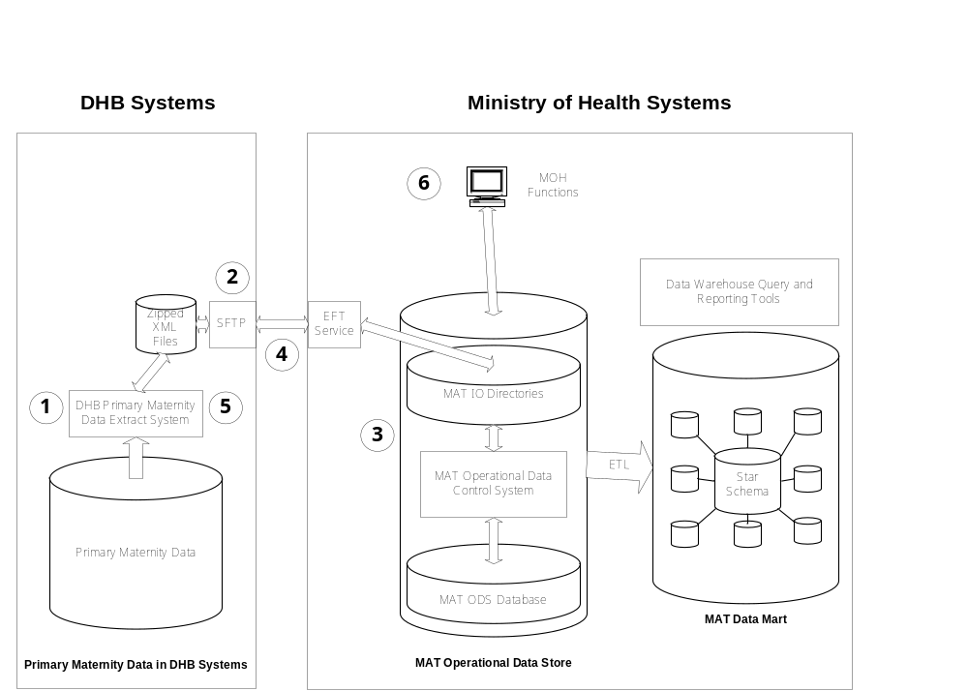
The above diagram is a conceptual representation only. The numbers in this diagram are explained in the step/action table in the section below.

Extract File Processing Steps

Step | Processing Action
1 | Extract:  - Primary Maternity data is extracted from the Submitter’s system.  - Extract file is zipped into a zip file
2 | Send:  - The zip file is sent to the Ministry by SFTP.
3 | Receive and Process:  - When the file is received by the National Collections it is fully validated by the MAT Operational Data Control System (ODS).  - Firstly compliance with the XSD Schema rules is checked. If there are any XSD errors, the file is rejected.  - Secondly compliance with business rules is checked. If errors are found while processing a pregnancy record, the data for the whole pregnancy is rejected. The rejected data is written to the Acknowledgment File together with appropriate error messages.  - Valid pregnancy details are inserted into the ODS database.
4 | Acknowledgement:  - An XML Extract Acknowledgement file is created for each received Extract file. The Extract Acknowledgment file also returns counts of the number of records received and rejected for each request type.  - An Extract Report file is created for each received Extract file. The Report file contains statistics of the error rate and counts by error number.  - MAT ODS sends an email alert to the Submitter when the Extract Acknowledgement and Report files have been created. The District will retrieve the files using SFTP.
5 | Acknowledgement Reconciliation:  - On receipt of Extract Acknowledgement file, the Submitter should verify that the extracted items have been acknowledged and all processed correctly.  - Errors should be corrected and the associated XML records resubmitted as appropriate. If a record has data outside the expected range of values and the Distict has verified that the values provided are correct, the pregnancy details should be resubmitted with the verified attribute set on the relevant data element(s)
6 | MOH Functions  Administrative monitoring tools and reports

Reversal Request File processing steps

The steps involved in the ODS for reversing a file are:

- Get all the Pregnancy Details records from the ODS with an Import File ID that matches with the ID of the file being reversed
- For each Pregnancy Details record
- If there is another Pregnancy Details record with the same unique identifier that has a later creation date and time than the processing date and time of the file being reversed, don’t do anything
- If the record is marked as deleted, set it to active again
- If the record is active, mark as deleted.
- Generate a Reversal Acknowledgement file.

MAT File Structure & Data Relationships

This chapter includes diagrams and XML fragments to illustrate the structure of the MAT XML files.
The complete schema definitions are downloadable from the following link: (provide link)

Notation
0..∞ | Zero to unlimited occurrences
[0..*] | Zero to unlimited occurrences
[0..1] | Zero to one occurrences
Solid outline  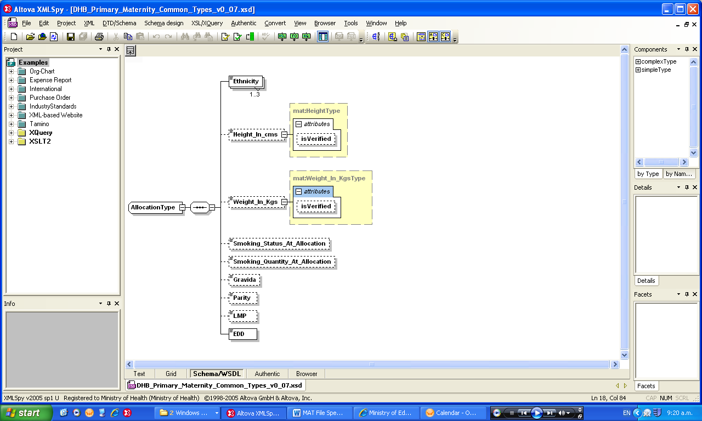 | Mandatory (must be provided)
Dotted outline | Non mandatory however there may be rules for when the item must be provided
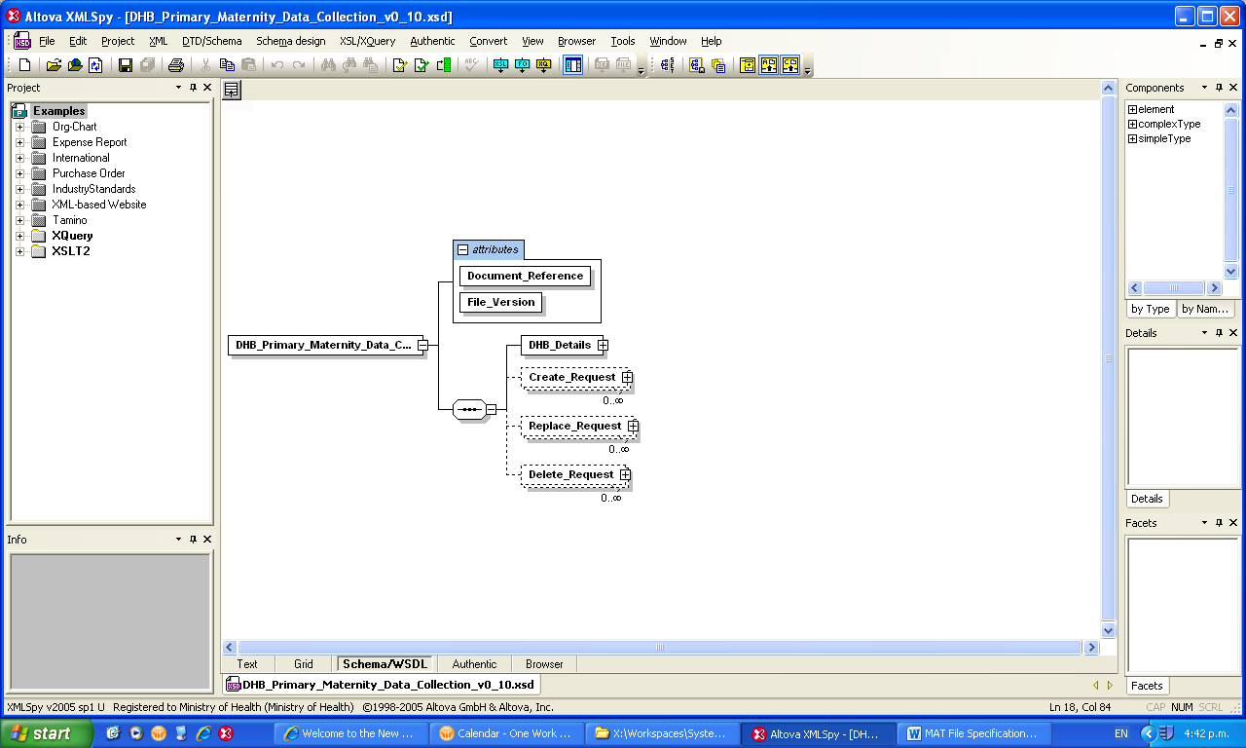 | Expands to another level

MAT Extract File XML Message Structure/ Format
The following sections detail the structure and the entity types defined in the XML schema document for the MAT Extract File.
The schema document defines the expected format and structure of the extract file. Some data-type restrictions are defined in the schemas but these are not exhaustive.
Chapter 6 defines the domains and detailed formats of the data values expected and the business validation rules around them.
For a summary of the Extract File structure refer to Appendix D: Extract File Structure Summary

DHB_Primary_Maternity_Data_Collection (Root Entity)
Entity Structure | 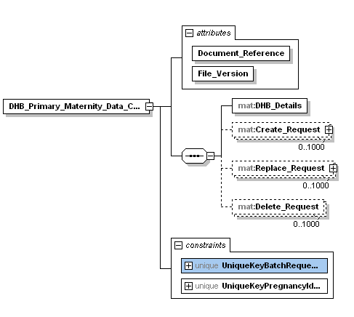

XML Instance Representation | <DHB_Primary_Maternity_Data_Collection Document_Reference=”xs:string” File_Version = “xs:string”>  <DHB_Details>DHB_DetailsType</DHB_Details>  <Create_Request> Create_RequestType</Create_Request>[0..1000]  <Replace_Request> Replace_RequestType</Replace_Request>[0..1000]  <Delete_Request>Delete_RequestType</Delete_Request>[0..1000]  </DHB_Primary_Maternity_Data_Collection>

DHB_Details
Entity Structure | 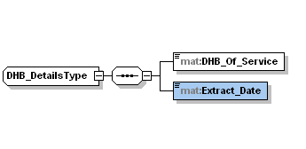

XML Instance Representation | <DHB_Details>  <DHB_Of_Service>DHBType</DHB_Of_Service>  <Extract_Date>xs:date</Extract_Date>  </DHB_Details>

Create_Request
Entity Structure | 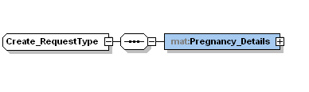

XML Instance Representation | <Create_Request>  <Pregnancy_Details> Pregnancy_DetailsType</ Pregnancy_Details>  </Create_Request>

Replace_Request
Entity Structure | 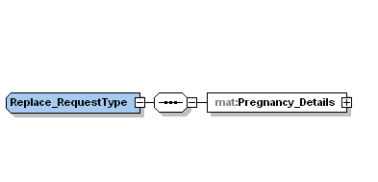

XML Instance Representation | <Replace_Request>  <Pregnancy_Details> Pregnancy_DetailsType</ Pregnancy_Details>  </Replace_Request>

Pregnancy_Details
Entity Structure | 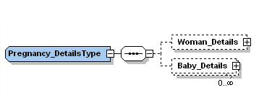

XML Instance Representation | <Pregnancy_Details>  <Woman_Details>Woman_DetailsType</Woman_Details>[0..1]  <Baby_Details>Baby_DetailsType</Baby_Details> [0..*]  </Pregnancy_Details>

Woman-Details
Entity Structure | 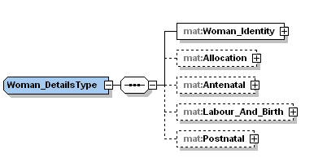

XML Instance Representation | <Woman_Details>  <Woman_Identity>Woman_IdentityType</Woman_Identity>  <Allocation>AllocationType</Allocation>[0..1]  <Antenatal>AntenatalType</Antenatal>[0..1]  <Labour_And_Birth>Labour_And_BirthType</Labour_And_Birth>[0..1]  <Postnatal>PostnatalType</Postnatal>[0..1]  </Woman_Details>

Baby_Details
Entity Structure | 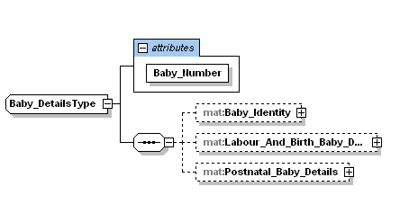

XML Instance Representation | <Baby_Details Baby_Number=”xs:positiveInteger”>  <Baby_Identity>Baby_IdentityType</Baby_Identity>[0..1]  <Labour_And_Birth_Baby_Details>Labour_And_Birth_Baby_DetailsType  </Labour_And_Birth_Baby_Details>[0..1]  <Postnatal_Baby_Details>Postnatal_Baby_DetailsType</Postnatal_Baby_Details>[0..1]  </Baby_Details>

Woman-Identity
Entity Structure | 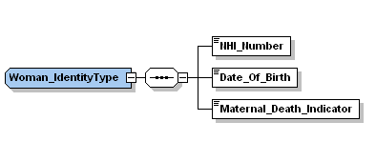

XML Instance Representation | <Woman_Identity>  <NHI_Number>NHIType</NHI_Number>  <Date_Of_Birth>xs:date</Date_Of_Birth>  <Maternal_Death-Indicator>xs:boolean</Maternal_Death_Indicator>  </Woman_Identity>

Important Note: In the case where the District is only supplying postnatal services to the baby, the woman’s identity and any other details relating to services to the woman would not be provided.
An example of this is where a woman died in childbirth. The baby is taken by a guardian to a different DHB district. The new DHB district provides postnatal services to the baby. The new DHB would only supply Baby Identity and Postnatal Baby Details segments in the pregnancy record.

Allocation
Entity Structure

XML Instance Representation | <Allocation>  <Ethnicity>xs:positiveInteger</Ethnicity>[1..3]  <Height_In_cms isVerified=”xs:boolean”>xs:positiveInteger</Height_In_cms>[0..1]  <Weight_In_Kgs isVerified=”xs:boolean”>xs:decimal</Weight_In_Kgs>[0..1]  <Smoking_Status_At_Allocation>xs:boolean</Smoking_Status_At_Allocation>[0..1]  <Smoking_Quantity_At_Allocation>xs:string</Smoking_Quantity_At_Allocation>[0..1]  <Gravida>xs:positiveInteger</Gravida>[0..1]  <Parity> xs:nonNegativeInteger </Parity>[0..1]  <LMP>xs:date</LMP>[0..1]  <EDD>xs:date</EDD>  </Allocation>

Important Note: If the Allocation segment is supplied, the Antenatal segment must also be supplied.

Antenatal
Entity Structure | 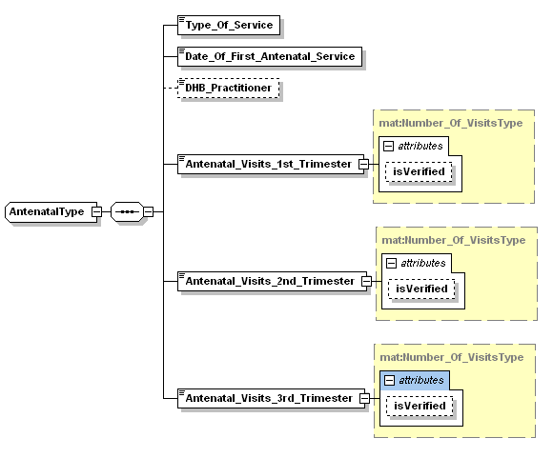

XML Instance Representation | <Antenatal>  <Type_Of_Service>xs:integer</Type_Of_Service>  <Date_Of_First_Antenatal_Service>xs:date</Date_Of_First_Antenatal_ Service>  <DHB_Practitioner>xs:string</DHB_Practitioner>[0..1]  <Antenatal_Visits_1st_Trimester isVerified=”xs:boolean”>xs:integer</Antenatal_Visits_1st_ Trimester>  <Antenatal_Visits_2nd_Trimester isVerified=”xs:boolean”>xs:integer</Antenatal_Visits_2nd_ Trimester>  <Antenatal_Visits_3rd_Trimester isVerified=”xs:boolean”>xs:integer</Antenatal_Visits_3rd_ Trimester>  </Antenatal>

Important Note: If the Antenatal segment is supplied, the Allocation segment must also be supplied.

Labour_And_Birth
Entity Structure | 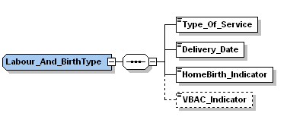

XML Instance Representation | <Labour_And_Birth>  <Type_Of_Service>xs:integer</Type_Of_Service>  <Delivery_Date>xs:date</Delivery_Date>  <HomeBirth_Indicator>xs:boolean</HomeBirth_Indicator>  <VBAC_Indicator>xs:boolean</VBAC_Indicator>[0..1]  </Labour_And_Birth>

Postnatal
Entity Structure | 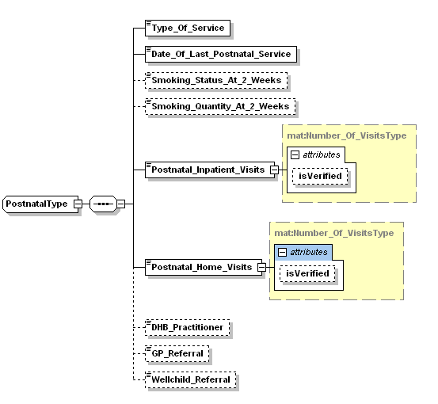

XML Instance Representation | <Postnatal>  <Type_Of_Service>xs:integer</Type_Of_Service>  <Date_Of_Last_Postnatal_Service>xs:date</Date_Of_Last_Postnatal_Service>  <Smoking_Status_At_2_Weeks>xs:boolean</Smoking_Status_At_2_Weeks>[0..1]  <Smoking_Quantity_At_2_Weeks>xs:string</Smoking_Quantity_At_2_Weeks>[0..1]  <Postnatal_Inpatient_Visits isVerified=”xs:boolean”>xs:integer</Postnatal_Inpatient_Visits>  <Postnatal_Home_Visits isVerified=”xs:boolean”>xs:integer</Postnatal_Home_Visits>  <DHB_Practitioner>xs:string</DHB_Practitioner>[0..1]  <GP_Referral>xs:string</GP_Referral>[0..1]  <Wellchild_Referral>xs:string</Wellchild_Referral>[0..1]  </Postnatal>

Baby_Identity
Entity Structure | 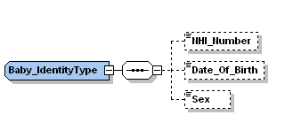

XML Instance Representation | <Baby_Identity>  <NHI_Number>xs:token</NHI_Number>[0..1]  <Date_Of_Birth>xs:date</Date_Of_Birth>[0..1]  <Sex>xs:string</Sex>[0..1]  </Baby_Identity>

Important Note: Baby Identity must be supplied for a live birth and when a Postnatal Baby segment is supplied.
\

Labour_And_Birth_Baby_Details
Entity Structure | 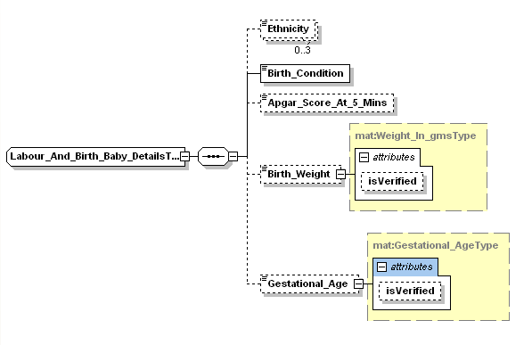

XML Instance Representation | <Labour_And_Birth_Baby_Details>  <Ethnicity>xs:positiveInteger</Ethnicity>[0..3]  <Birth_Condition>xs:string</Birth_Condition>  <Apgar_Score_At_5_Mins>xs:nonNegativeInteger</Apgar_Score_At_5_Mins>[0..1]  <Birth_Weight isVerified=”xs:boolean”>xs:positiveIntegerS</Birth_Weight>[0..1]  <Gestational_Age isVerified=”xs:boolean”>xs:positiveInteger</Gestational_Age>[0..1]  </Labour_And_Birth_Baby_Details>

Postnatal_Baby_Details
Entity Structure | 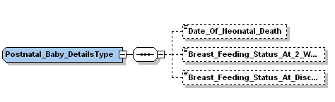

XML Instance Representation | <Postnatal_Baby_Details>  <Date_Of_Neonatal_Death>xs:date</Date_Of_Neonatal_Death>  <Breast_Feeding_Status_At_2_Weeks>Breast_Feeding_StatusType  </Breast_Feeding_Status_At_2_Weeks>[0..1]  <Breast_Feeding_Status_At_Discharge>Breast_Feeding_StatusType  </Breast_Feeding_Status_At_Discharge>[0..1]  </Postnatal_Baby_Details>

MAT Acknowledgment File XML Message Structure/ Format
An XML Acknowledgement file will be created for each received Extract XML file, incorporating any errors.
The Submitter will be able to retrieve the Acknowledgement file using SFTP.
The following sections detail the structure and the entity types defined in the XML schema document for the MAT Acknowledgment file.

DHB_Primary_Maternity_Data_Collection_Acknowledgement (Root Entity)
Entity Structure | 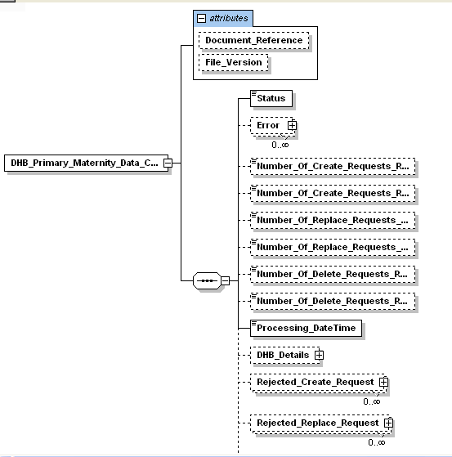  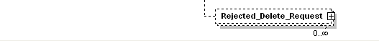

XML Instance Representation | <DHB_Primary_Maternity_Data_Collection_Acknowledgement Document_Reference=”xs:string” File_Version = “xs:string”>  <Status> xs:string</Status>  <Error>ErrorType</Error>[0..*]  <! Errors reported at this level are file errors>  <Number_Of_Create_Requests_Received>xs:nonNegativeInteger</Number_Of_  Create_Requests_Received>  <Number_Of_Create_Requests_Rejected>xs:nonNegativeInteger</Number_Of_  Create_Requests_Rejected>  <Number_Of_Replace_Requests_Received>xs:nonNegativeInteger</Number_Of_  Replace_Requests_Received>  <Number_Of_Replace_Requests_Rejected>xs:nonNegativeInteger</Number_Of_  Replace_Requests_Rejected>  <Number_Of_Delete_Requests_Received>xs:nonNegativeInteger</Number_Of_  Delete_Requests_Received>  <Number_Of_Delete_Requests_Rejected>xs:nonNegativeInteger</Number_Of_  Delete_Requests_Rejected>  <Processing_DateTime>xs:dateTime</Processing_DateTime>  <File_Version>xs:string</File_Version>  <DHB_Details> DHB_DetailsType</DHB_Details>  <Rejected_Create_Request>Rejected_Create_RequestType</Rejected_Create_  Request> [0..*]  <Rejected_Replace_Request>Rejected_Replace_RequestType</Rejected_Replace_  Request> [0..*]  <Rejected_Delete_Request>Rejected_Delete_RequestType</Rejected_Delete_  Request> [0..*]  </DHB_Primary_Maternity_Data_Collection_Acknowledgement>

Error
Entity Structure | 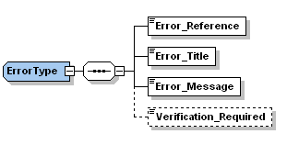

XML Instance Representation | <Error>  <Error_Reference>xs:string</Error_Reference>  <Error_Title> xs:string </Error_Title>  <Error_Message> xs:string </Error_Message>  <Verification_Required>xs:boolean</Verification_Required>[0..1]  </Error>

Rejected_Create_Request
Entity Structure | 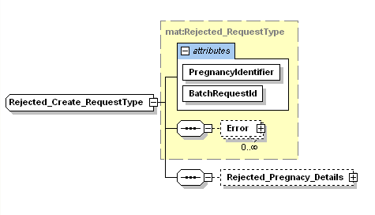

XML Instance Representation | <Rejected_Create_Request Pregnancy_Identifier=”guid” BatchRequestId=xs:integer>  <Error>ErrorType</Error>[0..*]  <Rejected_Pregnancy_Details>Rejected_Pregnancy_DetailsType</Rejected_Pregnancy_  Details>  </Rejected_Create_Request>

Rejected_Replace_Request
Entity Structure | 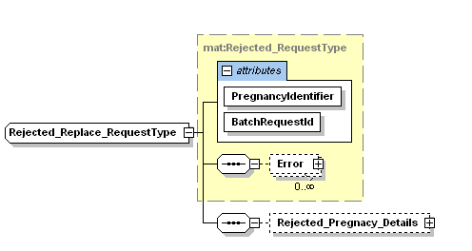

XML Instance Representation | <Rejected_Replace_Request Pregnancy_Identifier=”guid” BatchRequestId=xs:integer >  <Error>ErrorType</Error>[0..*]  <Rejected_Pregnancy_Details>Rejected_Pregnancy_DetailsType</Rejected_Pregnancy_  Details>  </Rejected_Replace_Request>

Rejected_Delete_Request
Entity Structure | 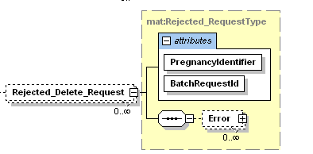

XML Instance Representation | <Rejected_Delete_Request Pregnancy_Identifier=”guid” BatchRequestId=xs:integer >  <Error>ErrorType</Error> [0..*]  </Rejected_Delete_Request>

Rejected Segments
Rejected segments have the same structure as the corresponding segment on the input file with one or more Error segments appended. Below is an example of the Rejected Woman Identity segment.
Entity Structure | 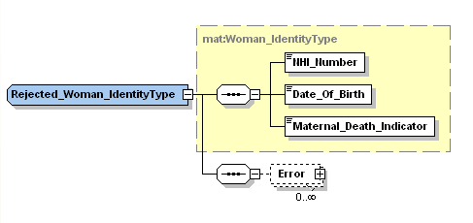

XML Instance Representation | <Rejected_Woman_Identity>  <NHI_Number>NHIType</NHI_Number>  <Date_Of_Birth>xs:date</Date_Of_Birth>  <Maternal_Death-Indicator>xs:boolean</Maternal_Death_Indicator>  <Error>ErrorType</Error>[0..*]  </ Rejected_Woman_Identity>

Explanation of the Error Segment
When errors are detected by the validation process Error segments are inserted in the acknowledgement file, one Error segment per error.
A Verification Required element indicates whether the data submitted for rejected item needs to be checked by the DHB and resubmitted if the data is correct as recorded.
Example:

<mat:Rejected_Labour_And_Birth_Baby_Details>
<mat:Ethnicity>10000</mat:Ethnicity>
<mat:Birth_Condition>LB</mat:Birth_Condition>
<mat:Apgar_Score_At_5_Mins>6</mat:Apgar_Score_At_5_Mins>
<mat:Gestational_Age>45</mat:Gestational_Age>
<mat:Error>
<mat:Error_Reference>RM-M61-12</mat:Error_Reference>
<mat:Error_Title>Error – Missing conditional data</mat:Error_Title>
<mat:Error_Message>The Birth Weight has not been supplied in the Labour
and Birth Baby Details segment. It must be supplied when Birth
Condition = ‘LB’</mat:Error_Message>
</mat:Error>
<mat:Error>
<mat:Error_Reference>RM-M61-16</mat:Error_Reference>
<mat:Error_Title>Error – Value not within range</mat:Error_Title>
<mat:Error_Message>The Gestational Age in the Labour and Birth Baby
Details segment is not within the range of probable values 20 – 44
weeks. Please review and confirm as correct.</mat:Error_Message>
<mat:Verification_Required>true</mat:Verification_Required>
</mat:Error>
</mat:Labour_And_Birth_Baby_Details>

MAT Reversal Request XML Message Structure/ Format
The following sections detail the structure and the entity types defined in the XML schema document for the MAT Reversal Request.
The schema document defines the format and structure of the reversal request file expected.

DHB_Primary_Maternity_Data_Collection_Reversal (Root Entity)
Entity Structure | 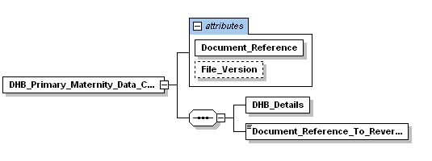

XML Instance Representation | <DHB_Primary_Maternity_Data_Collection_Reversal Document_Reference=”xs:string” File_Version = “xs:string”>  <DHB_Details>DHB_DetailsType</DHB_Details>  <Document_Reference_To_Reverse>xs:string </ Document_Reference_To_Reverse>  </DHB_Primary_Maternity_Data_Collection_Reversal>

MAT Reversal Acknowledgement File XML Message Structure/ Format
An XML Acknowledgement file will be created for each received Extract Reversal Request XML file, incorporating any errors.
The Submitter will be able to retrieve the Extract Reversal Request Acknowledgement file using SFTP.
The following sections detail the structure and the entity types defined in the XML schema document for the MAT Extract Reversal Request Acknowledgment file.

DHB_Primary_Maternity_Data_Collection_Reversal_Acknowledgement (Root Entity)
Entity Structure | 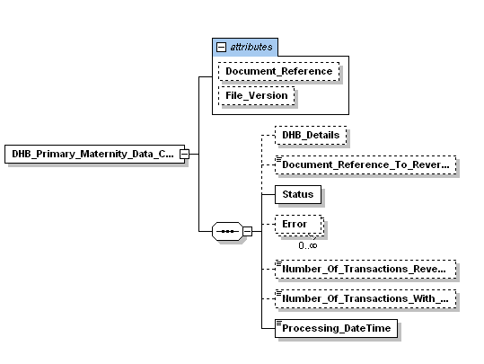

XML Instance Representation | <DHB_Primary_Maternity_Data_Collection_Reversal_Acknowledgement Document_Reference=”xs:string” File_Version = “xs:string”>  <DHB_Details>DHB_DetailsType</DHB_Details>[0..1]  <Document_Reference_To_Reverse>xs:string </ Document_Reference_To_Reverse>[0..1]  <Status> StatusType</Status>  <Error>Errortype</Error>[0..*]  <Number_Of_Transactions_Reversed>xs:nonNegativeInteger</Number_Of_Transactions_  Reversed >[0..1]  <Number_Of_Transactions_With_Subsequent_Updates>xs:nonNegativeInteger</Number_Of_  Transactions_With_Subsequent_Updates >[0..1]  <Processing_Datetime>xs:dateTime</Processing_Datetime>  </DHB_Primary_Maternity_Data_Collection_Acknowledgement>

Initial Input File Validation

This section describes the initial validation of the input file where the file name, file version, conformance to schema and authorisation to load data are checked.

Input file name format and file attributes
The format of the Input file name is:
AAAA_MATYYYYMMDD_XXXX_nnn_ZZZZZZ.xml
Where:
  - AAAA denotes the target system.
  - ZZZZZZZ denotes the input file type
  - YYYYMMDD is the extract date
  - XXXX is the Submitter code (refer to 6.1.2 for code set)
  - nnn denotes a sequential number to allow for multiple extracts to occur on the same day. For the first extract of the day this should be 001, for the second 002 and so on.

The attributes of the Input file are listed below.

Input File Attributes
Attribute | Type | Format | M/O/C | Coded
Target system | Code | AAAA | M | Y
Input file type | Code | Char(7) | M | Y
Extract date | Date | YYYY-MM-DD | M | -
Submitter | Code | NNNN | M | Y
Sequence number | Positive Integer | NNN | M | -
Document reference | String | AAAA_MATYYYYMMDD_XXXX_NNN_ZZZZZZZ | M | -
File version | String | NNNNN.NN | M | -

Input file name code set attributes
The attributes of the Input file name that have coded values are listed below.

Input File Name Code Set
Coded Data Element | Range | Description | Submitter Type
Target system | PROD  COMP | Production  Compliance
Input file type | EXTRACT  REVERSE | Extract  Reversal
Submitter | 1011  1021  1022  1023  2031  2042  2047  2051  2071  3061  3081  3082  3091  3092  3093  3101  4111  4121  4123  4160  7999 | Northland DHB  Waitemata DHB  Auckland DHB  Counties Manakau DHB  Waikato DHB  Lakes DHB  Bay of Plenty DHB  Tairawhiti DHB  Taranaki DHB  Hawkes Bay DHB  MidCentral DHB  Wanganui DHB  Capital and Coast DHB  Hutt Valley DHB  Wairarapa DHB  Nelson Marlborough DHB  West Coast DHB  Canterbury DHB  South Canterbury DHB  Southern DHB  Clevermed Limited | DHB  DHB  DHB  DHB  DHB  DHB  DHB  DHB  DHB  DHB  DHB  DHB  DHB  DHB  DHB  DHB  DHB  DHB  DHB  DHB  VEN
File Version | 00000.01  00001.00 | Retrospective Data (1 Jan 2007 to 01 Aug 2012.)  Current file version (1 July 2011 to current date)

Important Note: The files submitted by Clevermed Limited must have version 00001.00.

Antenatal

Input file initial validation rules
The following rules identify the requirements for the initial validation of MAT Input files.

Rule Reference | Rule  Description | Affected  Data | Response Message Reference
BR-M01-01 | - The file name must comply with the format identified in 6.1 above. | - File name format | - RM-M01-01
BR-M01-02 | - The elements must comply with the data code ranges identified in section 6.1.1 above. | - Target system  - File type  - Submitter | - RM-M01-02  - RM-M01-12  - RM-M01-03
BR-M01-03 | - The Extract Date must be less than or equal to the date the file is received. | - Extract Date | - RM-M01-04
BR-M01-04 | - The Extract date must be greater than or equal to the Extract date of the last file processed. | - Extract Date | - RM-M01-05
BR-M01-05 | - If Sequence number is greater than 1, then Sequence number must be equal to Sequence number of the last accepted file on Extract date +1 | - Sequence number | - RM-M01-06
BR-M01-08 | - The Submitter must be certified to submit the file version to the Target system | - Target system  - File version  - Submitter | - RM-M01-09
BR-M01-13 | - The file must be readable  (The root segment must be present in the extract file.)  (The File version must be the present in the Extract file) | - File | - RM-M01-15
BR-M01-16 | - The data elements must be in the correct order |  | - RM-M01-08
BR-M01-17 | - The Target system in the input file name must match the processing system | - Target system | - RM-M01-19
BR-M01-18 | - The Extract Date must be a valid date | - Extract Date | - RM-M01-21
BR-M01-19 | - The file must be in the correct Submitter input folder | - Submitter | - RM-M01-20

Input file initial validation error messages
The following rule responses apply to the Validation process:
Important Notes:
Response messages are intended to provide clarity around conditions where rules are not successfully met:
- An ‘Error’ is fatal and the process cannot proceed until corrected.
- A ‘Warning’ means unusual conditions encountered but are acceptable.
- A message is expected for each instance of an encountered error or warning condition.

Response Message Reference | Error or  Warning | Message  Title | Response  Message
RM-M01-01 | Error | Error – Incorrect Data Format | - The Input file name does not comply with the correct format.
RM-M01-02 | Error | Error – Incorrect Code Range | - The Target system in the Input file name is not within the correct code range.
RM-M01-03 | Error | Error – Incorrect Code Range | - The Submitter in the Input file name is not within the correct code range.
RM-M01-04 | Error | Error – Invalid Data | - The Extract date in the Input file is not less than or equal to the date the file is received by MOH.
RM-M01-05 | Error | Error – Invalid Sequence | - The Extract date in the Input file is not greater than or equal to the Extract date of the last file processed by MOH.
RM-M01-06 | Error | Error – Invalid Sequence | - The Sequence number in the Input file is not greater than the Sequence number of the last accepted file accepted by MOH.
RM-M01-08 | Error | Error – XSD Validation | - A system generated contextual XSD error message is provided
RM-M01-09 | Error | Error – Invalid Data | - The Submitter in the Input file name is not certified to submit this file version to the Target System
RM-M01-12 | Error | Error – Incorrect Code Range | - The Input file type in the Input file name is not within the correct code range.
RM-M01-15 | Error | Error – Invalid Data | - The file is unreadable
RM-M01-19 | Error | Error – Invalid Data | - Input file has been submitted to wrong Target system
RM-M01-20 | Error | Error – Invalid Data | - The Submitter in the input file name does not match the Submitter in the input folder name
RM-M01-21 | Error | Error – Invalid Data | - The Extract date in the Input file is not a valid date

MAT Segment Formats, Code Sets and Validation Rules

Extract file root segment

Extract file root segment data attributes
The attributes of the Root segment are listed below.
Table Key: M = Mandatory. O = Optional. C = Conditional.
Root segment Attributes
Attribute | Type | Format | M/O/C | Coded
Document reference | String | AAAA_MATYYYYMMDD_XXXX_NNN_ZZZZZZZ | M | -
File version | String | NNNNN.NN | M | -

Extract file root segment rules
The following rules apply to the data associated with the Validation process.

Rule Reference | Rule  Description | Affected  Data | Response Message Reference
BR-M01-09 | - The Document reference must be present in the Extract file | - Document reference | - RM-M01-08
BR-M01-10 | - The Document reference must be the same as the File name | - Document reference | - RM-M01-14
BR-M01-15 | - The File version must comply with the data format identified in section 7.1.1 | - File version | - RM-M01-08

Extract file root segment error messages
The following rule responses apply to the Validation process:
Important Notes:
Response messages are intended to provide clarity around conditions where rules are not successfully met:
- An ‘Error’ is fatal and the process cannot proceed until corrected.
- A ‘Warning’ means unusual conditions encountered but are acceptable.
- A message is expected for each instance of an encountered error or warning condition.

Response Message Reference | Error or  Warning | Message  Title | Response  Message
RM-M01-08 | Error | Error – XSD Validation | - A system generated contextual XSD error message is provided
RM-M01-14 | Error | Error – Invalid Data | - The Document reference and the file name are not the same

DHB Details Segment

DHB Details segment data elements
The data elements of the DHB Details segment are listed below.
Table Key: M = Mandatory. O = Optional. C = Conditional.
DHB Details Elements
Data Element | Type | Format | M/O/C | Coded
DHB of Service | Code | NNNN | M | Y
Extract Date | Date | YYYY-MM-DD | M | -

DHB Details segment code set elements
The data elements of the DHB Details segment that have coded values are listed below.

DHB Details Code Set
Coded Data Element | Range | Description
DHB of Service | 1011 | Northland DHB
DHB of Service | 1021 | Waitemata DHB
DHB of Service | 1022 | Auckland DHB
DHB of Service | 1023 | Counties Manakau DHB
DHB of Service | 2031 | Waikato DHB
DHB of Service | 2042 | Lakes DHB
DHB of Service | 2047 | Bay of Plenty DHB
DHB of Service | 2051 | Tairawhiti DHB
DHB of Service | 2071 | Taranaki DHB
DHB of Service | 3061 | Hawkes Bay DHB
DHB of Service | 3081 | MidCentral DHB
DHB of Service | 3082 | Wanganui DHB
DHB of Service | 3091 | Capital and Coast DHB
DHB of Service | 3092 | Hutt Valley DHB
DHB of Service | 3093 | Wairarapa DHB
DHB of Service | 3101 | Nelson Marlborough DHB
DHB of Service | 4111 | West Coast DHB
DHB of Service | 4121 | Canterbury DHB
DHB of Service | 4123 | South Canterbury DHB
DHB of Service | 4131 | Otago District Health Board (merged to 4160)
DHB of Service | 4141 | Southland District Health Board (merged to 4160)
DHB of Service | 4160 | Southern DHB

DHB Details segment rules
The following rules apply to the data associated with the Validation process.

Rule Reference | Rule  Description | Affected  Data | Response Message Reference
BR-M11-01 | - The segment must contain all mandatory data as identified in section 7.2.1 above. | - DHB of Service  - Extract Date | - RM-M01-08
BR-M11-02 | - The data elements must comply with the data formats identified in section 7.2.1 above. | - DHB of Service  - Extract Date | - RM-M01-08
BR-M11-03 | - The data elements must comply with the data code ranges identified in section 7.2.2 above. | - DHB of Service | - RM-M11-05
BR-M11-04 | - The Extract Date must equal to Extract Date in the file name | - Extract Date | - RM-M11-06
BR-M11-05 | - The segment must be present in the input file | - DHB Details | - RM-M01-08
BR-M01-14 | - The DHB of Service must be active. | - DHB of Service | - RM-M01-16

DHB Details segment error messages
The following rule responses apply to the Validation process:
Important Notes:
Response messages are intended to provide clarity around conditions where rules are not successfully met:
- An ‘Error’ is fatal and the process cannot proceed until corrected.
- A ‘Warning’ means unusual conditions encountered but are acceptable.
- A message is expected for each instance of an encountered error or warning condition.

Response Message Reference | Error or  Warning | Message  Title | Response  Message
RM-M01-08 | Error | Error – XSD Validation | - A system generated contextual XSD error message is provided
RM-M11-05 | Error | Error – Incorrect Code Range | - The DHB of Service in the DHB Details segment is not within the correct code range.
RM-M11-06 | Error | Error – Invalid Data | - The Extract Date in the DHB Details segment is not equal to the Extract Date in the file name
RM-M01-16 | Error | Error – Invalid Data | - The DHB of Service in the DHB Details segment is not active - You are not enabled to submit this file – please contact compliance@moh.govt.nz

Request segment
Refer also to Section 8 MAT Extract File Record Types for more details about the request types.

Request segment data attributes
The attributes of the Request segment (where request type is Create, Replace or Delete) are listed below.
Table Key: M = Mandatory. O = Optional. C = Conditional.
Request Type Attributes
Attribute | Type | Format | M/O/C | Coded
Pregnancy Identifier | GUID | [0-9a-fA-F]{8}-[0-9a-fA-F]{4}-[0-9a-fA-F]{4}-[0-9a-fA-F]{4}-[0-9a-fA-F]{12} | M | -
Batch Request ID | Integer | 9(5) | M | -

Request segment rules
The following rules apply to the data associated with the Validation process.

Rule Reference | Rule  Description | Affected  Data | Response Message Reference
BR-M16-01 | - The segment must contain all mandatory attributes as identified in section 7.3.1 above. | - Pregnancy Identifier  - Batch Request ID | - RM-M01-08
BR-M16-02 | - The attributes must comply with the data formats identified in section 7.3.1 above. | - Pregnancy Identifier  - Batch Request ID | - RM-M01-08
BR-M16-05 | - The Batch Request ID must be unique in the Extract File | - Batch Request ID | - RM-M01-08
BR-M16-06 | - If the request type is Create or Replace Pregnancy Details must be present | - Pregnancy Details | - RM-M01-08
BR-M16-07 | - There should be at least one Create, Replace or Delete Request present in the file |  | - RM-M16-08

Request Type segment error messages
The following rule responses apply to the Validation process:
Important Notes:
Response messages are intended to provide clarity around conditions where rules are not successfully met:
- An ‘Error’ is fatal and the process cannot proceed until corrected.
- A ‘Warning’ means unusual conditions encountered but are acceptable.
- A message is expected for each instance of an encountered error or warning condition.
Response Message Reference | Error or  Warning | Message  Title | Response  Message
RM-M01-08 | Error | Error – XSD Validation | - A system generated contextual XSD error message is provided
RM-M16-08 | Error | Error – Missing  Data | - The file does not contain any Create, Replace or Delete Requests

Woman Identity segment

Woman Identity segment data elements
The data elements of the Woman Identity segment are listed below.
Table Key: M = Mandatory. O = Optional. C = Conditional.
Woman Identity Elements
Data Element | Type | Format | M/O/C | Coded
NHI Number | ID | AAANNNN | M | -
Date of Birth | Date | YYYY-MM-DD | M | -
Maternal Death Indicator | Boolean | ‘true’ or ‘false’ | M | -

Woman Identity segment rules
The following rules apply to the data associated with the Validation process.

Rule Reference | Rule  Description | Affected  Data | Response Message Reference
BR-M21-01 | - The segment must contain all mandatory data as identified in section 7.4.1 above. | - NHI Number  - Date of Birth  - Maternal Death Indicator | - RM-M01-08
BR-M21-02 | - The data elements must comply with the data formats identified in section 7.4.1 above. | - NHI Number  - Date of Birth  - Maternal Death Indicator | - RM-M01-08
BR-M21-03 | - The NHI Number must be registered on the NHI database before submission. | - NHI Number | - RM-M21-05
BR-M21-04 | - The Date of Birth in this segment must match the Date of Birth held in the NHI database for the NHI Number. | - Date of Birth  - NHI Number | - RM-M21-06
BR-M21-05 | - If the Woman Details segment is supplied, the Woman Identity segment must be present | - Woman Identity | - RM-M01-08
BR-M21-06 | - The Sex held in the NHI database for the NHI Number must be ‘F’. | - Sex  - NHI Number | - RM-M21-10

Woman Identity segment error messages
The following rule responses apply to the Validation process:
Important Notes:
Response messages are intended to provide clarity around conditions where rules are not successfully met:
- An ‘Error’ is fatal and the process cannot proceed until corrected.
- A ‘Warning’ means unusual conditions encountered but are acceptable.
- A message is expected for each instance of an encountered error or warning condition.

Response Message Reference | Error or  Warning | Message  Title | Response  Message
RM-M01-08 | Error | Error – XSD Validation | - A system generated contextual XSD error message is provided
RM-M21-05 | Error | Error – Invalid Data | - The NHI Number supplied in the Woman Identity segment is not valid in the NHI Database.
RM-M21-06 | Error | Error – Invalid Data | - The Date of Birth in the Woman Identity segment does not match the Date of Birth in the NHI Database for the NHI Number.
RM-M21-10 | Error | Error – Invalid Data | - The NHI Number supplied in the Woman Identity segment is not registered as belonging to a woman.

Allocation segment

Allocation data elements
The data elements of the Allocation Segment are listed below.
Table Key: M = Mandatory. O = Optional. C = Conditional.
Allocation Elements
Data Element | Type | Format | M/O/C | Coded | Verified Attribute*
Ethnicity 1 | Code | NNNNN | M | Y | -
Ethnicity 2 | Code | NNNNN | O | Y | -
Ethnicity 3 | Code | NNNNN | O | Y | -
Height in cms | Positive Integer | NNN | O | - | Y
Weight in Kgs | Decimal | NNN.N | O | - | Y
Smoking Status at Allocation | Boolean | ‘true’ or ‘false’ | O | - | -
Smoking Quantity at Allocation | Code | A | O | Y | -
Gravida | Integer | NN | O | - | -
Parity | Integer | NN | O | - | -
LMP | Date | YYYY-MM-DD | O | - | -
EDD | Date | YYYY-MM-DD | M | - | -

* The Verified attribute is a Boolean indicator that the DHB may use to confirm that the value for the element being submitted is legitimately outside the permissible range.

Allocation segment code sets
The data elements of the Allocation segment that have coded values are listed below.

Allocation Code Set
Coded Data Element | Range | Description
Ethnicity |  | Refer to Appendix C for the complete list of valid Level 4 ethnicity codes and a mapping table of Level 2 codes to Level 4 codes
Smoking Quantity at Allocation | L | Less than 10 cigarettes per day
Smoking Quantity at Allocation | M | 10 – 20 cigarettes per day
Smoking Quantity at Allocation | H | More than 20 cigarettes per day

Allocation segment rules
The following rules apply to the data associated with the Validation process.

Rule Reference | Rule  Description | Affected  Data | Response Message Reference
BR-M31-01 | - The segment must contain all mandatory data as identified in section 7.5.1 above. | - Ethnicity 1  - EDD | - RM-M01-08
BR-M31-02 | - The data elements, when present, must comply with the data formats identified in section 7.5.1 above. | - Ethnicity 1, 2, or 3  - Height in cms  - Weight in Kgs  - Smoking Status at Allocation  - Gravida  - Parity  - LMP  - EDD  - Verified | - RM-M01-08
BR-M31-03 | - The data elements, when present, must comply with the data code ranges identified in section 7.5.2 above. | - Ethnicity 1, 2 or 3  - Smoking Quantity at Allocation | - RM-M31-16  - RM-M01-08
BR-M31-04 | - The Allocation and Antenatal segments must be supplied together. One cannot be supplied without the other | - Allocation | - RM-M31-01
BR-M31-05 | - If not NULL or verified, Height in cms must be in the range 100 cm – 215 cm | - Height in cms | - RM-M31-19
BR-M31-06 | - If not NULL or verified, Weight in kgs must be in the range 40 kg – 180 kg | - Weight in Kgs | - RM-M31-20
BR-M31-07 | - If not NULL, Gravida must be between 1 and 99 | - Gravida | - RM-M01-08
BR-M31-08 | - If not NULL, Parity must be between 0 and 99 | - Parity | - RM-M01-08
BR-M31-09 | - If not NULL, Parity must be less than or equal to Gravida | - Parity  - Gravida | - RM-M31-23
BR-M31-10 | - If not NULL, LMP must be less than or equal to Date of First Antenatal Service | - LMP  - Date of First Antenatal Service | - RM-M31-24
BR-M31-11 | - EDD must be greater than or equal to Date of First Antenatal Service | - EDD  - Date of First Antenatal Service | - RM-M31-25
BR-M31-12 | - EDD must be less than Date of First Antenatal Service + 45 weeks | - EDD  - Date of First Antenatal Service | - RM-M31-26
BR-M31-14 | - No more than three Ethnicities should be supplied. | - Ethnicity | - RM-M01-08

Allocation segment error messages
The following rule responses apply to the Validation process:
Important Notes:
Response messages are intended to provide clarity around conditions where rules are not successfully met:
- An ‘Error’ is fatal and the process cannot proceed until corrected.
- A ‘Warning’ means unusual conditions encountered but are acceptable.
- A message is expected for each instance of an encountered error or warning condition.
Response Message Reference | Error or  Warning | Message  Title | Response  Message
RM-M01-08 | Error | Error – XSD Validation | - A system generated contextual XSD error message is provided.
RM-M31-01 | Error | Error – Missing  Mandatory Data | - The Allocation and Antenatal segments must be supplied together.
RM-M31-16 | Error | Error – Incorrect Code Range | - The Ethnicity in the Allocation segment is not within the correct code range.
RM-M31-19 | Error | Error – Value Not Within Range | - The Height in cms in the Allocation segment is not within the range of probable values. Please review and confirm as correct.
RM-M31-20 | Error | Error – Value Not Within Range | - The Weight in Kgs in the Allocation segment is not within the range of probable values. Please review and confirm as correct.
RM-M31-21 | Error | Error – Invalid data | - The Gravida in the Allocation segment is not within the range of valid values.
RM-M31-22 | Error | Error – Invalid data | - The Parity in the Allocation segment is not within the range of valid values.
RM-M31-23 | Error | Error – Invalid data | - The Parity in the Allocation segment is not less than or equal to the Gravida.
RM-M31-24 | Error | Error – Invalid data | - The LMP in the Allocation segment is not less than or equal to the Date of First Antenatal Service.
RM-M31-25 | Error | Error – Invalid data | - The EDD in the Allocation segment is not greater than or equal to the Date of First Antenatal Service.
RM-M31-26 | Error | Error – Invalid data | - The EDD in the Allocation segment is not less than the Date of First Antenatal Service + 45 weeks.

Antenatal segment

Antenatal data elements
The data elements of the Antenatal Segment are listed below.
Table Key: M = Mandatory. O = Optional. C = Conditional.
Antenatal Elements
Data Element | Type | Format | M/O/C | Coded | Verified attribute*
Type of Service | Code | N | M | Y | -
Date of First Antenatal Service | Date | YYYY-MM-DD | M | - | -
DHB Practitioner | ID | NN-NNNNN or NNNNN or NNNNNN | C | - | -
Antenatal Visits 1st Trimester | Integer | NN | M | - | Y
Antenatal Visits 2nd Trimester | Integer | NN | M | - | Y
Antenatal Visits 3rd Trimester | Integer | NN | M | - | Y

* The Verified attribute is a Boolean indicator that the DHB may use to confirm that the value for the element being submitted is legitimately outside the permissible range.

Antenatal segment code sets
The data elements of the Antenatal segment that have coded values are listed below.

Antenatal Code Set
Coded Data Element | Range | Description
Type of Service | 1 | LMC Services provided by a DHB employed midwife
Type of Service | 2 | Co-ordinated DHB midwifery services
Type of Service | 3 | DHB midwifery services and postnatal care for woman who have a medical LMC under the Section 88 Maternity Services Notice

Antenatal segment rules
The following rules apply to the data associated with the Validation process.

Rule Reference | Rule  Description | Affected  Data | Response Message Reference
BR-M41-01 | - The segment must contain all mandatory data as identified in section 7.6.1 above. | - Type of Service  - Date of First Antenatal Service  - Antenatal Visits 1st trimester  - Antenatal Visits 2nd trimester  - Antenatal Visits 3rd trimester | - RM-M01-08
BR-M41-02 | - The data elements, if present, must comply with the data formats identified in section 7.6.1 above. | - Type of Service  - Date of First Antenatal Service  - Antenatal Visits 1st trimester  - Antenatal Visits 2nd trimester  - Antenatal Visits 3rd trimester  - Verified | - RM-M01-08
BR-M41-03 | - The data elements must comply with the data code ranges identified in section 7.6.2 above. | - Type of Service | - RM-M01-08
BR-M31-04 | - The Allocation and Antenatal segments must be supplied together. One cannot be supplied without the other | - Antenatal | - RM-M31-01
BR-M41-04 | - The Date of First Antenatal Service must be less than or equal to Extract Date. | - Date of First Antenatal Service  - Extract Date | - RM-M41-14
BR-M41-05 | - The segment must contain DHB Practitioner if Type of Service = 1 or 2. | - DHB Practitioner  - Type of Service | - RM-M41-15
BR-M41-06 | - The DHB Practitioner must be registered and the registration details must be in the HPI database.  - For a midwife the registration number is their full Midwifery Council of New Zealand Registration Number, including the hyphen (e.g. 15-12345)  - For a Medical Professional the registration number is their New Zealand Medical Council Number in the format (NNNNN).  - For a Nurses the registration number is their New Zealand Nursing Council Number in the format (NNNNNN). | - DHB Practitioner | - RM-M41-16
BR-M41-07 | - If not verified, Antenatal Visits 1st trimester must be between 0 and 10 | - Antenatal Visits 1st trimester | - RM-M41-17
BR-M41-08 | - If not verified, Antenatal Visits 2nd trimester must be between 0 and 15 | - Antenatal Visits 2nd trimester | - RM-M41-18
BR-M41-09 | - If not verified, Antenatal Visits 3rd trimester must be between 0 and 30 | - Antenatal Visits 3rd trimester | - RM-M41-19

Antenatal segment error messages
The following rule responses apply to the Validation process:
Important Notes:
Response messages are intended to provide clarity around conditions where rules are not successfully met:
- An ‘Error’ is fatal and the process cannot proceed until corrected.
- A ‘Warning’ means unusual conditions encountered but are acceptable.
- A message is expected for each instance of an encountered error or warning condition.
Response Message Reference | Error or  Warning | Message  Title | Response  Message
RM-M01-08 | Error | Error – XSD Validation | - A system generated contextual XSD error message is provided
RM-M41-14 | Error | Error – Invalid Data | - The Date of First Antenatal Service in the Antenatal segment is not less than or equal to the date the Extract Date.
RM-M41-15 | Error | Error – Missing  Conditional Data | - The DHB Practitioner has not been supplied in the Antenatal segment. It must be supplied when Type of Service = 1 or 2
RM-M41-16 | Error | Error – Invalid Data | - The DHB Practitioner supplied in the Antenatal segment does not exist in the HPI Database.
RM-M41-17 | Error | Error – Invalid Data | - The Antenatal Visits 1st Trimester in the Antenatal segment is not in the range 0 to 10.
RM-M41-18 | Error | Error – Invalid Data | - The Antenatal Visits 2nd Trimester in the Antenatal segment is not in the range 0 to 15.
RM-M41-19 | Error | Error – Invalid Data | - The Antenatal Visits 3rd Trimester in the Antenatal segment is not in the range 0 to 30.
RM-M31-01 | Error | Error – Missing  Mandatory Data | - The Allocation and Antenatal segments must be supplied together.

Labour and Birth segment

Labour and Birth data elements
The data elements of the Labour and Birth Segment are listed below.
Table Key: M = Mandatory. O = Optional. C = Conditional.
Labour and Birth Elements
Data Element | Type | Format | M/O/C | Coded
Type of Service | Code | N | M | Y
Delivery Date | Date | YYYY-MM-DD | M | -
Home Birth Indicator | Boolean | ‘true’ or ‘false’ | M | -
VBAC Indicator | Boolean | ‘true’ or ‘false’ | O | -

Labour and Birth segment code sets
The data elements of the Labour and Birth segment that have coded values are listed below.

Labour and Birth Code Set
Coded Data Element | Range | Description
Type of Service | 1 | LMC Services provided by a DHB employed midwife
Type of Service | 2 | Co-ordinated DHB midwifery services
Type of Service | 3 | DHB midwifery services and postnatal care for woman who have a medical LMC under the Section 88 Maternity Services Notice

Labour and Birth segment rules
The following rules apply to the data associated with the Validation process.

Rule Reference | Rule  Description | Affected  Data | Response Message Reference
BR-M51-01 | - The segment must contain all mandatory data as identified in section 7.7.1 above. | - Type of Service  - Delivery Date  - Home Birth Indicator | - RM-M01-08
BR-M51-02 | - The data elements, when present, must comply with the data formats identified in section 7.7.1 above. | - Type of Service  - Delivery Date  - Home Birth Indicator  - VBAC Indicator | - RM-M01-08
BR-M51-03 | - The data elements must comply with the data code ranges identified in section 7.7.2 above. | - Type of Service | - RM-M01-08
BR-M51-04 | - If Date of First Antenatal Service is supplied for the pregnancy, the Delivery Date must be greater than or equal to Date of First Antenatal Service. | - Delivery Date  - Date of First Antenatal Service | - RM-M51-14
BR-M51-11 | - At least one Labour and Birth Baby Details segment must be supplied when this segment is supplied. | - Labour and Birth Baby Details | - RM-M51-15

Labour and Birth segment error messages
The following rule responses apply to the Validation process:
Important Notes:
Response messages are intended to provide clarity around conditions where rules are not successfully met:
- An ‘Error’ is fatal and the process cannot proceed until corrected.
- A ‘Warning’ means unusual conditions encountered but are acceptable.
- A message is expected for each instance of an encountered error or warning condition.

Response Message Reference | Error or  Warning | Message  Title | Response  Message
RM-M01-08 | Error | Error – XSD Validation | - A system generated contextual XSD error message is provided
RM-M51-14 | Error | Error – Invalid Data | - The Delivery Date in the Labour and Birth segment is not greater than or equal to Date of First Antenatal Service.
RM-M51-15 | Error | Error – Missing  Conditional Data | - Labour and Birth Baby Details segment has not been supplied.

Postnatal segment

Postnatal data elements
The data elements of the Postnatal Segment are listed below.
Table Key: M = Mandatory. O = Optional. C = Conditional.
Postnatal Elements
Data Element | Type | Format | M/O/C | Coded | Verified attribute*
Type of Service | Code | N | M | Y | -
Date of Last Postnatal Service | Date | YYYY-MM-DD | M | - | -
Smoking Status at 2 Weeks | Boolean | ‘true’ or ‘false’ | O | - | -
Smoking Quantity at 2 Weeks | Code | A | O | Y | -
Postnatal Inpatient Visits | Integer | NN | M | Y | Y
Postnatal Home Visits | Integer | NN | M | Y | Y
DHB Practitioner | ID | NN-NNNNN or NNNNN or NNNNNN | C | - | -
GP Referral | Code | A | O | Y | -
Wellchild Referral | Code | A | O | Y | -

* The Verified attribute is a Boolean indicator that the DHB may use to confirm that the value for the element being submitted is legitimately outside the permissible range.

Postnatal segment code sets
The data elements of the Postnatal segment that have coded values are listed below.

Postnatal Code Set
Coded Data Element | Range | Description
Type of Service | 1 | LMC Services provided by a DHB employed midwife
Type of Service | 2 | Co-ordinated DHB midwifery services
Type of Service | 3 | DHB midwifery services and postnatal care for woman who have a medical LMC under the Section 88 Maternity Services Notice
Smoking Quantity at 2 Weeks | L | Less than 10 cigarettes per day
Smoking Quantity at 2 Weeks | M | 10 – 20 cigarettes per day
Smoking Quantity at 2 Weeks | H | More than 20 cigarettes per day
GP Referral | Y | Yes
GP Referral | D | Declined Referral
Wellchild Referral | P | Plunket
Wellchild Referral | O | Other
Wellchild Referral | D | Declined Referral

Postnatal segment rules
The following rules apply to the data associated with the Validation process.

Rule Reference | Rule  Description | Affected  Data | Response Message Reference
BR-M71-01 | - The segment must contain all mandatory data as identified in section 7.8.1 above. | - Type of Service  - Date of Last Postnatal Service  - Postnatal Inpatient Visits  - Postnatal Home Visits | - RM-M01-08
BR-M71-02 | - The data elements must comply with the data formats identified in section 7.8.1 above. | - Type of Service  - Date of Last Postnatal Service  - Smoking Status at 2 Weeks  - Postnatal Inpatient Visits  - Postnatal Home Visits  - Verified | - RM-M01-08
BR-M71-03 | - The data elements must comply with the data code ranges identified in section 7.8.2 above. | - Type of Service  - Smoking Quantity at 2 Weeks  - GP Referral  - Wellchild Referral | - RM-M01-08
BR-M71-04 | - If the Baby Date of Birth is supplied for the pregnancy, the Date of Last Postnatal Service must be greater than or equal to Baby Date of Birth. | - Date of Last Postnatal Service  - Baby Date of Birth | - RM-M71-19
BR-M71-06 | - If not verified, Postnatal Inpatient Visits must be in the range 0 – 14 | - Postnatal Inpatient Visits | - RM-M71-21
BR-M71-07 | - If not verified, Postnatal Home Visits must be in the range 0 – 30 | - Postnatal Home Visits | - RM-M71-22
BR-M71-08 | - The segment must contain DHB Practitioner if Type of Service = 1 or 2. | - DHB Practitioner  - Type of Service | - RM-M71-23
BR-M71-09 | - The DHB Practitioner must be registered and the registration details must be in the HPI database.  - For a midwife the registration number is their full Midwifery Council of New Zealand Registration Number, including the hyphen (e.g. 15-12345).  - For a Medical Professional the registration number is their New Zealand Medical Council Number. | - DHB Practitioner | - RM-M71-24
BR-M71-10 | - The segment must contain Wellchild Referral if  - Birth Condition is supplied for the pregnancy and Birth Condition = ‘LB’.  and  - Date of Neonatal Death is supplied for the pregnancy and Date of Neonatal Death is NULL | - Wellchild Referral  - Birth Condition  - Date of Neonatal Death | - RM-M71-25

Postnatal segment error messages
The following rule responses apply to the Validation process:
Important Notes:
Response messages are intended to provide clarity around conditions where rules are not successfully met:
- An ‘Error’ is fatal and the process cannot proceed until corrected.
- A ‘Warning’ means unusual conditions encountered but are acceptable.
- A message is expected for each instance of an encountered error or warning condition.
Response Message Reference | Error or  Warning | Message  Title | Response  Message
RM-M01-08 | Error | Error – XSD Validation | - A system generated contextual XSD error message is provided
RM-M71-19 | Error | Error – Invalid Data | - The Date of Last Postnatal Service in the Postnatal segment is not greater than or equal to the Date of Birth.
RM-M71-21 | Error | Error – Value Not Within Range | - The Postnatal Inpatient Visits in the Postnatal segment is not within the range of probable values 0-14. Please review and confirm as correct.
RM-M71-22 | Error | Error – Value Not Within Range | - The Postnatal Home Visits in the Postnatal segment is not within the range of probable values 0-30. Please review and confirm as correct.
RM-M71-23 | Error | Error – Missing  Conditional Data | - The DHB Practitioner field has not been supplied in the Postnatal segment. It must be supplied when Type of Service = 1 or 2
RM-M71-24 | Error | Error – Invalid Data | - The DHB Practitioner supplied in the Postnatal segment does not exist in the HPI Database.
RM-M71-25 | Error | Error – Missing  Conditional Data | - The Wellchild Referral field has not been supplied in the Postnatal segment. It must be supplied when Birth Condition = ‘LB’ and Date of Neonatal Death is NULL

Baby Details segment

Baby Details segment data elements
The attribute of the Baby Details segment is listed below.
Table Key: M = Mandatory. O = Optional. C = Conditional.
Baby Details Attributes
Attribute | Type | Format | M/O/C | Coded
Baby Number | Positive Integer | 99 | M | -

Baby Details segment rules
The following rules apply to the data associated with the Validation process.

Rule Reference | Rule  Description | Affected  Data | Response Message Reference
BR-M86-01 | - The segment must contain the attribute as identified in section 7.9.1 above | - Baby Number | - RM-M01-08
BR-M86-02 | - The attribute must comply with the data formats identified in section 7.9.1 above. | - Baby Number | - RM-M01-08
BR-M86-03 | - The Baby Number must be unique in the Pregnancy Details segment. | - Baby Number | - RM-M86-03

Baby Details segment error messages
The following rule responses apply to the Validation process:
Important Notes:
Response messages are intended to provide clarity around conditions where rules are not successfully met:
- An ‘Error’ is fatal and the process cannot proceed until corrected.
- A ‘Warning’ means unusual conditions encountered but are acceptable.
- A message is expected for each instance of an encountered error or warning condition.
Response Message Reference | Error or  Warning | Message  Title | Response  Message
RM-M01-08 | Error | Error – XSD Validation | - A system generated contextual XSD error message is provided.
RM-M86-03 | Error | Error – Invalid Data | - The Baby Number supplied in the Baby Details segment is not unique in the Pregnancy Details segment

Baby Identity segment

Baby Identity segment data elements
The data elements of the Baby Identity segment are listed below. They are validated against the National Health Index (NHI) database.

Table Key: M = Mandatory. O = Optional. C = Conditional.
Baby Identity Elements
Data Element | Type | Format | M/O/C | Coded
NHI Number | ID | AAANNNN | C | -
Date of Birth | Date | YYYY-MM-DD | C | -
Sex | Code | A | C | Yes

Baby Identity segment code set elements
The data elements of the Baby Identity Segment that have coded values are listed below.
Baby Identity Code Set
Coded Data Element | Range | Description
Sex | M | Male
Sex | F | Female
Sex | U | Unknown
Sex | I | Indeterminate

Baby Identity segment rules
The following rules apply to the data associated with the Validation process.

Rule Reference | Rule  Description | Affected  Data | Response Message Reference
BR-M91-01 | - The segment must contain all the data elements as identified in section 7.10.1 above if Birth condition is supplied for the pregnancy and Birth condition = ‘LB’. | - NHI Number  - Date of Birth  - Sex | - RM-M91-01  - RM-M91-02  - RM-M91-03
BR-M91-02 | - The data elements must comply with the data formats identified in section 7.10.1 above. | - NHI Number  - Date of Birth | - RM-M01-08
BR-M91-03 | - The data elements must comply with the data code ranges identified in section 7.10.2 above. | - Sex | - RM-M01-08
BR-M91-04 | - The NHI Number must be registered on the NHI database before submission. | - NHI Number | - RM-M91-06
BR-M91-05 | - The Date of Birth in this segment must be ≤ the Extract Date. | - Date of Birth  - Extract Date | - RM-M91-07
BR-M91-06 | - The Baby Identity segment must be present if  - the Birth Condition is supplied for the pregnancy and Birth Condition = ‘LB’  or  - the Postnatal Baby Details segment is supplied. | - Baby Identity | - RM-M91-09

Baby Identity segment error messages
The following rule responses apply to the Validation process:
Important Notes:
Response messages are intended to provide clarity around conditions where rules are not successfully met:
- An ‘Error’ is fatal and the process cannot proceed until corrected.
- A ‘Warning’ means unusual conditions encountered but are acceptable.
- A message is expected for each instance of an encountered error or warning condition.

Response Message Reference | Error or  Warning | Message  Title | Response  Message
RM-M01-08 | Error | Error – XSD Validation | - A system generated contextual XSD error message is provided.
RM-M91-01 | Error | Error – Missing  Conditional Data | - The NHI number field has not been supplied in the Baby Identity segment. It must be supplied when Birth Condition = ‘LB’
RM-M91-02 | Error | Error – Missing  Conditional Data | - The Date of Birth field has not been supplied in the Baby Identity segment. It must be supplied when Birth Condition = ‘LB’.
RM-M91-03 | Error | Error – Missing Conditional Data | - The Sex field has not been supplied in the Baby Identity segment. It must be supplied when Birth Condition = ‘LB’.
RM-M91-06 | Error | Error – Invalid Data | - The NHI Number supplied in the Baby Identity segment is not valid in the NHI Database.
RM-M91-07 | Error | Error – Invalid Data | - The Date of Birth in the Baby Identity segment is not less than or equal to the Extract Date.
RM-M91-09 | Error | Error – Missing  Mandatory Data | - The Baby Identity segment has not been supplied

Labour and Birth Baby Details segment

Labour and Birth Baby Details data elements
The data elements of the Labour and Birth Baby Details Segment are listed below.
Table Key: M = Mandatory. O = Optional. C = Conditional.
Labour and Birth Baby Details Elements
Data Element | Type | Format | M/O/C | Coded | Verified attribute*
Ethnicity 1 | Code | NNNNN | O | Y | -
Ethnicity 2 | Code | NNNNN | O | Y | -
Ethnicity 3 | Code | NNNNN | O | Y | -
Birth Condition | Code | AA | M | Y | -
Apgar Score at 5 Mins | Non-negative Integer | NN | C | - | -
Birth Weight | Positive Integer | NNNN | C | - | Y
Gestational Age | Positive Integer | NN | C | - | Y

* The Verified attribute is a Boolean indicator that the DHB may use to confirm that the value for the element being submitted is legitimately outside the permissible range.

Labour and Birth Baby Details segment code sets
The data elements of the Labour and Birth Baby Details segment that have coded values are listed below.

Labour and Birth Baby Details Code Set
Coded Data Element | Range | Description
Ethnicity |  | Refer to Appendix C for the complete list of valid Level 4 ethnicity codes and a mapping table of Level 2 codes to Level 4 codes
Birth Condition | LB | Live Born
Birth Condition | SB | Still born

Labour and Birth Baby Details segment rules
The following rules apply to the data associated with the Validation process.

Rule Reference | Rule  Description | Affected  Data | Response Message Reference
BR-M61-01 | - The segment must contain all mandatory data as identified in section 7.11.1 above. | - Birth Condition | - RM-M01-08
BR-M61-02 | - The data elements, when present, must comply with the data formats identified in section 7.11.1 above. | - Ethnicity  - Birth Condition  - Apgar Score at 5 Mins  - Birth Weight  - Gestational Age  - Verified | - RM-M01-08
BR-M61-03 | - The data elements must comply with the data code ranges identified in section 7.11.2 above. | - Ethnicity | - RM-M61-08
BR-M61-04 | - The segment must contain at least one Ethnicity if Birth Condition = ‘LB’. | - Ethnicity  - Birth Condition | - RM-M61-09
BR-M61-05 | - The segment must contain Apgar Score at 5 Mins if Birth Condition = ‘LB’. | - Apgar Score at 5 Mins  - Birth Condition | - RM-M61-11
BR-M61-06 | - The segment must contain Birth Weight if Birth Condition = ‘LB’. | - Birth Weight  - Birth Condition | - RM-M61-12
BR-M61-07 | - The segment must contain Gestational Age if Birth Condition = ‘LB’. | - Gestational Age  - Birth Condition | - RM-M61-13
BR-M61-08 | - Apgar Score at 5 Mins must be between 0 and 10 | - Apgar Score at 5 Mins | - RM-M61-14
BR-M61-09 | - If not verified, Birth Weight must be between 300 and 7000 (gm) | - Birth Weight | - RM-M61-15
BR-M61-10 | - If not verified, Gestational Age must be between 20 and 44 (weeks) | - Gestational Age | - RM-M61-16
BR-M61-11 | - No more than three Ethnicities should be supplied. | - Ethnicity | - RM-M01-08

Labour and Birth Baby Details segment error messages
The following rule responses apply to the Validation process:
Important Notes:
Response messages are intended to provide clarity around conditions where rules are not successfully met:
- An ‘Error’ is fatal and the process cannot proceed until corrected.
- A ‘Warning’ means unusual conditions encountered but are acceptable.
- A message is expected for each instance of an encountered error or warning condition.
Response Message Reference | Error or  Warning | Message  Title | Response  Message
RM-M01-08 | Error | Error – XSD Validation | - A system generated contextual XSD error message is provided.
RM-M61-08 | Error | Error – Incorrect Code Range | - The Ethnicity in the Labour and Birth Baby Details segment is not within the correct code range.
RM-M61-09 | Error | Error – Missing  Conditional Data | - Ethnicity has not been supplied in the Labour and Birth Baby Details segment. It must be supplied when Birth Condition = ‘LB’
RM-M61-11 | Error | Error – Missing  Conditional Data | - The Apgar Score at 5 Mins has not been supplied in the Labour and Birth Baby Details segment. It must be supplied when Birth Condition = ‘LB’
RM-M61-12 | Error | Error – Missing  Conditional Data | - The Birth Weight has not been supplied in the Labour and Birth Baby Details segment. It must be supplied when Birth Condition = ‘LB’
RM-M61-13 | Error | Error – Missing  Conditional Data | - The Gestational Age has not been supplied in the Labour and Birth Baby Details segment. It must be supplied when Birth Condition = ‘LB’
RM-M61-14 | Error | Error – Invalid Data | - The Apgar Score at 5 Mins in the Labour and Birth Baby Details segment is not within the range 0-10.
RM-M61-15 | Error | Error – Value Not Within Range | - The Birth Weight in the Labour and Birth Baby Details segment is not within the range of probable values 300-7000 (gm). Please review and confirm as correct.
RM-M61-16 | Error | Error – Value Not Within Range | - The Gestational Age in the Labour and Birth Baby Details segment is not within the range of probable values 20-44 (weeks). Please review and confirm as correct.

Postnatal Baby Details segment

Postnatal Baby Details data elements
The data elements of the Postnatal Baby Details Segment are listed below.
Table Key: M = Mandatory. O = Optional. C = Conditional.
Postnatal Baby Details Elements
Data Element | Type | Format | M/O/C | Coded
Breast Feeding Status at 2 Weeks | Code | Char(10) | C | Y
Breast Feeding Status at Discharge | Code | Char(10) | C | Y
Date of Neonatal Death | Date | YYYY-MM-DD | O | -

Postnatal Baby Details segment code sets
The data elements of the Postnatal Baby Details segment that have coded values are listed below.

Postnatal Baby Details Code Set
Coded Data Element | Range | Description
Breast Feeding Status | Exclusive | The baby has never had any water, formula or other liquid or solid food; and only breast milk, from the breast or expressed, and prescribed medicines have been given to the baby from birth.
Breast Feeding Status | Fully | The baby has taken breast milk only, no other liquids or solids except a minimal amount of water or prescribed medicines, in the previous 48 hours.
Breast Feeding Status | Partial | The baby has taken some breast-milk and some infant formula or other solid food in the past 48 hours
Breast Feeding Status | Artificial | The baby has had no breast milk in the past 48 hours but has had alternative liquid such as infant formula with or without solid food in the past 48 hours

Postnatal Baby Details segment rules
The following rules apply to the data associated with the Validation process.

Rule Reference | Rule  Description | Affected  Data | Response Message Reference
BR-M81-01 | - The data elements, when present must comply with the data formats identified in section 7.12.1 above. | - Date of Neonatal Death | - RM-M01-08
BR-M81-02 | - The data elements must comply with the data code ranges identified in section 7.12.2 above. | - Breast Feeding Status at 2 Weeks  - Breast Feeding Status at Discharge | - RM-M01-08
BR-M81-03 | - The segment must contain Breast Feeding Status at 2 Weeks if  - Birth Condition is supplied for the pregnancy and Birth Condition = ‘LB’.  and  - [Date of Neonatal Death is NULL  or Date of Neonatal Death is greater than (Date of Birth + 14 days).] | - Breast Feeding Status at 2 Weeks  - Birth Condition  - Date of Neonatal Death  - Date of Birth | - RM-M81-05
BR-M81-04 | - The segment must contain Breast Feeding Status at Discharge if  - Birth Condition is supplied for the pregnancy and Birth Condition = ‘LB’.  and  - Date of Neonatal Death is NULL | - Breast Feeding Status at Discharge  - Birth Condition  - Date of Neonatal Death | - RM-M81-06

Postnatal Baby Details segment error messages
The following rule responses apply to the Validation process:
Important Notes:
Response messages are intended to provide clarity around conditions where rules are not successfully met:
- An ‘Error’ is fatal and the process cannot proceed until corrected.
- A ‘Warning’ means unusual conditions encountered but are acceptable.
- A message is expected for each instance of an encountered error or warning condition.
Response Message Reference | Error or  Warning | Message  Title | Response  Message
RM-M01-08 | Error | Error – XSD Validation | - A system generated contextual XSD error message is provided.
RM-M81-05 | Error | Error – Missing  Conditional Data | - The Breast Feeding Status at 2 Weeks field has not been supplied in the Postnatal Baby Details segment. It must be supplied when Birth Condition = ‘LB’ and [Date of Neonatal Death is NULL or Date of Neonatal Death is greater than (Date of Birth + 14 days).]
RM-M81-06 | Error | Error – Missing  Conditional Data | - The Breast Feeding Status at Discharge field has not been supplied in the Postnatal Baby Details segment. It must be supplied when Birth Condition = ‘LB’ and Date of Neonatal Death is NULL

Reverse file root segment

Reverse file root segment rules
The following rules apply to the data associated with the Validation process.

Rule Reference | Rule  Description | Affected  Data | Response Message Reference
BR-M311-01 | - The root segment must be present in the reverse file. | - Root segment | - RM-M01-08

Reverse file root segment error messages
The following rule responses apply to the Validation process:
Important Notes:
Response messages are intended to provide clarity around conditions where rules are not successfully met:
- An ‘Error’ is fatal and the process cannot proceed until corrected.
- A ‘Warning’ means unusual conditions encountered but are acceptable.
- A message is expected for each instance of an encountered error or warning condition.
Response Message Reference | Error or  Warning | Message  Title | Response  Message
RM-M01-08 | Error | Error – XSD Validation | - A system generated contextual XSD error message is provided

Reversal segment

Reversal data elements
The data elements of the Reversal Segment are listed below.
Table Key: M = Mandatory. O = Optional. C = Conditional.
Reversal Elements
Data Element | Type | Format | M/O/C | Coded
Document Reference To Reverse | String | Char(37) | M | -

Reversal segment rules
The following rules apply to the data associated with the Validation process.

Rule Reference | Rule  Description | Affected  Data | Response Message Reference
BR-M301-01 | - The segment must contain all mandatory data as identified in section 7.14.1 above. | - Document Reference To Reverse | - RM-M01-08
BR-M301-02 | - The data element must comply with the data formats identified in section 7.14.1 above. | - Document Reference To Reverse | - RM-M01-08
BR-M301-03 | - Ensuring the Submitter of the original record can only reverse the record within the same environment. | - DHB | - RM-301-03

Reversal segment error messages
The following rule responses apply to the Validation process:
Important Notes:
Response messages are intended to provide clarity around conditions where rules are not successfully met:
- An ‘Error’ is fatal and the process cannot proceed until corrected.
- A ‘Warning’ means unusual conditions encountered but are acceptable.
- A message is expected for each instance of an encountered error or warning condition.
Response Message Reference | Error or  Warning | Message  Title | Response  Message
RM-M01-08 | Error | Error – XSD Validation | - A system generated contextual XSD error message is provided.
RM-M301-03 | Error | Error – Invalid DHB | - The Submitter of this data differs from the originating Submitter or submitting or original environments differ.

MAT Extract File Record Types

The Extract File has the following request types that allow the submission of data:
- A Create request is used for adding new pregnancy records
  - A Create record should be used to send all the data for the pregnancy that the DHB has. The Submitter assigns a unique identifier (a GUID) to a pregnancy record. This is the pregnancy record’s identifier in the MAT ODS database
  - For a new pregnancy record to be created it must not exist in the ODS database i.e. There must not be a record in the ODS with the same Pregnancy Identifier.
  - If a pregnancy record with a different Pregnancy Identifier exists in the ODS database with data that is either partly or entirely the same, the create record will be rejected. See Table 1: Duplicate record identification fields.
  - Create should not be used to establish a pregnancy record with a view to later updating it with more data.
- A Replace request is used for changing an existing pregnancy record
  - The Replace request allows the DHB to correct any issues with the pregnancy data.
  - The Replace request must have the same Pregnancy Identifier as the Pregnancy Identifier that was used to add the pregnancy to the database.
  - The Replace record replaces everything for the given Pregnancy Identifier. Therefore all the data must be re sent.
- A Delete request is used for deleting an existing pregnancy record
  - An active pregnancy record must exist in the ODS database for the Pregnancy Identifier supplied in a Delete request.
  - The Delete request labels the pregnancy record with the given Pregnancy Identifier as deleted in the MAT ODS database. Therefore a Pregnancy Identifier should not be re-used.
  - Delete and then Create should not be used to amend data. Replace should be used.

Table 1: Duplicate record identification fields
Module | Fields
Antenatal | DHB of Service, Woman NHI, Date of First Antenatal Service
Labour/Birth | DHB of Service, Woman NHI, Delivery Date
Postnatal | DHB of Service, Woman NHI, Date of Postnatal Service

Extract file record request processing rules
The following rules identify the requirements for Request Processing that takes valid pregnancy records and attempts to apply them to the ODS database. Note that the below rules apply to active records in the database unless stated otherwise.

Rule Reference | Rule  Description | Affected  Data | Response Message Reference
BR-M101-01 | - The Pregnancy Identifier on a Create Request must not exist in the ODS database. | - Pregnancy Identifier | - RM-M101-01
BR-M101-03 | - If the DHB of Service, Woman NHI and Date of First Antenatal Service in a Create Request must not be the same as those in a pregnancy record in the ODS database. | - DHB of Service  - Woman NHI  - Date of First Antenatal Service | - RM-M101-04
BR-M101-04 | - If the DHB of Service, Woman NHI and Delivery Date in a Create Request must not be the same as those in a pregnancy record in the ODS database. | - DHB of Service  - Woman NHI  - Delivery Date | - RM-M101-05
BR-M101-05 | - If the DHB of Service, Woman NHI and Date of Last Postnatal Service in a Create Request must not be the same as those in a pregnancy record in the ODS database. | - DHB of Service  - Woman NHI  - Date of Last Postnatal Service | - RM-M101-06
BR-M101-06 | - The Pregnancy Identifier on a Replace Request must exist in the ODS database. | - Pregnancy Identifier | - RM-M101-02
BR-M101-07 | - The Pregnancy Identifier on a Delete Request must exist in the ODS database. | - Pregnancy Identifier | - RM-M101-02
BR-M101-08 | - The pregnancy on a Delete or Replace Request must not be flagged as ‘deleted’ in the ODS database. | - Pregnancy Identifier | - RM-M101-03
BR-M101-09 | - The pregnancy on a Delete or Replace Request must not be flagged as a reversal of a create request in the ODS database. | - Pregnancy Identifier | - RM-M101-07
BR-M101-10 | - The Pregnancy Identifier on a Create Request must not exist in the ODS database where the pregnancy details have been marked as deleted | - Pregnancy Identifier | - RM-M101-08
BR-M101-11 | - If the DHB of Service, Woman NHI and Date of First Antenatal Service in a Create Request must not be the same as those in a pregnancy record within the same input file | - DHB of Service  - Woman NHI  - Date of First Antenatal Service | - RM-M101-09
BR-M101-12 | - If the DHB of Service, Woman NHI and Delivery Date in a Create Request must not be the same as those in a pregnancy record within the same input file | - DHB of Service  - Woman NHI  - Delivery Date | - RM-M101-10
BR-M101-13 | - If the DHB of Service, Woman NHI and Date of Last Postnatal Service in a Create Request must not be the same as those in a pregnancy record within the same input file | - DHB of Service  - Woman NHI  - Date of Last Postnatal Service | - RM-M101-11
BR-M101-14 | - The Baby NHI should not be duplicated within the same input file | - Baby NHI | - RM-M101-12

Extract file record request processing error messages
The following rule responses apply to the Request Processing process:
Important Notes:
Response messages are intended to provide clarity around conditions where rules are not successfully met:
- An ‘Error’ is fatal and the process cannot proceed until corrected.
- A ‘Warning’ means unusual conditions encountered but are acceptable.
- A message is expected for each instance of an encountered error or warning condition.
Response Message Reference | Error or  Warning | Message  Title | Response  Message
RM-M101-01 | Error | Error – Invalid Data | - The Pregnancy Identifier already exists in the ODS database.
RM-M101-02 | Error | Error – Invalid Data | - The Pregnancy Identifier does not exist in the ODS database.
RM-M101-03 | Error | Error – Invalid Data | - The pregnancy that is being deleted or replaced has been previously deleted.
RM-M101-04 | Error | Error – Invalid Data | - Duplicate – A pregnancy record with the same DHB of Service, Woman NHI and Date of First Antenatal Service already exists in the ODS database.
RM-M101-05 | Error | Error – Invalid Data | - Duplicate – A pregnancy record with the same DHB of Service, Woman NHI and Delivery Date already exists in the ODS database.
RM-M101-06 | Error | Error – Invalid Data | - Duplicate – A pregnancy record with the same DHB of Service, Woman NHI and Date of Last Postnatal Service already exists in the ODS database.
RM-M101-07 | Error | Error – Invalid Data | - The pregnancy that is being deleted or replaced has been previously created then reversed.
RM-M101-08 | Error | Error – Invalid Data | - The Pregnancy Identifier already exists in the ODS database as a deleted record and cannot be reused.
RM-M101-09 | Error | Error – Invalid Data | - Duplicate – A pregnancy record with the same DHB of Service, Woman NHI and Date of First Antenatal Service already exists in this input file.
RM-M101-10 | Error | Error – Invalid Data | - Duplicate – A pregnancy record with the same DHB of Service, Woman NHI and Delivery Date already exists in this input file.
RM-M101-11 | Error | Error – Invalid Data | - Duplicate – A pregnancy record with the same DHB of Service, Woman NHI and Date of Last Postnatal Service already exists in this input file.
RM-M101-12 | Error | Error – Invalid Data | - Duplicate – A pregnancy record with the same Baby NHI already exists in this input file.

MAT Extract File Reversal

Reverse file initial processing rules
The rules around initial validation for the reversal file are the same as those for the extract file apart from BR-M01-03, -04 & -05 (See Section 6.1 Input file name and format and file attributes).

DHB Details
Refer to Section 7.2 DHB Details Segment

Extract file reversal request processing rules
The following rules identify the requirements for Reversal Request Processing that takes valid reversal request and attempts to apply it to the ODS database.

Rule Reference | Rule  Description | Affected  Data | Response Message Reference
BR-M201-01 | - The Document Reference To Reverse must be the same as the Import File ID of an Import File in the ODS database. | - Document Reference To Reverse  - Import File ID | - RM-M201-01
BR-M201-02 | - Only one reversal request is allowed per Import File ID | - Import File ID | - RM-M201-02

Extract file reversal request processing error messages
The following rule responses apply to the Reversal Request Processing process:
Important Notes:
Response messages are intended to provide clarity around conditions where rules are not successfully met:
- An ‘Error’ is fatal and the process cannot proceed until corrected.
- A ‘Warning’ means unusual conditions encountered but are acceptable.
- A message is expected for each instance of an encountered error or warning condition.
Response Message Reference | Error or  Warning | Message  Title | Response  Message
RM-M201-01 | Error | Error – Invalid Data | - There is no Import File in the ODS database with the same ID as the Document Reference To Reverse
RM-M201-02 | Error | Error – Invalid Data | - The Import File with the file ID supplied in Document Reference To Reverse has already been reversed

Data model
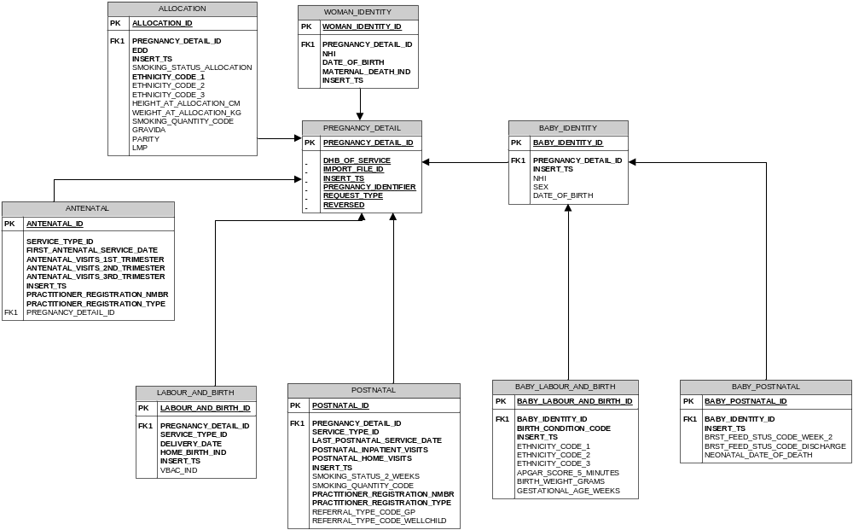

APPENDICES

Appendix A: Definitions, Glossary and References

For the purposes of this document the following terms, acronyms and abbreviations have the specific meaning as listed in the definition below:

Abbreviation/Term | Description
DHB | District Health Board
DHB of Service | The DHB that is responsible for providing the primary maternity service
EDD | Estimated Date of Delivery  The latest Estimated Date of Delivery for the woman that has been recorded during the antenatal period.
Gravida | The number of pregnancies for the woman, including the current one.
GUID | Globally Unique Identifier (or 'Universally Unique Identifier'). A GUID is a 128-bit integer number commonly used as an identifier in software for things such as database keys. The value of a GUID is represented as a 32-character hexadecimal string, such as {21EC2020-3AEA-1069-A2DD-08002B30309D}
HPI | Health Practitioner Index  The HPI is the central source of core information about all registered practitioners.
LMP | Last Menstrual Period
Module | A pregnancy is divided into modules of care. i.e.  - Allocation  - Antenatal  - Labour and Birth  - Postnatal
NHI | National Health Index
NHI Number | The primary unique lifetime identifier for all New Zealand that takes precedence over all other identifiers for consumers of health care services
MOH | Ministry of Health
ODS | Operational Data System  In the context of DHB Primary Maternity data the ODS is the system that collects valid data. Collected data is subsequently transferred to the Maternity Collection Data Warehouse (MAT) where it is used for reporting and analysis.
Parity | The number of times a woman has borne children counting multiple births as one and including stillbirths.
Record | A record constitutes a DHB’s data for a pregnancy. A record may contain all the data for the pregnancy if the DHB provided all the care and services related to the pregnancy. If more than one DHB provided care and/or services there would be more than one record for the pregnancy each containing the modules for which the relevant DHB provided care and/or services.
SFTP | SSH File Transfer Protocol.  A network protocol that provides file access, file transfer, and file management functionality over any reliable data stream.
Submitter | An organisation that submits an extract file containing DHB Primary Maternity Service data.  The organisation may be a DHB or a representative acting on behalf of a DHB.
VBAC | Vaginal birth after previous birth by caesarean section and no previous vaginal birth
Verified | The Verified attribute of data elements in the Extract File is a Boolean indicator that the DHB may use to confirm that the value for the element being submitted is legitimately outside the permissible range.

Appendix B: NHI Number Validation
To establish if an NHI Number is valid or not, the provider should use the following validation routine below.
Validation Steps
Step | Description | Example: EPT6335 | Example: CGC2720 | Example: DAB8233
1 | Alphabetic characters must be within the Alphabet Conversion Table (see above), that is, they aren’t ‘I’ or ‘O’. | EPT | CGC | DAB
2 | NNNC numbers must be numeric. | 6335 | 2720 | 8233
3 | Assign first alpha character its corresponding value from the Alphabet Conversion Table and multiply value by 7. | 5*7 = 35 | 3*7 = 21 | 4*7 = 28
4 | Assign second alpha character its corresponding value from the Alphabet Conversion Table and multiply value by 6. | 14*6 = 84 | 7*6 = 42 | 1*6 = 6
5 | Assign third alpha character its corresponding value from the Alphabet Conversion Table and multiply value by 5. | 18*5 = 90 | 3*5 = 15 | 2*5 = 10
6 | Multiply first number by 4. | 6*4 = 24 | 2*4 = 8 | 8*4 = 32
7 | Multiply second number by 3. | 3*3 = 9 | 7*3 = 21 | 2*3 = 6
8 | Multiply third number by 2. | 3*2 = 6 | 2*2 = 4 | 3*2 = 6
9 | Total the results of steps 3 to 8. | 35+84+90+24+9+6 = 248 | 21+42+15+8+21+4 = 111 | 28+6+10+32+6+6 = 88
10 | Apply modulus 11 to create a checksum.  NB: Excel has a modulus function MOD (n,d) where n is the number to be converted (eg the sum calculated in step 9), and d equals the modulus (in the case of the NHI this is 11). | 248/11 =22 r 6  (6 is the checksum) | 111/11 = 10 r 1  (1 is the checksum) | 88/11 = 8 r 0  (0 is the checksum)
11 | If checksum is ‘0’ then the NHI number is not used. | Continue to step 12 | Continue to step 12 | NHI number bad.  Continue to step 15.
12 | Subtract checksum from 11 to create check digit. | 11-6 = 5 | 11-1 = 10
13 | If the check digit equals ‘10’ convert to ‘0’ | Continue to step 14 | Convert ‘10’ to ‘0’
14 | Fourth number must equal the checksum. | 5 = 5 | 0 = 0
15 | NHI number passes the NHI validation routine. | Yes | Yes | No (see note 1)
Note 1: No digit can be added to the end of the NHI to create a valid NHI number
Alpha Conversion Table
Use this table to determine the Alpha characters value within the NHI Validation Routine.
A | 1 | K | 10 | U | 19
B | 2 | L | 11 | V | 20
C | 3 | M | 12 | W | 21
D | 4 | N | 13 | X | 22
E | 5 | P | 14 | Y | 23
F | 6 | Q | 15 | Z | 24
G | 7 | R | 16
H | 8 | S | 17
J | 9 | T | 18

This validation routine allows health and disability support services to confirm the NHI is in the correct format and that it is a valid NHI number. Its main purpose is to identify mistyped NHI numbers.
The validation routine does not confirm that a health and disability support services has assigned the NHI number to a correct individual. Nor does it mean the NHI number has been registered, on the NHI. For example pre-allocated NHI numbers are not ‘active’ until they have been sent to the NHI in the registration transaction (NEWHCU).

Appendix C: Ethnicity Data Protocols
For details refer to the Ethnicity Data Protocols for the Health and Disability sector on HNZ website.
Ethnicity – Health New Zealand | Te Whatu Ora
C.1 Level 4 Ethnicity Codes
The table below shows the full set of Level 4 codes

Level 4 Ethnicity Codes
Code | Description
10000 | European NFD
11111 | New Zealand European / Päkehä
12000 | Other European NFD
12100 | British NFD
12111 | Celtic
12112 | Channel Islander
12113 | Cornish
12114 | English
12115 | Gaelic
12116 | Irish
12117 | Manx
12118 | Orkney Islander
12119 | Scottish (Scots)
12120 | Shetland Islander
12121 | Welsh
12199 | British NEC
12211 | Dutch / Netherlands
12311 | Greek (including Greek Cypriot)
12411 | Polish
12500 | South Slav (formerly Yugoslav groups) NFD
12511 | Croat / Croatian
12512 | Dalmatian
12513 | Macedonian
12514 | Serb / Serbian
12515 | Slovene / Slovenian
12599 | South Slav (formerly Yugoslav) NEC
12611 | Italian
12711 | German
12811 | Australian
12911 | Albanian
12912 | Armenian
12913 | Austrian
12914 | Belgian
12915 | Bulgarian
12916 | Byelorussian
12917 | Corsican
12918 | Cypriot Unspecified
12919 | Czech
12920 | Danish
12921 | Estonian
12922 | Finnish
12923 | Flemish
12924 | French
12925 | Greenlander
12926 | Hungarian
12927 | Icelander
12928 | Latvian
12929 | Lithuanian
12930 | Maltese
12931 | Norwegian
12932 | Portuguese
12933 | Romanian / Rumanian
12934 | Romany / Gypsy
12935 | Russian
12936 | Sardinian
12937 | Slavic / Slav
12938 | Slovak
12939 | Spanish
12940 | Swedish
12941 | Swiss
12942 | Ukrainian
12943 | American (US)
12944 | Burgher
12945 | Canadian
12946 | Falkland Islander / Kelper
12947 | New Caledonian
12948 | South African
12999 | European NEC
21111 | Mäori
30000 | Pacific peoples NFD
31111 | Samoan
32100 | Cook Island Maori NFD
32111 | Aitutaki Islander
32112 | Atiu Islander
32113 | Mangaia Islander
32114 | Manihiki Islander
32115 | Mauke Islander
32116 | Mitiaro Islander
32117 | Palmerston Islander
32118 | Penrhyn Islander
32119 | Pukapuka Islander
32120 | Rakahanga Islander
32121 | Rarotongan
33111 | Tongan
34111 | Niuean
35111 | Tokelauan
36111 | Fijian (except Fiji Indian / Indo-Fijian)
37100 | Other Pacific peoples NFD
37111 | Admiralty Islander
37112 | Australian Aboriginal
37113 | Austral Islander
37114 | Belau / Palau Islander
37115 | Bismark Archipelagoan
37116 | Bougainvillean
37117 | Caroline Islander
37118 | Easter Islander
37119 | Gambier Islander
37120 | Guadalcanalian
37121 | Guam Islander / Chamorro
37122 | Hawaiian
37123 | Kanaka / Kanak
37124 | I-Kiribati / Gilbertese
37125 | Malaitian
37126 | Manus Islander
37127 | Marianas Islander
37128 | Marquesas Islander
37129 | Marshall Islander
37130 | Nauru Islander
37131 | New Britain Islander
37132 | New Georgian
37133 | New Irelander
37134 | Ocean Islander / Banaban
37135 | Papuan / New Guinean / Irian Jayan
37136 | Phoenix Islander
37137 | Pitcairn Islander
37138 | Rotuman / Rotuman Islander
37139 | Santa Cruz Islander
37140 | Society Islander (including Tahitian)
37141 | Solomon Islander
37142 | Torres Strait Islander / Thursday Islander
37143 | Tuamotu Islander
37144 | Tuvalu Islander / Ellice Islander
37145 | Vanuatu Islander / New Hebridean
37146 | Wake Islander
37147 | Wallis Islander
37148 | Yap Islander
37199 | Other Pacific peoples NEC
40000 | Asian NFD
41000 | Southeast Asian NFD
41111 | Filipino
41211 | Khmer / Kampuchean / Cambodian
41311 | Vietnamese
41411 | Burmese
41412 | Indonesian (including Javanese / Sundanese / Sumatran)
41413 | Lao / Laotian
41414 | Malay / Malayan
41415 | Thai / Tai / Siamese
41499 | Other Southeast Asian NEC
42100 | Chinese NFD
42111 | Hong Kong Chinese
42112 | Kampuchean Chinese
42113 | Malaysian Chinese
42114 | Singaporean Chinese
42115 | Vietnamese Chinese
42116 | Taiwanese Chinese
42199 | Chinese NEC
43100 | Indian NFD
43111 | Bengali
43112 | Fijian Indian / Indo-Fijian
43113 | Gujarati
43114 | Tamil
43115 | Punjabi
43116 | Sikh
43199 | Indian NEC
44100 | Sri Lankan NFD
44111 | Sinhalese
44112 | Sri Lankan Tamil
44199 | Sri Lankan NEC
44211 | Japanese
44311 | Korean
44411 | Afghani
44412 | Bangladeshi
44413 | Nepalese
44414 | Pakistani
44415 | Tibetan
44499 | Other Asian NEC
51100 | Middle Eastern NFD
51111 | Algerian
51112 | Arab
51113 | Assyrian
51114 | Egyptian
51115 | Iranian / Persian
51116 | Iraqi
51117 | Israeli / Jewish / Hebrew
51118 | Jordanian
51119 | Kurd
51120 | Lebanese
51121 | Libyan
51122 | Moroccan
51123 | Omani
51124 | Palestinian
51125 | Syrian
51126 | Tunisian
51127 | Turkish (including Turkish Cypriot)
51128 | Yemeni
51199 | Middle Eastern NEC
52100 | Latin American / Hispanic NFD
52111 | Argentinian
52112 | Bolivian
52113 | Brazilian
52114 | Chilean
52115 | Colombian
52116 | Costa Rican
52117 | Creole (Latin America)
52118 | Ecuadorian
52119 | Guatemalan
52120 | Guyanese
52121 | Honduran
52122 | Malvinian (Spanish-speaking Falkland Islander)
52123 | Mexican
52124 | Nicaraguan
52125 | Panamanian
52126 | Paraguayan
52127 | Peruvian
52128 | Puerto Rican
52129 | Uruguayan
52130 | Venezuelan
52199 | Latin American / Hispanic NEC
53100 | African NFD
53111 | Black
53112 | Creole (US)
53113 | Jamaican
53114 | Kenyan
53115 | Nigerian
53116 | African American
53117 | Ugandan
53118 | West Indian / Caribbean
53119 | Somali
53199 | Other African NEC
54100 | Other NFD
54111 | Central American Indian
54112 | Inuit / Eskimo
54113 | Mauritian
54114 | North American Indian
54115 | Seychelles Islander
54116 | South American Indian
54199 | Other NEC
96666 | Repeated value
97777 | Response unidentifiable
98888 | Response outside scope
99999 | Not stated

C.2 Level 4 to Level 2 Mapping
If the DHB holds ethnicity data as Level 2 ethnicity codes, the table below shows how to convert a Level 2 code to a Level 4 code for MAT ODS.

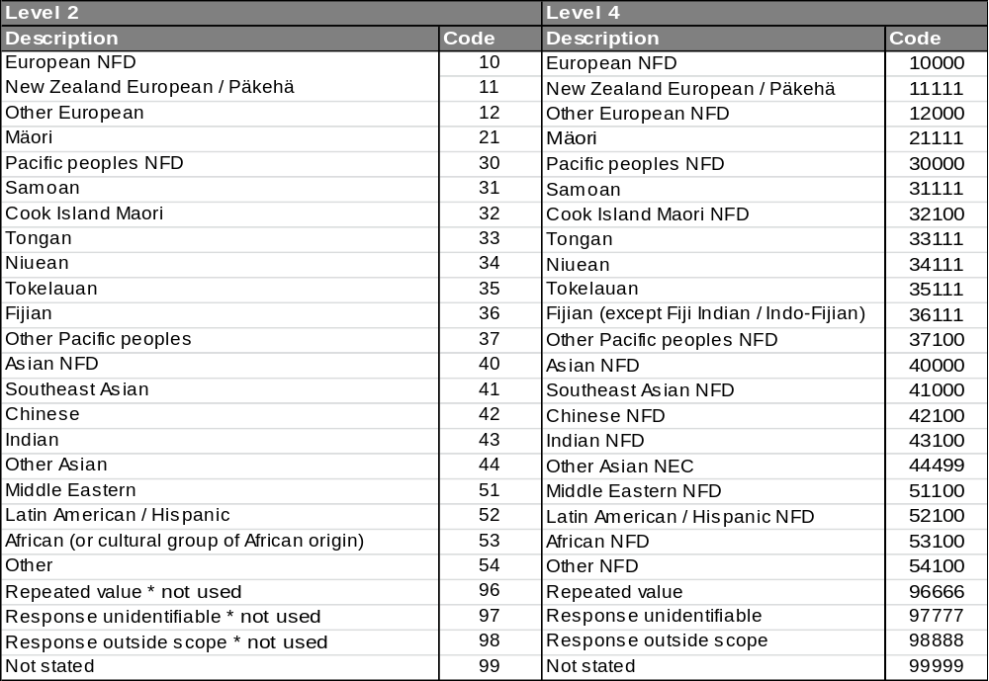

Appendix D: Extract File Structure Summary
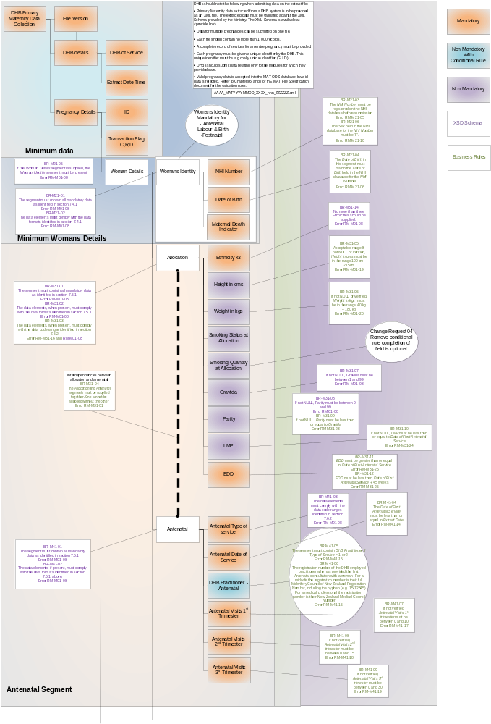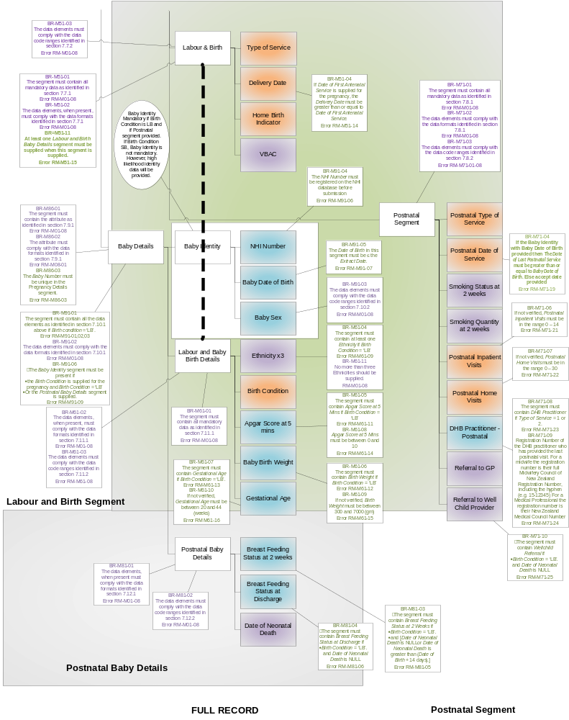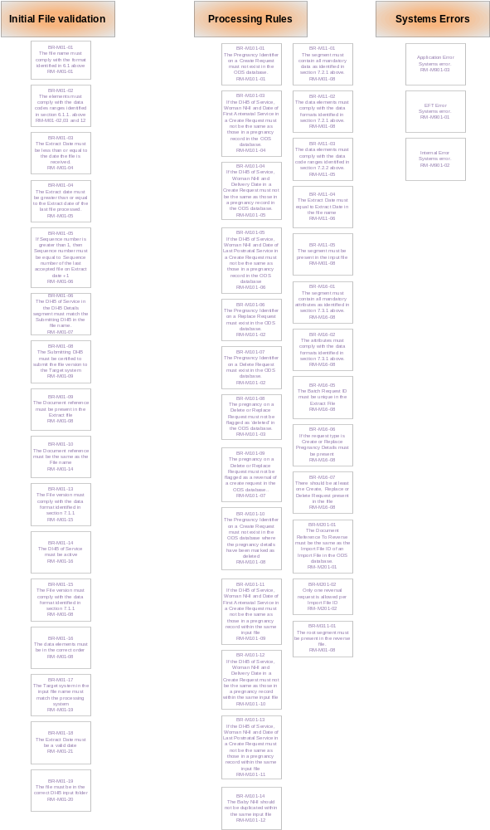

Appendix E: System Errors

The following errors will be delivered to the Error folder. They will not be returned to the DHB.

Response Message Reference | Error or  Warning | Message  Title | Response  Message
RM-M901-01 | Error | Error – System Error | - EFT error - Input file has been placed in the wrong DHB / Submitter’s directory [directory]
RM-M901-02 | Error | Error – System Error | - Internal error - [error description]
RM-M901-03 | Error | Error – System Error | - Application error - [error description]

Appendix F: Related Documents/Files

Document/File | Version
DHB Primary Maternity Data Collection Detailed Business Requirements | 1.1
DHB_Primary_Maternity_Data_Collection_v1.0.xsd | 1.0
DHB_Primary_Maternity_Data_Collection_Acknowledgement_v1.0.xsd | 1.0
DHB_Primary_Maternity_Common_Types_v1.0.xsd | 1.0
DHB_Primary_Maternity_Data_Collection_Reversal_v1.0.xsd | 1.0
DHB_Primary_Maternity_Data_Collection_Reversal_Acknowledgement_v1.0.xsd | 1.0

Appendix G: Examples

G.1 File rejected because of XSD schema errors

G1.1 Extract file

<?xml version="1.0" encoding="utf-8"?>
<mat:DHB_Primary_Maternity_Data_Collection_Document xmlns:xsi="http://www.w3.org/2001/XMLSchema-instance"
xmlns:mat="http://moh.govt.nz/maternity/v1.0"
File_Version="1.00"
Document_Reference="TEST_MAT20120831_3061_001_EXTRACT.xml"
xsi:schemaLocation="http://moh.govt.nz/maternity/v1.0 ./xsd/DHB_Primary_Maternity_Data_Collection_v1.0.xsd">
<mat:DHB_Details>
<mat:DHB_Of_Service>3061</mat:DHB_Of_Service>
<mat:Extract_DateTime>2012-08-31T09:14:30</mat:Extract_DateTime>
</mat:DHB_Details>
<mat:Create_Request PregnancyIdentifier="4d473add-feb4-4225-938b-baf9ff54026f" BatchRequestId="1">
<mat:Pregnancy_Details>
<mat:Woman_Details>
<mat:Woman_Identity>
<mat:NHI_Number>Test NHI</mat:NHI_Number>
<mat:Date_Of_Birth>1973-03-13-TEST</mat:Date_Of_Birth>
<mat:Maternal_Death_Indicator>false</mat:Maternal_Death_Indicator>
</mat:Woman_Identity>
<mat:Allocation>
<mat:Ethnicity>21111</mat:Ethnicity>
<mat:Smoking_Status_At_Allocation>true</mat:Smoking_Status_At_Allocation>
<mat:Smoking_Quantity_At_Allocation>L</mat:Smoking_Quantity_At_Allocation>
<mat:Gravida>1</mat:Gravida>
<mat:Parity>5</mat:Parity>
<mat:LMP>2010-05-20</mat:LMP>
<mat:EDD>2011-02-24</mat:EDD>
</mat:Allocation>
<mat:Labour_And_Birth>
<mat:Type_Of_Service>1</mat:Type_Of_Service>
<mat:Delivery_Date>2011-02-24</mat:Delivery_Date>
<mat:HomeBirth_Indicator>false</mat:HomeBirth_Indicator>
</mat:Labour_And_Birth>
<mat:Postnatal>
<mat:Type_Of_Service>1</mat:Type_Of_Service>
<mat:Date_Of_Last_Postnatal_Service>2011-04-07</mat:Date_Of_Last_Postnatal_Service>
<mat:Smoking_Status_At_2_Weeks>true</mat:Smoking_Status_At_2_Weeks>
<mat:Smoking_Quantity_At_2_Weeks>M</mat:Smoking_Quantity_At_2_Weeks>
<mat:Postnatal_Inpatient_Visits isVerified="true">1</mat:Postnatal_Inpatient_Visits>
<mat:Postnatal_Home_Visits isVerified="true">7</mat:Postnatal_Home_Visits>
<mat:DHB_Practitioner>163886</mat:DHB_Practitioner>
<mat:GP_Referral>Y</mat:GP_Referral>
<mat:Wellchild_Referral>P</mat:Wellchild_Referral>
</mat:Postnatal>
</mat:Woman_Details>
<mat:Baby_Details Baby_Number="1">
<mat:Baby_Identity>
<mat:NHI_Number>Test NHI</mat:NHI_Number>
<mat:Date_Of_Birth>2011-02-24-1</mat:Date_Of_Birth>
<mat:Sex>M</mat:Sex>
</mat:Baby_Identity>
<mat:Labour_And_Birth_Baby_Details>
<mat:Ethnicity>21111</mat:Ethnicity>
<mat:Birth_Condition>LB</mat:Birth_Condition>
<mat:Apgar_Score_At_5_Mins>9</mat:Apgar_Score_At_5_Mins>
<mat:Birth_Weight isVerified="true">28101</mat:Birth_Weight>
<mat:Gestational_Age isVerified="true">40</mat:Gestational_Age>
</mat:Labour_And_Birth_Baby_Details>
<mat:Postnatal_Baby_Details>
<mat:Breast_Feeding_Status_At_2_Weeks>Partial1</mat:Breast_Feeding_Status_At_2_Weeks>
<mat:Breast_Feeding_Status_At_Discharge>Partial</mat:Breast_Feeding_Status_At_Discharge>
</mat:Postnatal_Baby_Details>
</mat:Baby_Details>
</mat:Pregnancy_Details>
</mat:Create_Request>
</mat:DHB_Primary_Maternity_Data_Collection_Document>

G1.2 Response file

<?xml version="1.0" encoding="UTF-8" standalone="yes"?>
<DHB_Primary_Maternity_Data_Collection_Acknowledgement xmlns="http://moh.govt.nz/maternity/v1.0" Document_Reference="TEST_MAT20120831_3061_001_EXTRACT.xml" File_Version="1.00">
<Status>REJECTED</Status>
<Error>
<Error_Reference>RM-M01-08</Error_Reference>
<Error_Title>Error - Invalid Data, on Line number 15</Error_Title>
<Error_Message>cvc-maxLength-valid: Value 'LMC4295_TEST' with length = '12' is not facet-valid with respect to maxLength '10' for type 'NHIType'.</Error_Message>
</Error>
<Error>
<Error_Reference>RM-M01-08</Error_Reference>
<Error_Title>Error - Invalid Data, on Line number 15</Error_Title>
<Error_Message>cvc-type.3.1.3: The value Test NHI of element 'mat:NHI_Number' is not valid.</Error_Message>
</Error>
<Error>
<Error_Reference>RM-M01-08</Error_Reference>
<Error_Title>Error - Invalid Data, on Line number 16</Error_Title>
<Error_Message>Error in parsing time zone: '1973-03-13-TEST'.</Error_Message>
</Error>
<Error>
<Error_Reference>RM-M01-08</Error_Reference>
<Error_Title>Error - Invalid Data, on Line number 16</Error_Title>
<Error_Message>cvc-datatype-valid.1.2.1: '1973-03-13-TEST' is not a valid value for 'date'.</Error_Message>
</Error>
<Error>
<Error_Reference>RM-M01-08</Error_Reference>
<Error_Title>Error - Invalid Data, on Line number 16</Error_Title>
<Error_Message>cvc-type.3.1.3: The value '1973-03-13-TEST' of element 'mat:Date_Of_Birth' is not valid.</Error_Message>
</Error>
<Error>
<Error_Reference>RM-M01-08</Error_Reference>
<Error_Title>Error - Invalid Data, on Line number 48</Error_Title>
<Error_Message>Error in parsing time zone: '2011-02-24-1'.</Error_Message>
</Error>
<Error>
<Error_Reference>RM-M01-08</Error_Reference>
<Error_Title>Error - Invalid Data, on Line number 48</Error_Title>
<Error_Message>cvc-datatype-valid.1.2.1: '2011-02-24-1' is not a valid value for 'date'.</Error_Message>
</Error>
<Error>
<Error_Reference>RM-M01-08</Error_Reference>
<Error_Title>Error - Invalid Data, on Line number 48</Error_Title>
<Error_Message>cvc-type.3.1.3: The value '2011-02-24-1' of element 'mat:Date_Of_Birth' is not valid.</Error_Message>
</Error>
<Error>
<Error_Reference>RM-M01-08</Error_Reference>
<Error_Title>Error - Invalid Data, on Line number 55</Error_Title>
<Error_Message>cvc-maxInclusive-valid: Value '28101' is not facet-valid with respect to maxInclusive '9999' for type 'Weight_In_gmsBaseType'.</Error_Message>
</Error>
<Error>
<Error_Reference>RM-M01-08</Error_Reference>
<Error_Title>Error - Invalid Data, on Line number 55</Error_Title>
<Error_Message>cvc-complex-type.2.2: Element 'mat:Birth_Weight' must have no element [children], and the value must be valid.</Error_Message>
</Error>
<Error>
<Error_Reference>RM-M01-08</Error_Reference>
<Error_Title>Error - Invalid Data, on Line number 59</Error_Title>
<Error_Message>cvc-enumeration-valid: Value 'Partial1' is not facet-valid with respect to enumeration '[Exclusive, Fully, Partial, Artificial]'. It must be a value from the enumeration.</Error_Message>
</Error>
<Error>
<Error_Reference>RM-M01-08</Error_Reference>
<Error_Title>Error - Invalid Data, on Line number 59</Error_Title>
<Error_Message>cvc-type.3.1.3: The value 'Partial1' of element 'mat:Breast_Feeding_Status_At_2_Weeks' is not valid.</Error_Message>
</Error>
<Number_Of_Create_Requests_Received>1</Number_Of_Create_Requests_Received>
<Number_Of_Create_Requests_Rejected>1</Number_Of_Create_Requests_Rejected>
<Number_Of_Replace_Requests_Received>0</Number_Of_Replace_Requests_Received>
<Number_Of_Replace_Requests_Rejected>0</Number_Of_Replace_Requests_Rejected>
<Number_Of_Delete_Requests_Received>0</Number_Of_Delete_Requests_Received>
<Number_Of_Delete_Requests_Rejected>0</Number_Of_Delete_Requests_Rejected>
<Processing_DateTime>2012-11-26T11:50:07.091+13:00</Processing_DateTime>
<DHB_Details>
<DHB_Of_Service>3061</DHB_Of_Service>
<Extract_DateTime>2012-08-31T09:14:30+12:00</Extract_DateTime>
</DHB_Details>
</DHB_Primary_Maternity_Data_Collection_Acknowledgement>

G1.3 Report

DHB Primary Maternity Service Data Collection File Submission Report
 | Submitting Organisation: | Capital and Coast DHB
 | Extract File Name: | TEST_MAT20120831_3061_001_EXTRACT.xml
 | Extract Date: | 31/08/2012
 | Processing Date: | 26/11/2012
 | File Status: | REJECTED

 | Data Validation Error Summary
Error Reference |  | Error Message | Count | Affected NHI
RM-M01-08 |  | cvc-maxLength-valid: Value Test NHI' with length = '12' is not facet-valid with respect to maxLength '10' for type 'NHIType'. | 1
RM-M01-08 |  | cvc-type.3.1.3: The value Test NHI' of element 'mat:NHI_Number' is not valid. | 1
RM-M01-08 |  | Error in parsing time zone: '1973-03-13-TEST'. | 1
RM-M01-08 |  | cvc-datatype-valid.1.2.1: '1973-03-13-TEST' is not a valid value for 'date'. | 1
RM-M01-08 |  | cvc-type.3.1.3: The value '1973-03-13-TEST' of element 'mat:Date_Of_Birth' is not valid. | 1
RM-M01-08 |  | Error in parsing time zone: '2011-02-24-1'. | 1
RM-M01-08 |  | cvc-datatype-valid.1.2.1: '2011-02-24-1' is not a valid value for 'date'. | 1
RM-M01-08 |  | cvc-type.3.1.3: The value '2011-02-24-1' of element 'mat:Date_Of_Birth' is not valid. | 1
RM-M01-08 |  | cvc-maxInclusive-valid: Value '28101' is not facet-valid with respect to maxInclusive '9999' for type 'Weight_In_gmsBaseType'. | 1
RM-M01-08 |  | cvc-complex-type.2.2: Element 'mat:Birth_Weight' must have no element [children], and the value must be valid. | 1
RM-M01-08 |  | cvc-enumeration-valid: Value 'Partial1' is not facet-valid with respect to enumeration '[Exclusive, Fully, Partial, Artificial]'. It must be a value from the enumeration. | 1
RM-M01-08 |  | cvc-type.3.1.3: The value 'Partial1' of element 'mat:Breast_Feeding_Status_At_2_Weeks' is not valid. | 1
Total |  |  | 12

G.2 File with test data

G2.1 Extract file

<?xml version="1.0" encoding="utf-8"?>
<mat:DHB_Primary_Maternity_Data_Collection_Document xmlns:xsi="http://www.w3.org/2001/XMLSchema-instance" xmlns:mat="http://moh.govt.nz/maternity/v1.0"
Document_Reference="TEST_MAT20120831_3061_001_EXTRACT.xml" File_Version="1.00"
xsi:schemaLocation="http://moh.govt.nz/maternity/v1.0
file:///X:/Workspaces/Testing%20Services/Projects/DHB%20Primary%20Maternity%20Data/Mat%20XML%20Files/Sample%20Mat%20files/Latest%20XSD/DHB_Primary_Maternity_Data_Collection_v0_10.xsd">
<mat:DHB_Details>
<mat:DHB_Of_Service>3061</mat:DHB_Of_Service>
<mat:Extract_DateTime>2012-08-31T09:14:30</mat:Extract_DateTime>
</mat:DHB_Details>
<mat:Create_Request PregnancyIdentifier="2103bfab-b1ad-4566-b087-44228c47186d" BatchRequestId="1">
<mat:Pregnancy_Details>
<mat:Woman_Details>
<mat:Woman_Identity>
<mat:NHI_Number>Test NHI</mat:NHI_Number>
<mat:Date_Of_Birth>1983-01-04</mat:Date_Of_Birth>
<mat:Maternal_Death_Indicator>false</mat:Maternal_Death_Indicator>
</mat:Woman_Identity>
<mat:Allocation>
<mat:Ethnicity>21111</mat:Ethnicity>
<mat:Height_In_cms isVerified="true">161</mat:Height_In_cms>
<mat:Smoking_Status_At_Allocation>true</mat:Smoking_Status_At_Allocation>
<mat:Smoking_Quantity_At_Allocation>L</mat:Smoking_Quantity_At_Allocation>
<mat:Gravida>4</mat:Gravida>
<mat:Parity>3</mat:Parity>
<mat:LMP>2010-01-25</mat:LMP>
<mat:EDD>2010-11-01</mat:EDD>
</mat:Allocation>
<mat:Antenatal>
<mat:Type_Of_Service>1</mat:Type_Of_Service>
<mat:Date_Of_First_Antenatal_Service>2010-03-17</mat:Date_Of_First_Antenatal_Service>
<mat:DHB_Practitioner>163886</mat:DHB_Practitioner>
<mat:Antenatal_Visits_1st_Trimester isVerified="true">0</mat:Antenatal_Visits_1st_Trimester>
<mat:Antenatal_Visits_2nd_Trimester isVerified="true">1</mat:Antenatal_Visits_2nd_Trimester>
<mat:Antenatal_Visits_3rd_Trimester isVerified="true">8</mat:Antenatal_Visits_3rd_Trimester>
</mat:Antenatal>
<mat:Labour_And_Birth>
<mat:Type_Of_Service>1</mat:Type_Of_Service>
<mat:Delivery_Date>2010-11-03</mat:Delivery_Date>
<mat:HomeBirth_Indicator>false</mat:HomeBirth_Indicator>
<mat:VBAC_Indicator>false</mat:VBAC_Indicator>
</mat:Labour_And_Birth>
<mat:Postnatal>
<mat:Type_Of_Service>1</mat:Type_Of_Service>
<mat:Date_Of_Last_Postnatal_Service>2010-12-06</mat:Date_Of_Last_Postnatal_Service>
<mat:Smoking_Status_At_2_Weeks>false</mat:Smoking_Status_At_2_Weeks>
<mat:Postnatal_Inpatient_Visits isVerified="true">2</mat:Postnatal_Inpatient_Visits>
<mat:Postnatal_Home_Visits isVerified="true">4</mat:Postnatal_Home_Visits>
<mat:DHB_Practitioner>163886</mat:DHB_Practitioner>
<mat:GP_Referral>Y</mat:GP_Referral>
<mat:Wellchild_Referral>P</mat:Wellchild_Referral>
</mat:Postnatal>
</mat:Woman_Details>
<mat:Baby_Details Baby_Number="1">
<mat:Baby_Identity>
<mat:NHI_Number> Test NHI </mat:NHI_Number>
<mat:Date_Of_Birth>2010-11-03</mat:Date_Of_Birth>
<mat:Sex>M</mat:Sex>
</mat:Baby_Identity>
<mat:Labour_And_Birth_Baby_Details>
<mat:Ethnicity>21111</mat:Ethnicity>
<mat:Birth_Condition>LB</mat:Birth_Condition>
<mat:Apgar_Score_At_5_Mins>9</mat:Apgar_Score_At_5_Mins>
<mat:Birth_Weight isVerified="true">3145</mat:Birth_Weight>
<mat:Gestational_Age isVerified="true">40</mat:Gestational_Age>
</mat:Labour_And_Birth_Baby_Details>
<mat:Postnatal_Baby_Details>
<mat:Breast_Feeding_Status_At_2_Weeks>Partial</mat:Breast_Feeding_Status_At_2_Weeks>
<mat:Breast_Feeding_Status_At_Discharge>Partial</mat:Breast_Feeding_Status_At_Discharge>
</mat:Postnatal_Baby_Details>
</mat:Baby_Details>
</mat:Pregnancy_Details>
</mat:Create_Request>
<mat:Replace_Request PregnancyIdentifier="97b81bd4-828d-466b-8ca8-29fa5936b6fa" BatchRequestId="2">
<mat:Pregnancy_Details>
<mat:Woman_Details>
<mat:Woman_Identity>
<mat:NHI_Number> Test NHI </mat:NHI_Number>
<mat:Date_Of_Birth>1975-09-24</mat:Date_Of_Birth>
<mat:Maternal_Death_Indicator>false</mat:Maternal_Death_Indicator>
</mat:Woman_Identity>
<mat:Allocation>
<mat:Ethnicity>21111</mat:Ethnicity>
<mat:Height_In_cms isVerified="true">174</mat:Height_In_cms>
<mat:Weight_In_Kgs isVerified="true">71</mat:Weight_In_Kgs>
<mat:Smoking_Status_At_Allocation>true</mat:Smoking_Status_At_Allocation>
<mat:Smoking_Quantity_At_Allocation>M</mat:Smoking_Quantity_At_Allocation>
<mat:Gravida>7</mat:Gravida>
<mat:Parity>3</mat:Parity>
<mat:LMP>2010-04-02</mat:LMP>
<mat:EDD>2011-01-07</mat:EDD>
</mat:Allocation>
<mat:Antenatal>
<mat:Type_Of_Service>1</mat:Type_Of_Service>
<mat:Date_Of_First_Antenatal_Service>2010-09-08</mat:Date_Of_First_Antenatal_Service>
<mat:DHB_Practitioner>163886</mat:DHB_Practitioner>
<mat:Antenatal_Visits_1st_Trimester isVerified="true">0</mat:Antenatal_Visits_1st_Trimester>
<mat:Antenatal_Visits_2nd_Trimester isVerified="true">1</mat:Antenatal_Visits_2nd_Trimester>
<mat:Antenatal_Visits_3rd_Trimester isVerified="true">4</mat:Antenatal_Visits_3rd_Trimester>
</mat:Antenatal>
<mat:Labour_And_Birth>
<mat:Type_Of_Service>1</mat:Type_Of_Service>
<mat:Delivery_Date>2010-12-25</mat:Delivery_Date>
<mat:HomeBirth_Indicator>false</mat:HomeBirth_Indicator>
</mat:Labour_And_Birth>
<mat:Postnatal>
<mat:Type_Of_Service>1</mat:Type_Of_Service>
<mat:Date_Of_Last_Postnatal_Service>2011-01-15</mat:Date_Of_Last_Postnatal_Service>
<mat:Smoking_Status_At_2_Weeks>true</mat:Smoking_Status_At_2_Weeks>
<mat:Smoking_Quantity_At_2_Weeks>L</mat:Smoking_Quantity_At_2_Weeks>
<mat:Postnatal_Inpatient_Visits isVerified="true">3</mat:Postnatal_Inpatient_Visits>
<mat:Postnatal_Home_Visits isVerified="true">7</mat:Postnatal_Home_Visits>
<mat:DHB_Practitioner>163886</mat:DHB_Practitioner>
<mat:GP_Referral>Y</mat:GP_Referral>
<mat:Wellchild_Referral>P</mat:Wellchild_Referral>
</mat:Postnatal>
</mat:Woman_Details>
<mat:Baby_Details Baby_Number="1">
<mat:Baby_Identity>
<mat:NHI_Number> Test NHI </mat:NHI_Number>
<mat:Date_Of_Birth>2010-12-25</mat:Date_Of_Birth>
<mat:Sex>F</mat:Sex>
</mat:Baby_Identity>
<mat:Labour_And_Birth_Baby_Details>
<mat:Ethnicity>21111</mat:Ethnicity>
<mat:Birth_Condition>LB</mat:Birth_Condition>
<mat:Apgar_Score_At_5_Mins>8</mat:Apgar_Score_At_5_Mins>
<mat:Birth_Weight isVerified="true">3135</mat:Birth_Weight>
<mat:Gestational_Age isVerified="true">38</mat:Gestational_Age>
</mat:Labour_And_Birth_Baby_Details>
<mat:Postnatal_Baby_Details>
<mat:Breast_Feeding_Status_At_2_Weeks>Exclusive</mat:Breast_Feeding_Status_At_2_Weeks>
<mat:Breast_Feeding_Status_At_Discharge>Exclusive</mat:Breast_Feeding_Status_At_Discharge>
</mat:Postnatal_Baby_Details>
</mat:Baby_Details>
</mat:Pregnancy_Details>
</mat:Replace_Request>
<mat:Delete_Request PregnancyIdentifier="ac0e9b5a-d332-45a4-b6d4-7676f216f2be" BatchRequestId="3">
</mat:Delete_Request>
</mat:DHB_Primary_Maternity_Data_Collection_Document>

G2.2 Response file

<?xml version="1.0" encoding="UTF-8" standalone="yes" ?>
<DHB_Primary_Maternity_Data_Collection_Acknowledgement xmlns="http://moh.govt.nz/maternity/v1.0" Document_Reference="TEST_MAT20120831_3061_001_EXTRACT.xml" File_Version="1.00">
<Status>ACCEPTED</Status>
<Number_Of_Create_Requests_Received>1</Number_Of_Create_Requests_Received>
<Number_Of_Create_Requests_Rejected>0</Number_Of_Create_Requests_Rejected>
<Number_Of_Replace_Requests_Received>1</Number_Of_Replace_Requests_Received>
<Number_Of_Replace_Requests_Rejected>0</Number_Of_Replace_Requests_Rejected>
<Number_Of_Delete_Requests_Received>1</Number_Of_Delete_Requests_Received>
<Number_Of_Delete_Requests_Rejected>0</Number_Of_Delete_Requests_Rejected>
<Processing_DateTime>2012-11-26T11:54:57.966+13:00</Processing_DateTime>
<DHB_Details>
<DHB_Of_Service>3061</DHB_Of_Service>
<Extract_DateTime>2012-08-31T09:14:30+12:00</Extract_DateTime>
</DHB_Details>
</DHB_Primary_Maternity_Data_Collection_Acknowledgement>

G2.3 Report

DHB Primary Maternity Service Data Collection File Submission Report
 | Submitting organisation : | Capital and Coast DHB
 | Extract File Name: | TEST_MAT20120831_3061_001_EXTRACT.xml
 | Extract Date: | 31/08/2012
 | Processing Date: | 26/11/2012
 | File Status: | ACCEPTED

 | Data Validation Summary
Requests |  | Received | Accepted | Rejected | Success Rate %
CREATE |  | 1 | 1 | 0 | 100
REPLACE |  | 1 | 1 | 0 | 0
DELETE |  | 1 | 1 | 0 | 0
Total |  | 3 | 3 | 0 | 100

 | Data Validation Error Summary
Error Reference |  | Error Message | Count | Failed NHI
Total |  |  | 0

Appendix H: Reverse File Example
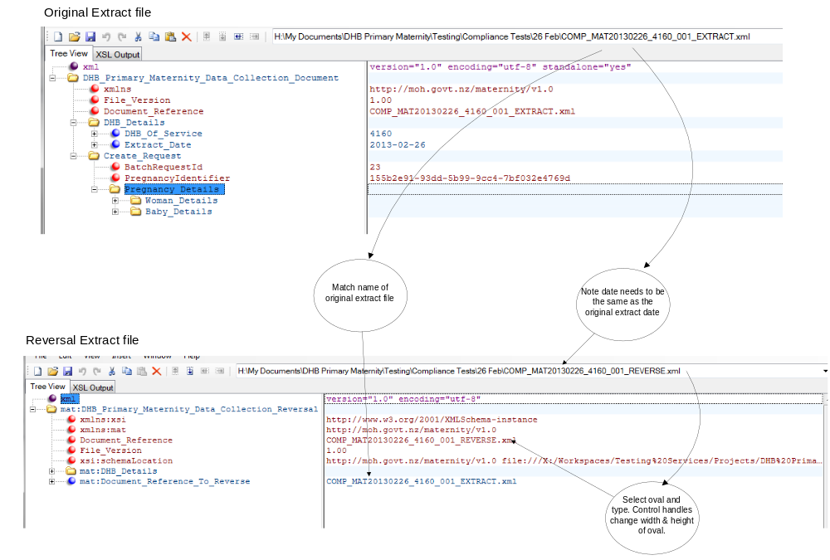

Appendix I: File Specification Version History

Version of File Spec | Date | Change
0.1 |  | Initial version with business rules based on Detailed Business Requirements v0.3 and XSD Schema v0.01
0.2 | 19/03/2012 | Extensive revision of 0.1 content based on review comments and inclusion of new information, business rules based on Detailed Business Requirements v0.5 and XSD Schema v0.05
0.3 | 11/04/2012 | Revisions for business rules and xml schema changes
1.0 | 13/04/2012 | Final version for sign off
2.0 | 22/06/2012 | Amendments to error messages. Inserted data model.
2.1 | 03/07/2012 | Additional error messages
2.2 | 05/07/2012 | Amended text of message RM-M01-06
2.3 | 19/10/2012 | Included ethnicity code Level 2 to Level 4 mapping table in Appendix C
3.0 | 28/11/2012 | Amendments to message numbers. Updates to sample files. Included notation guide in Section 5. Included Extract File Summary Diagram.
3.2 | 23/01/2013 | 5.1.2 & 7.2 Extract Datetime altered to Extract Date 7.5.4 & 7.6.4 RM-M31-01 message text.
3.3 | 8/02/2013 | Added “Important Notes” in section 5. Fixed up minor discrepancies
3.4 | 19/02/2013 | Amendment to RM-M01-06 message text. Inserted file size limit in 4.1.1. Amended report heading in G1.3
3.5 | 27/2/2013 | Example of reversal file added and new business rule RM-M101-13
4.0 | 21/3/2013 | Final
4.1 | 01/10/2014 | CASD 231621 – Amendments to BR-M71-04, RM-M71-19  Also amendments to BR-M31-11 and RM-M31-25
4.2 | 18/05/2016 | Amendments to allow an agent to submit files on behalf of a DHB

Date of Birth for Baby 1 if multiple birth

