The New Zealand Casemix System
An Overview

CASEMIX PROJECT GROUP
December 2015 v1.2

The information contained in this document was deemed to be accurate at the time of distribution.
This document has been developed by Casemix Project Group. The Information within this document may be reproduced in whole or in part for informing relevant stakeholders subject to the inclusion of acknowledgement of the source.

Acknowledgements:
Principal writers of this document were Michael Rains (Principal Analyst, DHB Shared Services) and Tracy Thompson (Senior Analyst – Classification Specialist, Ministry of Health). Comments on early drafts were sought from and provided by the Casemix Project Group, and other District Health Board or Ministry of Health personnel.
Enquiries or comments about the information in this document should be directed to:
Michael Rains – michael.rains@dhbss.health.nz, or
for coding specific questions to: Tracy Thompson – coding_helpdesk@moh.govt.nz or
for advice on using NMDS data to: Angela Pidd – operations@moh.govt.nz

The New Zealand Casemix System – An Overview

ISBN: 978-0-947491-19-2
HP 6283

Produced by the New Zealand Casemix Project Group
Publication December 2015 v1.2
Table of Contents
Introduction 3
Part I: The Idea of Casemix 4
History – Early to Recent 4
Part II: Casemix in General 5
Clinical Coding 6
Diagnosis Related Groups (DRGs) 9
Structure of AR-DRGs 10
National Collection for Admitted Patient Events 17
Updates to the AR-DRG Classification 18
The Grouper 18
Illustration of Relative Cost Profiles and Resource Contributions 18
Part III: Casemix Based Funding in New Zealand 21
Components of New Zealand’s Casemix System 21
How does Casemix Based Funding Fit Amongst all Hospital Funding? 22
New Zealand Casemix Cost Weight Model 22
Review Frequency 24
New Technology and Other Changes Affecting Cost Profiles 24
Co-payment Weights 24
DRG Mappings and NZ DRGs 25
The Casemix Framework Document 25
Encounters on the Pathway to a New Set of Weights 26
Casemix Group and the National Cost Collection and Pricing Programme 26
Aspects of the Wider Funding Framework 27
Implementation in the National Collection 27
Appendix A – New Zealand Casemix Based Funding Early History 28
Appendix B – Further Information and References 29
Appendix C – Glossary of Abbreviations 30

Introduction
The purpose of this document is to provide an overview of the New Zealand Casemix System – how it works and how it is used. It is intended to aid clinical staff, clinical coders, service managers, and other sector participants in understanding the casemix system, the importance of coding, and how it is applied in the funding of hospital admissions.
Casemix concerns the mix of patients treated, as described by a system which aggregates information about patients and treatments into groups based on the health condition or type of procedure. Casemix systems are used for a variety of purposes including hospital planning, clinical reviews, funding, monitoring, benchmarking and management. Internationally they have been implemented in a variety of settings including acute, sub-acute and non-acute care.
This publication is in three parts: the first sketches how casemix arose, the second concerns the casemix concept in general including standard facets of the classifications in use in New Zealand, and the third part describes casemix based funding in New Zealand for public hospital inpatient admissions.

Part I: The Idea of Casemix

History – Early to Recent
The notion of casemix has its roots in ideas extending back now for a century when US surgeon Ernest A Codman proposed some methods of standardisation of outputs of a hospital and his end result system. The idea was to compare outputs and outcomes of hospital stays between different hospitals. He authored a book, “The Product of a Hospital”, first published in 1914, and in an address to the Philadelphia County Medical Society in 1913 said:
“Really the whole hospital problem rests on one question: What happens to the cases?.....We must formulate some method of hospital report showing as nearly as possible what are the results of the treatment obtained at different institutions. This report must be made out and published by each hospital in a uniform manner, so that comparisons will be possible. With such a report as a starting point, those interested can begin to ask questions as to management and efficiency.”
Similar notions are implicit in a study of UK English hospital costs from the mid-60s when it was asked why hospitals with very different bed day or patient numbers could generate similar levels of expenditure. This study was by the then student US economist Martin Feldstein.
This problem remained one of interest in the US and the significant development of Diagnosis Related Groups, or DRGs, commenced in the late 1960s by Professors Robert Fetter, John Thompson, and colleagues at Yale University. This work evolved from Medicare registration requirements and had a heavy dependence on IT developments during the late 60s and 70s in relation to finding a way to measure and cost the output of hospitals.
Several versions of a DRG system were developed, the first in 1973 containing 54 Major Diagnostic Categories (MDCs) comprising 333 DRGs. The final original version in this sequence was developed by Yale University’s Health Systems Management Group and was intended to represent
“an inpatient classification system that differentiated the amount of hospital resources required to provide care and was clinically coherent in the sense that the groups were expected to evoke a set of clinical responses which resulted in a similar pattern of resources.”
The classification finally handed over to the Health Care Financing Administration (HCFA) in the US had 470 DRGs ranging across 23 Major Diagnostic Categories (MDCs).
For further information about New Zealand casemix based funding early history refer to Appendix A.

Part II: Casemix in General
Casemix refers to the range and type of patients treated by a hospital or other health service. A system of output groupings are used based on the clinical coding for the admission or other health service contact and possibly other characteristics of the patient or the event.
The notion of casemix is very general and can apply to a wide selection of health services. Examples include hospital admissions for medical or surgical events, resource planning based on indexing of the results of assessments of a person’s functional capability (InterRAI), or the range of dispensing’s undertaken by pharmacists.
This document will mainly reflect the notion of casemix for patients admitted to a hospital for treatment. However, in this context it has acquired broader connotations of funding, including the tools and information systems used to assist the planning, management and benchmarking of health services. These latter aspects will be addressed in Part III.
Thus a casemix system depends on using:
- a clinical coding classification to provide an electronic record of the clinical notes for each event, and
- a means of grouping each coded event to Diagnosis Related Groups (DRGs) derived from the clinical coding classification being used.
Throughout, the term DRG will be used in a general way, however, especially in Part III, the focus is largely on medical services, surgery, obstetrics, and neonatal services.
The clinical coding classification used in New Zealand is the same as that used in Australia, namely the Australian Modification of the World Health Organizations (WHO) disease publication International Statistical Classification of Diseases and Related Health Problems, Tenth Revision (ICD-10).

The Australian Modification is revised periodically, currently at two-year intervals. The current Edition in use in New Zealand is the 8th Edition which was implemented 1 July 2014. New Zealand uses the Australian-developed DRG set AR-DRG v6.0x developed to work with ICD-10-AM/ACHI 6th Edition.
The clinical coding classification consists of:
- A disease classification – The International Statistical Classification of Diseases and Related Health Problems, Tenth Revision, Australian Modification (ICD-10-AM)
- A procedure classification – The Australian Classification of Health Interventions (ACHI). ACHI is based on the Medicare Benefits Schedule (MBS) (with some exceptions) for use in Australian clinical practice
- Coding standards – The Australian Coding Standards (ACS). The Australian Coding Standards are a set of rules and national standards to provide guidance in the application of ICD-10-AM and ACHI codes and promote consistency in coding practice.
Other jurisdictions that use casemix systems include England, Canada, Ireland, and the Netherlands. Norway and Sweden are part of a Nordic consortium that uses the same Nordic-developed casemix system.
A list of the countries with a Licence Agreement for the AR-DRG Classification System can be found on the website of Australia’s Independent Hospital Pricing Authority (IHPA) click here.

Clinical Coding
This process involves a review of the clinical record so that documented clinical information for an episode of care can be translated into classification codes (ICD-10-AM/ACHI).
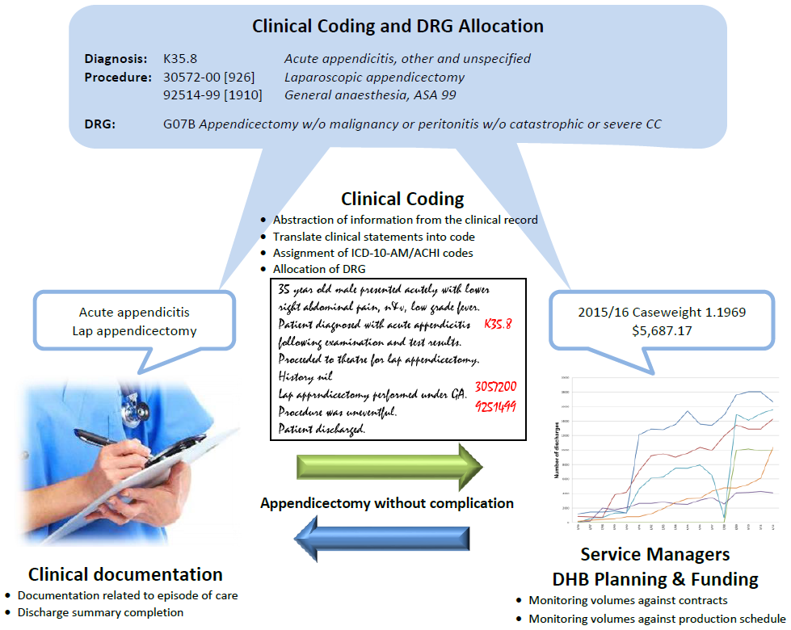
The clinical coding classification contains almost 24,000 codes covering diseases, procedures or interventions, external causes, and morphology. For ICD-10-AM/ACHI 6th and 8th Editions these are categorised as follows.
Clinical Code Type | ICD-10-AM/ACHI  Code Ranges | 6th Edition Count | 8th Edition Count
A: Diagnosis | A000 – U079 | 10,707 | 11,109
B: Injury | S0000 – T983 | 1,788 | 1,792
E: External Cause | U5000 – Y983 | 3,090 | 3,105
M: Morphology | M8000 – M9992 | 764 | 798
O: Operations and Procedures | 11000-00 – 97986-00 | 6,283 | 6,362
V-Z: Supplementary Codes | Z000 – Z999 | 689 | 702
Total Codes |  | 23,321 | 23,868
This coding classification is split into chapters based on the structure of the WHO ICD-10. Each chapter is further subdivided into homogeneous three character blocks, with further digits available for greater refinement.
A set of coding standards forms part of each edition of the coding classification. Their aim is to promote a sound coding convention and promote consistency among clinically similar admitted patient events.

Principal Diagnosis
This is meant to reflect the main reason for the patient’s admission to a healthcare facility. More formally it is:
“The diagnosis established after study to be chiefly responsible for occasioning an episode of admitted patient care, an episode of residential care, or an attendance at the healthcare establishment, as represented by a code.”
Example:
Patient presents with seizures. The patient had not previously been treated for seizures. CT scan revealed a large brain tumour.
Principal diagnosis: Brain tumour
Additional diagnosis: Nil

Additional Diagnoses
An additional diagnosis is defined as:
“a condition or complaint either coexisting with the principal diagnosis or arising during the episode of admitted patient care, episode of residential care or attendance to a health care establishment, as represented by a code.”
“For coding purposes, additional diagnoses should be interpreted as conditions that affect management in terms of requiring any of the following:
- commencement, alteration, or adjustment of therapeutic treatment
- diagnostic procedures
- increased clinical care and/or monitoring.”
A patient’s stay may also be longer than is usual when complications or comorbidities (CCs) are present. These CCs are coded as additional diagnoses when they meet the ACS 0002 criteria.
Example:
Patient is admitted for a fractured hip and during the episode of care develops ascites due to known underlying liver disease. The ascites is drained.

Principal diagnosis: Fractured hip
Additional diagnoses: Ascites
Liver disease
Procedure: Drainage of ascites

Condition Onset Flag (COF)
The condition onset flag (COF) provides a means of differentiating those conditions which arise during, from those arising before, an admitted patient episode of care. The COF is expected to help provide a better understanding of those conditions:
- patients already have when entering the hospital
- that arise during the episode of admitted patient care
A better understanding of those conditions arising during the episode of admitted patient care can inform prevention strategies in relation to complications of care. The values and definitions are:
COF 1: A condition which arises during the episode of admitted patient care and would not have been present or suspected on admission.
COF 2: A condition previously existing or suspected on admission, such as the presenting problem, a comorbidity or chronic disease.

Example:
Patient is admitted with acute appendicitis and has an appendicectomy. A wound infection develops in the post-operative period and a swab taken grows MRSA.

2 – Acute appendicitis
1 – Wound infection
1 – Staphylococcus aureus (infectious agent)
1 – MRSA
1 – Removal of organ (external cause code related to wound infection)
1 – Place of occurrence (of external cause)

Consistency and Completeness
The possibility of having an electronic record that reflects a complete clinical picture of an episode of care relies on having a complete clinical record. The importance of consistent, complete documentation in the clinical records cannot be over emphasised. Without such documentation the application of all coding guidelines is a difficult, if not impossible, task.
The resulting data can then be used in many aspects of service planning, epidemiology, and funding. As we will see in the next section, the presence of additional diagnoses can have a significant effect on the DRG assigned to an inpatient episode.

Diagnosis Related Groups (DRGs)
The almost 24,000 clinical codes on their own may lead to a huge number of possibilities. With the need to code additional diagnoses and there being space for up to 99 clinical codes reported to the national collection the number of possible combinations is enormous. It is clear that some systematic development of output groups is needed that reflect clinically similar events with comparable resource use.
General principles for a DRG classification are:
- There should be a manageable number: not too many that there are too few events in each group and analysis is not feasible, not too few that there are too many events in groups and some significant clinical differences remain unidentified
- The groups should be based on regularly collected data, most notable being the clinical coding of the clinical record for admitted patient episodes of care
- Each group should be clinically similar and resource comparable.
The system used in New Zealand is the AR-DRG, known as Australian Refined DRGs. Each version of AR-DRG is associated with an Edition of ICD-10-AM/ACHI.
Thus DRGs enable hospital production to be measured by linking the characteristics of patients treated (hospital activity) and the resources used in treating their patients (input costs). In particular, hospital output can be measured and provide a basis for funding; see Part III. Hospitals can compare outputs and engage in benchmarking comparisons and performance improvement.

DRG Codes
The codes used for DRGs in the AR-DRG classification have the structure ‘ADDS’, where A and S are letters and D is a digit. A can range over the entire alphabet, S is one of {A, B, C, D, Z}, and D is one of {0, 1, 2, 3, 4, 5, 6, 7, 8, 9}.
For example: I01A is the DRG code Bilateral/Multiple Major Joint Procedure of Lower Extremity with Revision or with Catastrophic Complication and/or Comorbidity:
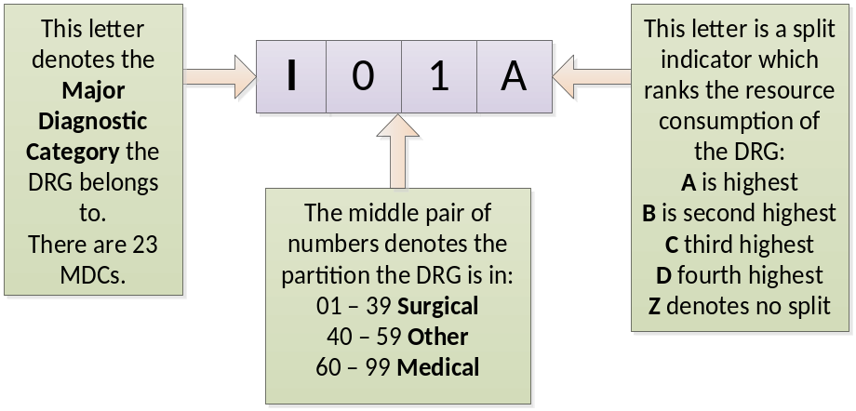
I01B is the DRG code Bilateral/Multiple Major Joint Procedure of Lower Extremity without Revision and without Catastrophic Complication and/or Comorbidity. These are the only two splits for these types of cases, and I01A contains those events with the highest level of complication.

Structure of AR-DRGs
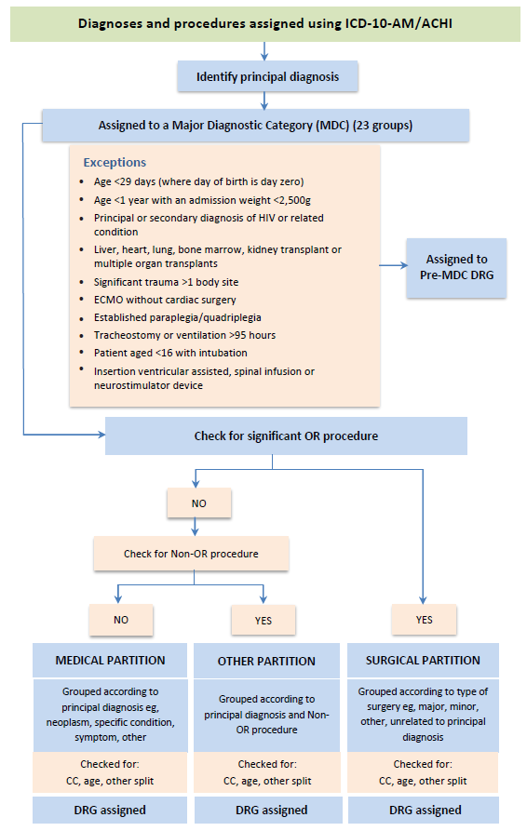

Complications and Comorbidities, CCLs and PCCLs
To gauge the likely effects of these additional diagnoses on resource consumption during the inpatient episode of care, each diagnosis code is assessed to determine if it is considered a complication or comorbidity for the DRG. Once this is determined a severity value is assigned reflecting its likelihood of increasing the resources normally employed. These values are called Complication and Comorbidity Levels (CCLs). A complex algorithm is provided with the AR-DRG classification that generates a single Patient Clinical Complexity Level (PCCL) from the collection of CCLs. The PCCL for a given inpatient episode of care thus represents the cumulative effect of all CCLs for the episode of care.
Complication and comorbidity level (CCL) values are integer and vary from 0 to 4 for surgical and neonatal episodes, and from 0 to 3 for medical episodes. They are developed through a combination of medical judgement and statistical analysis.
CCL Value | Description
0 | The diagnosis is not a complication or comorbidity; or  forms part of the definition for the ADRG assigned to the episode; or  Is excluded as a complication/comorbidity for this ADRG; or  Is closely related to the principal diagnosis; or  Is a complication/comorbidity, but conflicts with sex or mode of separation; or  Exactly the same code appears earlier on the record
1 | Minor complication/comorbidity
2 | Moderate complication/comorbidity
3 | Severe complication/comorbidity
4 | Catastrophic complication/comorbidity
CCL values for the same additional diagnosis can vary between DRGs. The CCL value given to a diagnosis depends on whether it is a valid CC and if it has been categorised from 0 to 4 for the DRG for the event record. Listed below are examples of additional diagnoses and the CCL values for the different DRGs.
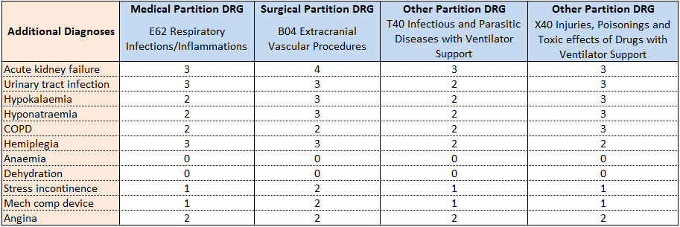

Patient Clinical Complexity Level (PCCL) values are integer and vary from 0 to 4
PCCL Value | Description
0 | No CC effect
1 | Minor CC effect
2 | Moderate CC effect
3 | Severe CC effect
4 | Catastrophic CC effect

In the DRG code example (on the previous page) the events in I01A are those with PCCL > 3.
The calculation of the PCCL is complex and is designed to prevent similar conditions from being counted more than once. In the table below are examples of the various combinations of CCL values that give a PCCL of 1 to 4.
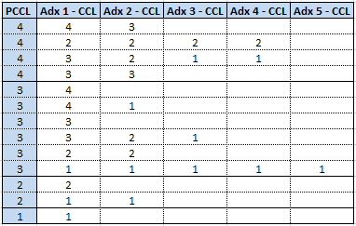
Adx = Additional diagnosis
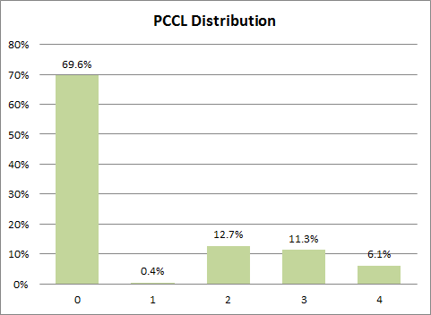
This chart shows the distribution of PCCL rankings in the 2013/14 admitted patient data that is casemix funded (see Part III). About 30% of events have some form of complication.
Major Diagnostic Categories (MDC) are generally based on a single body system or aetiology associated with a particular medical specialty. AR-DRG has 23 MDCs.
Pre-MDC is the set of DRGs for major procedures which are best described by the procedures performed and for which the principal diagnosis could be associated with any MDC. This set includes transplants, tracheostomy/mechanical ventilation, ECMO, insertion of ventricular assist devices, implantable spinal infusion devices, and neurostimulator devices.
The 23 MDCs and Pre MDC are:
MDC | MDC Description
Pre | Major Procedures – principal diagnosis associated with any MDC
01 | Diseases and disorders of the nervous system
02 | Diseases and disorders of the eye
03 | Diseases and disorders of the ear, nose, mouth and throat
04 | Diseases and disorders of the respiratory system
05 | Diseases and disorders of the circulatory system
06 | Diseases and disorders of the digestive system
07 | Diseases and disorders of the hepatobiliary system and pancreas
08 | Diseases and disorders of the musculoskeletal system and connective tissue
09 | Diseases and disorders of the skin, subcutaneous tissue and breast
10 | Endocrine, nutritional and metabolic diseases and disorders
11 | Diseases and disorders of the kidney and urinary tract
12 | Diseases and disorders of the male reproductive system
13 | Diseases and disorders of the female reproductive system
14 | Pregnancy, childbirth and the puerperium
15 | Newborns and other neonates
16 | Diseases and disorders of the blood and blood-forming organs and immunological disorders
17 | Neoplastic disorders (haematological and solid neoplasms)
18 | Infectious and parasitic diseases
19 | Mental diseases and disorders
20 | Alcohol/drug use and alcohol/drug induced organic mental disorders
21 | Injuries, poisoning and toxic effect of drugs
22 | Burns
23 | Factors influencing health status and other contacts with health services
 | Unrelated OR DRGs
 | Error DRGs
Note that MDCs 01, 15, 18, and 21 may have principal diagnoses associated with other MDCs. All other MDCs have an associated table of principal diagnoses. This means there is not always a direct structural relationship between the blocks of diagnosis codes in ICD-10-AM and the tables of codes used for MDC assignment. For example, codes in the diagnosis blocks D10 – D36 for benign neoplasms are distributed across 15 different MDCs.
Similarly, MDC 15 concerns patients that are either aged less than 28 days, or are aged less than one year and either have admission weight less than 1kg or a diagnosis of low birth weight or immaturity.

MDC Partitions
MDCs are subdivided into three partitions for surgical, other, and medical events. It is the presence or absence of OR NonOR procedures that is responsible for assignment to one of these partitions.

Operating Room (OR) Procedures
ORs are procedures considered significant across the AR-DRG classification. OR procedures considered significant for the MDC map to the surgical partition of the MDC.
By way of example, the procedures Total arthroplasty of hip, bilateral (or unilateral) are significant for MDC 08 (Musculoskeletal System and Connective Tissue) while the procedure Enteral Nutritional Support is not significant for any MDC. The latter may be provided across a wide range of MDCs.
If an OR is not significant for the MDC the event is grouped to one of the Unrelated OR DRGs 801A OR Procedures Unrelated to Principal Diagnosis w Catastrophic CC, 801B OR Procedures Unrelated to Principal Diagnosis W Severe or Moderate CC, 801C OR Procedures Unrelated to Principal Diagnosis W/O CC.

Non-Operating Room (NonOR) Procedures
NonORs are procedures considered significant by the classification for some MDCs, though may take place in operating rooms. If a NonOR is not significant in an MDC, the episode is grouped to a medical DRG.

Adjacent DRGs (ADRG)
An ADRG consists of one or more DRGs defined by the same diagnosis or procedure code list. DRGs within an ADRG have differing levels of resource consumption and may be partitioned based on several factors, including:
- Diagnoses or procedures used as a severity split
- Being a same day episode
- The level of comorbid conditions or clinical complication (refer to the CCL and PCCL sections)

Grouping to DRGs
There are now enough facets of the classification and its structure to outline the process that groups a clinically coded event record to a DRG.
In order to implement the structure outlined above we first need to ensure that admitted patient episodes provide data that can be used in the clinical coding and DRG classifications. This comprises the two stages known as demographic and clinical edits.

Demographic Edits
These are checks on the validity of the data elements: age, sex, admission weight, length of stay (LOS), same day status, Mental Health Legal Status, and the mode of discharge.

Clinical Edits
These validate all diagnosis and procedure codes in terms of ICD-10-AM or ACHI, patient’s age, and patient’s sex. The principal diagnosis is checked to ensure that it is acceptable as a principal diagnosis and that it is neither a manifestation code nor a code used to describe an external cause of injury and/or poisoning eg, is in the coding range U50 – Y98.

Error DRGs
Warning flags are generated where invalid data is found. Flags are classified as warning or fatal. A warning flag reflects invalid or inconsistent data provided, while a fatal flag occurs if the error encountered prevents assignment of MDC or DRG. Examples of the latter occur where there is invalid age, incorrect birth/admission weight, unacceptable principal diagnosis or a principal diagnosis inconsistent with the patient’s sex. In this case such a record is assigned to one of three error DRGs 960Z Ungroupable, 961Z Unacceptable Principal Diagnosis, and 963Z Neonatal Diagnosis Not Consistent with Age/Weight.

Clinical Coding Example
On the next page is a screen shot of a coded event record using the 3MTM CodefinderTM. The 3MTM CodefinderTM is the coding/grouping tool used by DHB clinical coders.
The example shows the effects that code assignments have on CCLs, PCCL and DRG allocation.

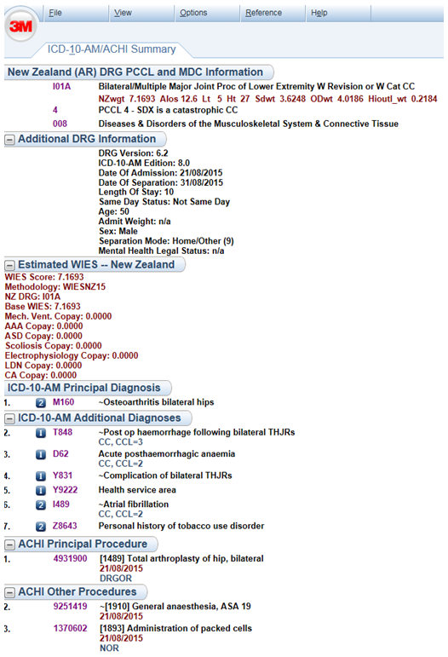
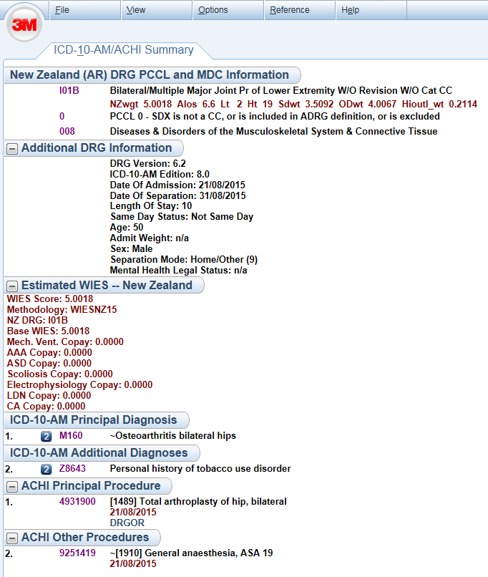
This section New Zealand (AR) DRG PCCL and MDC Information displays:
AR-DRG, NZWIES, PCCL and MDC

This section Additional DRG Information displays: DRG version, ICD-10-AM/ACHI Edition, event start and end dates, LOS, age, sex, discharge type etc

This section is a summary of the clinical coding for the admitted episode of patient care. It lists all the ICD-10-AM/ACHI codes/code descriptions, COF, and procedure dates.
After code allocation grouping occurs. The clinical codes that have an impact on the PCCL and DRG allocation are identified by the terms CC, CCL=x, and DRGOR. Other terms may also be used eg, NOR.
This section Estimated WIES – New Zealand displays: WIES version, NZWIES calculations, NZ DRG and co-payment value when applicable

National Collection for Admitted Patient Events
All public hospital admitted patient event records are submitted to a national collection known as the National Minimum Data Set (NMDS). Each record includes clinical coding for the event, demographic data, and administrative data. Up to 99 clinical codes are able to be reported in an event record. The NMDS collection plays a major role in the planning of health services for New Zealand. Among its many uses are provision of the base data for epidemiological studies, clinical research, burden of disease studies, service planning activity such as capacity forecasting, and financial management.
Though DHBs will know from their own systems the AR-DRG applying to an admitted patient event, the NMDS record provides the DRG and a cost weight (see Part III), along with other useful data when posting submitted records to the national collection. The Ministry of Health is the official calculator of the DRG and caseweight.
Given the significant nature of the uses of this data, often for development of significant new health sector systems, it is imperative that the data quality be as high as possible. In particular, the clinical coding submitted to the national collection should be at a very high standard in terms of its completeness and consistency with the coding standards. This in turn rests on good quality, complete clinical records being available to the clinical coders. Below are examples of the different grouping possibilities for clinical documentation.
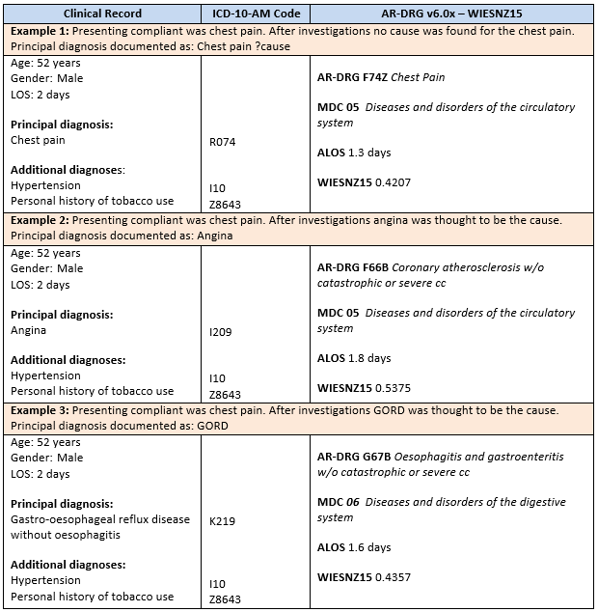

Updates to the AR-DRG Classification
As already noted New Zealand has adopted the Australian DRG and Clinical Coding classification systems. Responsibility for maintaining and updating these is assigned to the Independent Hospital Pricing Authority (IHPA). They have contracted the National Centre for Classification in Health (NCCH) to produce bi-annual upgrades to each. Key to this upgrade processes are the DRG Technical Group (DTG) and the ICD Technical Group (ITG) which include representatives from Australian States and jurisdictions. New Zealand is also represented on both of these advisory groups.
Australia has elected to update both the AR-DRG and Coding classifications biennially. However New Zealand chooses to upgrade approximately every four years. This approach maintains the currency of the DRG and ICD classifications while managing the costs of upgrading and the impacts that upgrades have on ICD and DRG time series data in the national collections.

The Grouper
Following each DRG classification review, NCCH document the definitions of the new DRG logic and this is approved by IHPA. NCCH then go out to tender for software vendors to develop products that meet these specifications. NCCH test the final products and award each a compliance status thus enabling vendors to either sell it as a standalone product or include it in existing software. This software is referred to as the Grouper.
Grouper software takes admitted patient event records (in a pre-defined format) and assigns them an AR-DRG. It also calculates CCL values for diagnoses reported in the event records and PCCL scores at the event level.
In New Zealand, all DHBs and the Ministry of Health have chosen to use the grouper software developed by the 3M Health Information Systems. A batch version is used at the Ministry of Health when loading NMDS event records and for local analysis. DHBs (and the Ministry of Health) use the 3MTM CodefinderTM version which also has a clinical coding interface.

Illustration of Relative Cost Profiles and Resource Contributions
DRGs are very useful to group different types of hospital discharges (mixes of cases) – for example medical versus surgical. Once these event records are grouped into DRGs analysis of the relative costs can be undertaken. The following charts and data illustrate the cost variations for different types of admitted patient healthcare provision. In the first two examples costs, taken from the national cost collection, are averaged over the two most recent years of cost data available. Both are high volume DRGs.

Example 1:

F76A Arrhythmia, Cardiac Arrest and Conduction Disorders W Cat or Sev CC
This medical DRG has 6.7% same day cases and for non-same day events ALOS = 4.75. The average cost per case is $5,184, with an average cost per day (non SD) of $1,150.
Inputs to this DRG are dominated by staff costs and diagnostics with a small contribution from pharmacy.

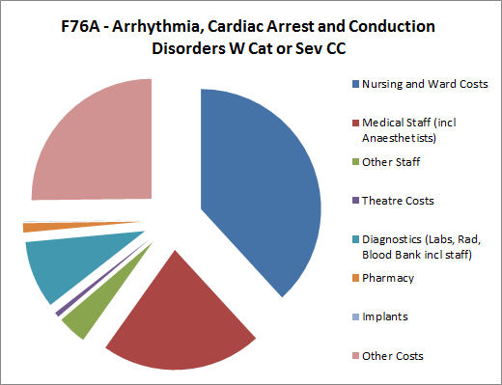

Example 2:

I03B Hip Replacement W/O Cat CC
This surgical DRG has just 0.2% same day cases with a non-same day ALOS of 5.43. The average cost per case is $15,819, for an average cost per day (non SD) of $2,917.
In this example the presence of significant theatre time and implant costs has led to a significantly higher average cost, even though the stay in hospital, on average, is not much longer than for the medical DRG of Example 1.

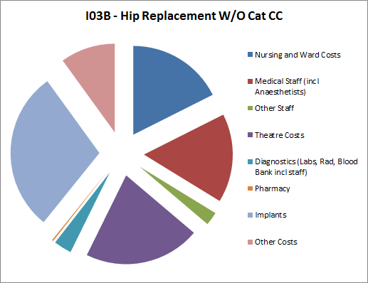

Example 3: Some Comparative Input Costs
In the most recent year of cost data the following input costs further illustrate how the cost of an event will vary depending on the type of treatment needed.
Table 1: Average Input Costs
Hospital Location | Average Cost
ICU (not NICU) | $4,668, per day
General Medical Ward | $532, per day
Theatre | $1,191, per hour

The above, sourced from a major tertiary hospital, are purely illustrative and the relative scale between them should be more interesting than the actual quantum. These figures may vary from hospital to hospital depending on the type of services provided and will vary from year to year.

Part III: Casemix Based Funding in New Zealand
Part of the original design expectation for DRGs was that they reflect comparable levels of resource input. In the previous section, it was shown that DRGs provide a standard way to look at the variability of production across facilities, and illustrations of the variation in inputs and of the overall cost among DRGs have been given.
New Zealand uses a Population-Based Funding Formula (PBFF) to devolve vote health funding to DHBs. DHBs then fund and purchase services from various providers, whether their own provider arm or community services. The New Zealand Casemix framework forms the main basis for DHB funders to purchase inpatient hospital services from other DHB providers. Weights from the Casemix framework are used as a default mechanism for the resulting Inter-district Flow (IDF) payments.
Casemix based funding uses a relative weighting by DRG and a casemix unit price. The weighting captures the variation in production, while the unit price is constant across all events to be funded in this way. The Notional or IDF revenue for an individual event is thus:
Revenue = (weight for the event’s DRG) x (unit price).
The weights direct revenue more fairly to providers of inpatient hospital services as it provides a consistent payment for clinically similar services using comparable levels of resources. A per diem method across all services would not adequately recognise the variation in output types across a range of hospital facilities, and if set on a national basis would significantly overpay some hospitals and significantly underpay other hospitals.

Components of New Zealand’s Casemix System
The casemix system in New Zealand is a single national system comprising of four components:
- Clinical coding classification, currently ICD-10-AM/ACHI 8th Edition
- A DRG set adapted to the coding classification, currently AR-DRG v6.0x, as adapted for use in New Zealand
- A set of cost weights adapted to the DRG set, denoted WIESNZyy, where yy = year implemented
- A Casemix Framework Document (CFD), which specifies which events in NMDS are casemix funded.
The current DRG set has 712 DRGs, though seven of these do not appear in casemix production (J11W, C03W which are NZ DRGs, three transplant DRGs (A01Z, A03Z, A05Z) and two dialysis DRGs (L61Z, L68Z)).

How does Casemix Based Funding Fit Amongst all Hospital Funding?
In New Zealand casemix based funding between the DHB funders and the provider of hospital services applies mainly to medical, surgical, obstetric, and neonatal inpatient services. Other services, most notably outpatient services, emergency department, mental health, rehabilitation, disability support and health of older people, are funded by different methods.
However, casemix based funding accounts for a significant proportion of all DHB funding, varying between 28% and 29%.

New Zealand Casemix Cost Weight Model
The New Zealand model is very similar to that used by Australia’s state of Victoria, known as WIES (weighted inlier equivalent separations) and now largely adopted in a national implementation across Australia. Note that separation is the Australian equivalent to a New Zealand discharge.
It incorporates length of stay (LOS) so as to obtain a better fit with costs. The New Zealand model is populated solely with New Zealand data elements, using activity data derived from the NMDS and event level cost data reported annually via the joint National Cost Collection and Pricing Programme (NCCP).
The model is built round the LOS distribution and an inlier range for each DRG. A low boundary (LB) and high boundary (HB) are determined which define the inlier range = [LB, HB]. The inlier range accounts for the majority of “typical” events for a DRG.
Weights are then developed for:
- Same day events
- One day events
- Low outliers (other events with LOS < LB)
- Inliers, for events in the inlier range, ie LB <= LOS <= HB
- High outliers (LOS > HB, in the main)

Role of LOS in the Weight Model
LOS analysis is needed to determine an average LOS, denoted ALOS. This central tendency is determined based on the most recent four years of data so as to account for clear trends. However in some cases there is not a clear upward or downward trend and the most recent year of data is used.
For most DRGs the formulae
LB = ALOS/3 and HB = 3*ALOS
are used to set a range that captures most typical events. It is referred to as L3H3.
For each DRG, LOS is generally a skewed distribution, though may also be bimodal (for example where two different models of care are in practice). Where the ALOS is high the factor of three used in L3H3 can create too wide an inlier range and allow too much cost variation across the inlier range; or we could say that some non-typical events are now being included in the inlier range. Other methods are then used to set the inlier range, and include (i) sometimes using 3/2 rather than three as a factor, or (ii) general statistics to estimate the central tendency and set the range.

Development of Cost Weights
The most recent year of event level cost data is used in the model, though for low volume DRGs more than one year may be used. This data generally covers 75% - 83% of all NMDS event records that would be casemix funded.
Total costs are used, less those corresponding to inputs funded separately. These are the partial cost coverage for clinical training, and the drug costs for pharmaceutical cancer treatments.
In some cases, adjustments are made where it is clear that implant or prosthetic costs have been under-reported. Each year the total new weights are constrained to equal those of the year of data used in the review. Consequently, the adjustments made for some costs help ensure the relativities are achieved without introducing unrealised volumes.

Sketch of Weight Development by Event LOS Types

Inliers
The weights for the inlier range reflect the ratio of the average cost for inlier events for the DRG to that for all inlier events.

Low Outliers
A simple approach to determining the weights for events with a stay less than LB is to simply divide the inlier weight by the LB to obtain a one-day weight, and then halving the result to obtain a same-day weight. This is done where volume is small or for medical events. Surgery is now often provided on the day of admission, and technology advances allow same day surgical events, the theatre and implant costs are brought forward in the calculation of same day weights for these DRGs.
For an increasing number of DRGs, principally those with a significant proportion of events provided in the emergency department or with stays shorter than a few hours, same day (SD) and one day (OD) weights are derived from the costs of these types of events. These DRGs are identified on the cost weight schedule with a SD or OD designation. The purpose is to avoid dilution of the weights for multi-day stays where there are high volumes of same day or overnight, low-cost events.

High Outliers
These events are those with LOS exceeding HB. They are weighted as the sum of the inlier weight, plus an allowance based on the number of high outlier days and a high outlier per diem. The latter is based on the average of inlier costs with theatre and implant costs removed divided by the average inlier length of stay. High outlier days do not take effect until the number of days for which mechanical ventilation was provided have been taken into account. The days when mechanical ventilation is provided are given a co-payment weight (see below) at a higher level than the high outlier per diem.
High outliers comprise approximately 2.9% of all casemix funded events.

Overall
This model provides incentive for efficiency – hospitals aim to provide services within the inlier period – and for equity – in that low outliers are paid less than inliers and high outlier events receive funding for each day of stay beyond the high boundary.

Review Frequency
In principle, the weights are reviewed every two years. However, where smaller or pressing changes are needed, these may be effected between the main review years.

New Technology and Other Changes Affecting Cost Profiles
Uptake of new technology, including change in models of care, affects the development of a new set of weights. Generally, these are reflected in changing cost profiles over time for a DRG. However, new technology is a little different in that it may initially only be taken up by a small number of providers. When this occurs, definitive identification in terms of the clinical coding is sought so that events employing the new technology can be identified in the national collection of admitted patient events, NMDS.
When new technology events can be unambiguously identified in terms of their clinical coding, the uneven uptake is addressed by:
- Either mapping the affected events to a locally defined DRG for the purposes of funding
- Or singling the events out for a weight co-payment attached to the starting DRG.
These devices may also be used for exceptional cases involving an existing technology and provision by a very small number of hospitals. In the event of option (i) being used, the new DRG is referred to as an NZ DRG. This option is particularly useful where several different DRGs may describe the production using the given new technology.
Example 1, the DRG code F03M is not part of the AR-DRG classification but is used in New Zealand for the funding of Transcatheter Pulmonary Valve Implants. These events involve new technology, have one provider at the time of writing, and would normally group to one of four DRGs in the AR-DRG classification: F03A, F03B, F04A, or F04B.
Example 2, endovascular repair for abdominal aortic aneurysms. These events are defined by a single procedure code, though production groups to one of two AR-DRGs: F08A or F08B. However, more than one hundred procedures are possible for events in these DRGs and this procedure represents only 25% of total production for this pair of DRGs. Consequently, a co-payment weight has been developed to compensate providers of this surgery for the high cost of the implant involved. Initially applying only to tertiary facilities, there has been a gradual spread in eligibility for this co-payment weight to other facilities as the technology is taken up by more hospitals.

Co-payment Weights
As of 2015/16 the casemix funding weight system makes co-payments for:
- Mechanical ventilation
- Live donor nephrectomies
- Implant costs for paediatric scoliosis surgery
- Electrophysiology studies
- Endovascular repair of abdominal aortic aneurysms
- Endovascular treatment of cerebral aneurysms
- Atrial septal defect cases
It is possible that when one or both of the coding and DRG classifications in use change the need for these co-payment weights will cease to exist.

DRG Mappings and NZ DRGs
As of 2015/16 the following DRG mappings occur:
- All event records grouped to a medical DRG on which a radiotherapy procedure is recorded are mapped to the DRG R64Z, Radiotherapy
- Event records where pelvic exenteration surgery occurred are mapped to the DRG N01Z, Pelvic Evisceration and Radical Vulvectomy
And the following NZ DRGs are in use:
- F03M, Transcatheter Pulmonary Valve Implant
- O66T, SFLP for Twin to Twin Transfusion Syndrome
The definitions of these can be found in the Casemix Framework Document. As with co-payment weights the need for these mappings may change or cease to exist when one or both of the coding and DRG classifications change.

The Casemix Framework Document
This document is updated as necessary in conjunction with each cost weight review. It specifies the following:
- Which NMDS events are casemix funded
- How LOS and weights are calculated
- Which purchase unit to assign to an event
In addition to these items this document includes:
- History of the components of casemix funding since 1998/99
- Unit prices for casemix funding
- The outpatient purchase unit for events excluded from casemix funding, where these can be unambiguously defined
- Embedded files for the cost weight schedule and the SAS program that corresponds to the framework implementation in the NMDS.
This document can be found at click here

Excluded Events
Examples of events that are excluded from casemix funding are:
- Mental health events, as they are funded in a different way
- Disability, rehabilitation, and health of older people services, which are funded on bed day rates
- Treatments that result in a sequence of same day attendances, such as radiotherapy, chemotherapy, and dialysis
- Same day events for some procedures where the patient is not expected to have complications, such as some screening, gastroscopies, colonoscopies, and bronchoscopies
- Treatments that have been subject to provision in inconsistent settings across DHBs, such as removal of skin lesions and provision of ophthalmology (Avastin) injections.

Encounters on the Pathway to a New Set of Weights
A variety of different circumstances are encountered when developing a new set of weights. Among them are:
- New technology changes
- Changes in models of care
  - Should be reflected implicitly in costs but may need impact assessment to be noticed
- Changes in underlying classifications, ie both clinical coding and DRG set
- Changes sought to the exclusion rules
- Assessment of the quality of cost reporting
- Casemix specific request for (mainly) implant costs
- Other funding frameworks
- Stakeholder requests, may involve Ministry of Health, National Health Committee, or DHBs
- Concerns over the adequacy of an existing weight. Inadequacy of weights are generally perceived because:
  - The focus is on procedure rather than DRG which can easily give a false idea of profitability
  - The role of price has not been taken into account.
All are considered as part of the review process.
Focusing on a procedure rather than the DRG is one of the most common causes of claims of under-funding. In order to assess the adequacy of funding one should compare revenue and costs for all the DRGs that a given procedure may appear under. As an averaging process is part of the weight development, it is possible that other procedures that also group under the same DRGs are over-funded, consequently providing the needed subsidy for a procedure with a higher cost profile.

Casemix Group and the National Cost Collection and Pricing Programme
The review of the casemix system is undertaken by the Casemix Group as part of the National Cost Collection and Pricing Programme (NCCP). NCCP has joint Ministry of Health and DHB membership with a Technical Reference Group (TRG) that oversees proposed changes to hospital pricing and recommends inter-district flow prices. In particular, this program recommends the unit price for casemix funding purposes.
All key results in NCCP are brought together in a sector-wide price book from which unit prices are developed. If accepted by the Ministry of Health, following consultation with DHBs, the new prices are given price uplift from the year of data used to the year of application as part of the Ministry of Health’s development of the new funding packages.
The Casemix Group membership is identified in an appendix of the Casemix Framework Document. All participants in the NCCP for a given year are listed in the consultation document circulated to DHBs and the Ministry of Health by NCCP’s Technical Reference Group (TRG).

Aspects of the Wider Funding Framework
In the wider overall funding picture, casemix is a baseline funding that needs to be supplemented for diseconomies and skews to the general casemix. Thus small volume facilities, possibly rural, receive a diseconomy adjuster as payment solely on the basis of volume produced may not meet the infrastructure costs for a service deemed to be required at such a site. This adjuster is maintained as part of the wider population-based funding formula and is not part of the NCCP.
At the other end of the volume scale, the tertiary facilities experience a skew to the general run of casemix and also face the diseconomies of maintaining capability and cover for services that provide for small volumes of very complex cases. They receive a tertiary adjuster determined as a supplement to the standard casemix funding. This adjuster is developed as part of the NCCP programme and consulted on with the Casemix Group.

Implementation in the National Collection
Once there is agreement on the implementation of the outputs of the NCCP, in particular the new weight set, these are implemented in the NMDS by the Ministry of Health’s National Collections team. This is a regular part of the Ministry of Health’s National Collections Annual Maintenance Program (NCAMP).
For the casemix system, NCAMP implements any new weight schedule, and changes to the Casemix Framework Document. An early edition of the updated framework document is made available via the NCAMP website and when finalised is posted to the link given above.
This implementation fully reflects the updated Casemix Framework Document, and provides the casemix funding WIESNZ weights on each submitted event record. Other field elements are added to a submitted record so that the weight can be calculated, along with other fields of value to DHBs and the wider health sector.
These fields include: AR-DRG, NZ DRG, CCLs, PCCL, purchase unit, LOS, WIESNZ weight. NMDS is the official calculator on every record of all these fields. Any other implementation of the Casemix Framework Document must ensure it is consistent with NMDS event records.

Appendix A – New Zealand Casemix Based Funding Early History

Early History
In Regional Health Authority (RHA) times and earlier, hospitals were funded using DRG sets from the United States’ Health Care Financing Administration (HCFA) or Australia’s AN-DRG series. These DRG sets and associated weights were developed in other countries based on cost profiles from different funding environments and used in New Zealand without local adaptation. Within New Zealand, unit prices were set differently in each region and may have been budget-based or set by negotiation.
One national system was sought in the late ‘90s and this led to the establishment of the Health Funding Authority (HFA) which was charged with uniting four regional approaches into a single national funding and purchasing system.
The Transitional HFA decided to use AN-DRG, which evolved into AR-DRG, as implemented in Australia’s state of Victoria. This funding model included some structure and policies on length of stay (LOS) which provided a good fit with New Zealand’s health sector.
At this stage, 1999, the Casemix Framework Document first came into being to provide national consistency for what was to be casemix funded. Its rules and the cost weight calculation were first implemented in the national collection for admitted patient events at this time. Also established at this time was a national Casemix (Cost Weights) Project Group which continues to the present.

Transition and Recent History
The initial casemix based funding mechanism was implemented without adaptation from the Victorian funding jurisdiction. However the next four years saw increasing adaptation of the Victorian weight model, using New Zealand-specific adjustments to Victorian cost data, as New Zealand costing data availability was sporadic. Nor was it supported by a set of costing standards that could promote consistency in cost reporting.
During this time supporting standards were developed and costing capability increased among DHBs, so that by 2005/06 a significant sample of DHB events could be costed and were usable in a new impetus to set the casemix weightings using only New Zealand cost and activity data.
The first weights based solely on New Zealand data elements became effective from 1 July 2008, following a year of development and consultation. The ongoing development of weights relies on a sufficient quantum of good quality cost data continuing to be supplied by New Zealand DHBs.
A full history of the funding components for each year since 1998/99 is given in the Casemix Framework Document.

Appendix B – Further Information and References
Australian Government – The Department of Health. The Review of the AR-DRG Classification System Development Process. URL: http://www.health.gov.au/internet/main/publishing.nsf/Content/Casemix-1 (Australian Commonwealth level description).
Commonwealth of Australia. 2008. Australian Refined Diagnosis Related Groups, Definitions Manuals Version 6.0. Australia: Australian Government Department of Health and Ageing.
Commonwealth of Australia. 2012. Australian Refined Diagnosis Related Groups, Version 6.0x, Addendum. Australia: National Casemix and Classification Centre, Australian Health Services Research Institute, University of Wollongong.
interRAI. Case-Mix Classification. URL: http://www.interrai.org/classification.html
Lim, EK and Lee CE. Casemix in Singapore – 5 Years On.
URL: http://www.annals.edu.sg/pdf200411/v33n5p660.pdf
Ministry of Health. Diagnosis Related Groups.
URL: http://www.health.govt.nz/nz-health-statistics/data-references/diagnosis-related-groups
Ministry of Health. Weighted Inlier Equivalent Separations. URL: http://www.health.govt.nz/nz-health-statistics/data-references/weighted-inlier-equivalent-separations
(The New Zealand casemix funding model; medical, surgical, maternity, neonatal)
National Casemix and Classification Centre. 2013. Australian Coding Standards, 8th Edition. Australia: National Casemix and Classification Centre, Australian Health Services Research Institute, University of Wollongong.
Nationwide Service Framework Library. Purchase Units. URL: http://www.nsfl.health.govt.nz/apps/nsfl.nsf/pagesmh/463
Nationwide Service Framework Library. Financial Standards and Guidelines. URL: http://www.nsfl.health.govt.nz/apps/nsfl.nsf/pagesmh/200
Nordic Casemix Centre. URL: http://www.nordcase.org/ (Nordic casemix)
Te Pou o Te Whakaaro Nui. Outcomes and Information. URL: http://www.tepou.co.nz/outcomes/casemix (Fledgling casemix system development for NZ Mental Health services)
The Royal Children’s Hospital Melbourne. DRG and Casemix Funding. URL: http://www.rch.org.au/rchhis/coding_casemix/DRG_and_Casemix_funding/
(Practical guide from The Royal Children’s Hospital Melbourne)
University of Wollongong. About Casemix. URL: http://nccc.uow.edu.au/casemix/aboutcasemix/index.html
Victoria State Government. Activity Based Funding. URL: http://health.vic.gov.au/abf/history.htm
(How it works in Victoria/Australia)
Images:
3M HIS Codefinder Screen shot (page 16)
http://medicalrecordsaudit.net/importance-medical-record-audit/ (page 6)

Appendix C – Glossary of Abbreviations
For the purposes of this document the acronyms used are defined in the following table.

Abbreviation | Definition
ACHI | Australian Classification of Health Interventions
ACS | Australian Coding Standards
ADRG | Adjacent Diagnosis Related Groups
Adx | Additional Diagnosis
ALOS | Average Length of Stay
AN-DRG | Australian National Diagnosis Related Groups
AR-DRG | Australian Refined Diagnosis Related Groups
Cat | Catastrophic
CC | Complication and/or Comorbidity
CCL | Complication and Comorbidity Level
CFD | Casemix Framework Document
COF | Condition Onset Flag
DHB | District Health Board
DRGs | Diagnosis Related Groups
DTG | DRG Technical Group
ECMO | Extracorporeal Membrane Oxygenation
GORD | Gastro-oesophageal Reflux Disease
HB | High Boundary
HCFA | Health Care Financing Administration
ICD | International Statistical Classification of Diseases
ICD-10 | International Statistical Classification of Diseases and Related Health Problems, Tenth Revision
ICD-10-AM | International Statistical Classification of Diseases and Related Health Problems, Tenth Revision, Australian Modification
ICU | Intensive Care Unit
ITG | ICD Technical Group
IHPA | Independent Hospital Pricing Authority, Australia
LB | Low Boundary
LOS | Length of Stay
MBS | Medicare Benefits Schedule
MDC | Major Diagnostic Category
NCAMP | National Collections Annual Maintenance Project
NCCH | National Centre for Classification in Health
NCCP | National Costing Collection and Pricing Programme
NICU | Neonatal Intensive Care Unit
NMDS | National Minimum Dataset
NonOR | Non-Operating Room
NZDRG | New Zealand Diagnosis Related Group
OD | One Day
OR | Operating Room
PCCL | Patient Clinical Complexity Level
RHA | Regional Health Authority
SD | Same Day
Separation | Australian equivalent of the New Zealand term discharge
Sev | Severe

Abbreviation | Definition
SFLP | Selective Fetoscopic Laser Photocoagulation
TRG | Technical Reference Group
UK | United Kingdom
US | Unites States
W | With
WHO | World Health Organization
WIES | Weighted Inlier Equivalent Separation
W/O | Without

WHO is responsible for producing international classifications on health, such as ICD-10, so that there is a meaningful and useful framework which governments, providers and consumers can use as a common language.
The modifications are overseen by the National Centre for Classification in Health, Australia. They include clinician input. In recent times the Australian reviewers have invited New Zealand participation in the reviews for the ICD-10-AM/ACHI classification and for new versions of the AR-DRGs.
From the Australian Coding Standards (ACS 0001) for ICD-10-AM/ACHI 8th Edition
From the Australian Coding Standards (ACS 0002) for ICD-10-AM/ACHI 8th Edition
From the Australian Coding Standards (ACS 0048) for ICD-10-AM/ACHI 8th Edition
Note that while New Zealand hospitals implemented ICD-10-AM/ACHI 8th Edition from 1 July 2014, the Casemix Group chooses to back-map these codes to ICD-10-AM/ACHI 6th Edition and use AR-DRG v6.0x. This is done for two years following a change in ICD-10-AM/ACHI coding Editions. It has been found that a much better fit of weights is obtained by not using back-mapped data in the weight setting process. Thus there is always a two year lag between moving to a new ICD-10-AM version and assigning cost weights based on that raw data.

