


Guidelines for Consultation with Obstetric and Related Medical Services
(Referral Guidelines)
  - Aratohu Aratohu Kimi Āwhina ki Te Ratonga Whakawhānau Pēpi, Ratonga Rata (Ngā Aratohu Tuku Atu)
March 2023

These guidelines are to be used in conjunction with the Primary Maternity Services Notice 2021 (www.health.govt.nz/publication/primary-maternity-services-notice-2021) and relevant funded maternity service specifications (https://nsfl.health.govt.nz/service-specifications/current-service-specifications/maternity-service-specifications).
Published in March 2023 by Te Whatu Ora – Health New Zealand
PO Box 793, Wellington 6140, New Zealand
ISBN 978-1-99-106708-1 (online)

This document is available at tewhatuora.govt.nz
 | This work is licensed under the Creative Commons Attribution 4.0 International licence. In essence, you are free to: share ie, copy and redistribute the material in any medium or format; adapt ie, remix, transform and build upon the material. You must give appropriate credit, provide a link to the licence and indicate if changes were made.

Contents
Glossary of terms used in the guidelines 4
Introduction 7
Purpose 7
Users of the Referral Guidelines 8
Te Tiriti o Waitangi 9
Guiding principles 11
Categories of referral 13
Process for referral for consultation and/or transfer of clinical responsibility for care 16
Timing 16
Process maps 17
Process maps as a continuum 18
Process for referral to a primary health care, allied health or kaupapa Māori service 18
Process for referral to a specialist for consultation 21
Process for transfer of clinical responsibility for care 23
Process for emergency transfer of clinical responsibility for care 26
Process for emergency transport 28
The woman/person declines a referral, consultation, transfer of clinical responsibility for care or emergency treatment or emergency transport 30
Conditions and referral categories 34
Further advice on Te Tiriti 54
Cultural safety 54
Update process 56

Glossary of terms used in the guidelines
Community maternity facility | A community-based birthing unit, usually staffed by midwives. Community maternity facilities provide access for women/people assessed as being at low risk of complications for labour and birth care. Such facilities do not provide specialist services.
Consultation | The process by which, in communication with the woman/person, a referrer seeks an assessment, opinion and advice about the woman/person and/or the baby from a specialist or secondary/tertiary hospital team, by way of a referral. A consultation may or may not result in transfer of clinical responsibility for care. Consultations may involve the woman/person and/or the baby being seen by the specialist; however, a discussion between health practitioners is often appropriate on its own. Consultation can take place in person, by telephone, videoconference, email or by other means as appropriate in the situation.
Emergency transport | The physical transport of a woman/person and/or baby by air or road ambulance in an emergency.
Family planning practitioner | A health practitioner who is registered with the Medical Council of New Zealand (established by the Health Practitioners Competence Assurance Act 2003) in the vocational scope of practice of family planning and reproductive health and who holds an annual practising certificate.
General practitioner (GP) | A health practitioner who is registered with the Medical Council of New Zealand (established by the Health Practitioners Competence Assurance Act 2003) in the vocational scope of general practice and holds a current annual practising certificate.
Health practitioner | Trained medical professionals, encompassing those who may provide health care at the time an offer of consultation or transfer of clinical responsibility for care becomes relevant.
Hospital team | The team that includes midwives, obstetricians, neonatologists, anaesthetists and others. These secondary or tertiary maternity team members work collaboratively together, and with the LMC, to achieve the best health outcome for the woman/person and their baby.
Lead maternity carer (LMC) | A person who is a midwife, obstetrician or a GP with a Diploma in Obstetrics, a Postgraduate Diploma in Obstetrics and Medical Gynaecology or equivalent (as determined by the Royal New Zealand College of General Practitioners) and who is either a maternity care provider or an employee of or contractor to a maternity care provider and has been selected by the woman/person to be their LMC.
Maternity care provider | All health practitioners who provide maternity care at the time an offer of consultation or transfer of clinical responsibility for care becomes relevant. For example, a maternity care provider may be a community midwife, obstetrician, GP or family planning practitioner.
Primary health care provider | A health care provider who works in the community and is not a specialist for the purposes of these guidelines. This provider may be another midwife, a GP or a nurse practitioner. Allied health providers include physiotherapists and, lactation consultants. Other relevant services include kaupapa Māori services, smoking cessation services, drug and alcohol services, nutrition services or mental health services.
Referral | The process by which one health practitioner (usually the LMC) seeks consultations with or transfers clinical responsibility for care of a condition affecting the woman/person and/or their baby to another appropriate health practitioner.
Secondary maternity service | A secondary maternity service that provides the services specified in the service specification for secondary and tertiary maternity services available from the Nationwide Service Framework Library.
Specialist | A medical practitioner who is registered with a vocational scope of practice in the register of medical practitioners maintained by the Medical Council of New Zealand and holds a current annual practicing certificate. For the purposes of these guidelines, this definition excludes GPs because GPs are covered by the primary referral process.
Tertiary maternity service | A tertiary maternity service that provides the services specified in the service specifications for secondary and tertiary maternity services available from the Nationwide Service Framework Library.
Three-way conversation | A single face-to-face phone or video communication event that simultaneously involves a woman/person, their LMC midwife/referrer and a specialist that is supported by documented care plans and/or written communications.
Transfer of clinical responsibility for care | The transfer of clinical responsibility for care from the LMC to a specialist. Responsibility for care may be transferred back to the LMC if/when clinically appropriate. In obstetric emergencies, transfer of clinical responsibility will be to the most appropriate available health practitioner.

Introduction

Purpose
The Guidelines for Consultation with Obstetric and Related Medical Services (the Referral Guidelines) aim to:
- set out the care pathways that women/people can expect when engaging with maternity care services (depending on their health needs)
- improve safety in and the quality of maternity care services
- improve the consistency of consultation, transfer of clinical responsibility for care and transport processes
- reassure women/people, their whānau and health practitioners if a primary health care or specialist consultation or a transfer of clinical responsibility for care is required
- promote and support coordination of care across maternity care providers.
The Referral Guidelines are based on best practice and are informed by available evidence, expert opinion and maternity service delivery in Aotearoa New Zealand. They sit alongside other relevant clinical guidelines and should be read in conjunction with Ngā Paerewa Health and Disability Services Standard NZS 8134:2021 (Ngā Paerewa) and the corresponding sector guidance for birthing units and district health board (DHB) in-patient / private hospital services. The Health and Disability Commissioner (Code of Health and Disability Services Consumers’ Rights) Regulations 1996 legislation is also relevant. Together, these documents provide a suite of information about best-practice maternity service provision.
The Referral Guidelines relate to medical care. We recognise that socioeconomic determinants also have an impact on health, but these sit beyond the Referral Guidelines’ scope.
Meaning of ‘LMC’ and ‘health practitioner’ in these guidelines
The terms ‘LMC’ and ‘health practitioner’ are used throughout the Referral Guidelines.
The Primary Maternity Services Notice 2021 defines a lead maternity carer (LMC) as:
- a midwife, an obstetrician or a general practitioner (GP) with a Diploma in Obstetrics, a Postgraduate Diploma in Obstetrics and Medical Gynaecology or equivalent (as determined by the Royal New Zealand College of General Practitioners); and
- either a maternity care provider in their own right or a practitioner who is an employee of or contractor to a maternity care provider; and
- who has been selected by the woman/person to provide her lead maternity care.
The LMC is based in the community and is responsible for coordinating the woman/person’s maternity and postnatal care, or a baby’s postnatal care once the care recipient is registered with them. Not every woman/person will have a named LMC due to specific care requirements or circumstances. Women/people may receive midwifery care from an employed case-loading midwife or hospital-based midwifery team. These midwives along with other health practitioners (such as GPs, nurse practitioners or family planning practitioners) may also need to refer the woman/person for specialist services.
For the purposes of the Referral Guidelines, the term ‘health practitioner’ encompasses those who may provide health care at the time an offer of consultation or transfer of clinical responsibility for care becomes relevant.
If the woman/person has an LMC (including a named community midwife/midwifery team), that LMC should make the referral. This supports clarity of responsibility and ongoing care provision and enables the LMC to remain as the main point of contact for communications and planning. Any other health practitioner providing care for a pregnant or postnatal woman/person or their baby who considers that a referral is warranted should contact the LMC in the first instance to discuss the case and their concerns.
If the woman/person does not yet have an LMC, the health practitioner providing care should prioritise linking the woman/person with an LMC before referring them to specialist services (where the referral is for a non-urgent issue). Health practitioners are expected to make a referral in acute or time-critical situations where the woman/person has not yet registered for maternity care, or when they have stated that they were unable to contact their usual carer or the hospital. The LMC should be notified that such a referral has occurred.

Users of the Referral Guidelines
The Referral Guidelines are relevant to all health practitioners involved in caring for pregnant and birthing women/people, postnatal women/people and their babies in Aotearoa New Zealand. Regardless of their place of work, health practitioners should use the Referral Guidelines to support their clinical judgement, knowledge and expertise and provide for a timely, consistent and effective approach to the woman/person’s maternity care.
Women/people and their whānau can use the Referral Guidelines to understand how they might access health services during pregnancy, birth and in the postpartum period.

Te Tiriti o Waitangi
Health practitioners can demonstrate that they are giving effect to Te Tiriti by practically applying the principles as articulated by the courts and the Waitangi Tribunal. Applying the principles to maternity service delivery is an obligation, enabling Māori to express their mana motuhake and ensures they receive high-quality, culturally safe care and achieve equitable health outcomes. Applying the principles of Te Tiriti is a mandated obligation of maternity services and health practitioners.
The principles of Te Tiriti provide the framework for maternity providers and health practitioners providing maternity services to Māori. Ngā Paerewa and, in particular, 1.1 Pae ora healthy futures supports the understanding of how these principles should be applied to maternity services.
The Waitangi Tribunal concluded that persistent health inequities that Māori experience were the consequence of the failure to apply the principles of Te Tiriti at structural, organisational and health practitioner levels of the health and disability sector. Giving effect to Te Tiriti requires health practitioners to know the principles of Te Tiriti and to capably apply these in partnership with Māori in their day-to-day maternity clinical practice.
For the health and disability sector, the Ministry of Health articulates the principles of Te Tiriti as follows.
- Tino rangatiratanga: Health practitioners support the right of Māori to receive effective maternity care, conceptualising the decisions of the woman/person as a continuation of a much older, Māori collective-endorsed practice of sovereignty of one’s own health and wellbeing, as well as that of one’s whānau.
- Equity: Health practitioners can contribute to equitable maternity health outcomes for Māori by ensuring that, at a minimum, maternity outcomes for Māori match those for other Aotearoa New Zealand ethnic groups. Equitable maternity outcomes will be achieved when health practitioners implement the Referral Guidelines recommendations in ways that give effect to the principles of Te Tiriti, relevant professional competencies and Ngā Paerewa.
- Active protection: Health practitioners share evidence-based information about maternity outcomes so that Māori can make decisions and prepare themselves to uphold their tikanga or cultural practice (for example, karakia, rongoā, support people). Health practitioners actively support Māori on the decision making continuum by providing quality evidence based information, free from bias and judgement.
- Options: Health practitioners ensure Māori have maternity care that enables them to uphold their tikanga or cultural practice regardless of where the birth takes place. Processes must complement a Māori person’s mana or inherent authority and dignity, support their tikanga or cultural practice and be culturally safe as defined by Māori.
- Partnership: Health practitioners work in partnership with Māori, including a person’s whānau if the person requests it. A partnered approach to the process and decision-making ensures Māori can enact their rangatiratanga or self-determine their futures while exercising mana motuhake or authority over their bodies and reproductive health.

Guiding principles
The woman/person, their baby and their whānau (as defined by the woman/person) are at the centre of all discussions and decisions.
- The woman/person should have continuity of maternity care through a single point of contact, regardless of how that care is provided (for example, through a community-based approach or through a secondary or tertiary maternity service).
- Health practitioners should take a holistic view of the woman/person’s circumstances, clinical and social history, and overall wellbeing (considering models of holistic wellbeing such as Te Whare Tapa Whā) and apply clinical judgement to individual or combinations of factors when determining the need for referral or a transfer of clinical responsibility for care.
- Under right 7 of the Health and Disability Commissioner (Code of Health and Disability Services Consumers’ Rights) Regulations 1996, the woman/person (or parents) has the right to make an informed decision and give informed consent on all aspects of their care, including the right to decline care and to decline referral for consultation or a transfer of clinical responsibility for care. To enable ‘informed decision’, right 6 of the Code requires that the woman/person (or parents) receive full, accurate, unbiased information about the options, the risks, side effects, benefits and costs of each option and the likely outcomes of the decisions.
- Health practitioners should be aware that different cultures conceptualise anatomy, pregnancy, birth and the postpartum period in different ways, and the practitioners should adapt their language and approach accordingly. Bias and stigma may be associated with certain health conditions. Health practitioners should recognise the importance of reflection and self-evaluation to ensure they communicate with women/people/parents in ways that do not perpetuate negative attitudes, behavioural bias or coercion.
- Health practitioners are responsible for clinical decisions and actions and for acting within their competency and scope of practice and within system constraints.
- Communication between all health practitioners involved with the woman/person’s or their baby’s care will include the woman/person or parents and will be open, clear, timely and appropriately documented in health records.
- Transfer of clinical responsibility for care is a negotiated process involving the woman/person (or parents), the LMC and the health practitioner to whom clinical responsibility is to be transferred.
- All health practitioners involved are responsible for appropriately documenting decisions in the woman/person or baby’s records, including any variation from the Referral Guidelines or other guidelines and the circumstances of any such variation. Documentation of all steps by all health practitioners involved is particularly necessary where clinical responsibility for care transfers from one health practitioner to another.
- Women/people and their babies should have access to an evidence-based and consistently high standard of care, regardless of where they live. The approach to referral for consultation, transfer of clinical responsibility for care and emergency transport should be nationally consistent with equitable access to services regardless of location, with some allowance for local needs and conditions. The ways that this standard of care is achieved may differ depending on local situations.

Categories of referral
Table 1: Categories of referral
Referral category | Consequent action
Primary | The LMC discusses with the woman/person (or parents) that a consultation may be warranted with a GP, midwife, nurse practitioner or other relevant primary or allied health provider (for example, kaupapa Māori service, Whānau Ora service, physiotherapy, lactation consultancy, smoking cessation service, drug and alcohol service, mental health service, etc.) because the pregnancy, labour, birth or puerperium (or the baby) is, or may be, affected by a condition that would be better managed by, or in conjunction with, another primary health care provider.  Where a referral occurs, there is a professional responsibility to maintain communication, collaboration and documentation and to inform the LMC in writing of the outcome of the referral. Where there is no LMC, communication must include the referrer. This should include discussion of any ongoing management of the condition by the primary health care provider. Clinical responsibility for the woman/person’s maternity care remains with the LMC.  Referring a person on to a primary health care, allied health or kaupapa Māori service provider may lead to a further referral for consultation or a transfer of clinical responsibility for care. In this event, the provider must notify the LMC (or the referrer if no LMC) of any referral or transfer.
Consultation | The LMC must recommend to the woman/person (or parents in the case of the baby) that a consultation with a specialist is warranted because the pregnancy, labour, birth or puerperium (or the baby) is or may be affected by the condition.  Where a consultation occurs, the decision regarding ongoing care and advice on management and any recommendation to subsequently transfer care must involve a three-way conversation between the woman/person, the specialist and the LMC. Where there is no LMC, any communications must include the referrer. This includes discussing any need for and timing of specialist review. Advice on the timing of the referral is provided for some of the listed conditions, but timing is generally indicated by the severity of the condition, the experience and scope of practice of the referrer, the availability of services and the woman/person’s ability to access those services.  A specialist will not automatically assume responsibility for ongoing care following a consultation. This responsibility will vary with the clinical situation and the wishes of the woman/person.  A consultation with a specialist may result in a transfer of clinical responsibility for care. In this event, the specialist formally notifies the LMC and documents it in the woman/person’s or their baby’s records. If the woman/person is not registered with an LMC, the specialist must notify the referrer and document the transfer in the woman/person’s or the baby’s records.
Transfer | The LMC must recommend to the woman/person (or parents in the case of the baby) that the responsibility for care be transferred to a specialist because the pregnancy, labour, birth or puerperium (or the baby) is or may be affected by the condition.  The decision regarding ongoing clinical roles/responsibilities must involve a three-way conversation between the woman/person, the specialist and the LMC. Where there is no LMC, all communications must include the referrer.  The specialist will assume ongoing clinical responsibility, and the role of the LMC from that point on will be agreed between those involved. This should include a discussion about timing for transferring clinical responsibility back to the LMC when the condition improves, which must involve the woman/person, the relevant specialist and the LMC. Where there is no LMC, the discussion must include the referrer.  Decisions on transferring clinical responsibility for care should be documented in the woman/person’s and/or their baby’s records.
Emergency | An emergency necessitates the immediate transfer of clinical responsibility for care to the most appropriate health practitioner available. Responding to an emergency may include providing emergency transport by road or air to a secondary or tertiary maternity facility that is able to provide the necessary level of care (see process map 5: Emergency transport).  In such circumstances, the clinical roles and responsibilities are dictated by the immediate needs of the woman/person and/or their baby and the skills and capabilities of the available health practitioners, including those involved in providing emergency transport if it is required. The LMC is likely to have an ongoing role throughout the emergency, with the nature of that role depending on the other health practitioners present.

Process for referral for consultation and/or transfer of clinical responsibility for care
The following process maps set out referral processes.
This guidance is for all health practitioners involved in a woman/person’s or the baby’s care during pregnancy and birth and during the postpartum period. It includes health practitioners involved in referral for consultation, transfer of clinical responsibility for care and emergency situations.
There is guidance on what to do if a woman/person (or the parents) declines any of these options.
The aim is to provide a consistent level of service, delivered according to local needs and conditions.

Timing
The decision to refer and the timeliness of being seen will depend on factors such as:
- the severity of the condition(s)
- the referrer’s experience and scope of practice
- the wishes/preferences of the woman/person and/or their whānau
- the maternity facility or service where the care is provided
- the availability of services or health practitioners
- woman/person’s or the baby’s access to services.
All health practitioners are responsible for their clinical decisions, including the timing of referral.
In light of the above factors, these guidelines do not generally include timing recommendations for each condition. However, there are some conditions for which a specific timing for referral for consultation or transfer of clinical responsibility for care is recommended to ensure that certain actions or treatments and management decisions occur appropriately.
There may be situations when services required for a woman/person (or baby) are not available in the area or are not available in a timely manner. In this situation, the referrer should make the referral and document it in the woman/person’s and/or the baby’s records. Where appropriate, the referrer should contact the service receiving the referral and advise it of the situation. The referrer should, where necessary, discuss other options for care with the woman/person or parents. Where a referral is not accepted, the service receiving the referral should provide advice to the referrer about a documented management plan and ensure that this is included in the woman/person’s or the baby’s records.

Process maps
The process maps that follow show the critical steps that referrers should take in response to the different categories of referral (primary, consultation, transfer and emergency – see table 1: Categories of referral above).
Flexibility is important if the Referral Guidelines are to be used effectively. Local situations vary in geography, demographics, workload and workforce. Situations can change rapidly, especially in emergencies. The process maps should provide a framework for, but not override, local protocols that have been developed involving a multidisciplinary approach to achieve the same outcome in ways that work for local needs and circumstances.
Where clinical responsibility for care is transferred to a specialist, the LMC can continue to provide care within their scope of practice and competence and with the support of the specialist team and with the woman/person’s (or parents’) agreement.
The process maps are a continuum: a referral may result in a specialist consultation or a transfer of clinical responsibility for care if that is found to be necessary.
Each of the six process maps must be used with reference to the process notes.
Referrers should not rely on the process maps alone for guidance.

Process maps as a continuum
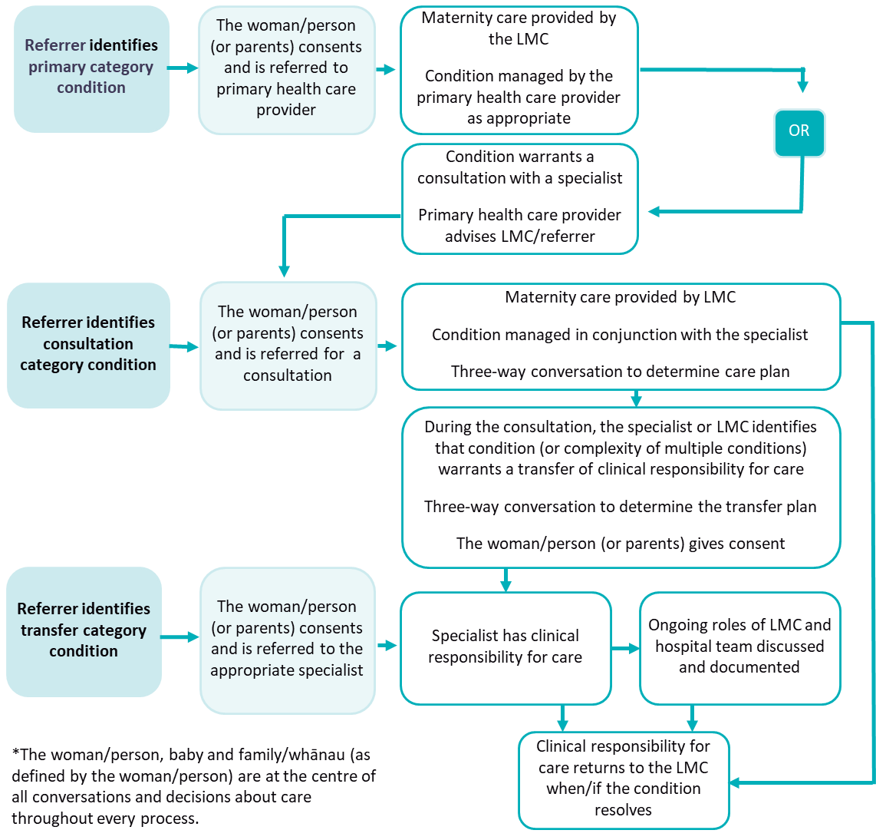

Process for referral to a primary health care, allied health or kaupapa Māori service
If a health practitioner finds that a woman/person (or baby) has a condition in the primary referral category, they should discuss with the woman/person (or parents) the fact that a consultation may be warranted with a primary health care, allied health or other service (for example, another midwife, GP, nurse practitioner, physiotherapist, lactation consultant or kaupapa Māori, Whānau Ora, nutrition, smoking cessation, drug and alcohol, or mental health service).
There are many health-related conditions that can affect pregnant women/people and babies. The list of referral criteria does not cover all of them by any means but instead focuses on those that are relevant during pregnancy and in the earliest days postpartum. It may be appropriate for a health practitioner to recommend that a woman/person (or parents) consult a GP, midwife, nurse practitioner or other allied health or kaupapa Māori service regarding a condition that is not included in the referral criteria list.
Most women/people in Aotearoa New Zealand are enrolled with a general practice or primary health care clinic, which holds their medical records and provides care for ongoing medical needs. Many women/people will attend their general practice to confirm their pregnancy and receive initial advice.
General practice and maternity care are funded separately. Maternity care provided by a midwife, a GP, rural generalist (obstetrics) or a hospital team is free to all eligible women/people. If a woman/person chooses a private specialist obstetrician, they may need to pay a charge in addition to the government subsidy. General practice care is partially subsidised and may incur a part charge when provided to pregnant women/people. Each practice sets its own charges. The referrer must advise the woman/person that there could be a charge for non-maternity related primary or allied health care.

Roles and responsibilities
When a woman/person or baby is referred to a primary health care, allied health or kaupapa Māori service, the new health care provider may provide advice or ongoing management for the condition while the referring LMC retains the clinical responsibility for maternity care. The referral may result in a recommendation that the condition requires the offer of a referral for specialist consultation or a transfer of clinical responsibility for care. This is covered by the consultation or transfer process maps. In all cases, there is a professional responsibility to maintain communication, collaboration and documentation and to inform the LMC/referrer, in writing, of the outcome of the referral. This information should be included in the woman/person’s or the baby’s records.

Communication
Referral to a primary health care, allied health or kaupapa Māori service requires the referrer to provide adequate information to that provider, including any relevant clinical notes, test results, histories, etc. It also requires the new health care provider to notify the LMC/referrer of:
- any subsequent referrals
- any recommendations for the LMC’s ongoing management of the woman/person and/or the baby
- changes in medication or management of the condition itself
- test results
- any other relevant information.
All communication and information sharing must be timely, appropriate and complete.
Process map 1: Referral to a primary health care, allied health or kaupapa Māori service
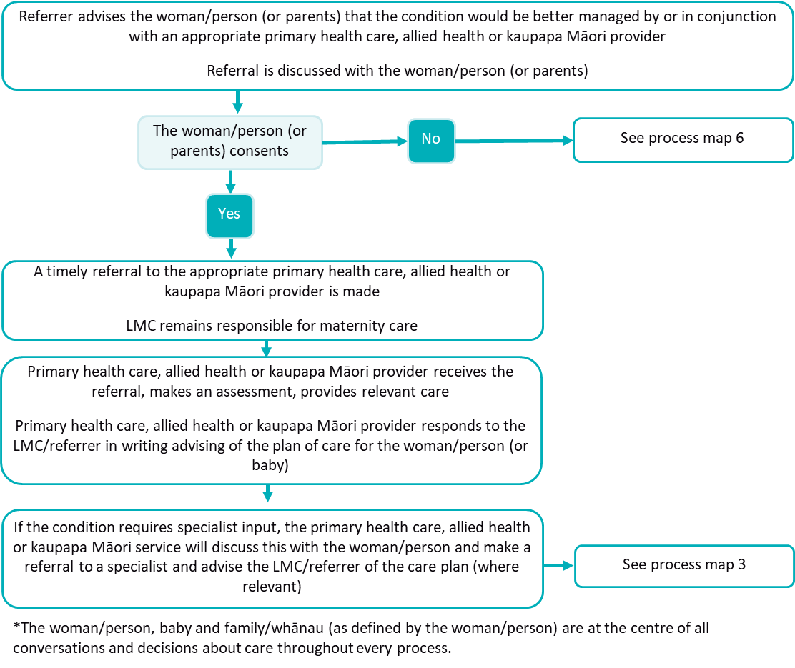

Process for referral to a specialist for consultation
For the conditions listed in the consultation referral category, the referrer must recommend the woman/person (or parents) consult with a specialist.
Consultation can be in the form of a discussion between the referrer and the specialist on the phone or via videoconference or email. The consultation may result in the specialist seeing the woman/person (or baby) in person. The specialist consultation may be done by an individual health practitioner and may include review by a secondary services team. If they are not the referrer, the LMC should be consulted on the need for referral. The consultation should discuss ongoing responsibilities between the LMC and the specialist.
If a woman/person sees a GP before an LMC is chosen and the GP identifies a condition that requires a specialist consultation, the GP can refer as per process map 2. Once the woman/person has chosen an LMC, the GP should provide the LMC with all the relevant information.
The specialist to whom the woman/person (or baby) is referred may be an obstetrician, gynaecologist, radiologist, anaesthetist, physician, psychiatrist, surgeon, paediatrician or a service such as genetic services.

Roles and responsibilities
At the time of the consultation, the clinical responsibility for care remains with the LMC. The specialist should advise the LMC/referrer of recommended monitoring and provide a documented care plan that has been agreed between the woman/person (or parents), the specialist and the LMC. The specialist may become responsible for managing the specific condition if that is appropriate and warranted, and if the woman/person (or parents) agrees.
If the condition increases in severity, or if there are multiple conditions warranting consultation with a specialist, the LMC/referrer may request that the clinical responsibility for care be transferred to the specialist.

Communication
This process assumes that the decisions about a woman/person’s (or baby’s) care are based on a three-way conversation between the woman/person or parents, the LMC and the specialist. Where there is no LMC, communication must include the referrer.
The referrer should provide the specialist with access to all necessary clinical notes and information at referral. The specialist is responsible for informing the LMC of decisions, recommendations and advice as part of the documented plan of care following the consultation. Where there is no LMC, communication must include the referrer.

Meeting local conditions
The referral process will need to take account of:
- capacity of local/regional secondary health care services to see women/people (or babies) in a timely manner
- access to the required specialist services in the area (for example, genetic services are not readily available in all areas of Aotearoa New Zealand)
- distances, time and cost for the woman/person to reach a hospital if an in-person consultation with a hospital-based specialist is needed.
These factors should not influence whether a referral to a specialist for consultation is made but may be pertinent in deciding whether service capacity can meet a specific clinical need.
The steps in process map 2 should be reflected in local processes or protocols.

Process map 2: Referral to a specialist for consultation
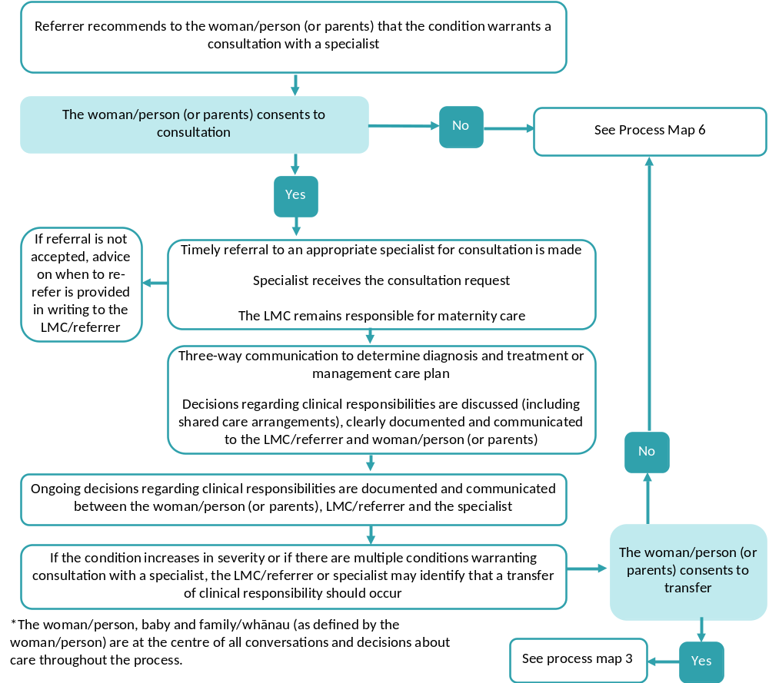

Process for transfer of clinical responsibility for care

Roles and responsibilities
If a condition increases in severity or there are multiple conditions warranting consultation with a specialist, the LMC/referrer may request that the clinical responsibility for care be transferred to the specialist.
For the conditions listed in the transfer referral category, the referrer must recommend transfer of clinical responsibility for care to a specialist. Once clinical responsibility for care is transferred, clinical decisions and decisions on the roles and responsibilities of all other health practitioners involved with the woman/person’s (or baby’s) care rest with the specialist, considering the needs and wishes of the woman/person (or parents). The LMC retains clinical responsibility for care until the transfer has been completed.
Continuity of care should be preserved wherever possible, and there is potential for LMCs to retain a role in providing care for the woman/person (or baby), especially where the LMC is a midwife. For example, a woman/person who is pregnant with twins requires specialist oversight but can continue to receive midwifery care from an LMC midwife. The specialist has clinical responsibility and a clear, written care plan including roles and responsibilities is documented in the woman/person’s or the baby’s records.
An LMC may decline ongoing involvement with a woman/person’s (or baby’s) care if the clinical situation moves outside their scope of practice or experience or unreasonably impacts on their workload. The LMC must ensure that all relevant care is transferred appropriately.

Communication
It is critical to document the point at which responsibility for coordination and provision of maternity or neonatal care is formally transferred to the specialist. This requires:
- a three-way conversation between the woman/person (or parents), the LMC and the specialist to determine that the transfer of clinical responsibility for care is appropriate and acceptable (where there is no LMC, communication must include the referrer)
- the LMC to provide the specialist with access to all relevant information, including any relevant clinical notes, test results (including through shared platforms) and histories
- a discussion and documented decision in the woman/person’s or baby’s records about the nature of the ongoing role of the LMC or whether all care is transferred to the specialist and the hospital midwifery team.
Transfer of clinical responsibility for care requires timely and full communication between the LMC and the specialist. All other health practitioners directly involved in the referral process (for example, the GP or other primary health care, allied health or kaupapa Māori services) should be informed of the decisions made.
Meeting local conditions
The process will need to take account of:
- capacity of local/regional secondary health care services to see women/people (or babies) in a timely manner
- access to the required specialist services in the area
- the distance, time and cost for the woman/person (or baby) to reach a hospital
- whether an in-person consultation with a hospital-based specialist (who may be located at the nearest main centre) is needed.
These factors should not influence whether transfer of clinical responsibility for care to a specialist is made but may be pertinent in deciding whether service capacity can meet a specific clinical need.
The steps in process map 3 should be reflected in local processes or protocols.
Process map 3: Transfer of clinical responsibility for care
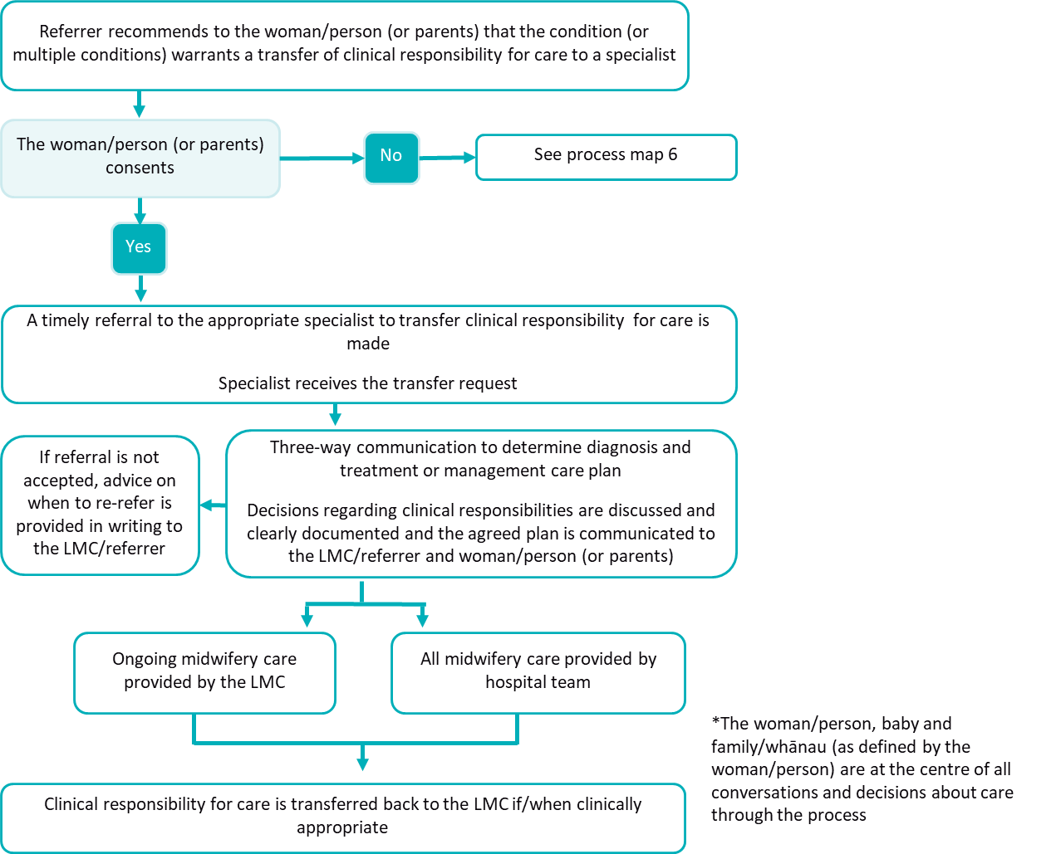

Process for emergency transfer of clinical responsibility for care
Conditions listed in the emergency category are those that require immediate attention by the most appropriate health practitioner available. The type of health practitioner will depend on the specific condition and whether the emergency is taking place within a hospital, at a community maternity facility or in the community. The most appropriate health practitioner may include (but is not limited to):
- the LMC
- other midwives
- a GP or rural hospital doctor / rural generalist (obstetrics)
- paramedics
- obstetricians, either in person or by telephone if no obstetrician is on site or the emergency is taking place in the community or at a community maternity facility
- an obstetric registrar on site at a tertiary maternity service
- an anaesthetist, paediatrician or other relevant specialist.

Roles and responsibilities
The roles and responsibilities during the emergency will be defined by clinical need. Generally, the most experienced and relevant health practitioner will take the lead and advise others of what actions they should take. The LMC has the lead until such time as they transfer the clinical responsibility for care to the most appropriate health practitioner (where this is possible). An obstetric or neonatal emergency often but not always involves a transfer of clinical responsibility from an LMC if it requires transport to or occurs within a secondary or tertiary maternity facility.
The transfer of clinical responsibility for care must be clearly established and documented in the woman/person’s or the baby’s records at the time or as soon as practicable once the situation has stabilised.

Communication
Effective communication with the woman/person, parents and/or the whānau (as defined by the woman/person) is essential in an emergency. As much information as possible should be provided to the woman/person, parents and/or whānau, and to others responding to the emergency at that time.
While it is not possible to discuss every potential emergency and its management, it is expected that the LMC will provided an overview of the management of obstetric or neonatal emergencies with the woman/person before such an emergency might occur.
Communication with the woman/person (or parents) may be difficult in some cases due to the nature of the emergency. Under right 7(4) of the Health and Disability Commissioner (Code of Health and Disability Services Consumers’ Rights) Regulations 1996, the health practitioner may provide services where it is in the best interests of the woman/person (or baby) and where reasonable steps have been taken to ascertain the woman/person’s (or parents’) views. This can be achieved through an antenatal conversation about emergencies documented in the clinical record and/or a birth plan. If the woman/person’s (or parents’) views are not clear, the health practitioner must consider the view of other suitable people who:
- are interested in the welfare of the woman/person and baby
- are available
- can appropriately provide the advice needed.
The steps in process map 4 should be reflected in local processes or protocols.
Process map 4: Emergency transfer of clinical responsibility for care
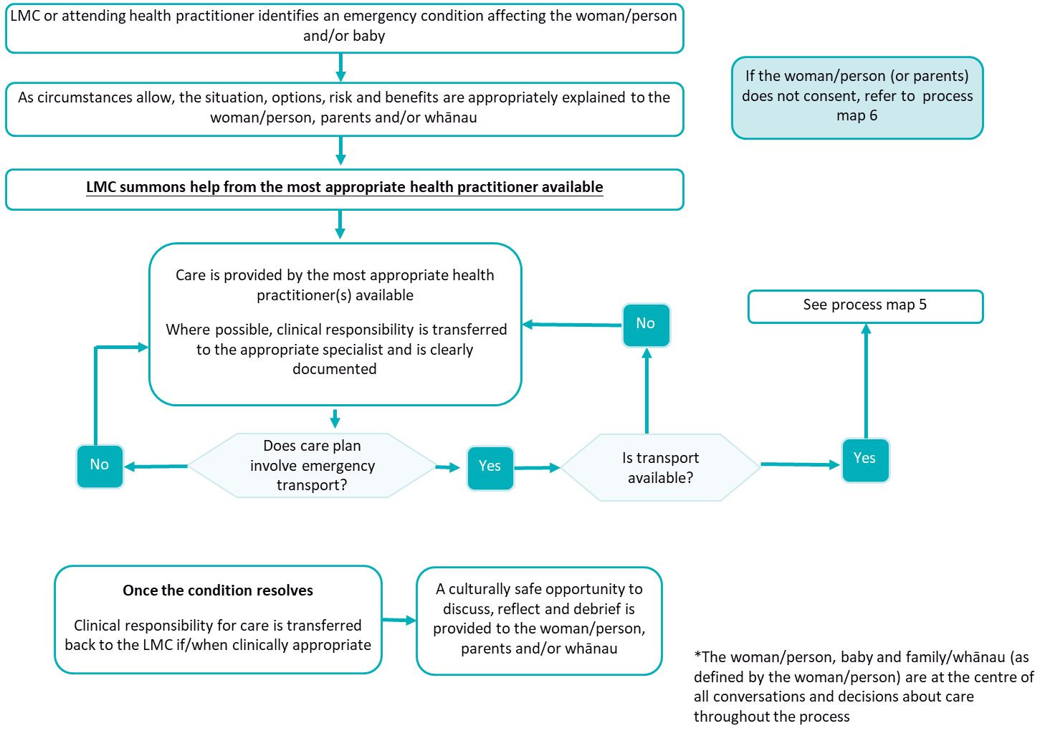

Process for emergency transport
Emergency transport refers to transport used in situations where the woman/person and/or the baby must be moved from the community to a secondary or tertiary maternity facility, or between secondary and tertiary facilities. During this period, the LMC may be consulting and working with other health practitioners as shown in process map 4. Transfer of clinical responsibility for care may have occurred before transport.

Clinical responsibility for care during emergency transport
Until care is formally transferred to a specialist, the LMC retains clinical responsibility for care. This means that paramedics or ambulance crew must take clinical direction from the LMC when they are responding to an obstetric or neonatal emergency.
If the LMC cannot provide a clinical escort during transport, clinical responsibility is transferred to the paramedic crew for the period of transport only. This clinical responsibility will normally be considered to have been transferred when the woman/person and/or the baby arrives at the secondary or tertiary maternity facility.

Emergency transport between maternity facilities
Health services have specific processes for requesting emergency transport from one facility to another. LMCs should ensure they are aware of the processes in their local area. For the purposes of the Referral Guidelines, maternity facilities include community maternity facilities, base hospitals and other facilities from which women/people and/or babies may need to be transported in the event of an obstetric or neonatal emergency.
If the agreed emergency transport process is not practical in the situation or is not available (for example, due to communication difficulties), LMCs should follow the procedure detailed in process map 5 for transport from the community to a secondary or tertiary facility.

Emergency transport resulting from a telephone consultation with a specialist
If an LMC consults with a specialist and a decision is made for emergency transport, the specialist decides on the most appropriate mode of transport in consultation with the emergency services and the LMC. The secondary or tertiary facility must inform the LMC of what transport to expect and the timeframe. The process is the same regardless of mode of transport (that is, air, water or road). If the woman/person and/or the baby is being transported in a private car, the LMC must explain this to the hospital team.
If the hospital team decides to use a retrieval team, the hospital team must inform the LMC the team is on its way and when it can be expected. Specific instructions should be provided to the LMC to maintain clinical safety until the team arrives.

LMC responsibilities before and during the emergency transport process
In preparation, all LMCs and core midwives employed at a community birthing facility should:
- be familiar with the process of arranging emergency transport in their locality and be familiar with the processes for emergency transfer of clinical responsibility for care (if required)
- provide care until emergency transport arrives
- ensure the woman/person and their support people understand the need for emergency transport and the emergency transfer of clinical responsibility for care (if required) and that the woman/person has provided consent (If the woman/person or parents do not consent to the emergency transport of their baby, please see ‘The woman/person declines a referral, consultation, transfer of clinical responsibility for care or emergency treatment or transport’ below)
- provide up-to-date clinical records and necessary administrative data to facilitate transport and transfer.
The steps in process map 5 should be reflected in local processes or protocols.

Process map 5: Emergency transport
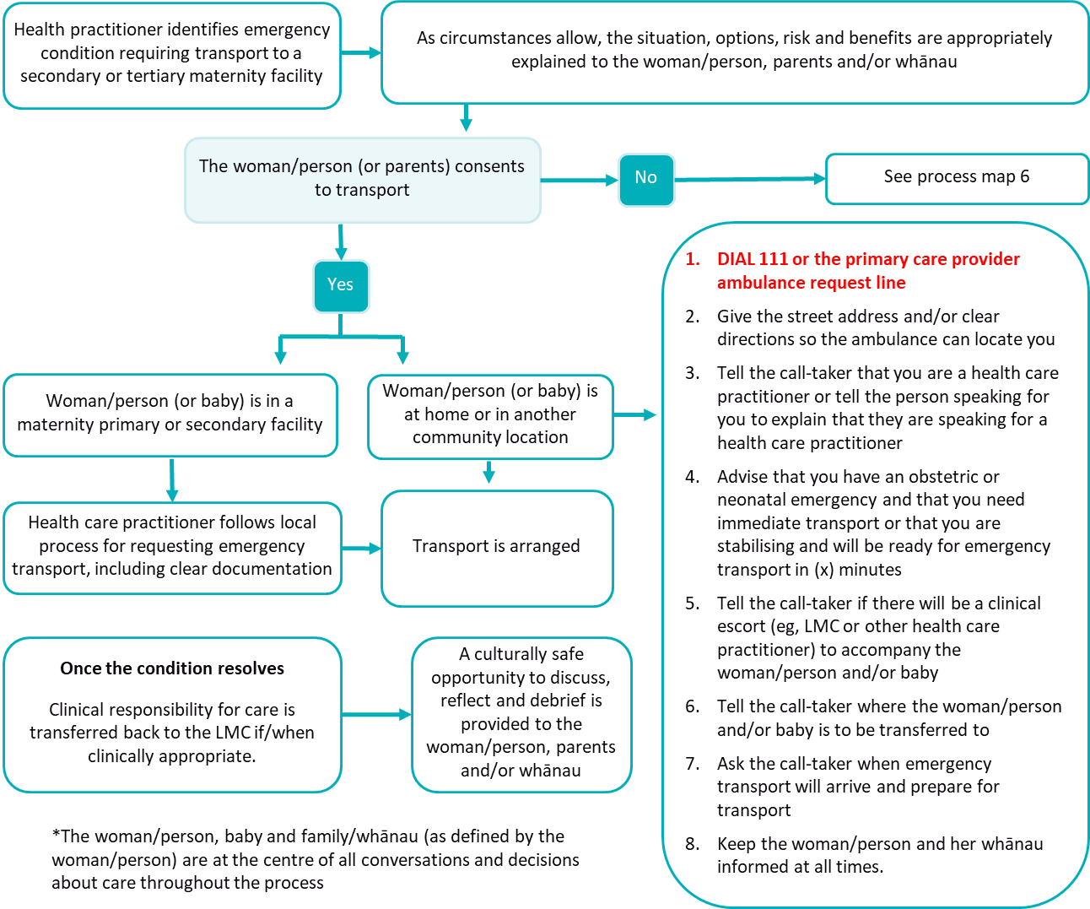

The woman/person declines a referral, consultation, transfer of clinical responsibility for care or emergency treatment or emergency transport
The right to informed consent, including the right to refuse medical treatment, is enshrined in law and in the Health and Disability Commissioner (Code of Health and Disability Services Consumers’ Rights) Regulations 1996 (right 7). A woman/person (or parents) can choose to decline treatment, referral to another health practitioner, or transfer of clinical responsibility for care. To allow informed decision-making, right 6 of the Code requires that the woman/person (or parents) receive accurate, honest information about the options available and the risks, side effects, benefits and costs of these options.
If a woman/person (or parents) chooses not to be referred or not to consult with a specialist, the health practitioner may be left operating outside their experience or scope of practice and/or may feel that they cannot provide the level of care the woman/person and/or baby needs. If, as a result, the health practitioner decides to remove themselves from that role, they must ensure that all relevant care is transferred appropriately.
If a woman/person (or parents) declines a referral, consultation or transfer of clinical responsibility for care, the health practitioner should:
- ensure that appropriate conversations about the situation, options, risks and benefits have occurred
- clarify with the woman/person (or parents) when it may be appropriate to revisit this decision (for example, a change in the clinical circumstances) and document this conversation in the woman/person’s or the baby’s records
- explain to the woman/person (or parents) that they need to consider discussing the case with at least one of the following (ensuring that the woman/person’s and/or baby’s right to privacy is maintained appropriately):
- another midwife or GP
- an appropriate specialist
- an experienced colleague/mentor
- share the outcomes of any discussion that they have had and any resulting advice with the woman/person (or parents) and document this conversation in the woman/person’s or the baby’s records
- document the process, discussions, recommendations given and decisions made and the woman/person’s (or parents) response in the care plan and note an alternative plan should the clinical condition change.
If, after this process, the health practitioner and the woman/person (or parents) have not reached agreement on satisfactory care arrangements, the health practitioner must decide whether to continue or discontinue care.
If the health practitioner decides to continue care, they should:
- continue making recommendations to the woman/person (or baby) for safe maternity care, including further offers of referral
- engage other health practitioners as appropriate for professional support (for example, secondary obstetric or neonatal service, other midwives, etc)
- continue to document all discussions and decisions in the woman/person’s or baby’s records.
If the health practitioner decides to discontinue care, they should:
- clearly communicate the decision and the reasons for that decision to the woman/person (or parents)
- help the woman/person (or parents) find alternative care within a reasonable timeframe
- provide a full handover to the new care provider
- provide the woman/person (or parents) with that provider’s contact details and ensure that the woman/person (or parents) understands the changes to their maternity or the baby’s care
- document the steps taken and that the woman/person (or baby) has been discharged from the health practitioner’s care.

Obstetric or neonatal emergency
In an obstetric or neonatal emergency, the health practitioner cannot refuse to attend the woman/person and/or baby. If the woman/person declines emergency transport or transfer of clinical responsibility for care while in active labour, the health practitioner should remain in attendance. This may result in the health practitioner being called on to deal with a situation that is not within their scope of practice, may be outside their experience or ability to deal with safely or may require treatment that they cannot perform. In these situations, the health practitioner should:
- provide care within professional standards
- provide care to the best of their ability
- attempt to access appropriate resources and/or personnel to provide any necessary care (dependent on the woman/person’s consent)
- clearly document all discussions and actions in the woman/person’s or the baby’s records
- debrief with clinical colleagues after the event with appropriate support.

When the woman/person or parents decline care for their baby
Parents can decline care for their baby, but they cannot unreasonably withhold care for emergency treatment without which there is a risk of serious harm or death. If parents decline consent for treatment of the baby, health practitioners should discuss the baby’s needs and treatment options with the parents and whānau and document all advice given and actions taken in the baby’s record.

Process map 6: Woman/person (or parents) declines treatment
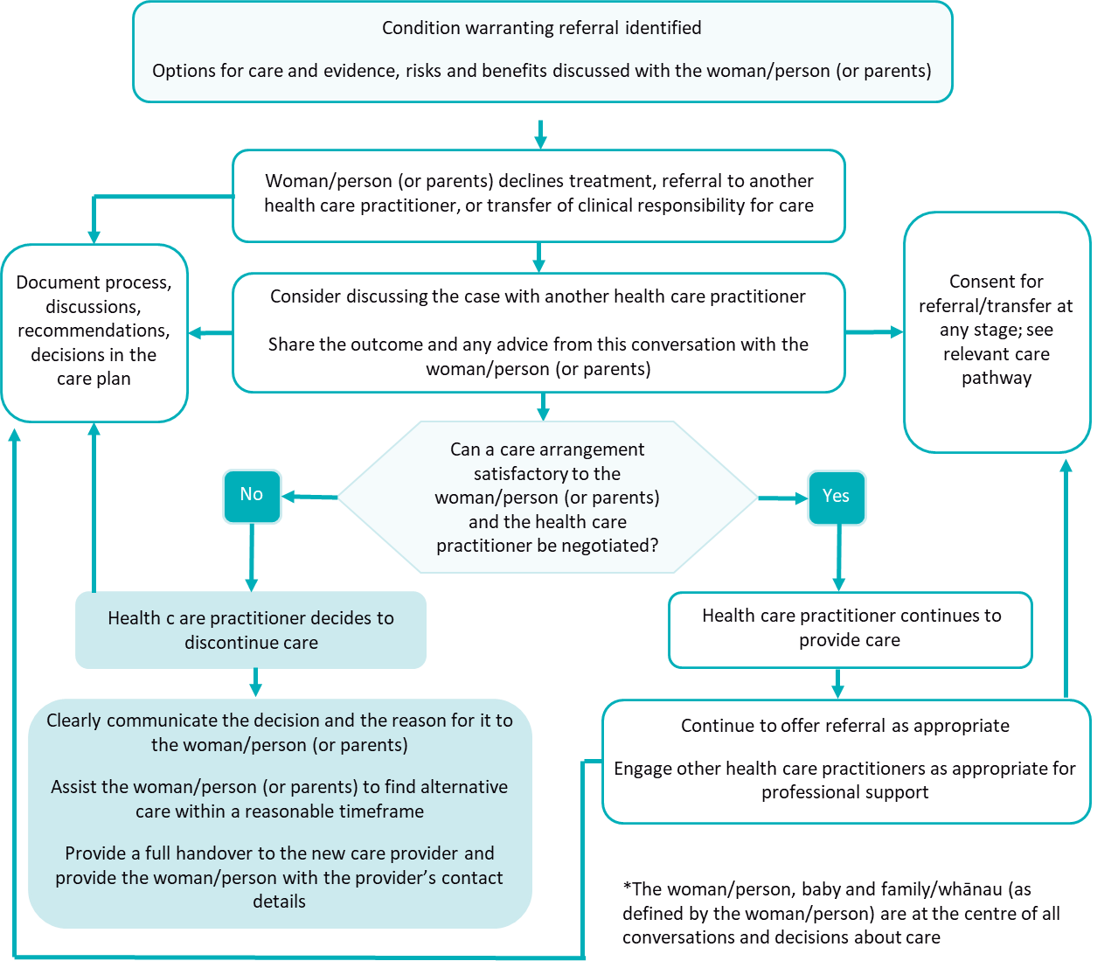

Conditions and referral categories
Table 2: Conditions and referral categories provides a list of conditions for which a health practitioner should recommend to the woman/person (or parents) that a primary referral, consultation or transfer of clinical responsibility for care take place.
The referral categories are detailed in Table 1 and the processes that should be used are detailed in Table 2.
Health practitioners must use clinical judgement in deciding when and to whom to refer a woman/person and/or baby. For example, a condition that is normally a cause for a referral to a primary health care or allied health or kaupapa Māori service may be severe enough on presentation to warrant a specialist consultation. There may be multiple conditions that together warrant referral for consultation or a transfer of clinical responsibility for care.
The referral categories may form part of a continuum. Placing a condition in the consultation category does not preclude a subsequent transfer of clinical responsibility for care if that is indicated by the results of the consultation or if the condition persists or worsens.
All decisions concerning a woman/person’s and/or the baby’s care, including recommendations for referrals, consultations and/or transfer of clinical responsibility for care, must be made in discussion with the woman/person (or parents), and with all health practitioners involved in the care.
A woman/person and their LMC should discuss requests to have a consultation with a specialist or clinical responsibility for care transferred when there is no clinical indication.
Table 2: Conditions and referral categories
Code | Condition | Description | Referral category
Pre-existing and/or co-existing medical conditions
Anaesthetics
1001 | Anaesthetic difficulties | Previous failure or complication (eg, difficult intubation, failed epidural, severe needle phobia) | Consultation
1002 | Malignant hyperthermia, neuromuscular disease or suxamethonium apnoea |  | Consultation
Autoimmune/rheumatology
1003 | SLE / connective tissue disorder | Active, major organ involvement, on medication | Transfer
1004 | SLE / connective tissue disorder | Inactive, no renal involvement, no hypertension, or only skin/joint problems | Consultation
1005 | Thrombophilia including antiphospholipid syndrome | On warfarin, previous obstetric complications or maternal thrombosis | Transfer
1006 | Thrombophilia including antiphospholipid syndrome | No previous obstetric complications or maternal thrombosis | Consultation
Cardiac
1007 | Arrhythmia, palpitations, murmurs | Recurrent, persistent or associated with other symptoms  Note: Respiratory sinus arrhythmia does not require referral | Primary
1008 | Cardiac valve disease | Mitral/aortic regurgitation | Consultation
1009 | Cardiac valve disease | Mitral/aortic stenosis | Transfer
1011 | Cardiac valve replacement |  | Transfer
1012 | Cardiomyopathy |  | Transfer
1013 | Congenital cardiac disease |  | Consultation
1014 | Hypertension | Hypertension confirmed pre-conception or before 20 weeks’ gestation with or without a known cause, measured on two or more occasions at least four hours apart or on antihypertensive medication | Consultation before 16 weeks’ gestation
1015 | Hypertension | Diastolic BP >110 mmHg or systolic BP >160 mmHg | Transfer
1016 | Ischaemic heart disease. |  | Transfer
1017 | Pulmonary hypertension |  | Transfer
Endocrine
1019 | Diabetes | Pre-existing (Type 1, Type 2, MODY) | Transfer
1020 | Diabetes | Gestational, well controlled on diet or metformin | Consultation
1021 | Diabetes | Gestational, requiring insulin | Transfer
1023 | Hypopituitarism |  | Consultation
1076 | Other known endocrine disorders significant in pregnancy | eg, Addison’s disease, Cushing’s disease | Consultation
1024 | Prolactinoma |  | Consultation
1022 | Thyroid disease | Hypothyroidism | Primary
1082 |  | Hyperthyroidism | Consultation
Gastroenterology
1077 | Bariatric surgery |  | Consultation in the second trimester
1025 | Cholecystitis | Presenting as acute abdominal pain | Consultation
1026 | Cholestasis of pregnancy |  | Transfer
1029 | Hepatitis | Acute | Consultation
1030 |  | Chronic active | Consultation
1081 |  | Active chronic on immunosuppressants | Transfer
1027 | Inflammatory bowel disease | Active or on medication | Consultation
1028 |  | Inactive | Primary
1031 | Oesophageal varices |  | Transfer
1072 | Previous fatty liver in pregnancy |  | Consultation
Genetic
1032 | Any known genetic condition significant in pregnancy |  | Transfer
1033 | Marfan syndrome |  | Transfer
Haematological
1034 | Anaemia | Hb < 90 g/L, not responding to treatment | Consultation
1036 | Bleeding disorders | Including Von Willebrand disease | Consultation
1035 | Haemolytic anaemia |  | Transfer
1039 | Sickle cell disease |  | Transfer
1037 | Thalassaemia |  | Consultation
1038 | Thrombocytopaenia |  | Consultation
1040 | Thromboembolism | Previous deep vein thrombosis, pulmonary embolism | Consultation
1041 | Thrombophilia |  | Consultation
Infectious diseases
1042 | CMV/toxoplasmosis | Acute | Transfer
1044 | HIV positive |  | Transfer
1045 | Listeriosis | Acute | Transfer
1046 | Rubella |  | Consultation
1047 | Syphilis |  | Consultation
1048 | Tuberculosis | Active | Transfer
1073 |  | Contact | Primary
1049 | Varicella | Acute | Transfer
Mental health
1058 | Current alcohol or drug misuse / dependency |  | Primary
1078 | Depression and anxiety disorders |  | Primary
1059 | Other mental health condition | Stable and/or on medication, eg, bipolar disorder | Consultation
1079 |  | Acute unstable psychosis | Transfer
1074 |  | Complex mental health needs | Consultation
Neurological
1050 | Arteriovenous malformation, cerebrovascular accident, transient ischaemic attacks |  | Consultation
1051 | Epilepsy | Controlled | Consultation
1052 |  | Poor control or multiple medications | Transfer in first trimester
1075 |  | New diagnosis | Transfer
1053 | Multiple sclerosis |  | Consultation
1056 | Muscular dystrophy or myotonic dystrophy |  | Transfer
1054 | Myasthenia gravis |  | Transfer
1055 | Spinal cord lesion |  | Transfer
Renal disease
1061 | Glomerulonephritis |  | Transfer
1062 | Proteinuria | Chronic | Consultation
1063 | Pyleonephritis |  | Consultation
1065 | Renal abnormality or vesico-ureteric reflux |  | Consultation
1064 | Renal failure |  | Transfer
Respiratory disease
1069 | Acute respiratory condition |  | Primary
1067 | Asthma | Moderate (using reliever more than twice per week) | Primary
1068 |  | Severe (continuous or near continuous oral steroids or hospitalisation) | Consultation
1071 | Chronic obstructive pulmonary disease (COPD) |  | Consultation
1070 | Cystic fibrosis |  | Transfer
Transplant
1080 | Organ transplant |  | Transfer
Previous gynaecological conditions or surgery
2001 | Cervical surgery, including cone biopsy, laser excision or large loop excision of the transformation zone (LLETZ) | One LLETZ procedure with known depth excision ≥10 mm without subsequent term vaginal birth or more than one LLETZ procedure and/or cold knife cone biopsies | Consultation before 16 weeks’ gestation
2003 | Congenital abnormalities of the uterus | Without previous term pregnancy outcome | Consultation before 16 weeks’ gestation
2011 | Female genital mutilation |  | Consultation
2007 | Previous uterine surgery | Myomectomy | Consultation
2008 |  | Previous uterine perforation | Consultation
2009 | Prolapse | Previous surgery | Consultation
2010 | Vaginal abnormality | eg, septum | Consultation
Previous maternity history
3002 | Alloimmune thrombocytopaenia | As risk to fetus of thrombocytopaenia | Transfer
3003 | Caesarean section |  | Consultation
3019 | Fetal congenital abnormality |  | Consultation
3023 | Fetal growth restriction | Born ≥ 20+0 weeks with neonatal *FGR diagnosis | Consultation before 16 weeks’ gestation
3008 | Hypertensive disease | Commence aspirin between 12 and 16 weeks’ gestation  Pre-eclampsia with significant fetal growth restriction (FGR) or requiring birth < 34 weeks’ gestation | Consultation before 16 weeks’ gestation
3021 |  | Commence aspirin between 12 and 16 weeks’ gestation  Previous eclampsia or HELLP | Consultation before 16 weeks’ gestation
3011 | Manual removal | With adherent placenta, consider previous management of third stage | Consultation
3020 | Obstetric anal sphincter injury | 3a, 3b, 3c and 4th degree tearing, with or without symptoms | Consultation
3012 | Perinatal death |  | Consultation
3013 | Postpartum haemorrhage | > 1000 mL | Consultation
3017 | Previous dilation and curettage | Previous complications or three or more procedures | Consultation before 16 weeks’ gestation
3001 | Previous placental abruption |  | Consultation
3014 | Previous spontaneous preterm birth | Between 16 and 31+6 weeks’ gestation | Consultation before 16 weeks’ gestation
3022 | Previous spontaneous preterm birth | Between 32 and 6+6 weeks’ gestation | Consultation before 26 weeks’ gestation
3015 | Recurrent miscarriage | Three or more | Consultation before 16 weeks’ gestation
3016 | Shoulder dystocia |  | Consultation
3018 | SUDI (Sudden unexplained death in infancy) |  | Primary
3005 | Trophoblastic disease | Hydatidiform mole or vesicular mole, within last 12 months | Consultation
Current pregnancy
4001 | Acute abdominal pain |  | Consultation
4002 | Abdominal trauma |  | Consultation
4003 | Abnormal CTG |  | Consultation
4004 | Antepartum haemorrhage |  | Consultation
4005 | Blood group antibodies |  | Consultation
4017 | Class II obesity | Body mass index (BMI) 35–40 kg/m² | Consultation
4034 | Class III obesity | BMI 40–49 kg/m²; include an anaesthetic consultation | Consultation
4035 | Class IV obesity | BMI > 50 kg/m²; include an anaesthetic consultation | Transfer
4046 | Contraceptive device in-situ | Includes both intrauterine devices/systems and implants | Consultation in first trimester
4047 | COVID-19  Refer to heath pathway for risk stratification | Active infection | Consultation
4036 | COVID-19  Refer to heath pathway for risk stratification | Previous infection this pregnancy | Consultation
4006 | Eclampsia |  | Emergency
4007 | Fetal abnormality |  | Consultation
4008 | Gestational proteinuria | Protein creatinine ratio > 30 | Consultation
4009 | Gestational hypertension | New onset hypertension after 20 weeks’ gestation without signs of pre-eclampsia; systolic BP >140 mmHg or diastolic BP >90 mmHg measured on two or more occasions at least four hours apart | Consultation
4029 | Herpes genitalis | Active lesions | Consultation
4033 | Influenza-like illness |  | Primary
4010 | Intrauterine death |  | Transfer
4048 | Fetal growth restriction | Early-onset (< 32+0 weeks)  *EFW customised or *AC < 3rd centile  or  *UA with absent or reversed end-diastolic flow  or  *EFW customised or *AC < 10th centile AND abnormal Doppler (*UA and/or *UtA) | Consultation
4049 | Fetal growth restriction | Late-onset (≥ 32+0 weeks)  *EFW customised or *AC < 3rd centile  or  two or more of:  - *EFW customised or *AC < 10th centile  - slowing fetal growth (*EFW or *AC decline > 30 centiles from 28+0 weeks)  - abnormal Doppler (*UA, *CPR and/or *UtA) | Consultation
4050 |  | *EFW < 3rd centile OR at risk of birth < 28+0 weeks’ gestation  or  at risk of birthweight < 1,000g | Transfer
4051 | Isolated small for gestational age (SGA) | EFW and/or AC 3rd to <10th centile with normal Doppler measurements. | Consultation
4013 | Infant large for gestational age | EFW > 90th centile and AC > 90th centile, in the absence of diabetes | Consultation
4015 | Malignancy |  | Transfer
4016 | Malpresentation | > 36 weeks’ gestation; breech, transverse, oblique or unstable lie | Consultation
4018 | Multiple pregnancy | Dichorionic twins | Transfer
4037 |  | Monochorionic twins and higher order multiples | Transfer at diagnosis
4019 | Oligohydramnios | No pool depth > 2 cm | Consultation
4038 | Parvovirus B19 infection |  | Consultation
4020 | Placenta praevia; vasa praevia | > 32 weeks’ gestation | Transfer
4039 | Polycystic kidneys | Maternal (not fetal) finding | Consultation
4021 | Polyhydramnios | Mild (deepest pocket measurement 9–11 cm) | Consultation
4040 |  | Moderate (deepest pocket measurement 12–15 cm) or severe (deepest pocket measurement > 16 cm) | Transfer
4022 | Pre-eclampsia | New onset hypertension after 20 weeks’ gestation (systolic BP > 140 mmHg or diastolic BP > 90 mmHg measured on two or more occasions at least four hours apart) with one or more of the following: proteinuria > 30 mg/mmol, other organ dysfunction (renal, liver, neurological, haematological), or uteroplacental dysfunction (for example, fetal growth restriction, abruption) | Transfer
4023 | Preterm rupture of membranes | < 37+0 weeks’ gestation and not in labour | Transfer
4024 | Prolonged pregnancy | Refer in a timely manner for planned induction by 42 weeks gestation | Consultation
4025 | Premature labour | Between 34 and 36+6 weeks gestation | Consultation
4026 |  | < 34 weeks’ gestation | Transfer
4027 | Pre-labour rupture of membranes at term | Consult before 24 hours | Consultation
4028 | Persistent reduced fetal movements | Following normal cardiotocograph but still reduced movements – may require a scan for liquor assessment/ growth assessment | Consultation
4041 | Short cervix | Finding on ultrasound of a cervix < 25 mm before 24 weeks’ gestation | Consultation as soon as possible after detection
4045 | Syphilis | First diagnosed in current pregnancy | Consultation
4042 | Thromboembolism | Deep vein thrombosis, pulmonary embolism | Emergency
4044 |  | Investigated for possible DVT or PE (negative result) | Consultation
4032 | Urinary tract infection (UTI) | Recurrent | Consultation
4031 | Uterine fibroids | Cervical fibroids, retroplacental fibroids, submucosal or intramural fibroids > 5 cm, multiple fibroids | Consultation
4043 | Velamentous cord insertion |  | Consultation
Labour and birth – first and second stage
5001 | Amniotic fluid embolism |  | Emergency
5002 | Anhydramnios |  | Transfer
5003 | Cerebral anoxia / cardiac arrest |  | Emergency
5004 | Complications of anaesthetic |  | Consultation
5005 | Complications of other analgesia |  | Consultation
5007 | Cord prolapse or presentation |  | Emergency
5008 | Deep transverse arrest |  | Transfer
5009 | Epidural |  | Consultation
5011 | Fetal heart rate abnormalities |  | Consultation
5012 | Hypertonic uterus |  | Consultation
5013 | Induction of labour |  | Consultation
5010 | Instrumental vaginal birth |  | Transfer
5016 | Intrapartum haemorrhage |  | Transfer
5027 | Labour requiring oxytocin augmentation |  | Consultation
5006 | Malpresentation | Compound presentation | Transfer
5028 |  | Breech diagnosed in labour | Transfer
5017 | Maternal tachycardia | Sustained | Consultation
5018 | Meconium liquor | Moderate or thick | Consultation
5019 | Obstetric shock |  | Emergency
5020 | Obstructed labour |  | Transfer
5021 | Prolonged first stage of labour | < 2 cm in four hours for nullipara. Slowing in the progress of labour for second and subsequent labours. Take into consideration descent and rotation of fetal head and changes in strength, duration and frequency of contractions | Consultation
5023 | Prolonged active second stage of labour | > two hours of active pushing with no progress for nullipara or > one hour of active pushing with no progress for multipara | Consultation
5024 | Pyrexia in labour | > 38 degrees with or without fetal tachycardia | Consultation
5025 | Shoulder dystocia |  | Emergency
5026 | Uterine inversion |  | Emergency
Labour and birth – third stage
6001 | 3rd and 4th degree lacerations |  | Transfer
6002 | Cervical laceration |  | Transfer
6003 | Postpartum haemorrhage (PPH) | > 500 mL of blood loss with ongoing losses | Consultation
6008 |  | Ongoing uncontrolled bleeding | Emergency
6004 | Retained placenta |  | Transfer
6005 | Shock |  | Emergency
6006 | Vaginal laceration | Complex | Consultation
6007 | Vulval and perineal haematoma |  | Transfer
Following birth – woman/person
7001 | Breast infection | Suspected abscess or not settling with antibiotics | Consultation
7002 | Neonatal death | Discussion and plan | Consultation
7003 | Post-birth neurological deficit | eg, neuropraxia | Consultation
7004 | Postnatal depression |  | Primary
7005 | Postnatal psychiatric event | Including bipolar, psychosis | Transfer
7007 | Pyrexia of unknown origin |  | Consultation
7008 | Secondary PPH |  | Consultation
7006 | Sepsis | >38°C or <36°C; heart rate > 100 beats per minute; respiratory rate > 25 breaths per minute; systolic blood pressure < 90 mmHg; new onset of pain; altered mental state | Transfer
7009 | Suspected epidural abscess or haematoma | May overlap with 7003 | Emergency
7010 | Suspected post-dural puncture headache |  | Consultation
7011 | Recall or awareness under general anaesthesia |  | Consultation
7012 | Vaginal or perianal prolapse |  | Consultation
Following birth – baby
General
8001 | Abnormal neonatal examination | Minor abnormalities not specified elsewhere | Primary
8074 | Abnormal pulse oximetry screen result | Persistent oxygen saturation 90–94% on third test | Consultation
8075 | Abnormal red eye reflex | As per the red reflex screening assessment | Consultation
8057 | Birth injury |  | Consultation
8003 | Congenital anomaly | Conditions that may require early treatment | Consultation
8002 | Fetal ultrasound abnormality | Any | Consultation
Cardiovascular
8058 | Absent femoral pulses |  | Consultation
8004 | Heart murmur, no symptoms |  | Consultation
8005 | Heart murmur with symptoms |  | Transfer
8059 | Hypoxaemia | < 90% oxygen saturation | Consultation
8006 | Persistent or recurrent cyanosis |  | Transfer
8060 | Persistent tachycardia |  | Consultation
CNS
8008 | Convulsions or unresponsiveness |  | Emergency
8009 | Excessive irritability |  | Consultation
8010 | Limpness, hypotonic | With abnormal vital signs or other abnormality | Emergency
8069 |  | With normal vital signs | Consultation
8007 | Microcephaly | Occipitofrontal head circumference < 3rd percentile | Consultation
8011 | Severe infant depression at birth | eg, Apgar score of ≤ 6 at 1 minute with little improvement by 10 minutes | Emergency
8072 | Moderate infant depression at birth | eg, Apgar score of ≤ 6 at 10 minutes | Transfer
Gastrointestinal
8024 | Abdominal distension or mass |  | Consultation
8027 | Inguinal hernia |  | Consultation
8026 | No passage of meconium by 36 hours |  | Consultation
8025 | Persistent or bile-stained vomiting |  | Consultation
8070 | Persistent fresh blood in stools |  | Consultation
8023 | Suspected oesophageal atresia | Unable to pass a gastric tube in a mucousy baby | Transfer
Genitourinary
8062 | Ambiguous genitalia |  | Consultation
8063 | Antenatal genitorenal renal dilation | Anterior-posterior renal pelvic diameter (AP RPD) < 15 mm with no peripheral dilatation or additional findings (P1) | Primary
8064 | Antenatal genitorenal renal dilation | AP RPD ≥15 mm or with no peripheral dilatation or additional findings OR AP RPD <15 mm with peripheral dilatation (P2) | Consultation
8065 | Antenatal genitorenal renal dilation | Antenatal AP RPD > 7mm with central calyceal dilation (A2) or postnatal AP RPD ≥15 mm with peripheral dilatation or additional findings or any AR RPD with additional findings (P3) | Consultation
8028 | Failure to pass urine in the first 24-hour period |  | Consultation
8029 | Hypospadias or foreskin abnormality |  | Consultation
8030 | Undescended testes |  | Primary
Growth and feeding
8014 | Dehydration or > 10 - 12.5% weight loss since birth |  | Consultation
8061 | Weight loss of > 12.5% since birth |  | Transfer
8016 | Fetal growth restriction | Customised *BW < 3rd centile  or  customised *BW ≥ 3 to < 10 centile and ≥ 2 of:  - *BMI z-score < -1.3  - length z-score < -1.3  - skin/body fat z-score < -1.3 (where equipment and expertise allow)  - antenatal *FGR diagnosis  - major *FGR risk factor  - placental insufficiency on histology  or  customised *BW ≥ 10 centile, antenatal *FGR diagnosis and evidence of placental insufficiency | Consultation
8017 | Low birthweight | Birthweight 2,000–2,500 g | Consultation
8018 |  | Birthweight < 2,000 g | Transfer
8015 | Persistent vomiting without blood or bile |  | Consultation
8019 | Poor weight gain | Birthweight not regained by 14 days | Consultation
8021 | Preterm | Between 35+0 and 36+6 weeks’ gestation | Consultation
8022 |  | < 35 weeks’ gestation | Transfer
8013 | Sustained feeding difficulties in a newborn not related to gestational age |  | Consultation
Haematology
8031 | Evidence of a bleeding tendency | Haematemesis, melaena, haematuria, purpura, generalised petechiae | Transfer
8032 | Haemorrhage from cord or another site |  | Transfer
8033 | Maternal isoimmunisation | Rhesus or other antibodies  Refer before birth | Transfer
8034 | Maternal thrombocytopaenia |  | Consultation
8066 | Neonatal subgaleal haemorrhage | Normal vital signs and head circumference stable with no signs of ongoing bleeding | Transfer
8067 |  | Any concern about baby’s vital signs OR signs of ongoing bleeding OR head circumference increasing | Emergency
Infection
8076 | COVID-19 | Current infection | Consultation
8073 | Sepsis |  | Consultation
8036 | Suspected chorio-amnionitis | Fetal tachycardia, maternal pyrexia, offensive liquor | Consultation
8037 | Temperature instability | Temp < 36.5°C or > 37.5°C confirmed within one hour following appropriate management | Consultation
Jaundice
8038 | Any in first 24 hours |  | Transfer
8039 | Bilirubin > 250 micromol/L in first 48 hours |  | Consultation
8040 | Bilirubin > 300 micromol/L at any time |  | Consultation
8041 | Prolonged jaundice: visible or > 150 micromol/L from two weeks in term infant and three weeks in preterm infant |  | Consultation
8042 | Significant jaundice in previous infant |  | Consultation
Maternal factors
8043 | Infant of a woman/person with history of substance or alcohol misuse/ dependence in this pregnancy | eg, methadone, marijuana, alcohol, codeine, valium, methamphetamines | Consultation
8044 | Infant of woman/person with diabetes | Hypoglycaemia (blood sugar < 2.0 mM) | Transfer
8068 | Infant of woman/person with diabetes | Hypoglycaemia  (blood sugar 2.0–2.5 mM) | Consultation
8045 | Infant of woman/person with diabetes | Apparently normal infant or with abnormal findings other than hypoglycaemia | Consultation
8046 | Intrauterine infection | Toxoplasmosis, rubella, cytomegalovirus (CMV), other Referral before birth often appropriate | Consultation
8048 | Maternal medication with risk to baby | eg, carbimazole, antipsychotics and antidepressants. | Primary
8079 | Maternal medication with risk to baby | Anticonvulsant | Consultation
8077 |  | Lithium-based medications | Consultation
8049 | Maternal or family history with risk factors for baby | eg, vesico-ureteric reflux, bleeding disorder, congenital heart disease, deafness, Graves’ disease, syphilis, severe handicap in parent, bipolar disease, schizophrenia, other psychiatric condition | Consultation
Orthopaedics
8051 | Congenital hip problem | Unstable hips, breech birth, family history of dislocated hips | Consultation
8052 | Congenital foot problem | Talipes equinovarus or significant positional foot deformity | Consultation
Respiratory
8054 | Apnoea | Baby has stopped breathing for more than 20 seconds and needs resuscitation | Emergency
8071 |  | Repeated pauses in breathing (> 10 seconds) | Transfer
8055 | Persistent tachypnoea | Respiratory rate > 60/min for more than one hour from birth | Consultation
8053 | Respiratory distress | Any cyanosis, persistent grunting, pallor | Transfer
8056 | Stridor, nasal obstruction or respiratory symptoms not specified elsewhere | With normal O₂ saturation (> 95%) | Consultation
8078 |  | With low O₂ saturation (< 90%) | Transfer
*AC= abdominal circumference; BMI = body mass index; BW = birthweight; CPR = cerebroplacental ratio; EFW = estimated fetal weight; FGR = fetal growth restriction; UA = umbilical artery; UtA = uterine artery.

Further advice on Te Tiriti
The professional associations can offer helpful support for health practitioners around giving effect to the principles of Te Tiriti, for example:
- Medical Council of New Zealand: Statement on cultural safety
- Medical Council of New Zealand: He Ara Hauora Māori: A pathway to Māori health equity
- Midwifery Council of New Zealand: Statement on Cultural Competence for Midwives
- Ngā Maia Turanga Kaupapa, principles that give life and meaning to the midwifery profession’s recognition of Māori as tangata whenua and the profession’s obligations under Te Tiriti, in the Midwives’ Handbook for Practice
- The Royal Australasian College of Physicians: Guideline Commentary On Consulting With Māori And Their Whānau.
Health practitioners may also find it valuable to familiarise themselves with:
- Medical Council of New Zealand: Best Health Outcomes for Māori: Practice implications (Māuri Ora Associates 2006)
- Huria T, Pitama S, Lacey C. 2014. Improving Māori health through clinical assessment: Waikare o te waka o meihana. The New Zealand Medical Journal, 127(1393)
- Continuing Education, University of Otago: MIHI 501 Health Professionals Course: Application of the Hui Process / Meihana Model to Clinical Practice.

Cultural safety
Practising in a culturally safe way is important and a requirement of Te Tiriti, particularly in giving effect to the principles of active protection, options and partnership. Health practitioners must know that tikanga or correct protocols and practices are often specific to whānau, hapū and iwi and that observing tikanga does not involve a ‘one-size-fits-all’ approach. Similarly, mātauranga Māori or Māori knowledge is not a single entity; rather there is both traditional and contemporary mātauranga Māori, as well as mātauranga Māori that is specific to hapū and iwi environments, including land, seas, waterways, weather systems, the stars, flora and fauna, and things seen and unseen. Older forms of mātauranga Māori have been somewhat protected from colonisation because they were composed or narrated in te reo Māori.
Rangatiratanga or self-determining rights over tikanga and mātauranga Māori is crucial to the safety and survival of mātauranga Māori. For this reason, health practitioners should be very careful to avoid imposing their understanding of tikanga or mātauranga Māori on Māori through maternity care. In addition, they should not assume that all Māori are familiar with terms such as ‘tikanga’, ‘mātauranga’ and ‘Te Tiriti’. Māori who are unfamiliar with such terms can experience such an assumption as diminishing their mana as expressed by Te Tiriti, which would be an outcome that is the opposite of the intent of Te Tiriti, this guideline and Ngā Paerewa.

Update process
The Ministry of Health contracted consultants Allen + Clarke to update the 2012 Referral Guidelines. Our project team (Anna Gribble, Professor Frank Bloomfield, Dr Michelle Wise and Norma Campbell) is grateful for the advice and guidance received from the health and disability sector in response to draft documents.
Three literature reviews addressing three research questions were completed to inform the update of this guideline. Recommendations were developed by expert consensus, considering the evidence from the reviews of relevant clinical literature.
We wish to acknowledge and thank the Maternity Guidelines Review Steering Group for its advice and guidance. Members of the Maternity Guidelines Review Steering Group were:
- Dr Angela Beard (Co-Chair, He Hono Wāhine)
- Sue Bree (Co-Chair, Midwifery Leaders’ Group)
- Claire MacDonald (New Zealand College of Midwives)
- Dr Karaponi Okesene Gafa (Royal Australian and New Zealand College of Obstetricians and Gynaecologists, RANZCOG)
- Dr Lesley Dixon (New Zealand College of Midwives)
- Liz Lewis-Hills (New Zealand Society for the Study of Diabetes)
- Dr Mariam Buksh (Royal Australasian College of Physicians)
- Dr Matthew Drake (Australian and New Zealand College of Anaesthetists & Faculty of Pain Medicine)
- Dr Rachael McConnell (RANZCOG)
- Dr Rosemary Hall (New Zealand Society for the Study of Diabetes)
- Dr Sue Belgrave (RANZCOG)
- Dr Trevor Lloyd (The Royal New Zealand College of General Practitioners).
The Referral Guidelines are due for their next review in 2027.

In some areas, certain specialist obstetric procedures or maternity services may also be delivered by a rural generalist (obstetrics). A rural generalist (obstetrics) is credentialled by the institution they work in.
In: Waitangi Tribunal. 2019. Hauora: Report on Stage One of the Health Services and Outcomes Kaupapa Inquiry. Wellington: Waitangi Tribunal. URL: https://forms.justice.govt.nz/search/Documents/WT/wt_DOC_152801817/Hauora%20W.pdf (accessed 2 February 2022).
See Ministry of Health’s Te Tiriti o Waitangi Framework for the Ministry’s four goals, each expressed in terms of mana. URL: https://www.health.govt.nz/system/files/documents/pages/whakamaua-tiriti-o-waitangi-framework-a3-aug20.pdf (accessed 2 February 2022).
For more information, see the webpage Māori health models – Te Whare Tapa Whā on the Ministry of Health website at URL: www.health.govt.nz/our-work/populations/maori-health/maori-health-models/maori-health-models-te-whare-tapa-wha
New Zealand College of Midwives. 2017. Transfer Guidelines. Christchurch: New Zealand College of Midwives.
Te Tiriti o Waitangi framework as set out in: Ministry of Health. 2020. Whakamaua: Māori Health Action Plan 2020–2025. Wellington: Ministry of Health.

